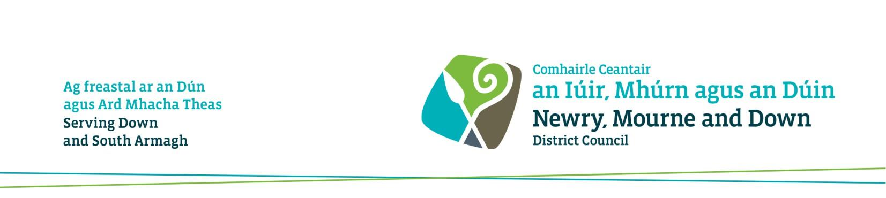

Women Returners Academy
Designed to support women to enter or return to the workplace through a structured, practical and engaging learning experience where females and businesses will be provided with the skills, tools and confidence to enhance personal effectiveness.

The aim is to provide a pathway for women living in the Newry, Mourne and Down District Council area to move into an entry level role.

On successful completion, it is expected that participants will have:
- Enhanced their qualifications having achieved a Level 2 Award in Business Administration Skills
- Increased confidence
- Developed the skills to take up employment in an administration role
- Improved their ability to inspire and engage others in their work
- Enhanced their capacity to make ethical decisions when problem solving
- Improved networking skills and access to a network of like-minded females
- A relationship with the Council’s economic development support and the College’s Business Services team, with a better understanding of the wider funding and support system
- Short-term and long-term goals personal to their own journey
- CV and Interview Skills

The flexible 10-week programme will be delivered on-line with guided mentoring support and 1:1 independent careers advice.

This programme will be delivered by South Eastern Regional College.

Selection Process
Places are limited and to progress to the selection process, potential candidates must: • Reside within the Newry, Mourne and Down District Council Area
• Be unemployed, under-employed (typically working less than 16 hrs) or at risk of redundancy at the time of application

Contact Us
For more information, or to register your interest email Deborah Scott at dscott@serc.ac.uk
