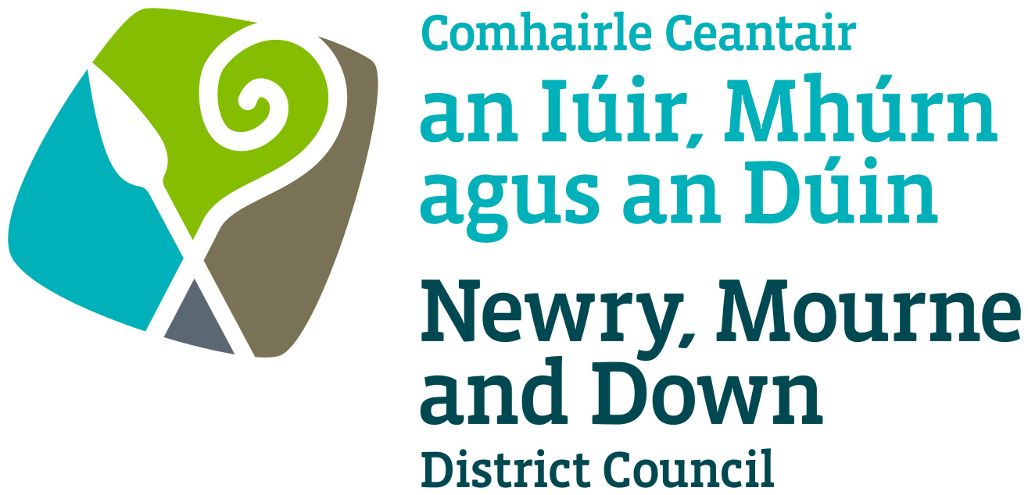

Street Trading

Temporary Licence Policy

NEWRY, MOURNE AND DOWN DISTRICT COUNCIL

ECONOMY REGENERATION AND TOURISM DEPARTMENT

Dated: 11 September 2023

CONTENTS

 | Page | Paragraph
Purpose | 1 | 1
Scope | 1 | 2
References | 1 | 3
Background | 1 | 4
General Principles | 2-3 | 5
General | 3 | 6
Criteria | 3-5 | 7
Fees | 5 | 8
Policy Owner | 6 | 9
Contact Details in regard of this Policy | 6 | 10
Policy Authorisation | 6 | 11
Policy Effective Date | 6 | 12
Policy Review Date | 6 | 13
Procedures | 6 | 14
Equality Screening | 6 | 15
Rural Impact Assessment | 6 | 16

1. Purpose

By virtue of Section 14 of the Street Trading Act (Northern Ireland) 2001 the District Council may grant to a person a temporary licence authorising him/her to engage in street trading in a street or part thereof in its District.

The purpose of this policy is to provide guidance on matters, which should be considered when deciding whether to grant to a person a Temporary Street Trading Licence. Its aim is to provide, insofar as is possible, consistent decision making so as to develop and thereafter maintain public confidence in Newry, Mourne and Down District Council’s (here after called ‘the District Council’) performance of its duties.

This policy should be read in conjunction with Street Trading Enforcement Policy and Street Trading Stall Design and Trading Policy.

2. Scope

This policy is intended to ensure that the District Council’s Members and Officers are aware of those matters to be taken into consideration when determining whether to grant a Temporary Licence.

3. References

3.1 Street Trading Act (Northern Ireland) 2001
3.2 Guide to the Street Trading Act (Northern Ireland) 2001

4. Background

The Street Trading Act (Northern Ireland) 2001 (here after called ‘the Act’) enables District Council’s to regulate Street Trading through designating, licensing and enforcement procedures. The Act received Royal Assent on the 5th April 2001, with a run-in period of 6 months and became operative on the
1st October 2001. The new Act repealed most of the provisions of the 1929 Street Trading (Regulation) Act, except Section 10, which contains the provisions whereby Market Rights can be acquired or extinguished.

Section 14 of the Act empowers the District Council to issue a temporary licence where a full licence may not be appropriate, for example, for special events such as festival and fairs. The District Council is given the discretion to allow temporary street trading at any place or any street within the District and in such manner as appears appropriate to the District Council.

The temporary licence may remain in force for such periods not exceeding seven consecutive days and no more than five temporary licences may be granted to an individual during any calendar year.

5. General Principles

5.1 Temporary street trading licences will be considered having due regard to those criteria as set out under section 7 of this policy.

5.2 Each case must be considered on its own merits, but there are general principles that apply in all cases. The duty of the District Council is to make sure that each temporary licence application is fairly and objectively assessed and that all relevant factors are considered.

5.3 Applications must be received by the District Council not less than 42 days before the date of the first day of the proposed special event/trading date. The District Council however reserves the right to consider applications for temporary trading where this time period cannot be complied with.

5.4 Without prejudice to its right, to consider the previous guidance (Section 5.2) the District Council (in consultation with interested parties) may consider applications to permit temporary street trading outside of this broad definition in order to add colour, ambience, novelty and/or tradition in particular locations and during seasonal periods.

5.5 An application for temporary street trading will be deemed valid only if it is in the approved application form, fully completed and accompanied by all requested documentation and payment of fees.

5.6 The District Council will where possible within time constraints consult with: -
- The Sub-Divisional Commander of the Police Service of Northern Ireland (PSNI) in which the streets are situated;
- The Department for Regional Development as regards that Department’s functions with respect to roads and regulation of road traffic;
- Criminal Records Office with regard to previous Trading related convictions.

5.7 Without prejudice to its right to take account of any relevant consideration in determining the suitability of each temporary street trading licence, the District Council will take into account: -
- The safety of the public and any risks, which may arise.
- The appropriateness and suitability of the street or part thereof and commodities in relation to the location.
- The potential adverse impact that temporary street trading may have upon the character and appearance of the area in question.
- The extent to which the sale of the commodity will provide a useful service to the event or occasion not otherwise provided in the area.
- The potential environmental effects such as additional litter, cleansing requirements, odour and noise.
- The potential for the proposed said temporary street trading Licence to have an adverse effect in terms of anti-social behaviour and public disorder (for example trading outside licensed premises late at night).
- Any other Statutory provision which would be appropriate to consider.
- Previous complaints arising from any street trading activities in that street of part thereof.
- The conditions pertaining to the event e.g. road closures, provision of marshals, off-street activities and venues, number of persons anticipated and age profile.
- The number of temporary street trading licences already granted for a street or part thereof for a specified period and adequacy in the context of the commodity or service proposed to be offered.
- Fitness of the applicant in respect of any previous trading offences, including verbal and written warnings.

5.8 This policy may be reviewed, amended or replaced at any time without any further requirement to consult other parties.

6. General

6.1 A temporary licence shall remain in force for such period, not exceeding seven days, as may be specified in the licence.

6.2 A temporary licence will be subject to such conditions as the District Council may specify in the licence and as set out in Temporary Street Trading Licence Criteria.

6.3 The District Council will grant no more than five temporary licences to an applicant during any year.

6.4 The District Council retains its right to amend or replace this policy at any given time.

6.5 Temporary licences cannot be sub-let.

  - Any person engaged in temporary trading must ensure that he/she complies strictly with the provisions of the Highway Code.

  - Temporary trading will not be permitted outside of the allocated times specified in the licence.

  - It shall be the policy of the District Council that a trader must obtain a separate licence for each receptacle used as defined in Section 25 of the Act.

  - In the circumstance that an applicant cannot trade, a refund will only be given if the District Council is informed in writing 7 days before trading is due to commence.

7 Criteria

7.1 The District Council will allocate the number of pitches to be made available for the event.

7.2 The District Council will stipulate the type of trading allowed for the event/events. It will also provide a list of items that are banned from sale.

7.3 The District Council will stipulate the type of receptacle to be allowed on the pitch.

7.4 The District Council retains its right to amend or replace these criteria at any given time.

7.5 CRITERIA FOR THE AWARD OF TEMPORARY STREET TRADING LICENCES

Persons fitting into the first criteria 7.5 (1) will be awarded a Street Trading Licence subject to the number of pitches being available. If no applicants meet the first criteria, then the District Council shall continue down the following list (in order) until an applicant meet one of the criteria: -

7.5 (1) Applicant who currently holds a Street Trading Licence for the DEA and has no relevant convictions in relation to that trading or breaches under Section 9 (Parts b – g inclusive) of the 2001 Street Trading Act.

7.5 (2) Applicant who has previously traded within the DEA and has no relevant convictions in relation to that trading or breaches under Section 9 (Parts b – g inclusive) of the 2001 Street Trading Act.

7.5 (3) A new Applicant with or without trading history either inside or outside of the District and has no history of relevant trading convictions or breaches under Section 9 (Parts b – g inclusive) of the 2001 Street Trading Act.

Under Section 9 of the Act the District Council have discretion for refusing an application on the following grounds. In addition, the District Council will apply the following criteria as discretionary grounds for refusal. The District Council reserves the right to award a street trading licence where these criteria may apply and subject to any condition to trade that the District Council may deem appropriate.

7.5 (4) Applicant who has previously traded within the District Council area and who has been guilty of a breach under Section 9 of the Act (Parts b - g inclusive).

7.5 (5) Applicant who has previously traded outside the District Council area and has been guilty of a breach under Section 9 of the Act (Parts b - g inclusive).

7.5 (6) Applicant who has previously traded within the District (as a Street Trader under the 2001 Act or 1929 Act) and has been convicted of an offence relating to trading.

In the situation of two or more Applicants meeting any of the above criteria then the following scores will be awarded to their application and the highest score will be awarded the Licence.

- 2 or more verbal or written warnings | - minus | 5 Points
- Fixed Penalty in previous 12 months (each) | - minus | 5 Points
- Breaches under Section 9 of the Street Trading Act 2001 (b-g inclusive) (each) | - minus | 5 Points
- Appearance and Appropriateness of stall/vehicle by assessment of the following subject matters: Consumer Protection, Food Hygiene, Health & Safety, Odour, Compatibility of Commodity, Litter control and/or Noise | + plus | 0-8 Points
7.5 (7) Applicant who has previously traded anywhere (as a Street Trader under the 2001 Act of 1929 Act) and has been convicted of an offence relating to trading.
7.6 Where two or more applicants meet the same criteria the District Council will allocate the licence to trade at the site/area via a lottery system.

Where necessary a District Council Elected Member (The Chairperson or Deputy Chair) will carry out the Lottery within 2-3 days of the closing date of applications. Applicants will be notified of the results of the lottery within 2 days after the lottery is carried out.

8 Fees

8.1 Section 15 of The Street Trading Act (Northern Ireland) 2001 enables a District Council to charge: -

- for the grant or renewal of a street trading licence;
- for the grant of a temporary licence; or
- for varying under Section 11 (1) (a) the conditions specified in a street trading licence.

Such fees as the District Council may determine and as may be sufficient in the aggregate, taking one year with another to cover any reasonable administrative or other costs (excluding the costs mentioned in subsection (2) (c) in connection with its functions under this Act, not otherwise recoverable.

The District Council may determine the time and manner in which fees or charges are to be paid.

8.2 The following detailed costing for temporary street trading fees are based on actual costs of administering the District Council’s functions in dealing with applications, enforcement of licensed traders and designation (in relation to stationary traders) costs. These costs do not take into account the cost of enforcement and seizure of unlicensed trading.

8.3 The temporary street trading fees are: -

TYPE OF LICENCE | APPLICATION FEE  (Non-refundable)  £ | LICENCE FEE  (Including Application Fee)  £
Temporary Licence | £88 | £88 for first application  £55 for each subsequent application (maximum of four per calendar year).  Increase the fee for a double pitch to £142  - standard pitch size is 5m x 2m
Variation | £60 | n/a

(Table 1)
6.

9. Policy Owner

Mr Conor Mallon, Director of Economy, Regeneration and Tourism

10. Contact Details in regard of this Policy

Mr Jonathan McGilly
Assistant Director of Economy, Regeneration and Tourism
Newry, Mourne and Down District Council
O’Hagan House
Monaghan Row
Newry
BT35 8DJ

Telephone: 0330 137 4000

11. Policy Authorisation

Development Committee Meeting Authorised on: 11 September 2023
Council Authorised on: 02 October 2023

12. Policy Effective Date
02 October 2023

13. Policy Review Date
02 October 2027

The policy will be reviewed in line with the Council’s agreed policy review cycle i.e. every 4 years (as per Council’s Equality Scheme commitment 4.31).

14. Procedures

Refer to the Temporary Street Trading Procedure

15. Equality Screening

The policy has been equality screened, and the outcome is that it is not subject to an EQIA (with no mitigating measures required).

13. Rural Impact Assessment
Due regard to rural needs has been considered and a rural needs impact assessment has been completed.

Version 2.0

