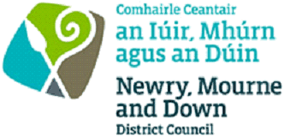

ENVIRONMENTAL HEALTH

Form of Application for Registration

Articles 13 &14, Local Government (Miscellaneous Provisions) (NI) Order 1985
to carry on the Business of: TATTOOING/EAR PIERCING/ELECTROLYSIS/ACUPUNTURE/COSMETIC PIERCING/
SEMI PERMANENT SKIN COLOURING

1 Full Name of Applicant

2 Home Address:  (or in case of a Company, the registered or  principal office) | Tel:
3 Name of Business: (if applicable)

4 Address of premises to be registered

5 Have you previously been registered in this  respect by any other District Council:  If yes, by which District Council: | Yes/No
6 Have you ever been convicted of any  offence under Article 15 of the Order?  If yes give details: | Yes/No

I hereby apply to be registered to carry on the business of *(tattooing) (ear-piercing) (electrolysis) (acupuncture) (cosmetic piercing) (semi-permanent skin colouring) and for the premises mentioned at Part 4 above to be registered for the carrying on of that business.
* Delete those not applicable

Signed ………………………………………. Date……………………………………

The application form should be completed and returned to Active and Healthy Communities, Health and Wellbeing, Newry, Mourne and Down District Council, Council Offices, Greenbank Industrial Estate, Rampart Rd, Newry, BT34 2QU together with the REGISTRATION FEE OF £50.00.

Data Protection Act 1998
Newry, Mourne and Down District Council collects the Data on this form for the purposes of the Management and application of the LG (MP) (NI) Order 1985. This data may be passed to other relevant Government agencies.

