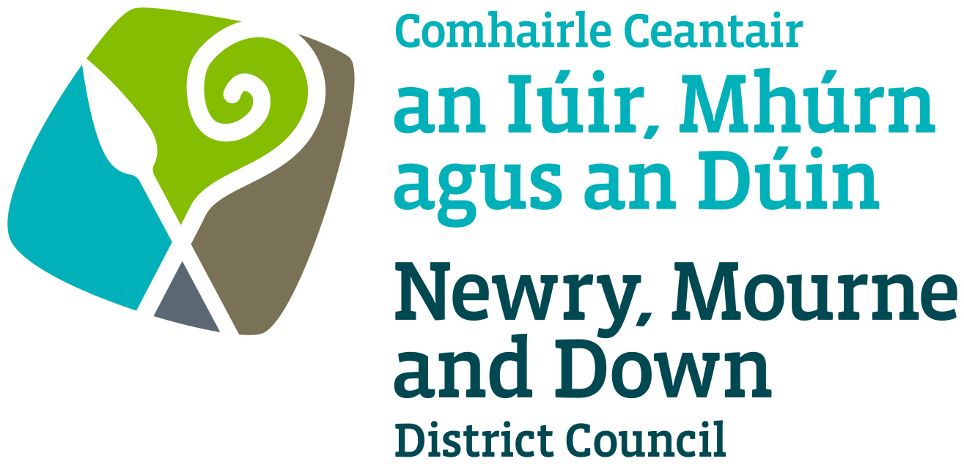

Street Trading

Stationary Licence
Policy

NEWRY, MOURNE AND DOWN DISTRICT COUNCIL

ECONOMY REGENERATION AND TOURISM DEPARTMENT

Dated: 11 September 2023

CONTENTS

 | Page | Paragraph
Purpose | 1 | 1
Scope | 1 | 2
References | 1 | 3
Background | 1 | 4
General Principles | 1- 3 | 5
General | 3 - 4 | 6
Criteria | 4-6 | 7
Fees | 7 | 8
Policy Owner | 7 | 9
Contacts Details in regard to this Policy | 6 | 10
Policy Authorisation | 7 | 11
Policy Effective Date | 7 | 12
Policy Review Date | 7 | 13
Procedures | 7 | 14
Equality Screening | 7 | 15
Rural Impact Assessment | 7 | 16

1. Purpose

By virtue of Section 1 of The Street Trading Act (Northern Ireland) 2001 The District Council may grant to a person a licence to trade in a stationary position on a designated site.

The purpose of this policy document is to provide guidance on matters, which should be considered when deciding whether to grant or refuse an application for a Stationary Trading Licence. Its aim is to provide, in so far as is possible, consistent decision making so as to develop and thereafter maintain public confidence in Newry, Mourne and Down District Council’s (here after called ‘the District Council’) performance of its duties.

This Stationary Street Trading Policy should be read in conjunction with the Policy for Dealing with Changed Circumstances Affecting Licensed Street Trading, Street Trading Enforcement Policy and Street Trading Stall Design and Trading Policy.

2. Scope

This Policy is intended to ensure that the District Council Members and Officers are aware of those matters to be taken into consideration when determining whether to grant a Stationary Street Trading Licence.

3. References

3.1 Street Trading Act (Northern Ireland) 2001
3.2 Guide to the Street Trading Act (Northern Ireland) 2001

4. Background

The Street Trading Act (Northern Ireland) 2001 (here after called ‘the Act’) enables District Councils to regulate Street Trading through designating, licensing and enforcement procedures. The Act received Royal Assent on the 5 April 2001, with a run-in period of 6 months and became operative on 1 October 2001. The new Act repealed most of the provisions of the 1929 Street Trading (Regulation) Act, except Section 10, which contains the provisions whereby market rights can be acquired or extinguished.

Section 1 of the Act empowers District Council’s to issue Stationary Street Trading Licences.

5. General Principles

  - Each case must be considered on its own merits, but there are general principles that apply in all cases. The duty of the District Council is to make sure that each stationary street trading licence application is fairly and objectively assessed and that all relevant factors are considered.

  - The District Council will consider applications, in writing on the prescribed form, to permit stationary trading at a designated site within the boundaries of the District Council.

  - Mandatory grounds for refusing an application
- A District Council shall refuse an application under section 5 of the Act if the applicant: -
  - is not an individual; or
  - has not reached the upper limit of compulsory school age, within the meaning of Article 46 of the Education and Libraries (Northern Ireland) Order 1986 (NI 3).

The District Council will consider all applications received in accordance with section 5 of this Act for Stationary Trading. However, District Council are required to refuse an application under Section 8, Mandatory Grounds for Refusing an application and may refuse an application under Section 9, Discretionary grounds for Refusing an Application of this Act.

5.4 Discretionary grounds for refusing an application
1) A District Council may refuse an application under section 5 on any of the following grounds: -
a) that -
- the location at which the applicant wishes to trade as a stationary trader is unsuitable;
- the space is in the designated street in which the applicant wishes to trade as a stationary trader is inadequate for the applicant to do so without causing undue interference or inconvenience to persons or vehicles using the street;
- the area or areas of the District in which the applicant wishes to trade as a stationary trader are unsuitable for the applicant to do so without, causing undue interference or inconvenience to persons or vehicles in the area or areas;
- there are sufficient traders trading in the street, or at premises adjoining it, in the articles, things or services in which the applicant wishes to trade; or
- the nature of the articles, things or services in which the applicant wishes to trade in such that their sale or supply, would adversely affect the general amenity of the area in which the applicant wishes to trade;

    - that the applicant has, in connection with the application, made a statement in which he knows to be false in a material particular;
- that the applicant is, on account of misconduct or some other reasons, relating to trading activities, unsuitable to hold a street trading licence.
- that the applicant has, without reasonable excuse, failed to avail himself to a reasonable extent of a previous street trading licence.
- that the applicant has at any time been granted a street trading licence by the District Council, which was revoked or could have been revoked on the grounds that he had refused or neglected to pay fees or other charges due to the District Council in respect of the licence;
- that the applicant has failed to provide the particulars required by the District Council to deal with the application;
- that the applicant has failed to provide or identify suitable or adequate arrangements for storing any articles, things or receptacles in or with which he proposed to trade.

  - If the District Council considers that grounds for refusal exist under subsection (1) (d), it may grant the applicant a licence subject to conditions which permit him/her.
    - to trade on fewer days or during a shorter period in each day than is specified in the application; or
- to trade in a different designated street or in a different area from that specified in the application.

  - In addition to Mandatory Grounds and Discretionary Grounds for refusing an application, the District Council will also consider: -
  - The safety of the public and any risks which may arise.
  - The potential environmental effects such as additional litter, cleansing requirements, odour and noise.
  - The potential for the proposed said stationary street trading licence to have an adverse effect in terms of anti-social behaviour and public disorder.
  - Previous complaints arising from street trading activities in the area or part thereof.
  - Any other Statutory provision which would be appropriate to consider.

6. General

6.1 The District Council retains its right to amend or replace this Policy at any given time.

6.2 All licence ‘application fees’ are non-refundable.

6.3 An application for stationary street trading will be deemed valid only if it is in the approved application form, fully completed and accompanied by all requested documentation and payment of fees.

6.4 It shall be a condition of licence that all receptacles are registered with the District Council’s Environmental Health Section and are licensed to trade in such commodities being offered for sale.

6.5 Licences will only permit trading on the stated days and times on the licence. The time during which the licence holder may sell or supply articles, things or offer services must be agreed with the District Council prior to the issuing of the licence.

6.6 It shall be the policy of the District Council that a trader must obtain a separate licence for each designated street trading pitch used.

6.7 If a stationary trader wishes to cease trading, they must give 28 days’ notice in writing to the District Council.

6.8 Stationary licences cannot be sub-let, sold on or transferred.

6.9 All stationary traders must comply strictly with the requirements of the Highway Code.

6.10 The following method of payment to the District Council of fees and charges imposed under Section 15 of the Street Trading Act (Northern Ireland) 2001 will apply: Payment made three months in advance of trading.

6.11 Refunds of ‘street trading licence fees’ will only be given when the licence holder has not been able to trade due to circumstances beyond their control, for example when a road is closed, or a site is inaccessible for any purpose such as road works etc. In the event of this occurring, the District Council must be informed no later than the day of trading.

6.12 Stationary Street Trading Licences can be issued for a maximum period of 3 years or for such term as the District Council will determine.

6.13 All available Stationary Street Trading sites will be advertised on the District Council’s website.

7. Criteria

7.1 The criteria is laid out in the applicant criteria and the criteria for the award of street trading licences shall apply. The District Council retains its right to amend or replace these criteria at any given time.

  - Application criteria for inclusion: -

- All applicants must provide proof of identity via photographic means.
- All applicants must provide a photograph of his/her stall when fully erected.

- All applicants must provide confirmation of public liability insurance. (Games stall trader to ensure correct public liability insurance cover.)

- All applicants must submit a completed application form with the correct fee.

- The successful applicant’s receptacles will be required to be registered by the District Council’s Environmental Health Section to trade in such commodities being offered for sale.

- Multiple applications will not be accepted either by person or for receptacle.

- All applicants must provide the exact size of receptacle when erected including tow bar, accurate dimensions must be given.

- The District Council will stipulate the type of trading allowed for the event/events. It will also provide a list of items that are banned from sale.

  - CRITERIA FOR THE AWARD OF STATIONARY TRADING LICENCES

Persons fitting into the first criteria 7.3 (1) will be awarded a Street Trading Licence subject to the number of pitches being available. If no applicants meet the first criteria, then the District Council shall continue down the following list (in order) until an applicant meet one of the criteria: -
7.3 (1) Applicant who is presently trading at that location and has no relevant convictions in relation to that trading or breaches under Section 9 (Parts b – g inclusive) of the 2001 Street Trading Act.
7.3 (2) Applicant who has previously traded at that location and has no relevant convictions in relation to that trading or breaches under Section 9 (Parts b – g inclusive) of the 2001 Street Trading Act.
7.3 (3) Applicant who has previously traded within the District Council area and has no relevant convictions in relation to that trading or breaches under Section 9 (Parts b – g inclusive) of the 2001 Street Trading Act.
7.3 (4) A new Applicant with or without trading history either inside or outside of the District subject to no history of relevant trading convictions or breaches under Section 9 (Parts b – g inclusive) of the 2001 Street Trading Act.
Section 9 of the Street Trading Act (NI) 2001 outlines discretionary grounds for
refusing an application. In addition, the criteria outlined in 7.3(5) to 7.3(8) will
apply. The District Council reserves the right to award a street trading licence
where these criteria may apply and subject to any condition to trade that the
District Council may deem appropriate.
7.3 (5) Applicant who has previously traded within the District who has been guilty of a breach under Section 9 of the Act (Parts b - g inclusive).
7.3 (6) Applicant who has previously traded outside the District Council area and has been guilty of a breach under Section 9 of the Act (parts b - g inclusive).
7.3 (7) Applicant who has previously traded within the District (as a Street Trader under the 2001 Act or 1929 Act) and has been convicted of an offence relating to trading (subject to the District Council’s approval).
7.3 (8) Applicant who has previously traded anywhere (as a Street Trader under the 2001 Act of 1929 Act) and has been convicted of an offence relating to trading (subject to the District Council’s approval).
In the situation of two or more Applicants meeting any of the above criteria then the following scores will be awarded to their application and the highest score will be awarded the Licence.

- 2 or more verbal or written warnings | - minus | 5 Points
- Fixed Penalty in previous 12 months (each) | - minus | 5 Points
- Breaches under Section 9 of the Street Trading Act 2001 (b-g inclusive) (each) | - minus | 5 Points
- Appearance and Appropriateness of stall/vehicle by assessment of the following subject matters: Consumer Protection, Food Hygiene, Health & Safety, Odour, Compatibility of Commodity, Litter control and/or Noise | + plus | 0-8 Points

7.4 Where two or more applicants meet the same criteria the District Council will allocate the licence to trade at the site/area via a lottery system.

Where necessary a District Council Elected Member (The Chairperson or Deputy Chair) will carry out the Lottery within 2-3 days of the closing date of applications. Applicants will be notified of the results of the lottery within 2 days after the lottery is carried out.

8. Fees

8.1 Section 15 of The Street Trading Act (Northern Ireland) 2001 enables a District Council to charge: -
- for the grant or renewal of a street trading licence;
- for varying under Section 11(1) (a) the conditions specified in a street trading licence.

Such fees as the District Council may determine and as may be sufficient in the aggregate, taking one year with another to cover any reasonable administrative or other costs (excluding the costs mentioned in subsection (2) (c) in connection with its functions under this Act, not otherwise recoverable.
The District Council may determine the time and manner in which fees or charges are to be paid.

8.2 The following detailed costing for stationary street trading fees are based on actual costs of administering the District Council’s functions in dealing with applications, enforcement of licensed traders and designation (in relation to stationary traders) costs. These costs do not take into account the cost of enforcement and seizure of unlicensed trading.

  - The Stationary Street Trading Fees are: -

TYPE OF LICENCE | APPLICATION FEE  (Non-refundable)  £ | LICENCE FEE  (Including Application Fee)  £
Stationary Licence | £88.00 | £1015 per annum  £502 (October-March inclusive)
Variation | £60.00 | n/a

(Table 1)

9. Policy Owner

Mr Conor Mallon, Director of Economy, Regeneration and Tourism

10. Contact Details in regard of this Policy

Mr Jonathan McGilly
Assistant Director of Economy, Regeneration and Tourism
Newry, Mourne and Down District Council
O’Hagan House
Monaghan Row
Newry
BT35 8DJ

Telephone: 0330 137 4000

11. Policy Authorisation

Development Committee Meeting Authorised on: 11 September 2023
Council Authorised on: 02 October 2023

12. Policy Effective Date
02 October 2023

13. Policy Review Date
02 October 2027

The policy will be reviewed in line with the Council’s agreed policy review cycle i.e. every 4 years (as per Council’s Equality Scheme commitment 4.31).

14. Procedures

Refer to the Stationary Licence Street Trading Procedure.

15. Equality Screening

The policy has been equality screened, and the outcome is that it is not subject to an EQIA (with no mitigating measures required).

16. Rural Impact Assessment
Due regard to rural needs has been considered and a rural needs impact assessment has been completed.

Version 2.0

