Ag freastal ar an Dún
agus Ard Mhacha Theas
Serving Down
and South Armagh
Name of Nominating Club/Organisation/Person

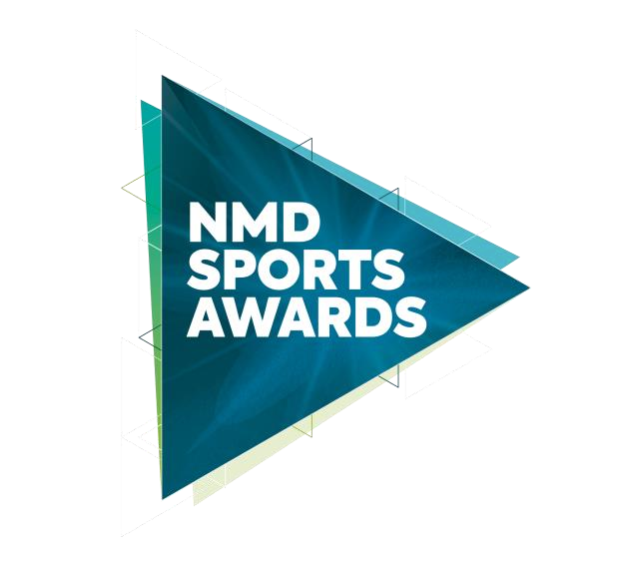
Senior Sport Volunteer of the Year 2022
In association with
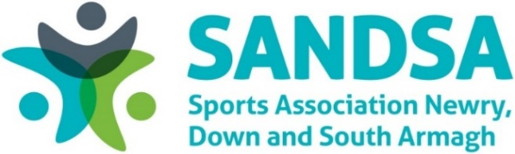

This award recognises the important work carried out by an up-and-coming volunteer, based in the Newry, Mourne and Down District Council area, who has made an outstanding contribution to the development of sport during 2022.

Criteria
Nominees must demonstrate the following:
- The Senior Sports Volunteer must be over 25
- Evidence that the nominee has contributed to an aspect of school sport, community sport and/or club sport, and has been a positive role model in areas such as:
- Caretaker
- Catering Organiser
- Club promoter
- Club transport organiser
- Event organiser
- Maintenance officer
All sections of this form must be completed and must not be extended beyond the pages provided.

Contact details for nominee
Name:
Club:
Address:
Telephone:
Email:
Date of Birth:
Contact details for nominating club (for reference only)
Name:
Role within Club:
Address:
Telephone:
Email:
Nominee Information:
Involvement (e.g. Caretaker/
Maintenance/Transport

Name of Club,
Organisation or Sport:

Number of Years involved in Volunteering:
Please provide detailed evidence of the voluntary contribution towards as aspect of school sport, community sport and/or club sport, and reflect that the nominee has been a positive role model in any of the areas as indicated under the criteria (A-F).

Closing Date

Nominations must be received by 4pm on Monday 30 January 2023 to be considered for the NMD Sports Awards, in association with SANDSA 2022. Any nominations received after this date will not be considered. The judges’ decision is final, and no correspondence will be entered.

You can post your completed forms to either:

Sports Awards Sports Awards
Leisure and Sport Department Leisure and Sport Department
Newry Leisure Centre Down Leisure Centre
60 Cecil Street 114 Market Street
Newry Downpatrick
BT35 6AU BT30 6LZ

You can email your completed forms to: leisureandsport@nmandd.org

Newry, Mourne and Down District Council takes the confidentiality of personal data seriously and is committed to protecting your privacy. Our privacy notice explains how we collect, use and disclose information that you provide to Newry, Mourne and Down District Council. A copy of our privacy notice is available on request or via the following link: http://www.newrymournedown.org/media/uploads/privacy_notice.pdf

