Ag freastal ar an Dún
agus Ard Mhacha Theas
Serving Down
and South Armagh
Name of Nominating Club/Organisation/Person

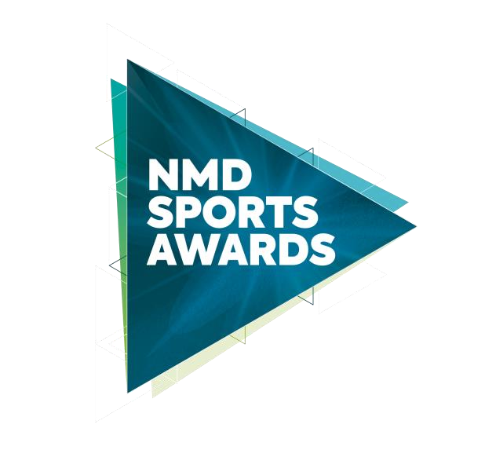
Junior Sportsperson of the Year 2022
In association with
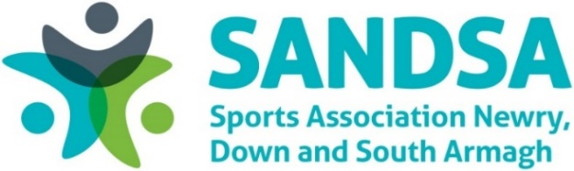

This award recognises the achievements of a Junior Sportsperson based in the Newry, Mourne and Down District Council area, which has excelled in either provincial, interprovincial, national (UK or Ireland, International or world competition during 2022

Criteria
Nominees must demonstrate the following:

- Significant success during the calendar year 2022.
- All Clubs are restricted to nominating Junior Sportsperson.
- All Junior nominees must be under the age of 18.
- Please provide details of the Junior Sportsperson’s involvement and/or achievements and success during the calendar year 2022.
- Provide supporting information for this application to include team dedication, motivation, commitment, and enthusiasm in their role.
- All sections of this form must be completed and must not extend beyond the pages provided.

Contact details for nominee
Name:
Club:
Address:
Telephone:
Email:
Date of Birth:
Contact details for nominating club (for reference only)
Name:
Role within Club:
Address:
Telephone:
Email:
Nominee Information:
Please provide details of the Junior Sportsperson’s involvement and/or achievements and success during the calendar year 2022.
Provide supporting information for this application and include the individual’s dedication, motivation, commitment, and enthusiasm in their role during the 2022 calendar year.

Closing Date

Nominations must be received by 4pm on Monday 30 January 2023 to be considered for the NMD Sports Awards, in association with SANDSA 2022. Any nominations received after this date will not be considered. The judges’ decision is final, and no correspondence will be entered.

You can post your completed forms to either:

Sports Awards Sports Awards
Leisure and Sport Department Leisure and Sport Department
Newry Leisure Centre Down Leisure Centre
60 Cecil Street 114 Market Street
Newry Downpatrick
BT35 6AU BT30 6LZ

You can email your completed forms to: leisureandsport@nmandd.org

Newry, Mourne and Down District Council takes the confidentiality of personal data seriously and is committed to protecting your privacy. Our privacy notice explains how we collect, use and disclose information that you provide to Newry, Mourne and Down District Council. A copy of our privacy notice is available on request or via the following link: http://www.newrymournedown.org/media/uploads/privacy_notice.pdf

