Ag freastal ar an Dún
agus Ard Mhacha Theas
Serving Down
and South Armagh
Name of Nominating Club/Organisation/Person

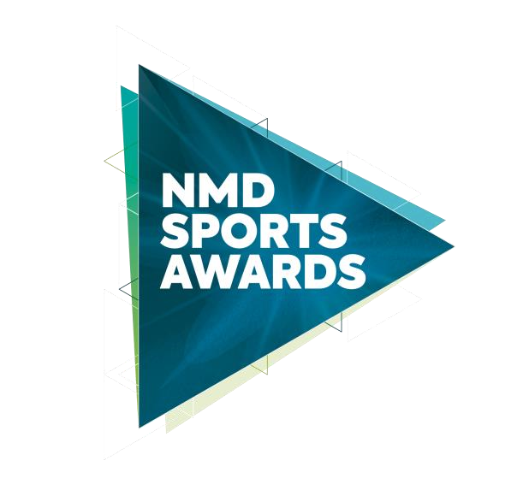
Senior Club Coach of the Year 2022
In association with
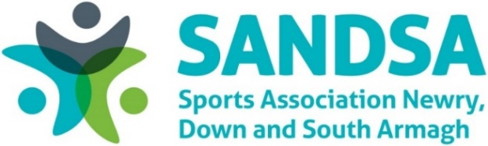

This award recognises the important work carried out by an up-and-coming young club coach, based in the Newry, Mourne and Down District Council area, through his or her coaching achievements and the impact made on the people they coached during 2022.

Criteria
Nominees must demonstrate the following:

- The senior coach must be actively coaching within Newry, Mourne and Down District Council area.
- The senior coach should meet all appropriate governing body professional coaching standards.
- The senior coach must be over the age of 25.
- Evidence of their coaching and successes in their field.
- Although active coaching should be the main reason for receiving the award, supporting consideration may be given for the following contribution in the field of coaching:
- A distinguished career as a coach
- Educating or mentoring other coaches
- Promotion of character development and ethical sport
- All sections of this form must be completed and must not extend beyond the pages provided.

Contact details for nominee
Name:
Club:
Address:
Telephone:
Email:
Date of Birth:
Coaching Qualifications:

Contact details of nominating NMDD club that coach is currently coaching from (for reference only)
Name:
Role within Club:
Address:
Telephone:
Email:
Nominee Information:
Please provide details of the nominee’s coaching involvement and/or achievements during the calendar year 2022.
Please provide supporting information for this application to include dedication, motivation, commitment, and enthusiasm in their role.

- Although active coaching should be the main reason for receiving the award, supporting consideration may be given for the following contribution in the field of coaching:
- A distinguished career as a coach
- Educating or mentoring other coaches
- Promotion of character development and ethical sport
Closing Date

Nominations must be received by 4pm on Monday 30 January 2023 to be considered for the NMD Sports Awards, in association with SANDSA 2022. Any nominations received after this date will not be considered. The judges’ decision is final, and no correspondence will be entered.

You can post your completed forms to either:

Sports Awards Sports Awards
Leisure and Sport Department Leisure and Sport Department
Newry Leisure Centre Down Leisure Centre
60 Cecil Street 114 Market Street
Newry Downpatrick
BT35 6AU BT30 6LZ

You can email your completed forms to: leisureandsport@nmandd.org

Newry, Mourne and Down District Council takes the confidentiality of personal data seriously and is committed to protecting your privacy. Our privacy notice explains how we collect, use and disclose information that you provide to Newry, Mourne and Down District Council. A copy of our privacy notice is available on request or via the following link: http://www.newrymournedown.org/media/uploads/privacy_notice.pdf

