SOCIAL PARTNER APPLICATION PACK

for the Newry, Mourne and Down District Council PEACE IV Partnership

PEACE IV PROGRAMME

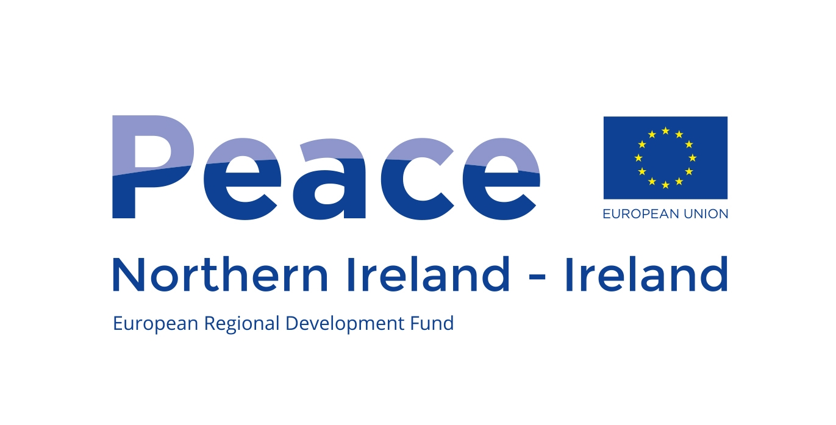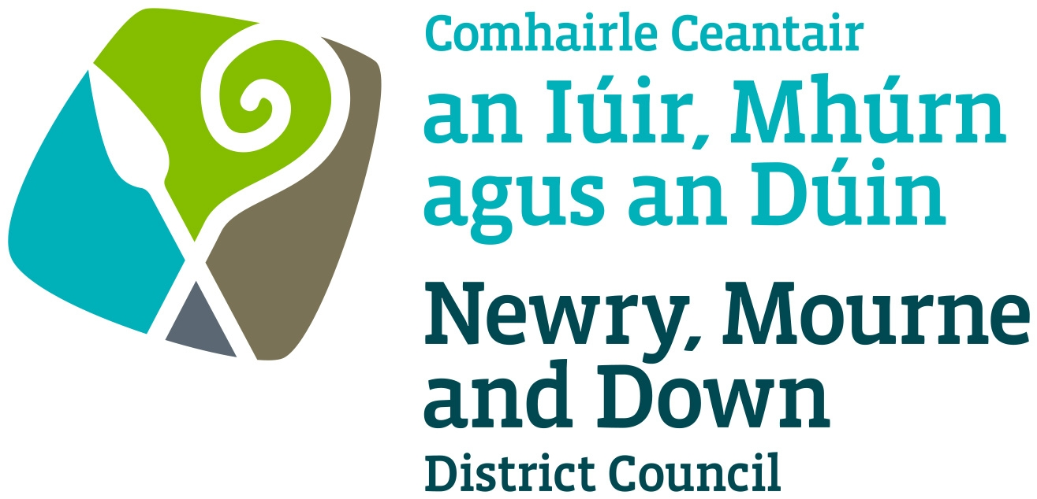

Social Partner Specification

The Newry, Mourne and Down District Council PEACE IV Partnership (2017 – 2020) wishes to recruit social partner positions and create reserve lists of appropriate appointees for the whole of the Newry, Mourne and Down District Council area:

This is a voluntary appointment with only travel costs and minor expenses reimbursed. Social partners are appointed on an individual basis and be advocates of processes to address issues of sectarianism and racism.

Essential Criteria

Successful candidates will:

- Be over 18 years of age.

- Be required to attend a minimum of 8 meetings per annum.

- Have an understanding of the sectarianism and racism issues facing the Newry, Mourne and Down District Council area.

- Have relevant knowledge, skills and experience gained through professional and / or community and voluntary undertakings, which are directly applicable to the Peace IV programme.

- Have a generic understanding of good relations and in particular issues around ex-combatants, interface areas, ex-political prisoners and youth.

- Have experience of successful partnership working or committee membership involving a range of partners such as community organisations, statutory bodies, local council etc.

- Be committed to actively promoting and participating in all aspects of the Peace IV programme and encourage community participation.

- Adhere to the Code of Conduct.

Desirable criteria

- Candidates should have a knowledge and understanding of the principles of corporate governance and standards of behaviour.

SOCIAL PARTNER APPLICATION FORM

The Newry, Mourne and Down District Council PEACE IV Partnership
PEACE IV PROGRAMME

Closes Friday 3rd August 2018 at 12 noon.

A Council wide Action Plan has been developed and will address Three Specific Objectives:
- Children and Young People;
- Shared Spaces and Services and
- Building Positive Relations.

Social Partners are reflective of the local community and bring with them expertise on peace and reconciliation. They will act as navigators with a check and balance function. It is important that the members of the Peace IV Partnership have the relevant knowledge, skills and experience to appropriately address these objectives and produce practical outputs for the Council area.

Applicant Details:

1. Name ______________________________________________

2. Home Address ______________________________________________
______________________________________________
______________________________________________
Post Code ___________________________________

3. Work Address ______________________________________________
(if applicable) ______________________________________________
______________________________________________
Post Code ___________________________________

4. Telephone No __________________ Mobile No___________________

5. Email Address ______________________________________________

6. Rank in order, the area you feel you may be best suited to represent

DEA area | Rank in order the areas you feel you may be best suited to represent  (1 for the most to 7 for the least)
Slieve Gullion
Newry
Crotlieve
The Mournes
Slieve Croob
Downpatrick
Rowallane
7. Please demonstrate your understanding of the key sectarianism and racism issues within the Newry, Mourne and Down District Council area?

8. By way of example demonstrate relevant knowledge, skills and experience gained through professional and / or community and voluntary undertakings, which are directly applicable to the PEACE IV programme.

9. Please outline your experience of participating on successful partnerships or committees.

10. Please outline any other relevant experience.

11. Do you commit to attending a minimum of 8 meetings per year?
(Please tick)

Yes No

12. Do you commit to actively promoting and participating in all aspects of the Peace IV programme and encourage community participation?

Yes No

I can confirm that all the information provided is true and accurate.

Signed: _____________________ Date: _________________

Completed applications must be signed and returned by Friday 3rd August 2018 at 12 noon to:

Justyna McCabe
Programmes Manager
McGrath Centre
1 Margaret Street
Newry
BT34 1DF

Or email your application to:
programmesunit@nmandd.org

Late applications will not be accepted.

Please complete the monitoring form and return it with your application.

Monitoring form

The information you supply on this form will be treated strictly confidential and will be used for monitoring purposes.

Council DEA area in which you reside:

Slieve Gullion | Newry | Crotlieve | The Mournes | Slieve Croob | Downpatrick | Rowallane | Other

18 - 25 | 26 - 40 | 41- 60 | 61 and over
Age:

Gender:

Male Female

Community background:

I am a member of the Protestant community

I am a member of the Roman Catholic community

I am a member of neither the Protestant nor Roman Catholic communities

Ethnic origin:

White Chinese Indian Irish Traveller

Pakistani Bangladeshi Black African Black Caribbean

Black other (please specify) ____________

Mixed ethnic group (please specify) ____________

Nationality:

Please state:

Disability:

Under the Disability Discrimination Act 1995 a person is considered to have a disability if he/she has a physical or mental impairment which has a substantial and long-term adverse effect on his/her ability to carry out normal day to day activities.

Do you consider that you meet this definition of disability?

Yes No

Dependants:

Do you have a personal responsibility for the care of a child or children, a person with a disability or a dependant older person?

Yes No

