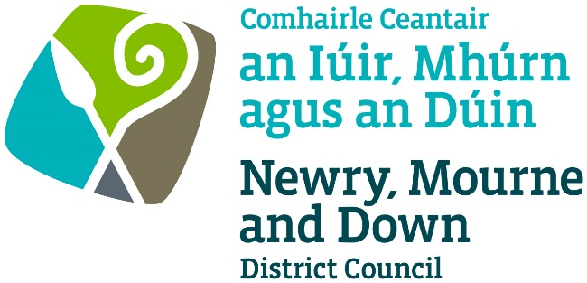

LOCAL GOVERNMENT (MISCELLANEOUS PROVISIONS) (NORTHERN IRELAND) ORDER 1985

SCHEDULE OF FEES   
FOR ENTERTAINMENTS LICENCES WITH EFFECT FROM 1st SEPTEMBER 2009

|  |  |  |
| --- | --- | --- |
| An application relating to an **indoor** place of entertainment to which paragraph 1(2)(a), (b) or (d) and (6) of the above-mentioned Schedule applies, where that place or premises (as the case may be) may hold: | OccasionalLicenceFee | FullLicenceFee |
| - not more than 100 persons; | £50 | £100 |
| - 101 to 200 persons; | £75 | £150 |
| - 201 to 300 persons; | £125 | £250 |
| - 301 to 500 persons: | £200 | £400 |
| - 501 to 1,000 persons; and | £375 | £750 |
| - over 1,000 persons | £500 | £1,000 |

|  |  |
| --- | --- |
| An application relating to an **indoo**r place of entertainment to which paragraph 1(2)(c) and (6) of the above mentioned Schedule applies  (i.e. **a circus**). | £50 |
| An application relating to an **indoor** place of entertainment to which Paragraph 1(4) and (6) of the above mentioned Schedule applies (i.e. where **machines** for **entertainment or amusement**, or equipment for the playing of **billiards, pool,** **snooker** or other similar games, are provided). | £100 |
| An application relating to an **indoor** place of entertainment of any capacity for a licence to be granted under paragraph 4(2) of the above mentioned Schedule (i.e. an **occasional licence**) in respect of:   1. a place used wholly or mainly for public religious worship in relation to an entertainment to which paragraph 1(2)(a), (b) or (d) and (6) of the above mentioned Schedule applies other than any music or singing. 2. a place used for religious meetings or services in relation to an entertainment to which paragraph 1(2)(a), (b) or (d) and (6) of the above mentioned Schedule applies other than any music or singing performed as an incident of a religious meeting or service; or 3. an educational institution while not being used as such in relation to an entertainment to which paragraph 1(2)(a), (b) or (d) and (6) of the above mentioned Schedule applies. | £50 |
| An application relating to an **indoor** place of entertainment of any capacity to which paragraph 1(2)(a), (b) or (d) and (6) of the above-mentioned Schedule apply for a licence to be granted under paragraph 4(2) of that Schedule (i.e. an **occasional** licence) where the application is made by a \***voluntary organisation** or a charity. | £50 |

|  |  |
| --- | --- |
| An application by a **\*voluntary organisation** or a charity relating to **outdoor** musical entertainments to which paragraph 2 of the above mentioned Schedule applies, where that place may hold:   * not more than 500 persons; or   - over 500 | £125  £250 |
| An application, **other than** by a voluntary organisation or a charity, relating to **outdoor** musical entertainments to which paragraph 2 of the above mentioned Schedule applies, where that place may hold:   * not more than 500 persons; or   - over 500 | £1,000  £2,000 |
| An application under paragraph 7A of the above mentioned Schedule for the **variation** of the terms, conditions or restrictions on or subject to which an entertainments licence is held. | £80 |

#### Footnotes

**\*** A “voluntary organisation” means an organisation carrying on or proposing to carry on activities otherwise than for the purpose of gain by the organisation or individual members thereof.

Dated this 18th day of June 2009