Department of Agricultural, Environment and Rural Affairs
Tackling Rural Poverty and Social Isolation (TRPSI) Programme
Rural Business Development Grant Scheme 2021-22

APPLICATION FORM

GUIDANCE NOTES ARE PROVIDED FOR EACH QUESTION. YOU SHOULD READ THESE CAREFULLY BEFORE ANSWERING THE QUESTIONS
General Data Protection Regulations (GDPR) - When you apply for Rural Business Development Capital Grant Scheme we will ask for some personal information because, for example, your personal email address or telephone number is used on the applicant organisation’s behalf. When you provide this information it is processed in adherence with the GDPR, Data Protection Act 2018 as well as the scheme’s Terms and Conditions to enable us to communicate with you about the application.
Only fully completed application forms submitted with the required documentation (as per checklist at end of application) will be considered. Any application submitted with missing information or incomplete questions will be deemed incomplete and subsequently rejected.
This grant scheme accepts application and claim documentation in electronic form. You must use the same email address throughout the process for submitting your application form and any Letter of Offer and claim documentation.
The closing date for receipt of applications is 12noon on Friday 30th July 2021.
Applications should be submitted to their local Council via the method listed in the guidance notes. Applications submitted after this date/time will not be accepted.

For Official Use Only:
Application Ref: | RBDS - | Acknowledged by:
Date Received: |  | Time Received:

Q1 Applicant Details
(a) | Name of Organisation:
(b) | Organisation/Individual Contact Details:
 | Contact names
 | Address
 | Town
 | County
 | Post Code
 | Tel Number
 | Mobile Number
 | E Mail Address
 | Website

(c ) What term best describes your organisation (select 1 option and provide relevant detail):
Sole Trader |  | HMRC Self-Assessment Number
Limited Company |  | Company Number
Business Partnership |  | HMRC Self- Assessment Number for each partner:
Other |  | Describe status and provide detail of business registration:

Q2 Business Overview
(a) What date was your business established?
- If your business is located at a different address to Q1b, please provide your business address:
(c) What sector does your business operate in?
Agriculture / Gardening |  | Automotive |  |  | Building/construction
Consultancy |  | Creative industry |  |  | Food/Drink manufacture
IT/communications |  | Leisure/fitness |  |  | Manufacturing / Engineering
Services – animal & equestrian |  | Services – customer, health & personal care |  |  | Services – professional
Restaurant / café / hospitality |  | Retail / Wholesale |  |  | Tourism
Training / Coaching |  | Transport & Logistics
Other |  | Please state:

- Provide an overview of your current business activities to include products / services offered, types of customers, method of sale and any export.
Maximum 500 words – TYPE HERE.

- Provide the number of employees involved in your business, including yourself:
 | Male | Female |  | Male | Female
Permanent full-time |  |  | Permanent part-time
Temporary full-time |  |  | Temporary part-time
Full-time employee must work at least 30 hours per week. A part-time employee must work at least 16 hours per week.

- What was your sales turnover last year?
Last financial year: | £
If you have been trading for less than 1 year, provide your sales to date | £

- Has your business been impacted by COVID 19? | Yes |  | No
If yes, please provide an outline of the impact to include details of staff furloughed or temporarily laid off and impact on sales.
Maximum 500 words – TYPE HERE.

Q3 Project Details
- Project Title:

- Project Description: Describe your proposed project and detail any changes to your existing activity and any new business activities such as new product or services, new customers or markets that you intend to target or new methods of selling.
Maximum 500 words – TYPE HERE.

- Project Need: Describe the need for your project and outline your evidence of this need
Maximum 500 words – TYPE HERE.

- Project Outcome: Outline what the anticipated outcomes of implementing the project will be over the next 12months. Please provide specific detail on the impact this grant will have on your business in the relevant sections below
Sustaining existing or creating new employment

Sustaining existing income levels or generating additional income as a result of proposed project
Business recovery plans due to COVID 19

Increased innovation in the market place or within the business (eg new product, services, markets entry, selling or delivery methods)

- Management Strength: Outline your skills and experience to deliver the proposed project and sustain and develop your business. Please include details of any other external support you have received to set up or develop your business (eg Go for It Programme, business mentoring, management of previous grant aid etc)
Maximum 500 words – TYPE HERE.

Q4 Project Costs

- Is your business VAT registered? |  |  |  |  |  |  |  |  |  | Yes |  | No
If yes, please provide the VAT registration number below:

- Evidence of Value: Detail the quotes that you have obtained in respect of the individual items you wish to purchase. You must follow the procurement process detailed in the guidance notes and submit the specification and quotes with your application. Example provided in line 1; continue on a separate sheet if necessary.

Item | Estimates Costs – Quotes Received
 | Supplier 1 | Quote | Supplier 2 | Quote
Example:  Printer, Model XYZ, A3 paper, colour | ABC Printers Ltd | £240.00 | Printers R Us | £252.00

- Breakdown of costs:
*If you are VAT registered, TRPSI funding should be applied for against the Net cost. You do not need to complete the VAT and gross cost column. If you are not VAT registered, you should complete all columns and you may apply for funding against the gross cost. Grant request is 50% grant rate between £500 and up to £4,999.
Item | Preferred Supplier | Net Cost (£) | VAT Amount (£) | Gross cost (£) | TRPSI Funding Applied for (£)*
Example: Printer | ABC Printers Ltd | 200.00 | 40.00 | 240.00 | 120.00
Total Cost |  | £ | £ | £ | £

- Please provide details of all sources of funding for the project:
Source of funding | Name of Funder | Current status of application | Total Amount applied for £
TRPSI Scheme (this application) | DAERA | Submitted
Own resources – cash | Self
Own resources – loans
Other – please state
TOTAL (this should match the total cost listed above) |  |  | £

- Please confirm that you can purchase the item(s) in full before claiming funding back against the item: | Yes |  | No

Q5 Project Timescales
To be eligible for grant aid, you must be able to complete your project in a short timeframe, between Letter of Offer issue (anticipated October 2021) and by 17 December 2021. By 17 December 2021, all works must be completed and onsite and must be fully paid and cleared the bank.

Your claim for payment must be submitted to your local Council by 14 January 2022.
Please confirm if you can complete your project as described by 17 December 2021 and submit your claim by 14 January 2022: | Yes |  | No

- Please confirm that you can purchase the item(s) in full before claiming funding back against the item: | Yes |  | No

Q6 Signposting
Would you like to be registered onto your local Councils Economic Development Database to be kept up to date with other relevant programmes and initiatives? | Yes |  | No

De Minimis Aid Declaration
Financial Assistance awarded under the Rural Business Development Grant Scheme is classified as De Minimis Aid as set out in European Commission Regulation (EU) No 1407/2013 of 18 December 2013 on the application of Articles 107 and 108 of the Treaty on the Functioning of the European Union to de minimis aid. If you have received other de minimis aid from Government Departments, Intertrade Ireland or Local Councils over the last 3 years this might impact on your eligibility to receive mentoring support.
The maximum amount of de minimis aid that an undertaking can receive within a 3 year fiscal period in the UK is €200,000. Where an undertaking is part of a group, linked either though limited companies or individual shareholders, the de minimis limit may apply to some or all of the combined group and not just individual undertakings.
To allow us to determine whether awarding this grant will breach this limit, please complete the table below that details the date and value of any de minimis aid the company has received during your last 3 fiscal (accounting) years. Where the Company is part of a group, please complete the table for all group companies.
Please note that it is your responsibility to check whether the support you have received was classed as ‘de minimis’ aid. If in doubt, please check with whoever provided you with the support.
Has the company (or any company within the Group if applicable) received any form of public support or grant that was classed as de minimis in the last 3 years?  If ‘Yes’, please provide detail in the table below:- |  |  |  |  |  |  | Yes | No
Date support/grant funding awarded |  | Funding body | Purpose / Scheme |  |  |  | Amount
 |  |  |  |  |  | Total
What is the date of the end of your accounting (fiscal) year (dd/mm)?
Declaration
I confirm that:
- The details provided on this form are current and accurate to the best of my knowledge.
- The company is solvent and no distress or execution has been levied against it.
- I understand that completion of this form neither entitles nor requires me to take part in any business support scheme in the future.

Signed on behalf of applicant |  |  |  | Print Name
Position |  |  |  | Date

CHECKLIST
Please ensure you have: | √
Filled in all parts of the form
Provided copies of all specifications for items detailed in Evidence of Value question 4 (b)
Provided copies of all quotations as detailed in Evidence of Value question 4 (b)
Provided additional pages, where appropriate.
Signed the De Minimis Aid Declaration Form
Signed the Declaration below

DECLARATION
- Application

- I declare that all of the information provided in this application and accompanying documents is true and correct.
- I confirm that I am age 18 or above.
- I confirm that the project detailed in the application has not commenced.
- I confirm that I have a bank account used by the business.
- I confirm that I can complete this project, and all items can be paid and cleared my bank account by 17 December 2021.

Signed by Applicant:
Print name:
Date: | / /
Position held:

Data Protection and Freedom of Information Issues

DAERA and our delivery agents take data protection and freedom of information issues seriously. We take care to ensure that any personal information supplied is dealt with in a way which complies with the requirements of the Data Protection Act 2018 and the General Data Protection Regulation. This means that any personal information you supply will be processed principally for the purpose for which it has been provided. However, DAERA may also use it for other legitimate purposes in line with the Data Protection Act 2018 and Freedom of Information legislation. These include:

    - Occupational health and welfare;
    - Compilation of statistics;
    - Disclosure to other organisations when required by law to do so;
    - Disclosure under the Freedom of Information Act 2000 or the Environmental Information Regulations 2004 where such disclosure is in the public interest;
    - The prevention and detection of fraud or maladministration (e.g. The Comptroller & Auditor General and HM Revenue & Customs).
For further details on your privacy see the DAERA Privacy Statement (www.daera-ni.gov.uk/daera-privacy-statement)

The Rural Business Development Grant Scheme is funded by the Department of Agriculture, Environment and Rural Affairs (DAERA) as part of the Tackling Rural Poverty and Social Isolation (TRPSI) Programme.

WARNING

To knowingly or recklessly make a false statement to obtain aid for yourself or anyone else, will lead to disqualification, liability to refund of any aid already paid and possible prosecution.
The information provided on this form may be made available to other Departments/Agencies for the purposes of preventing and detecting crime.

DAERA FRAUD HOTLINE 0808 1002716

The closing date for receipt of applications is 12noon on Friday 30 July 2021. Applications submitted after this date/time will not be accepted.

The Rural Business Development Grant Pilot Scheme is funded by the Department of Agriculture, Environment and Rural Affairs as part of the Tackling Rural Poverty and Social Isolation Programme.

The Scheme is being administered by local Councils.

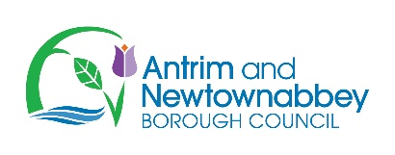 | 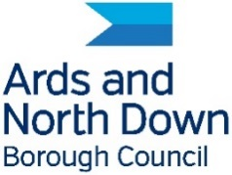 | 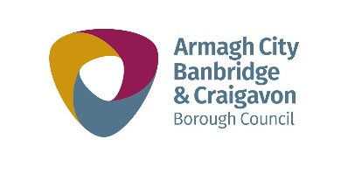
 | 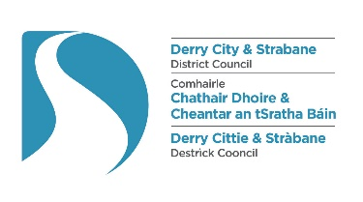 | 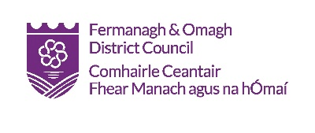
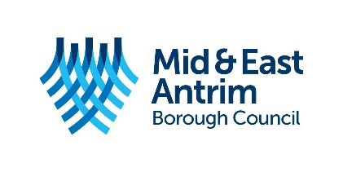 |  | 