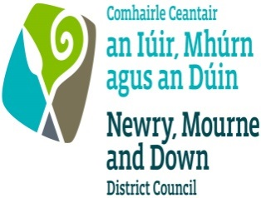

SOCIETY’S LOTTERY – RETURN BY PROMOTER

Betting, Gaming, Lotteries and Amusements
(Northern Ireland) Order 1985
To be sent by the promoter of the lottery to the District Council named
below not later than the end of the third month after the date of the lottery

PART I

To NEWRY, MOURNE AND DOWN DISTRICT COUNCIL
I,
(full forenames and surname of promoter of lottery
of |  |  |  |  |  |  |  | Tel
(full residential address)
Being the promoter of a lottery promoted on behalf of
(name of registered society)
registered by the above-named District Council under Article 136 of the Betting, Gaming, Lotteries and Amusements (Northern Ireland) Order 1985 hereby make the following return in respect of that Lottery:
1. |  | The date of the lottery was
2. |  | The total proceeds from the sale of tickets or chances were £
3. |  | The amount of the total proceeds appropriated on account of expenses (exclusive of
 |  | prizes) was £
4. |  | The amount of the total proceeds appropriated for the provision of prizes was
 |  | £
5. |  | The purpose(s) to which the proceeds of the lottery were applied
 |  | (give separate details if more than one purpose)
6. |  | The amount of the proceeds which was applied for the purpose(s) named above was
 |  | (give separate details if more than one purpose)
7.
 |  | (full forenames and surname of holder of lottery certificate, or, where holder of certificate is
 |  | a body corporate, title of body)
 |  | of
(full address, or, where holder of certificate is a body corporate, that of its registered or principal office)

Acted as an external lottery consultant or manager in the promotion of the lottery.
8. |  | A copy of a ticket sold in the said lottery is attached.

I hereby certify that I am a member of the said society and have been duly authorised in writing by the governing body of that society to act as the promoter of this lottery.

Dated the |  | Day of |  | 20

Signed:
Occupation:

PART II

CERTIFICATION OF LOTTERY RETURN

I, the undersigned, being a qualified accountant within the meaning of Article 2(1) of the Betting, Gaming, Lotteries and Amusements (Northern Ireland) Order 1985 hereby certify that

I have examined the accounts relating to the above lottery and to the best of my information and belief the information contained in this return is correct.

Dated the |  | Day of |  | 20

(Signature of qualified accountant)

(Address)

