DISTRICT ELECTORAL AREA (DEA)FORUM INDEPENDENT MEMBER
NOMINATION PACK

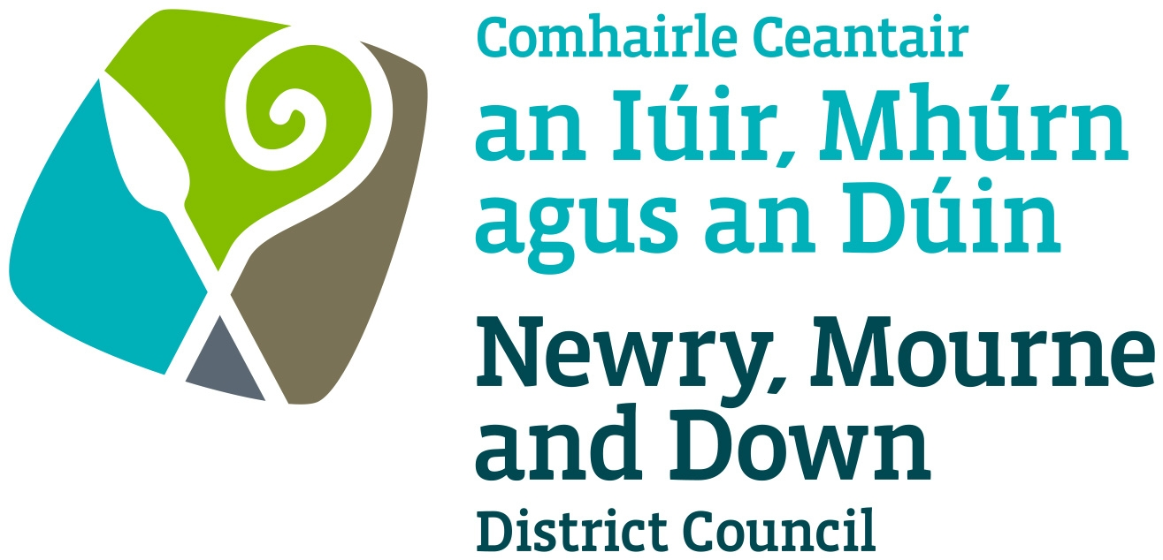

SECTION 1 – BACKGROUND

The Local Government Act (NI) 2014 makes provision for the duty of community planning on councils and their community planning partners. The Act provides the ‘high level framework for the operation of community planning’, and states that a district council must initiate, and having done so, maintain and facilitate community planning.

The Objectives of local government reform include: ‘bringing decision making closer to communities and citizens, creating a stronger and more effective local democracy, and improving service delivery by influencing place shaping and facilitating greater integration.’

In order to meet the strategic objectives as outlined in the Community Plan Newry, Mourne and Down District council have implemented a model of engagement, through the District Electoral Area (DEA) Forums structure. The seven District Electoral Areas are: Crotlieve, Downpatrick, Newry, Rowallane, Slieve Croob, Slieve Gullion and The Mournes.

DEA Forums provide the mechanism for continuous engagement at a community level, and input at a strategic level through the Newry, Mourne and Down Community Planning Partnership.

In order to operate effectively the Fora are dependent on ensuring that the membership is reflective of the views and opinions of the community it represents. DEA Forum membership will include:
- Elected Representatives for the District Electoral Area
- Independent Members - up to eight representatives from across the community, voluntary and business sector representatives.
- Statutory representatives from across sectors such as NIHE, SHSCT/SEHSCT, PSNI, EA etc

The term of service for Independent DEA Forum Members will be in line with the Council term commencing from after the 2023 Local Government Elections.

SECTION 2 – ELIGIBILITY

We seek to recruit voluntary Independent DEA Forum Members who can demonstrate representation on an established community, voluntary or business organisation.

We are looking for a membership that reflects the views and opinions of the community it represents and ask that Independent DEA Forum Members have a knowledge and experience in a minimum of 3 subsectors and can demonstrate representation on behalf of a local *network of groups or be nominated by a minimum of 3 organisations within the business, community and voluntary sectors who are independent of each other.

* For the purposes of nomination to the Forums, Newry, Mourne and Down District Council define a ‘network of groups’ as a group of constituted organisations that have come together to form a network (with governing documentation) representing a wider body of beneficiaries within the Council District or their District Electoral Area.

An individual DEA Forum may actively seek to recruit Independent Members from an underrepresented sector, using section 75 categories as guidance.

Nominees must meet either Criterion A or Criterion B as detailed below.

- Represent a network

A nominee must participate as an active member of a formally arranged partnership and have the authority to act as a spokesperson on behalf of this network. A signature must be provided by an office bearer of the network in respect of this nomination. (The office bearer cannot be the same person as the nominee).

* For the purposes of nomination to the Forums, Newry, Mourne and Down District Council define a ‘network of groups’ as a group of constituted organisations that have come together to form a network (with governing documentation) representing a wider body of beneficiaries within the Council District or their District Electoral Area.

B. Represent a number of individual groups

A nominee must be an active member across a minimum of 3 fully constituted organisations, which are independent of each other. A signature must be provided by an office bearer of each of the 3 organisations in respect of this nomination. (The office bearer cannot be the same person as the nominee).

If a nominee is being nominated to become an Independent Member on more than one DEA Forum, a separate nomination form must be completed for each DEA Forum for which the nominee is being nominated.

SECTION 3 – ASSESSMENT PROCESS

Newry, Mourne and Down District Council will assess nominations, with the support of Newry, Mourne and Down Strategic Stakeholder Forum (SSF).

The SSF is a constituent part of the Newry, Mourne and Down Community Planning structures and has membership drawn from a wide range of Community and Voluntary organisations throughout the District.

Should the Council receive more than 8 eligible nominations for any DEA Forum the following criteria will be taken into consideration.

- Nominees representing identified under-represented sector(s)
- The experience of the nominee of their chosen sector(s)
- How the nominee proposes to gather views of their sector(s) to feed back to the DEA Forum
- How the nominee proposes to bring back information from the DEA Forum to the constituent members of their sector
- Nominees from an underrepresented sector, using section 75 categories as guidance.
SECTION 4 - ONGOING RECRUITMENT

Should an Independent DEA Forum Member resign during their term, for those members representing networks the original nominating organisation will be able to nominate another suitable individual to be co-opted onto the respective Forum for the remainder of the term, subject to approval from Council. For members nominated by 3 or more individual organisations, a recruitment exercise will be carried out.

SECTION 5 – CLOSING DATE FOR NOMINATIONS

Completed nomination forms must be signed and returned by the closing date of 4pm on Friday 30 June 2023 via the email address below.

Incomplete nomination forms or forms submitted after the closing date will not be accepted.

Laura Higgins
DEA Administration
Newry, Mourne and Down District Council
Council: 0330 137 4000
Direct Line: 0330 137 4634
Email: laura.higgins@nmandd.org

If you have any queries regarding the nomination process, please e-mail:
Aisling Rennick
Engagement and Development Manager

Newry, Mourne and Down District Council

aisling.rennick@nmandd.org

NOMINATION FORM
For District Electoral Area (DEA) Forum Independent Membership

Section 1: Applicant Details

Name: _____________________________________________________

Contact address (including postcode):
______________________________________________________________________________________________________________________

Contact Number : ___________________________________________

Email address: _____________________________________________

Which Sector do you represent?
Community ☐
Voluntary ☐
Business ☐

For which District Electoral Area (DEA) Forum are seeking you seeking nomination? Please select one only (If you wish to be nominated to more than one DEA Forum, please compete a separate nomination form for each DEA Forum):
Crotlieve ☐ Downpatrick ☐
Newry ☐ Rowallane ☐
Slieve Croob ☐ Slieve Gullion ☐
The Mournes ☐

Are you being nominated by
A - Recognised Network ☐ B – 3 Independent Organisations ☐
Under Section 2 of the form please complete the relevant section.

Please indicate the sub sector(s) most relevant to your Network/Organisation(s) (tick a maximum of 3);

Advice Services |  | Men
Arts |  | Older People
Carers |  | Poverty
Children and Families |  | Race/Ethnicity
Community Development |  | Rural Development
Community Relations |  | Sport/Recreation
Community Safety |  | Sustainable Development
Criminal Justice |  | Transport
Disability |  | Urban Regeneration
Economic Development/Business |  | Women
Environment |  | Young People
Education/Training |  | Other (please specify)
Equality
Faith Based
Health and Wellbeing
Housing and Homelessness
LGBTQ+

SECTION 2 – Nominations

NOMINEES MUST COMPLETE ETHER SECTION A OR SECTION B

A: For nominations by a recognised Network

Name of nominating network: _______________________________
Signed on behalf of nominating network: _____________________
Position in network: _______________________________________

Contact Number: ____________________________________________

Email address: _____________________________________________
B: For nominations by 3 Organisations, independent of one another

Name of nominating network: _______________________________
Signed on behalf of nominating network: _____________________
Position in network: _______________________________________

Contact Number: ____________________________________________

Email address: _____________________________________________

Name of nominating network: _______________________________
Signed on behalf of nominating network: _____________________
Position in network: _______________________________________

Contact Number: ____________________________________________

Email address: _____________________________________________

Name of nominating network: _______________________________
Signed on behalf of nominating network: _____________________
Position in network: _______________________________________

Contact Number: ____________________________________________

Email address: _____________________________________________

Section 3: Experience

- The nominee's experience of their chosen sectors, please include dates - Max 200 words

- How the nominee will gather views from their sector(s) to be fed back to the DEA Forum - Max 200 words

- How the nominee will bring information back from the DEA Forum to the members within their sector(s) - Max 200 words

SECTION 4 – CLOSING DATE FOR NOMINATIONS

Completed nomination forms must be signed and returned by the closing date of 4pm on Friday 30 June 2023 via the email address below.

Laura Higgins
DEA Administration
Newry, Mourne and Down District Council
Council: 0330 137 4000
Direct Line: 0330 137 4634
Email: laura.higgins@nmandd.org

Newry, Mourne and Down District Council cannot accept incomplete nomination forms or nomination forms received after the closing date above.

