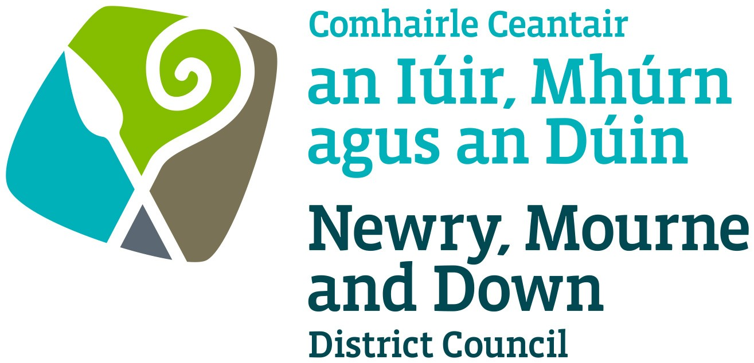

Summary Equality Scheme

This document is available in a range of formats on request.

For further information, advice or guidance please contact:
Colin Moffett
Newry, Mourne and Down District Council
Council Offices
Monaghan Row
Newry
BT35 8DJ

Tel: (028) 3031 3081
Email: colin.moffett@nmandd.org
www.newrymournedown.org

1. What is Section 75 of the Northern Ireland Act 1998?
Section 75 of the Northern Ireland Act 1998 (the Act) requires public authorities, in carrying out their functions relating to Northern Ireland, to have due regard to the need to promote equality of opportunity and regard to the desirability of promoting good relations across a range of categories outlined in the Act.

Newry, Mourne and Down District Council (the Council) is required to have due regard to the need to promote equality of opportunity between:
- persons of different religious belief, political opinion, racial group, age, marital status or sexual orientation
- men and women generally
- persons with a disability or without
- persons with dependants or without.

In addition, without prejudice to the obligations above, Council is required to have regard to the desirability of promoting good relations between persons of different religious belief, political opinion or racial group.

Council is committed to fulfilling the Section 75 statutory duties across all functions (including service provision, employment and procurement).

2. Newry, Mourne and Down District Council Equality Scheme

The Council’s equality scheme was approved by the Equality Commission for Northern Ireland on 25 March 2015. Our equality scheme sets out how the Council proposes to fulfil the Section 75 statutory duties.

While greater detail is contained within the Council’s equality scheme, the key commitments within the document are as follows:

Action plan
- Council is committed to undertaking an audit of inequalities to develop an action plan to help promote and mainstream equality of opportunity and good relations across the organisation’s functions.
- The Council’s action plan will be available on request and from the Council’s website. Progress on the delivery of action measures will be monitored annually and the action plan updated as necessary to ensure it remains effective and relevant to our functions and work.

Assessing the impact of policies
- All policies Council proposes to adopt must be equality screened prior to implementation, to assess the likely impact of the policy on the promotion of equality of opportunity and/or good relations. This is to ensure compliance with our statutory obligations, and an equality screening template has been developed to assist with this process.
- Where screening identifies an equality impact assessment (EQIA) is necessary, this will be conducted in accordance with Equality Commission guidance.
- Equality screening reports are published quarterly on the Council’s website.

Consultation
- Council is committed to consulting on our equality scheme, action measures, equality impact assessments and other matters relevant to the Section 75 statutory duties.
- Consultations will be carried out in accordance with the principles contained in the Equality Commission’s guidance ‘Section 75 of the Northern Ireland Act 1998 – A Guide for Public Authorities (April 2010)’. Council will seek the views of those directly affected, the Equality Commission, representative groups of Section 75 categories, other public authorities, voluntary and community groups, our employees and their trades unions and any other groups who have a legitimate interest in the matter.
- The accessibility and format of every method of consultation will be given careful consideration, particularly how best to communicate with people with disabilities (in particular people with learning disabilities), minority ethnic communities and children and young people. Account will be taken of existing and developing good practice.
- Information will be made available on request in alternative formats, usually within seven days. We will ensure that such consultees have equal time to respond.

Access to information and services
- Council is committed to ensuring the information we disseminate and the services we provide are fully accessible to all parts of the community.
- Some groups will not have the same access to information as others. In particular people with sensory, learning, communication and mobility disabilities may require printed information in other formats; members of ethnic minority groups, whose first language is not English; and children and young people may not be able to fully access or understand information.
- To ensure equality of opportunity in accessing information, we provide information in alternative formats on request, where reasonably practicable. Where the exact request cannot be met we will ensure a reasonable alternative is provided.
- Access to information and services will be monitored annually to ensure equality of opportunity and good relations are promoted.

Reporting on progress
- The Council prepares an annual report on the progress it has made on implementing the arrangements set out in the Equality Scheme (Section 75 annual progress report). This report will be sent to the Equality Commission by 31 August each year.
- The latest Section 75 annual progress report will be available on the Council’s website.
- As required by Schedule 9 paragraph 8 (3) of the Northern Ireland Act 1998 we will conduct a thorough review of the Equality Scheme every 5 years.

Complaints procedure
- Schedule 9 paragraph 10 of the Act refers to complaints. A person can make a complaint if they believe they may have been directly affected by an alleged failure to comply with the approved Equality Scheme.
- The Council are responsive to the views of members of the public. We will endeavour to resolve all complaints made to us.
- If a complaint is not resolved within a reasonable timescale, the complaint can be raised with the Equality Commission. A person wishing to make a complaint that the Council has failed to comply within its approved Equality Scheme should contact Colin Moffett.
- Complaints will be accepted in the format that best meets the complainant’s needs, and will be acknowledged in line with the Council’s Complaints, Comments and Compliments policy.
- The Council will co-operate fully with any investigation by the Equality Commission under sub-paragraph 11(1)(b) of Schedule 9 of the NI Act 1998.

3. Accessing the Equality Scheme

The Council’s equality scheme can be downloaded from our website at www.newrymournedown.org, or by contacting:

Colin Moffett
Newry, Mourne and Down District Council
Council Offices
Monaghan Row
Newry
BT35 8DJ

Tel: (028) 3031 3081
Email: colin.moffett@nmandd.org

In the context of Section 75, ‘policy’ is a very broadly defined and covers all the ways in which we propose to carry out our functions. In respect of the Council’s equality scheme, the term policy is used for any (proposed / amended / existing) strategy, policy initiative or practice and / or decision, whether written or unwritten and irrespective of the label given to it, e.g. ‘draft’, ‘pilot’, high level’ or ‘sectoral’.

