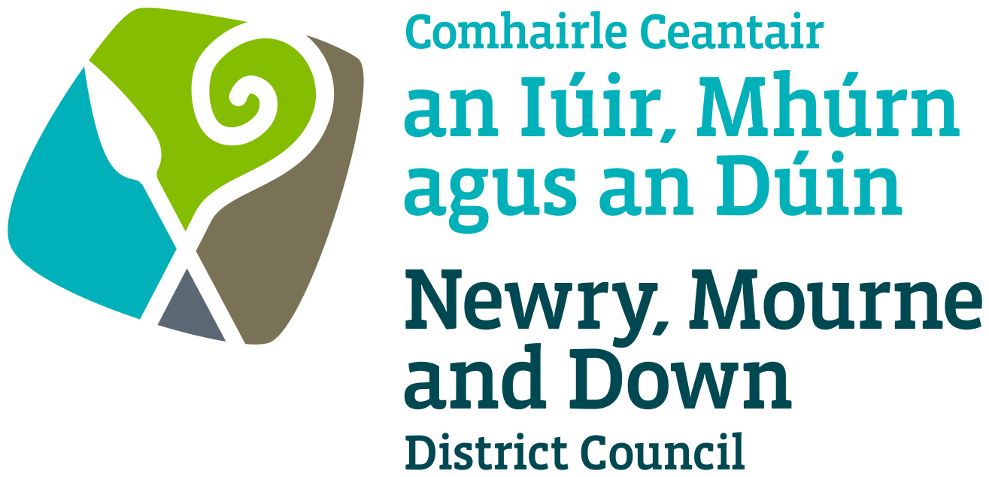
Newry Lower Hill Street Public Realm Scheme(Phase III)
Pre Planning Application Consultation-Comments

Name / Business ______________________________________________________
Email Address ______________________________________________________
Age <18 18-30 30-50 >50
What do you like about the proposals, and why?

What do you not like about the proposals, and why?

Is there anything we have missed out, and why?

Please rate how satisfied you are with the proposals in the table below:

Very dissatisfied | Somewhat Dissatisfied | Neither Satisfied Nor Dissatisfied | Somewhat Satisfied | Very Satisfied
1 | 2 | 3 | 4 | 5

Thank you for giving your views. Please leave completed form in the box provided.

