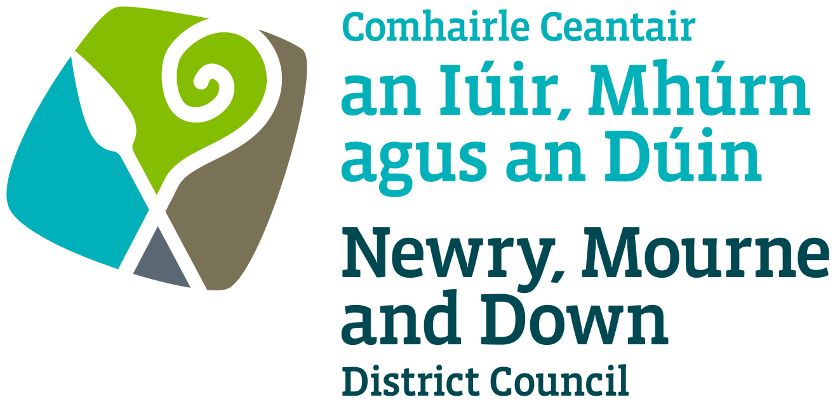

Street Trading

Mobile Licence
Policy

NEWRY, MOURNE AND DOWN DISTRICT COUNCIL

ECONOMY REGULATION AND TOURISM DEPARTMENT

Dated: 11 September 2023

CONTENTS

 | Page | Paragraph
Purpose | 1 | 1
Scope | 1 | 2
References | 1 | 3
Background | 1 | 4
General Principles | 2 -3 | 5
General | 3 | 6
Fees | 3 | 7
Criteria | 4 | 8
Policy Owner | 4 | 9
Contact Details in regard of this Policy | 4 | 10
Policy Authorisation | 5 | 11
Policy Effective Date | 5 | 12
Policy Review Date | 5 | 13
Procedures | 5 | 14
Equality Screening | 5 | 15
Rural Impact Assessment | 5 | 16

1. Purpose

By virtue of Section 1 of the Street Trading Act (Northern Ireland) 2001 the District Council may grant to a person a mobile licence permitting him/her to go from place to place, stopping for a time for the purpose of trading in its District.

The purpose of this policy document is to provide guidance on matters, which should be considered when deciding whether to grant or refuse an application for a Mobile street trading licence. Its aim is to provide, in so far as is possible, consistent decision making so as to develop and thereafter maintain public confidence in Newry, Mourne and Down District Council’s (here after called ‘the District Council’) performance of its duties.

This policy is to be read in conjunction with Street Trading Enforcement Policy and Stall Design and Trading Policy.

2. Scope

This Policy is intended to ensure that the District Council’s Members and Officers are aware of those matters to be taken into consideration when determining whether to grant a mobile street trading licence.

By virtue of Section 6 of the Street Trading Act (Northern Ireland) 2001 the District Council may grant to a person a mobile trader’s licence authorising them to engage in trading in an area or areas of the District.

3. References

  - Street Trading Act (Northern Ireland) 2001

  - Guide to the Street Trading Act (Northern Ireland) 2001

4. Background

The Street Trading Act (Northern Ireland) 2001 (here after called ‘the Act’) enables District Council’s to regulate street trading through designating licensing and enforcement procedures. The Act received Royal Assent on the 5 April 2001, with a run-in period of 6 months and became operative on 1 October 2001. The new Act repealed most of the provisions of the 1929 Street Trading (Regulation) Act, except Section 10, which contains the provisions whereby Market Rights can be acquired or extinguished. Section 1 of the Act empowers District Council’s to issue mobile street trading licences.
5. General Principles

5.1 Under Section 25 of the Act the definition of a ‘mobile trader’ means a person authorised by a street trading licence to trade from a vehicle which goes from place to place, stopping for a time for the purpose of trading.

5.2 Each case must be considered on its own merits, but there are general principles that apply in all cases. The duty of Newry, Mourne and Down District Council’s is to make sure that each mobile street trading application is fairly and objectively assessed and that all relevant factors are considered.

5.3 The District Council will consider applications, in writing on the prescribed form, to permit mobile street trading within the boundaries of Newry, Mourne & Down.

6. General

6.1 An application for mobile street trading will be deemed valid only if it is in the approved application form, fully completed and accompanied by all requested documentation and payment of fees.

6.2 An applicant wishing to trade as a mobile trader must state the area or areas in which trading is to take place.

6.3 The District Council retains its right to amend or replace this Policy at any given time.

6.4 It shall be the policy of the District Council that a trader must obtain a separate licence for each vehicle used for the purpose of going from place to place, stopping for a time for the purpose of trading.

6.5 For the purpose of enforcement procedure a mobile trader will be deemed to be stationary trading if the trader remains at the same location more than 10 minutes after the last sale. (Refer to paragraph 5.1 above)

6.6 Mobile trading will not be permitted in such commodities or offer for sale or supply any product which would have a detrimental effect on the surrounding area.

6.7 A mobile trader must give notice in writing to the District Council that trading has ceased.

6.8 Mobile licences cannot be sub-let, sold on, or transferred.

6.9 All mobile traders must adhere strictly to the provisions of the Highway Code.

6.10 All receptacles as defined in Section 25 of the Act, used for mobile trading will be required to be registered by the District Council’s Environmental Health Section to trade in such commodities being offered for sale.

6.11 Licences will be issued annually and will permit trading up to seven days per week from 9:00 am until 11:00 pm. These times may be altered subject to approval by the District Council.

7. Fees

7.1 Section 15 of The Street Trading Act (Northern Ireland) 2001 enables a District Council to charge: -

- for the grant or renewal of a street trading licence;
- for varying under Section 11 (1) (a) the conditions specified in a street trading licence.

Such fees as the District Council may determine and as may be sufficient in the aggregate, taking one year with another to cover any reasonable administrative or other costs (excluding the costs mentioned in subsection (2) (c) in connection with its functions under this Act, not otherwise recoverable.

The District Council may determine the time and manner in which fees or charges are to be paid.

7.2 The following detailed costing for mobile street trading fees are based on actual costs of administering the District Council’s functions in dealing with applications, enforcement of licensed traders and designation (in relation to stationary traders) costs. These costs do not take into account the cost of enforcement and seizure of unlicensed trading.

  - The mobile licence fees are as follows: -

TYPE OF LICENCE | APPLICATION FEE  (Non-refundable)  £ | LICENCE FEE  (Including Application Fee)  £
Mobile Licence | £88.00 | £338
Variation of Licence | £60.00 | N/A

(Table 1)

- Criteria

8.1 The District Council can limit the number of mobile traders within its District.

  - The District Council will stipulate the type of trading allowed for mobile street trading licences. It will also provide a list of items that are banned from sale.

  - The District Council will stipulate the type of receptacle to carry out mobile street trading.

  - The District Council retains its right to amend or replace these criteria at any given time.

  - Applicants must provide the following information: -
- All applicants must submit a completed application form with the correct fee.
- All applicants must provide proof of identity via photographic means.
- All applicants must provide confirmation of public liability insurance.
- All applicants must give a description of the articles, things or services in which they propose to trade.
- All applicants must provide a photograph of the receptacle.
- The applicant’s receptacles will be required to be registered with the District Council’s Environmental Health Section to trade in such commodities being offered for sale.

9. Policy Owner

Mr Conor Mallon, Director of Economy, Regeneration and Tourism

10. Contact Details in regard of this Policy

Mr Jonathan McGilly
Assistant Director of Economy, Regeneration and Tourism
Newry, Mourne and Down District Council
O’Hagan House
Monaghan Row
Newry
BT35 8DJ

Telephone: 0330 137 4000

11. Policy Authorisation

Development Committee Meeting Authorised on: 11 September 2023
Council Authorised on: 02 October 2023

12. Policy Effective Date
02 October 2023

13. Policy Review Date
02 October 2027

The policy will be reviewed in line with the Council’s agreed policy review cycle i.e. every 4 years (as per Council’s Equality Scheme commitment 4.31).

14. Procedures

Refer to the Mobile Licence Trading Procedure.

15. Equality Screening

The policy has been equality screened, and the outcome is that it is not subject to an EQIA (with no mitigating measures required).

16. Rural Impact Assessment
Due regard to rural needs has been considered and a rural needs impact assessment has been completed.

Version 2.0

