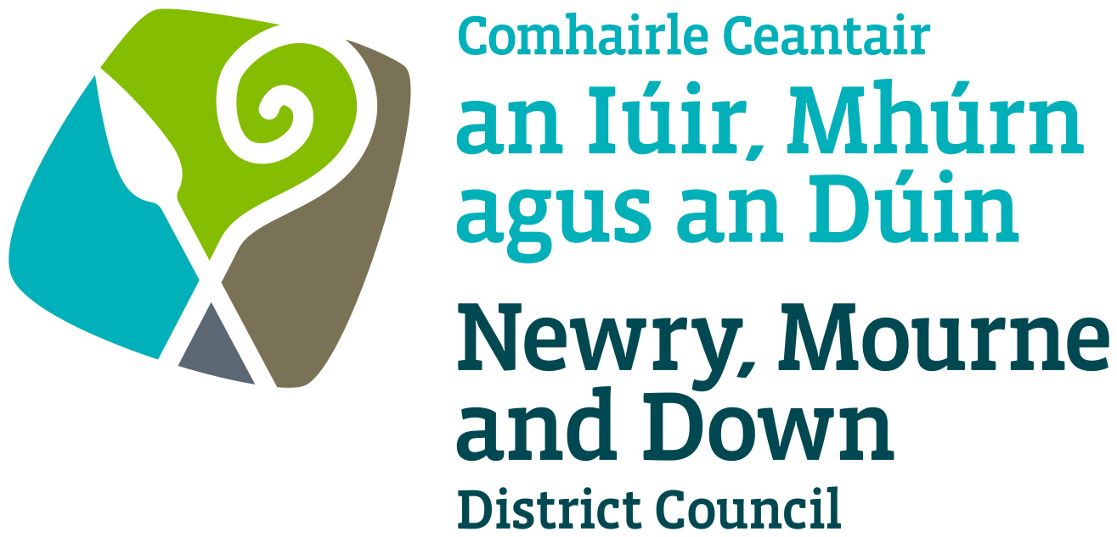

Local Development Plan
Preparatory Studies

Paper 8: The Coast

February 2017

Contents |  | Pg No.
Purpose and Content |  | 1
1.0 | Introduction | 2
2.0 | Regional and Local Policy Context | 3
2.1 | (a) Regional Development Strategy 2035 (RDS) | 3
2.2 | (b) Strategic Planning Policy Statement (SPPS) | 3
2.4 | (c) A Planning Strategy for Rural Northern Ireland | 5
2.5 | (d) Planning Policy Statement 15 – Planning and Flood Risk (PPS15) | 5
2.7 | (e) Planning Policy Statement 16 – Tourism (PPS16) | 6
2.8 | (f) Towards an Integrated Coastal Zone Management Strategy for NI 2006-2026 | 7
2.11 | (g) Newry, Mourne and Down District Council Corporate Plan 2015-2019 | 7
2.12 | (h) Newry, Mourne and Down draft Tourism Strategy 2017-2021 | 7
 | Area Plans & South East Coast Masterplan | 8
2.13 | (i) Area Plans | 8
2.17 | (j) South East Coast Masterplan | 8
3.0 | Terrestrial and Marine Planning and the Coast | 9
3.5 | Marine Policy and Legislative Framework | 10
3.6 | NI Government Marine Responsibilities | 11
3.8 | Marine Conservation Zones (MCZs) | 11
3.11 | Marine Licencing | 12
4.0 | Climate Change, Coastal Flooding and Coastal Erosion | 12
4.1 | Climate Change | 12
4.9 | Government Responsibility for Coastal Erosion and Flood Risk Management in NI | 14
 | Coastal Flooding | 15
4.10 | Rivers Agency Preliminary Flood Risk Assessment (PFRA) for Northern Ireland | 15
4.17 | Coastal Erosion | 16
5.0 | Coastal Development | 21
5.2 | The Coastal Zone | 21
5.6 | The Developed Coast and Undeveloped Coast | 22
5.8 | The Developed Coast | 23
5.11 | The Undeveloped Coast | 24
5.15 | Coastal and Marine Tourism and Recreation | 24
 | Blue Flag Beaches, Green Coast Awards and EU Bathing Water Status | 25
5.18 | Blue Flag Beaches | 25
5.19 | Green Coast Awards | 25
5.20 | EU Bathing Water Status | 26
5.21 | Mourne and Strangford Lough Coastal Walking Path | 26
5.25 | Ports, Harbours and Marinas | 27
6.0 | Renewables and the Coast | 28
6.6 | Offshore Renewable Energy Development | 28
6.9 | Tidal Resource Zone 5: Strangford Narrows | 30
6.12 | Wind Resource Zone 2: East Coast | 31
7.0 | Conclusions and Recommendations | 32
 | Appendix 1 - Glossary | 35
 | Appendix 2 – Marine Policy and Legislative Framework in Northern Ireland | 36
 | Appendix 3 – Map illustrating AONB designations along the coastline in the Newry, Mourne and Down District Council area | 37
 | Appendix 4 – Highland Council indicators used for classifying the Highland Coast | 38

Purpose: To provide Newry, Mourne and Down District Council with an overview of current planning policy for coastal areas, highlight how terrestrial and marine planning overlap, the implications for coastal land use planning from climate change, flooding and coastal erosion; and how coastal development policy will be informed through the LDP process.

Content: This paper provides:
- the regional context for formulating Local Development Plan policies for coastal development along with other Government policy objectives for this sector;
- the inter-relationship between terrestrial and marine planning;
- a focus on coastal flooding and erosion and the implications for coastal land use planning from climate change;
- An examination of the coastal zone, together with a definition of the developed and undeveloped coast;
- an overview of tourism and renewables in respect of the coastal area; and
- consideration of potential coastal issues that will help inform coastal policy development within the new LDP.

1.0 Introduction
1.1 Northern Ireland’s coastline is of great importance not only for its striking natural beauty, but also in terms of its scientific interest, its wildlife habitats and recreational opportunities. The coast is of great economic value and is the location of ports and many of our major urban areas and industries. Society continues to place considerable demands on coastal areas. In addition to man’s influence the coastline is also subject to continual change resulting from dynamic natural processes.

1.2 The District contains some of Northern Ireland’s most attractive coastal landscapes which are subject to special protection and management. These landscapes provide a range of habitats recognised internationally and nationally by the various designations such as Strangford Lough Special Area of Conservation (SAC), Special Protection Areas (SPA), Ramsar Sites, Areas of special Scientific Interest (ASSI) and National Nature Reserves (NNR). See Local Development Plan Paper 6 - Environmental Assets for further information on these protected sites.

1.3 The LDP will seek to implement the objectives of the Strategic Planning Policy Statement (SPPS) for Northern Ireland in protecting the undeveloped coast and supporting sensitive enhancement and regeneration of the developed coast. It will develop policies which consider the associated social, economic and environmental implications of development in coastal areas as well as the possible need for coastal protection to address climate change.

1.4 The Council is responsible for terrestrial planning not marine planning. Accordingly the Council’s responsibilities in respect of planning control do not extend below the low water mark. However the Council as the Local Planning Authority has an important role in the protection of marine and coastal designations, particularly where a development on land might have an impact on the reasons for designation. In these circumstances the Council will seek to prevent any significant effect on protected sites.

1.5 Newry, Mourne and Down District Council is located in the south east of Northern Ireland, covering parts of Counties Down and Armagh. As the third largest Council within Northern Ireland, it comprises approximately 11% of the total land area of Northern Ireland, 25% of Northern Ireland’s coastline (more than 100 miles of coastline), and provides services to over 178,000 residents, (10% of the NI population).

2.0 Regional and Local Policy Context
The Regional Policy Context is provided by the Regional Development Strategy 2035 (RDS) and regional planning policy statements. A summary of these documents as they pertain to plan making for the coastal area is provided in the following sections.
(a) Regional Development Strategy 2035
2.1 The RDS provides an overarching strategic planning framework to facilitate and
guide the public and private sectors. The RDS will influence the future distribution of development throughout the Region including the marine area. It is not limited to land use but recognises that policies for physical development have far reaching implications. The RDS therefore addresses economic, social and environmental issues aimed at achieving sustainable development and social cohesion.
The Regional Guidance (RG) within the RDS which relate to the coast includes:

- RG9: Reduce our carbon footprint and facilitate mitigation and adaptation to climate change whilst improving air quality.
Within RG9 minimising development in areas at risk from flooding from rivers, the sea and surface water run-off is outlined, the protection and extension of ecosystems and habitats that can reduce or buffer the effects of climate change is outlined and the identification of key assets and areas that are at risk through climate change is also outlined.

- RG11: Conserve, protect and, where possible, enhance our built heritage and our natural environment
Within RG11 the protection, enhancement and management of the coast is outlined. It states that the quality of coastal waters needs to be raised. Coastal areas need to be protected from coastal squeeze, to safeguard against loss of distinctive habitats and to help adaptation to climate change. The landscape setting of features should be conserved. The Marine Policy Statement (March 2011) and subsequent Marine Plan(s) will provide spatial guidance and detailed policy where appropriate for the terrestrial/marine interface and the marine environment. This will be complemented by work to advance integrated coastal zone management.

(b) Strategic Planning Policy Statement (SPPS)
2.2 The aim of the SPPS in relation to the coast is to protect the undeveloped coast from inappropriate development, consistent with the RDS; and to support the sensitive enhancement and regeneration of the developed coast largely within coastal settlements.

The regional strategic objectives for coastal development are to:

- conserve the natural character and landscape of the undeveloped coast and to protect it from excessive, inappropriate or obtrusive development; and

- facilitate appropriate development in coastal settlements and other parts of the developed coastline (subject to all other relevant planning policies) that contributes to a sustainable economy and which is sensitive to its coastal location.

2.3 The SPPS states that the following strategic policy must be taken into account in the preparation of Local Development Plans (LDPs) and in the determination of planning applications.

- There are few types of development which require a coastal location and the undeveloped coast will rarely be an appropriate location for new development. Where new development requires a coastal location, it must normally be directed into coastal settlements and other parts of the developed coast.

- In dealing with proposals that require a coastal location, planning authorities, must carefully assess the need for such development, its benefits for the local or regional economy and potential impacts on the environment. Development should only be permitted on the undeveloped coast where the proposal is of such national or regional importance as to outweigh any potential detrimental impact on the coastal environment and where there is no feasible alternative site within an existing urban area in the locality.

- Within the developed coast, areas of amenity value (such as parks, outdoor sports / play areas and coastal walkways) and areas or features designated for their importance to the archaeological, built or natural heritage, should be protected from inappropriate development. The relevant policies set out elsewhere in the SPPS will apply to all such areas and designations.

- Within the developed coast there will be a presumption in favour of development that promotes the enhancement and regeneration of urban waterfronts.

- In considering development proposals within the developed or undeveloped coast attention must be paid to the retention of existing public accesses and coastal walkways. Development which would result in the closure of existing access points or the severing of routes will normally only be acceptable where a suitable alternative is provided. Proposals to extend access to the coastline or for the provision of associated facilities such as pathways or picnic areas, should not impact adversely on the nature conservation, archaeological / built heritage, geological or landscape value of the area.

- Development will not be permitted in areas of the coast known to be at risk from flooding (see Flood Risk), coastal erosion, or land instability.
(c) A Planning Strategy for Rural Northern Ireland
2.4 Strategic Policy 13: The Coast aims to protect the coast from inappropriate development. The policy provisions of Planning Policy Statement 21 – Sustainable Development in the Countryside however take precedence over Policy SP 13 in so far as it relates to Green Belts and Countryside Policy Areas.

The Regional Policies within A Planning Strategy for Rural Northern Ireland (PSRNI) in relation to the Coast are the following:
- CO 1: The undeveloped coast - To conserve the natural character and landscape of the undeveloped coast.
- CO 2: The developed coast - To encourage and support proposals for the enhancement and regeneration of urban waterfronts.
- CO 3: Areas of amenity or conservation value on the coast - To protect from development those parts of the coast, within urban areas, which are important in terms of their amenity or nature conservation value.
- CO 4: Access to the coastline - To encourage schemes which provide or extend public access to the coastline.
- PSU 10: Development at Risk - Development will not normally be permitted in areas known to be at serious risk from flooding, coastal erosion or land instability.
It should be noted that some elements of the above policies and others within this section have been superseded by Planning Policy Statements 2, 6, 15 and 16.
(d) Planning Policy Statement 15 – Planning and Flood Risk (PPS 15)
2.5 The policies of PPS 15 supersede Policy PSU 10 ‘Development at Risk’ of PSRNI insofar as this policy relates to flood risk.

2.6 PPS 15 outlines that climate change is one of Northern Ireland’s foremost environmental, social and economic challenges. It is vitally important to ensure that our new and existing infrastructure is as resilient as possible to all potential impacts. This includes being able to adapt to both gradual climate change as well as the increased risk of extreme weather events such as flooding.

The main objectives of this planning policy statement are to:
- seek to prevent inappropriate new development in areas known to be at risk of flooding, or that may increase the flood risk elsewhere;

- ensure that the most up to date information on flood risk is taken into account when determining planning applications and zoning / designating land for development in development plans;

- adopt a precautionary approach to the identification of land for development through the development plan process and the determination of development proposals, in those areas susceptible to flooding where there is a lack of precise information on present day flood risk or future uncertainties associated with flood estimation, climate change predictions and scientific evidence;

- manage development in ways that are proportionate and appropriate to the 4 main sources of flood risk present in Northern Ireland, i.e. fluvial, coastal, surface water and water impoundment (reservoir) breach or failure;

- seek to protect development that is permitted within flood risk areas by ensuring that adequate and appropriate measures are employed to mitigate and manage the flood risks to the development and elsewhere;

- support the retention and restoration of natural flood plains and natural watercourses as a form of flood alleviation and an important environmental and social resource, and ensure that this is recognised in the decision making process;

- promote sustainable development through encouraging the use of sustainable drainage for new developments and redevelopment / regeneration schemes;

- promote public awareness of flood risk and the flood risk information that is available and of relevance to undertaking development; and

- promote an integrated and sustainable approach, both locally and at catchment scale, to the management of development and flood risk which contributes to:

- the safety and wellbeing of everyone;
- the prudent and efficient use of economic resources; and
- the conservation and enhancement of the natural environment and biodiversity;
- the conservation of archaeology and the built heritage.

(e) Planning Policy Statement 16 – Tourism (PPS 16)
2.7 The policies of PPS 16 supersede Coastal Policies CO 5, CO 6 and CO 7 of PSRNI and also those elements of the remaining coastal policies insofar as they relate to tourism development or the protection of tourism assets from inappropriate development. Where the above policies are referred to elsewhere in PSRNI, the policies of this statement will take precedence.

(f) Towards an Integrated Coastal Zone Management Strategy for Northern Ireland 2006-2026

2.8 In June 2006 the Department of the Environment (DOE) prepared a document titled ‘Towards an Integrated Coastal Zone Management Strategy for NI 2006-2026’, it sets out long-term objectives for achieving sustainable coastal management, through improvements to existing management systems, the development of new management systems and identifying and dealing with potential areas of conflict.

2.9 The Strategy highlights that policies aimed at achieving coastal management in Northern Ireland have, as of the time of publication, principally focused on individual sectoral interests such as aquaculture, environment, fisheries, renewable energy, waste management and tourism. This strategy seeks to bring together all those involved in the development, management and use of the coast within a framework that facilitates the integration of their interests and responsibilities. It seeks to identify the key factors affecting the Northern Ireland coast and put in place a series of widely supported aims, objectives and actions which will promote a coordinated and sustainable approach to the future management of our coastal zone.

2.10 Consistent with the principles of sustainable development the proposed strategy is organised around three priority themes of:
• Sustainable communities in the coastal zone
• Safeguarding and improving the environment within the coastal zone and
• Maintaining and enhancing the economy of the coastal zone;

(g) Newry, Mourne and Down District Council Corporate Plan 2015-2019

2.11 The Council’s mission as detailed in the Corporate Plan 2015-19 is to lead and serve a District that is prosperous, healthy, as well as sustainable from an economic, environmental and social perspective. This document outlines that one of the Council’s strategic objectives is to protect our natural and built environment and defines the key actions of this to include reducing the risk of flooding in high risk areas and the protection of the District’s rich natural and built heritage.

(h) Newry, Mourne and Down District Council draft Tourism Strategy 2017-2021

2.12 The vision of the draft Strategy is: By 2021 ‘NMD is a premier, year-round mountain and maritime destination in Ireland recognised for its EPIC experiences in outdoor adventure, its rich tapestry of cultural heritage, myths and unique stories, and its authentic local life’. The coastal region is an integral part of the draft Tourism Strategy. The Mourne Coast, which stretches from Strangford Lough to Carlingford Lough, is identified as a destination experience.

Area Plans & South East Coast Masterplan

(i) Area Plans

2.13 The Ards and Down Area Plan 2015 (ADAP) and the Banbridge/Newry and Mourne Area Plan 2015 (BNMAP) are the current statutory plans for the District and provide the framework against which to assess development proposals.

2.14 The BNMAP 2015 includes a section specific to the Countryside and Coast within the Plan Strategy. It states that sections of the coast are protected by a number of international and national nature conservation designations. These include Carlingford Lough Ramsar site, Carlingford Lough Special Protected Area (SPA), Murlough Special Area of Conservation (SAC), Carlingford Lough Area of Special Scientific Interest (ASSI), Kilkeel Steps (ASSI), Mourne Coast Area of Scientific Interest (ASI) and South Mourne Coast (ASI).

2.15 The ADAP 2015 does not include a section specific to the coast within the Plan Strategy. Nonetheless, there are sections of the coast which are protected by a number of international and national nature conservation designations; these are outlined in LDP Paper 6: Environmental Assets.

2.16 Almost all of the coastal region is within either the Mourne AONB or Strangford and Lecale AONB (see Appendix 3). The coastal region also contains a number of the District’s settlements, these are identified in Table 1 below.

Table 1: Coastal Settlements in Newry, Mourne and Down District

Towns | Villages | Small Settlements
Kilkeel | Annalong | Ardglass
Newcastle | Ballykinler | Ballyhornan
Warrenpoint | Dundrum | Ballymartin
 | Killyleagh | Greencastle
 | Killough | Glassdrumman/Mullartown
 | Rostrevor | Kilclief
 | Strangford | Killowen

(j) South East Coast Masterplan

2.17 The South East Coast Masterplan was published in January 2013. It provides guidance on the future strategic development of the South East Coast as well as specific guidance on the location and form of development in the town centres of Newcastle, Kilkeel and Warrenpoint over the next 20 years.

2.18 By 2025 the South East Coast Masterplan vision is “to become an area with a strong national and international reputation for being a high quality coastal landscape of great scenic, natural, historic and leisure value; and an area that provides an enjoyable place to live, to work, to explore, and to play in”.

2.19 It states that this is to be achieved by enabling the key towns of Newcastle, Kilkeel and Warrenpoint to collectively and individually embrace and prosper from their association with both their coastal setting and the wider character of the Mourne Mountains as an Area of Outstanding Natural Beauty. In particular, it will help to direct public and private investment to those areas that will most benefit local people, support local business and commerce and contribute to the long term viability and vitality of the Town Centre.

3.0 Terrestrial and Marine Planning and the Coast
3.1 As yet there is no official definition by the European Commission of the coastal zone, particularly in identifying how far inland ICZM should address. In many countries the inland limit, for ICZM purposes, has been defined between 1 and 3km. In Northern Ireland it has been decided to use a 3km inland limit and include flexibility in instances where this limit needs to be increased to take account of factors outside the zone but have an impact on the coastal zone i.e. Water Framework Directive. The seaward boundary is defined in legislation under the Northern Ireland Adjacent Waters Boundaries (Northern Ireland) Order (2002). In general, Northern Ireland’s territorial waters extend to 12 nautical miles from baseline (see definition in Appendix 1 - Glossary). In the case of planning, it should be noted that, development plans, Planning Policy Statements and the regulation of development proposals currently do not extend beyond low water mark of the ordinary tides.
3.2 The Crown Estate owns virtually the entire seabed out to the territorial limit, including the rights to explore and utilize the natural resources of the UK Continental Shelf (excluding oil, gas and coal). It also owns approximately 55% of the foreshore and around half of the beds of estuaries and tidal rivers in the UK.
3.3 The Department for Agriculture, Environment and Rural Affairs (DAERA) Environment, Marine and Fisheries Group have a wide range of responsibilities and work at all levels within the Government process from policy advice to practical hands-on work on the ground. With responsibility for the implementation of European, regional and national legislation relating to the coastal environment, habitats, species and landscapes. Essentially they are responsible for protecting the natural features of the coast and for promoting their appreciation among the public and within all sectors of Government.
3.4 As planning legislation extends to the mean low water mark; there is an area of overlapping responsibilities in the intertidal area, this is illustrated in Figure 1.
Figure 1: Geographical overlap between the marine and terrestrial environment
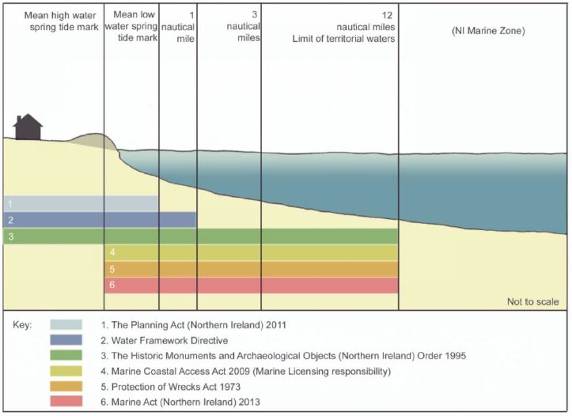
Source: DOE

Marine Policy and Legislative Framework

3.5 The UK Marine Policy Statement, the UK Marine and Coastal Access Act 2009 and the Marine Act (Northern Ireland) 2013 provide the policy and legislative framework for the management of the marine area in Northern Ireland. EC Directives also govern how we implement management measures in protecting all aspects of the marine area. These include Maritime Spatial Planning, Bathing Water, Water Framework, Marine Strategy Framework, Marine Cultural Heritage, Habitats and Birds Directives.

NI Government Marine Responsibilities

3.6 As outlined in ‘Planning in the Coastal Area – A developer’s guide to planning considerations and environmental responsibilities, April 2015’ the Marine Division, within the Department of Agriculture, Environment and Rural Affairs (DAERA) is responsible for protecting the marine area while maximising the sustainable use of its resources, now and for future generations. Their main areas of work include:

- managing ecological and water quality including bathing and shellfish waters under EC Directives;
- managing and protecting marine species and habitats;
- managing and protecting marine cultural heritage assets;
- managing legislative and consenting requirements in the marine area; and
- developing a Marine Plan for Northern Ireland.

3.7 A Marine Plan for Northern Ireland, which is currently being drafted by Marine Division, will provide a regional reflection of the national policy objectives within the UK Marine Policy Statement. It will take account of the economic, social and environmental needs to provide policies and guidance for all decisions which affect or have the potential to affect Northern Ireland’s marine area.

Marine Conservation Zones (MCZs)

3.8 The Marine Act (Northern Ireland) 2013 provides the mechanism for DAERA to establish a new type of Marine Protected Area (MPA), called Marine Conservation Zone (MCZ), in the Northern Ireland Inshore Region. MCZs are designated to protect nationally important habitats, species and geological features.
3.9 In Northern Ireland, MPAs consist of Ramsar sites, marine Special Areas of Conservation (SACs), Special Protection Areas (SPAs), Areas of Special Scientific Interest (ASSI), and Marine Conservation Zones (MCZs).
3.10 Strangford Lough was Northern Ireland's only Marine Nature Reserve but it was redesignated as Northern Ireland's first MCZ on the introduction of the Marine Act (Northern Ireland) 2013. On 12th December 2016 four further MCZs were designated in Northern Ireland including Carlingford Lough MCZ which is located within the Newry, Mourne and Down District.

Marine Licensing

3.11 As stated in ‘Planning in the Coastal Area – A developer’s guide to planning considerations and environmental responsibilities, April 2015’, the Marine and Coastal Access Act 2009 provides for a marine licensing system across England, Wales, Northern Ireland and Scotland’s offshore region. In Northern Ireland, it applies to all our marine waters from the mean high water spring tide mark out to 12 nautical miles (the inshore region). This includes the waters of any sea lough, estuary, or river, so far as the tide flows at mean high water spring tide. It should be noted that some of the tidal rivers in Northern Ireland can extend quite far inland, for example, the Newry River extends into the centre of Newry and The Foyle Estuary extends as far as Strabane.

3.12 Marine Division has responsibility for licensing various activities such as construction works, deposits in the sea, removal of objects or aggregates from the seabed, dredging from the seabed, or use of explosives and incineration. This licensing system allows for a consistent approach to decision making around activities, while ensuring sustainable development and conservation of our marine environment. It also ensures that any decision making is balanced with other uses of the marine environment. There is a shared responsibility between Marine Division and Planning Authorities for consenting or licensing projects in the intertidal area. This means that certain activities or development along the coast may require a marine licence as well as planning permission.

3.13 Some marine licensable activities may also form part of a plan or project that requires an Environmental Impact Assessment under The Marine Works (Environmental Impact Assessment) Regulations 2007 (as amended) or a Habitats Regulations Assessment under The Conservation (Natural Habitats, etc) Regulations (Northern Ireland) 1995 (as amended). However, the same proposal may also require an Environmental Impact Assessment for the onshore development under The Planning (Environmental Impact Assessment) Regulations (Northern Ireland) 2015 and/or a Habitat Regulations Assessment.

4.0 Climate change, coastal flooding and coastal erosion
Climate change
4.1 The SPPS states that the planning system should help to mitigate and adapt to climate change by avoiding development in areas with increased vulnerability to the effects of climate change, particularly areas of significant risk from flooding, landslip and coastal erosion and highly exposed sites at significant risk from impacts of storms.
4.2 In a NI Assembly research paper published in September 2016 the issue of climate change in the context of NI has been examined. The most recent climate change risk assessment suggests the increasing frequency and severity of flooding from a range of sources represents the most significant climate change risk to UK infrastructure. Assets and networks across all infrastructure sectors are already exposed to multiple sources of flooding, and the number of assets exposed to significant levels of flood risk could double by the 2080s with projected changes in the UK climate. The paper highlights that:
• Coastal infrastructures, particularly ports, are at risk from rising sea levels and a consequential increase in the height of onshore waves and storm surges.
• High onshore waves will also accelerate rates of coastal erosion and put increasing lengths of the UK rail network at risk, as well as sea walls that protect coastal settlements.
4.3 The research paper identifies the need for more action to manage increasing risk to existing networks (including flood and coastal erosion risk management infrastructure), from sea-level rise and increased rate of erosion. Referencing the risk assessment it also highlights the urgent need for research in Northern Ireland suggesting current knowledge of the threat posed by coastal erosion and flooding remains limited.
4.4 The UK Marine Policy Statement (2011) states that understanding the impacts and effects of climate change is key to maintaining a healthy environment. This will influence how we use and value our coasts and seas both now and in the future. Adaptation, including in the marine environment, is necessary to deal with the potential impacts of these changes which are already in train. Sea level rises, increased flooding and coastal erosion will lead to increased vulnerability for development and significant change along parts of the UK coast.

4.5 In Northern Ireland estimates of sea level change by the 2050s range between 13cm and 74cm, dependent upon scenario. Heightened sea levels are expected to exacerbate coastal erosion and compound the effects of storm surges. Storm surges, are temporary increases in tidal height caused by particular weather conditions in future their frequency or severity of may increase as climate change affects weather patterns.

4.6 The Northern Ireland Climate Change Adaptation Programme 2014 seeks to explore how we can best adapt to climate change. The Adaptation Programme will provide the Northern Ireland response to the priority climate change risks and opportunities identified in the Climate Change Risk Assessment (CCRA) for Northern Ireland. It will set out the strategic direction and objectives in preparing Northern Ireland for the effects of climate change. It also establishes a range of actions and key adaptation activities for the period 2014–2019.

4.7 Potential threats and opportunities from climate change in the natural environment include:

- Changes in soil moisture deficits and drying, with consequences for species
habitats and soil organic carbon;
- Increased risks from pests, diseases and invasive non-native species;
- Changes in species migration patterns with consequences for the conservation
network and cultural ecosystem services;
- Reduced water quality, due to pollution from point and diffuse sources;
- Risks to coastal habitats due to flooding;
- Tidal flooding and coastal erosion;
- Shifting of marine species, with consequences for ecosystem services; and
- Changes in fish catch latitude (plaice, sole).
4.8 The National Trust paper ‘Shifting Shores’ states that the impacts of climate change at the coast are becoming more apparent and widespread through increased erosion and flooding. It states that hard coastal defences such as concrete walls have a limited lifespan, and will be increasingly prone to failure. As they fail decisions need to be made about whether or not to replace them. It states that we must also acknowledge that sea defences often cause unwelcome side effects such as beach lowering in front of sea walls and, as a consequence of groynes, the starving of sediment supply to neighbouring areas.

Government Responsibility for Coastal Erosion and Flood Risk Management in Northern Ireland.

4.9 The Department for Infrastructure (DfI) has overall responsibility for flood risk management and policy in Northern Ireland. The NI Assembly Research Paper on Coastal Erosion highlights however that no single Executive Department has the responsibility for coastal erosion risk management. The Executive’s policy on coastal protection is determined by what is commonly known as the ‘Bateman Formula’. Under this formula central government departments have a responsibility to construct, maintain and repair the coastal defences in their possession. For example,

- The Department for Infrastructure’s (DfI) Rivers Agency has powers to maintain 26km of sea defences and two tidal barriers designed to reduce the risk of flooding (but not coastal erosion) to low lying coastal land;
- DfI’s Transport NI has responsibility for coastal defences that protect the public road and railway network;
- The Department of Agriculture, Environment and Rural Affairs (DAERA) is the marine licensing authority for deposits in the marine area below the mean high water spring tide, and also has responsibility for marine and coastal conservation;
- DAERA is also the marine planning authority for Northern Ireland and is currently drafting the NI Marine Plan;
- The EU Floods Directive which came into force in 2007 requires the production of flood risk assessments for all river basin districts and coastal areas within Member States. DfI’s Rivers Agency is the competent authority with regard to the production of these assessments.

Coastal Flooding

Rivers Agency Preliminary Flood Risk Assessment (PFRA) for Northern Ireland

4.10 Article 4 of the Floods Directive (2007/60/EC) requires that each Member State undertakes a Preliminary Flood Risk Assessment (PFRA). As the competent authority for Northern Ireland, Rivers Agency published this in 2011. The PFRA for Northern Ireland assesses the potential adverse consequences of future floods on human health, economic activity, cultural heritage and the environment taking into account long term developments such as climate change. It considers flooding from all of the main flood sources including rivers, the sea, surface water runoff (also known as pluvial flooding) and impounded water bodies (such as dams and reservoirs).

4.11 The Rivers Agency preliminary flood risk assessment for Northern Ireland estimates that:

▪ 46,000 or 5% of the 830,000 properties in Northern Ireland are at risk of flooding from rivers (fluvial) or the sea (coastal);
▪ Approximately 15,500 of these properties are protected to some extent by flood defence systems and the culvert network.

The report notes that while the threat is not widespread (the PFRA estimates approximately 1,800 people or 720 households are at risk of coastal flooding) coastal flooding has the potential to have a significant impact on public safety, economic activity and the environment.

4.12 Planning Policy Statement 15 - Planning and Flood Risk (PPS 15) highlights that development plans in taking account of flood risk management considerations have assumed greater significance in recent years as a result of the implementation of the European Union (EU) Floods Directive in Northern Ireland. The Directive considers a catchment wide approach to flood risk management and promotes sustainability practices, which includes the retention and restoration of natural floodplains as valuable flood storage areas. The Directive addresses the main sources of flooding and promotes a joined up approach amongst organisations that can influence and contribute effectively to flood risk management. The LDP, as a key land use planning tool for influencing spatial patterns and types of development, therefore has a key role in the implementation of this joined up approach to flood risk management.

4.13 The Council’s LDP will need to take account of the potential risks from all sources of flooding over the plan period and beyond as this will influence decisions on land use zoning. The LDP will avoid zoning land for development in flood risk areas. Outside of such areas it may still be appropriate for the LDP to mitigate against the risk of possible flooding, for example, by requiring susceptible areas within development sites to be retained as open space or indicating where the use of water resistant materials and forms of construction will be considered necessary. PPS15 also states that flood risk may also be an important consideration in the definition of settlement limits and in the designation of new settlements.

4.14 PPS 15 adds that, development plans may also need to consider the potential implications of flood risks beyond the Plan area. This may be necessary where:

a) development in locations beyond the Plan area has the potential to impact upon flood risk within the Plan area; or
b) Plan proposals could cause or increase the potential for flood risk in locations beyond the Plan area.

4.15 In considering the role of development plans and flood risk PPS 15 concludes that development plans have a role to play in furthering a more sustainable approach to flood management. This includes a number of measures such as:-
• Flood avoidance through the careful selection of housing and economics zonings;
• identifying flood plains and safeguarding them from development likely to impact upon their flood storage and conveyancing capacity;
• identifying and safeguarding from development areas of storm exceedence; and
• promoting sustainable drainage schemes. (SuDS)

4.16 Flood Maps (NI) contains a suite of detailed flood hazard maps that have been produced in accordance with the requirements of the EU Floods Directive. These maps have been prepared for areas that have been determined by government to be at significant risk of flooding and are an important step that will lead to the development of flood risk management plans for these areas.

Coastal Erosion

4.17 Coastal erosion can be defined as the removal of material from the coast by wave action, tidal currents and/or the activities of humans, typically causing a landward retreat of the coastline. Whilst coastal erosion is a natural process it does have the potential to cause issues where land retreats to a point where it impacts on day to day activities by causing flooding, rock falls, loss of land and damage to infrastructure.

4.18 Extreme weather events have also highlighted the problem of coastal erosion. Whilst this is also a natural process, human interventions including coastal engineering, land reclaim, river basin regulation works (especially construction of dams), dredging, vegetation clearing, gas mining and water extraction all contribute to erosion. This in turn undermines flood defences, both natural and manmade, creating the potential for coastal flooding and damage to infrastructure and private property.

4.19 According to Rivers Agency, whilst significant coastal flooding is a relatively infrequent occurrence in Northern Ireland, there have been some major events in recent times, notably the tidal surge of January 2014, which caused almost £1.4m worth of damage to roads, including £382,000 to fix the sea wall at the Rostrevor Road, near Warrenpoint.

Photo 1 – Damage to the sea wall and road at Rostrevor Road, Warrenpoint

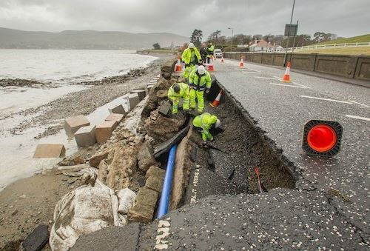

Source: http://www.newry.ie/news/latest-news/2269-storm-damages-rostrevor-road

4.20 As stated in ‘Towards an Integrated Coastal Zone Management Strategy for Northern Ireland 2006 – 2026’, coastal erosion is a potential impact of rising sea levels with existing beaches and dunes being put under increased pressure. This will have implications for wildlife and habitat protection, as well as for coastal planning policy. Coastal erosion is an issue for parts of Northern Ireland such as the County Down and North coasts.

4.21 Sea defences have traditionally been employed to manage coastal erosion, where there is a perceived threat to infrastructure, with, some arguing, little thought having been given to the wider environmental consequences. In many cases hard engineering approaches exacerbate the problem, causing more erosion further along the coastline.

4.22 The National Trust document entitled ‘Shifting Shores’ states that for many years, the default response to flooding and erosion along the coast has been to ‘hold the line’ and build our way out of trouble. It states that in some places defence is of course necessary, but increasingly we must view adaptation as having an equal role in the long-term health of the coastline. It adds that where we can, recreating a naturally functioning shoreline will free us from the sea defence cycle of construct, fail and reconstruct. It states that recent research identifies the disconnect between technical coastal change management and land use planning. As we make the switch from building our way out of trouble at the coast to planning our way out, this break in the system must be addressed.

4.23 A planning application for the construction of 127m of rock armouring coastal defences at Windmill Road Cranfield was submitted to Newry, Mourne and Down District Council in 2015 (see photos 2, 3 & 4 below).

Photo 2 – Existing hard defences in the vicinity of Windmill Road

Photo 3 & 4 - Erosion of the cliff edge and dunes at Windmill Road

Source: NMDDC

4.24 As part of this project involved development below the Mean High Water Spring Tide a Marine Licence was also required from the Department of Agriculture, Environment and Rural affairs (DAERA). The application site is adjacent to two European and a national designated site: Carlingford Lough SPA, Murlough SAC and Carlingford Lough ASSI.
4.25 DAERA considered that the proposed development could exacerbate coastal erosion and may harm a European protected habit and subsequently issued a refusal of the Marine Licence application on 13th June 2016. Planning permission for this development proposal was also refused on 16th August 2016.
4.26 This planning application provides a local example of the complex and often opposing issues to assess when dealing with planning applications along the coastline.
4.27 NIEA Marine Conservation Team (MCT) in responding to the proposed developed advised that a range of hard engineering solutions had already been put in place along this part of the County Down coast, these were not considered to have been successful and had simply transferred the problem along the shore. The NIEA MCT further stated that it was highly probable that the extensive use of shoreline protection in the area (some 3.28km was already protected out of 3.72km of coastline surveyed) had been a major contributing factor to shoreline erosion and instability to date.

This approach is supported by Professor Derek Jackson form the School of Environmental Sciences at the Ulster University:

“These defences are not solutions but are added problems and we should immediately shy away from these as our default position in ‘protecting coastlines that naturally erode and build up again.”

4.28 In an academic paper published in 2016 Andrew Cooper, Professor of Coastal Studies at Ulster University, stated that

“Constructing coastal defences (whether hard or soft) to protect human infrastructure has deleterious effects on the coastal eco- system (including reducing or eliminating sediment supply), preventing energy attenuation, reflecting or redirecting excess energy, reducing or eliminating habitat (coastal squeeze), and altering habitat type.”

“In large part, concern about coastal erosion and flooding is only loosely focussed and terms such as ’coastal protection’ and ‘working with natural processes’ mean different things to different people. Protecting a beach is not the same as protecting a house behind the beach – to protect the house means damaging or destroying the beach, while protecting the beach may mean letting the house collapse when erosion reaches it, yet both meanings are encompassed in the term “coastal protection”. Importantly, the different interpretations of these terms are diametrically opposed – following one interpretation will compromise the other.”

4.29 There is thus a clear challenge for the Council in developing planning policy to consider how to balance the need to reduce shoreline change and instability whilst meeting the expectations of coastal residents and landowners.
4.30 Figure 2 provides a visual illustration of coastal erosion along the Newry, Mourne and Down coastal stretch.

Figure 2 – Areas of Coastal Erosion along the South East Coast of NI
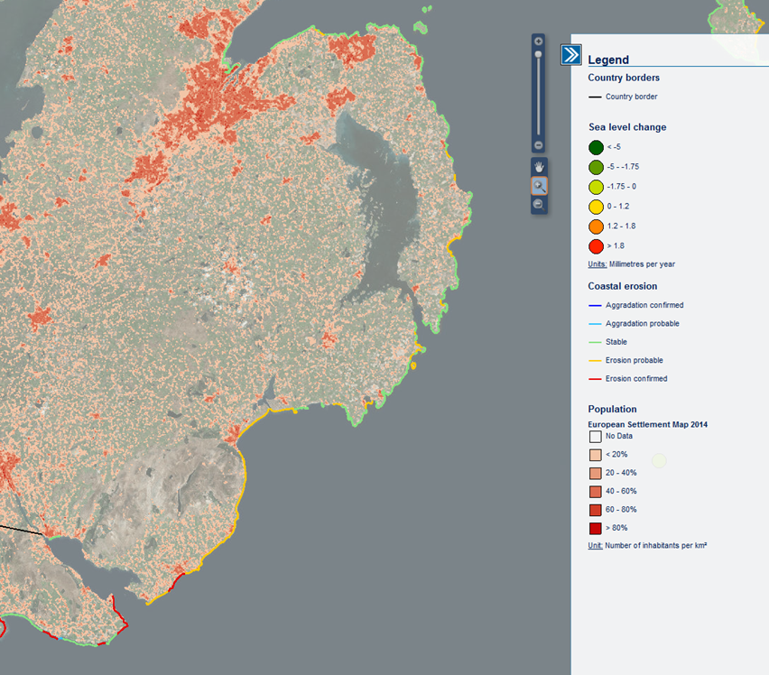
Source: European Atlas of the Seas

5.0 Coastal Development
5.1 The District’s extensive and varied coastline is of national, and in some parts international significance, containing many areas of special landscape and ecological significance. It is therefore important that the character and environmental qualities of the District’s Coast are protected from inappropriate development and that development which requires a coastal location is directed to the least environmentally sensitive areas. As outlined in Section 2.2 of this paper Regional Planning Policy in the form of the SPPS requires LDPs to distinguish between the developed and undeveloped coast and set out general policies for the conservation of the coastal environment.

The Coastal Zone

5.2 The coastal zone comprises three main elements: the land; the intertidal zone; and the sea. Statutory planning control does not extend to the entire coastal zone (see Figure 1), although some development which occurs offshore may impact onshore, for example fish farming.

5.3 In bringing forward policy proposals relating to coastal development the Council’s LDP will also consider the need for the identification of a coastal zone incorporating the developed and undeveloped coast.

5.4 It has been highlighted at paragraph 3.1 that there is no official definition by the European Commission of the coastal zone and it is widely acknowledged that the landward limit of the coastal zone is more difficult to define. A definition of the coastal zone as used by Argyll and Bute District Council within their Local Development Plan is as follows:

“Strip of land between Mean Low Water Springs (MLWS) and 1 km landwards. In some circumstances the coastal zone may extend further in land where the land exerts an influence on the uses of the sea and its ecology, or the lands uses and ecology are affected by the sea.”

5.5 The draft BNMAP 2015 contained a coastal zone in the form of a Coastal Policy Area (Policy COU 2). This extended from an area in Newry City south of the Greenbank Industrial Estate to beyond Maggie’s Leap, 1km south of Newcastle. It extended to Low Water Mark and included narrow strips of coast between the High Water Mark and the Low Water Mark along with other selected land. The landward element was however limited in scope. Following the introduction of PPS21 and the loss of the majority of Green Belt/Countryside Policy Area designations this limited coastal policy designation was removed from the plan prior to final adoption. The opportunity now exists as part of the new plan process to review this previous Coastal Policy Area and consider whether it should form part of an enlarged coastal zone with both a landward and seaward element.

The Developed Coast and Undeveloped Coast

5.6 The SPPS states that the undeveloped coast includes a wide variety of landscapes many of which are of high scenic quality as well as being of scientific interest, nature conservation value, and wildlife habitats. The aim of the SPPS is protect the undeveloped coast from inappropriate development and support the sensitive enhancement and regeneration of the developed coast.

5.7 The coastal section of the SPPS provides a limited definition of the developed coast, this is considered further under paragraph 5.5 below. Some planning authorities have gone further in their classification, for instance The Highland Council have outlined a classification based on primary and secondary indicators (see Appendix 1). The primary indicator for deciding whether a stretch of coast should be regarded as developed or undeveloped or isolated (third classification under Scottish Regional Policy) is settlement size while a number of secondary indicators allow the classification to be fine-tuned. These indicators relate to infrastructure, the degree of industrial/commercial/port, tourism/recreation presence, the level of offshore, and the character of the coastline.

The Developed Coast

5.8 The SPPS states that the developed coast includes existing settlements and major developments such as ports, isolated industrial units and power stations. This is not however exhaustive and does not reference all existing settlements. There is thus scope as part of the LDP process to more clearly define the extent of the developed coast. Some planning authorities have included sites of significance for national and international nature conservation, important cultural heritage resources as well as valuable areas of open space and recreation such as golf courses within this definition. 26

5.9 The developed coast should be the focus for developments requiring a coastal location or which contribute to the economic regeneration or well-being of settlements whose livelihood is dependent on coastal or marine activities and features or which meet the social needs of these communities. Where development on the coast is justified, opportunities for the development or re-use of vacant land and buildings should be considered in the first instance.

5.10 LDP Policy considerations within the developed coast include:

• Giving priority to promoting re-use of redundant land and buildings where there are opportunities to restore or enhance degraded coastal environments.
• Unless a coastal location is required, promoting locations on the landward side of existing settlements before considering development on the coastal strip or coastal frontage (as referred to in the SPPS).
• Avoiding coalescence of development along the coast.

The Undeveloped Coast

5.11 The undeveloped coast as defined by the Highland Council includes agricultural and forestry land, low intensity recreational uses and smaller settlements which depend on the coast for their livelihood. Extensive sections of the undeveloped coast are protected by national and international natural heritage designations and contain important cultural heritage resources.

5.12 Development opportunities, for example related to tourism, leisure and recreation, can make an important contribution to the economy of rural areas. Many of these developments which can assist in sustaining the long-term viability of coastal communities are likely to be on a modest scale. Ill-considered development, however, can have a detrimental effect on ecology and scenery as well as on cultural heritage interests; a key objective for the planning system is to provide a framework for investment in development while protecting the undeveloped coast from unjustified and inappropriate development.

5.13 Proposals which, for technical and other reasons, require a coastal location include ports and harbours, some tourism, leisure and recreation projects, some sewage treatment plants, the onshore elements of oil and gas developments and of fish farms, some energy schemes and specific defence establishments. Large development proposals are likely to present the greatest threat to the natural, cultural or scenic environment but the cumulative effect of smaller developments can be just as damaging. As relatively few types of development require a coastal location, the undeveloped coast should generally be considered for development only where:-

• the proposal is of such national or regional importance as to outweigh any potentially detrimental impact on the coastal environment and
• there are no feasible alternative sites within existing settlements or on other previously developed land.

5.14 There will be an opportunity through the LDP process to consider how the undeveloped coast should be defined within the District.

Coastal and Marine Tourism & Recreation

5.15 The District is an area abundant in natural, built and cultural heritage; its coastal environment coupled with its proximity to the Mourne Mountains give the area a distinct character. The first strategic objective outlined in the Corporate Plan 2015-2019 for the Newry, Mourne and Down District is that the District becomes one of the premier tourism destinations on the island of Ireland.

5.16 The Council’s draft Tourism Strategy recommends that strategies to improve access to water, where clear tourism benefits can be anticipated, should be brought forward. Coastal access is also highlighted by the SPPS which states that LDPs should promote and protect public access to and along the coast. Through the LDP process the Council will consider how planning policy, proposals and designations can support and enhance access to and within the coastal zone.

5.17 Further information on the District’s tourism assets and opportunities is contained within the LDP Paper 7 on Tourism and the coastal elements of the District’s tourism are outlined within this paper. The paper highlights that activity tourism is a strong and growing market across the District’s coastal region:
• Strangford Lough is a popular tourist destination offering activities such as leisure sailing, kayaking, fishing, bird watching and diving.
• Beaches within the District are popular tourist attractions, these include Murlough, Cranfield, Tyrella, Warrenpoint and Newcastle.
• The Mourne Coastal Trail and South East Coast Canoe Trail are key drivers in attracting activity tourism.

Blue Flag Beaches, Green Coast Awards and EU Bathing Water Status

Blue Flag Beaches

5.18 The Blue Flag Award is the definitive international beach award recognised in 49 countries, owned and run by the independent non-profit organisation Foundation for Environmental Education. The programme is designed to raise environmental awareness and increase good environmental practice amongst tourists, local communities and beach and marina operators. Within the District there are three blue flag beaches, these are Cranfield, Murlough and Tyrella.

Green Coast Award

5.19 A separate “certification” process exists that covers coastal and bathing water management called the ‘Green Coast Award’. The aim of this award scheme is to acknowledge those beaches which meet EC Guideline bathing water quality standards (the highest standard recognised under current EC legislation) but which are also prized for their natural, unspoiled environment. It is aimed particularly (but not solely) at rural beaches which do not qualify for other awards due to the lack of intensive management and high level of infrastructure around the beach area. This award has previously been awarded to Minerstown beach.

EU Bathing Water Status

5.20 EU Bathing Water is a designation that acknowledges that waters where people are bathing require more monitoring and clear reporting to the public. A key benefit of having EU Bathing Water status is that it puts a requirement on central government to regularly test water quality and if required, to take measures such as upgrading sewage treatment systems or addressing septic tanks or problems with agricultural run-off. The other benefits are primarily socio-economic as part of a wider programme to promote the area for tourism and as a hub for sustainable outdoor recreation. There are three beaches within the District that are currently applying for EU Bathing Water Status designation; these are Killough, Ballyhornan and Kilclief.

The LDP must acknowledge the existence of and opportunities for each of these coastal designations within the District. It should make provision for the prerequisites of each designation and afford each area with the necessary environmental protection.

Mourne and Strangford Lough Coastal Walking Path

5.21 In August 2015 a technical and feasibility study was completed with regard to a Mourne and Strangford Lough coastal walking path. The aim of the study was to “assess the feasibility of developing a coastal walking path between Greencastle and Portavogie identifying tourism and business development opportunities that will enhance the visitor experience along the way by creating unique attractions and experiences”.

5.22 The proposed 131km/81 mile path stretches from Greencastle, near Kilkeel to Portavogie. It follows the coastline from Greencastle to Strangford, crosses Strangford Lough to Portaferry and continues along the coastline to Portavogie passing through the three fishing villages of Kilkeel, Ardglass and Portavogie.
5.23 The study states that a Mourne and Strangford Lough coastal walking path, within a tourism context, has very strong potential. It states that the path can act as a demand generator, bring economic benefit, has great opportunity to develop experiential tourism, is a natural fit for visitor segments, opens up the Irish Sea coast, aligns with existing strategies and aligns with the Mourne Coastal Driving Route (MCDR).
5.24 There is an opportunity as part of the LDP process to consider how planning policies for the coastal region can support tourism access projects.
Ports, Harbours and Marinas
5.25 Ports and harbours are important economic generators and are essential to the operation of a range of different marine and coastal industries. The LDP will consider what land use policies and designations are required to maintain viable, thriving and stable harbour areas. In line with the SPPS, the LDP will seek to support the enhancement and upgrading of piers, landing facilities and other facilities associated with the industries that require a pier and/or harbour location.
5.26 To ensure that working harbours are not constrained by neighbouring development, the LDP will consider additional land requirements adjacent to harbours to support the needs of fishing and other harbour based industries, including marine renewables and aquaculture.
5.27 To support the fishing industry, marine engineering and renewable energy industries there is a need to consider the need for onshore working and storage space for equipment, maintenance and staff operations within a reasonable distance of berthing facilities. Specific to the fishing industry, the available space for handling and processing fish is also a critical issue that will be considered as part of the LDP policy development and designations.
5.28 Whilst economies of scale have reduced commercial fishing at smaller harbours and piers these still have the potential for leisure, recreation and tourism uses.
5.29 Plans for a £36m expansion of Kilkeel Harbour have been drawn up by Sea Source, these entail a new breakwater and onshore development to allow larger boats into the harbour. Invest Northern Ireland has commenced a feasibility study in conjunction with the Strategic Investment Board in relation to the proposed expansion of the Harbour.
5.30 The importance of Warrenpoint Harbour has previously been highlighted in the LDP Paper 3 on Employment and Economic Development. It is not only an important commercial freight gateway but has the potential to boost local tourism by attracting the cruise market.
6.0 Renewables and the coast
6.1 The LDP will seek to ensure that the Newry, Mourne and Down District continues to make a positive contribution to meeting NI’s targets for renewable energy generation. These targets are important given the compelling need to reduce our carbon footprint and reduce our reliance on fossil fuels. NI has made good progress to date, as highlighted in LDP Paper 9 Public Utilities, in renewable energy generation, although the District does face challenges in terms of the adequacy of the electricity network infrastructure.
6.2 The District has a comprehensive and diverse mix of renewable energy consents including on shore, hydro, mini hydro, solar, biomass and tidal. The coastal region has an important role to play in supporting the renewable energy sector.
6.3 The benefits of a coastal location for a large scale biomass plant have been demonstrated by the creation of Northern Ireland’s largest biomass plant at Lishally port in Derry. The port location enables the facility to import fuel by ship should issues arise in obtaining fuel in Northern Ireland. The 15.8 MW power station provides electricity to around 30-35,000 homes and it is estimated that over the course of its 20 year lifetime it is expected to divert around two million tonnes of wood earmarked for landfill to create electricity, increasing Northern Ireland’s renewable energy generation by around 10%.
6.4 The forthcoming Landscape Character Assessment Paper (LDP Paper 12) will look at landscape sensitivity and in particular wind farm development. This section of the Coast Paper will focus on the potential for renewable energy generation in the marine environment.
6.5 Whilst the Council seeks to support the further development of renewables throughout the District, there is also a need to take a sustainable approach by protecting and conserving our environment, including our landscape and protected species, our local communities and other sectors of our economy from unacceptable significant adverse effects as a result of proposed renewable energy developments. The LDP in line with the SPPS will seek to deliver the growth of this important industry in a sustainable manner.
Offshore Renewable Energy Development

6.6 Offshore wind along with wave and tidal energy are developing technologies which may have significant potential to meet renewable energy targets. Stronger wind speeds are generally available offshore, giving greater potential for electricity generation.

6.7 ‘The Regional Locational Guidance (RLG) for Offshore Renewable Energy Developments in NI Waters 2011’, provides non-statutory guidance and information on the opportunities for, and key considerations influencing the siting and consenting of offshore renewable energy developments in Northern Ireland (NI) waters. Part of the approach to the SEA included a review of existing resource within Northern Ireland waters for each of the three offshore renewable energy technologies. Supporting documentation identifies the main areas or zones of potential interest for development for each of the three technologies. These are based on potential available natural resource and the technical/operational parameters of the different technologies for example optimal wind speeds/tidal velocities and maximum water depth for development.

6.8 In total eight resource zones were identified within the Northern Ireland study area. These are listed below and illustrated in Figure 3.

- Wind Resource Zone 1: North Coast
- Wave Resource Zone 1: North Coast
- Tidal Resource Zone 1: North Coast
- Tidal Resource Zone 2: Rathlin Island and Torr Head
- Tidal Resource Zone 3: Maiden Islands
- Tidal Resource Zone 4: Copeland Islands
- Tidal Resource Zone 5: Strangford Narrows
- Wind Resource Zone 2: East Coast
Tidal Resource Zone 5: Strangford Narrows and Wind Resource Zone 2: East Coast are located within the Newry, Mourne and Down District coastal region.

Figure 3 – Offshore Wind and Renewables Resource Zones
Source: Regional Locational Guidance (RLG) for Offshore Renewable Energy Developments in NI Waters, September 2011

Tidal Resource Zone 5: Strangford Narrows

6.9 The Strangford Narrows connect Strangford Lough to the Irish Sea and here the tidal wave is forced through an opening less than 2km in width and less than approximately 15m in depth. Due to the local bathymetry strong currents on both the flood and ebb tides are observed here from north of Strangford Harbour and past Killard Point.

6.10 Marine Current Turbines LTD (MCT) developed the SeaGen S technology – a twin axial-flow turbine supported on a structure with the ability to raise the moving components out of the water for maintenance. The SeaGen device was installed at Strangford Lough in 2008 and was the world’s first grid connected tidal turbine to generate electricity onto the grid (see figure 4). Decommissioning of the turbine commenced in 2016 and the current owners Atlantis Resources hope to have the device fully removed from the site in 2017 to comply with The Crown Estate leasing requirements.
6.11 Atlantis Resources continue to hold an Agreement for Lease (AfL) from The Crown Estate as part of the divestment package from Siemens for the potential development of a 20MW tidal array within Strangford Narrows provided all permits and licences can be secured for the site. Atlantis Resources have not yet engaged with DAERA in relation to further pursuing this lease at this time.
Figure 4 – Strangford Lough Marine Energy Production Facility
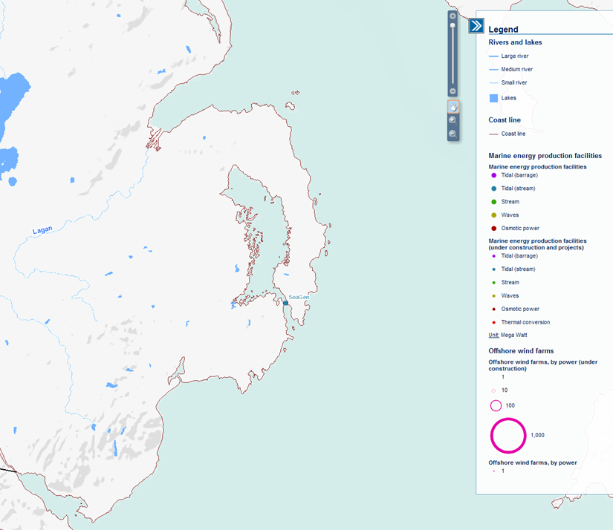Source: European Atlas of the Seas

Wind Resource Zone 2: East Coast

6.12 Wind Resource Zone 2: East Coast is located offshore of County Down where a sizeable wind resource extends from mid Ards Peninsula to Carlingford Lough and from 3km offshore out to the 12nm limit. This area has a large raw resource for offshore wind development. It is considered that nearshore shallower areas from 20m to 40m depth would initially be more economically attractive for development of offshore wind before 2020, although with newer deeper water jacket foundations opportunities for development may currently exist out to the 60m contour which follows the eastern boundary of the zone. Opportunities for offshore wind development exist across the entire zone. However, there are a number of potential constraints/interaction that could occur in this area that could influence the overall extent of the area of the zone that could be available for development. These include:
- Protected sites
- Seabirds and Marine Mammals/Reptiles and Fish
- Benthic Habitats
- Seascape and Landscape
- Shipping and Navigation and Ports and Harbours
- Commercial Fisheries

6.13 The potential of this wind resource zone has been recognised through the submission of a planning application for 120 wind turbines off the east coast, whilst the application was withdrawn in December 2014, Northern Ireland continues to be seen as a location with “superb offshore wind potential”.
6.14 In addition to the potential effects on the marine environment, the LDP will need to highlight that careful consideration will also be required to be given to any associated terrestrial infrastructure and associated environmental and other constraints that may apply in sensitive coastal locations. LDP renewable energy planning policy will consider the need for marine proposals and their associated terrestrial infrastructure to be considered as a single project/proposal.
6.15 The Sustainable Kilkeel 2020 study in particular highlighted the potential of the renewable energy sector and tourism in contributing to local economic growth. The study suggested that a leisure marina and off-shore supply and service yard could support the fishing, off-shore energy and marine tourism sectors.
7.0 Conclusions and Recommendations
7.1 This paper has provided an overview of the polices relevant to the coast in the Newry, Mourne and Down Council area and has demonstrated the overlapping relationship between terrestrial and marine planning. When preparing the LDP it is important to appreciate the anticipated impact climate change will have on the coast and to ensure that provision is made for these changes i.e. ensuring that inappropriate types of development are not permitted in those areas most vulnerable to coastal change, or to flooding from coastal waters, while also improving resilience of existing developments to long term climate change.
7.2 In order to make provision for a changing coastline the Local Development Plan Strategy could therefore include measures to:
- define the developed and undeveloped coast;
- define and designate a coastal policy zone (CPZ) covering both the developed and undeveloped coast. Within this adopt a high level criteria based policy on coastal erosion which would seek to ensure that:
  - development proposals avoid areas vulnerable to coastal change;
  - development proposals demonstrate the need for a coastal location;
  - in areas identified as vulnerable to coastal change, development proposals are accompanied by a coastal change vulnerability assessment;
  - an assessment on the impact of development on existing coastal defence infrastructure is provided, including whether new infrastructure is required; and
  - proposals for new or replacement coastal defences are permitted where it can be demonstrated that they work with natural processes and there will be no significant adverse impact on coastal processes or habitats, and the development will not result in increased coastal erosion or flooding elsewhere on the coastline.
- define a coastal flooding zone and consider identifying coastal flooding zones and ascertain if the coastal flooding policy provision within PPS 15 is adequate; and
- direct new development within coastal settlements to the landward boundary of the settlement.
7.3 This paper recognises the potential that the coast holds within this District in relation to the tourist industry, it is important therefore that the potential of this industry is capitalised upon and that the LDP facilitates the delivery and enhancement of endorsed tourist related projects. With regard to renewable energy, it has been demonstrated in this paper that there is potential for both tidal and wind energy projects within this District. It is therefore important that in the preparation of the LDP the provision for credible developments of this type are provided for.

7.4 In preparation of the LDP for Newry, Mourne and Down it is important to take into consideration:
- how coastal policies within the LDP could assist in the delivery of the Council’s Tourism Strategy and proposals within the South East Coast Masterplan;
- proposals which could further enhance the Mourne/Strangford Lough Coastal Walking Path project;
- marine plans and ensure that LDPs and marine plans are complementary, particularly with regard to the inter-tidal area. Proposals in the marine area should be supported by the appropriate infrastructure on land and reflected in local development plans e.g. protecting existing terrestrial sites which support marine industries, such as fisheries and harbours;
- how the LDP could support possible offshore renewable energy projects; for instance where offshore energy is identified as a realistic opportunity, provision should be made in appropriate locations for supportive terrestrial infrastructure;
- how the LDP could support future Marine and Harbour development to support Tourism and Economic development in coastal areas; and
- the formulation of shoreline management plans and how they could best provide for the management of the coastal area in the future.

Appendix 1 - Glossary
Baseline: A baseline is the line from which the seaward limits of a state's territorial sea and certain other maritime zones of jurisdiction are measured. Normally, a sea baseline follows the low-water line of a coastal state.
Coastal squeeze: habitat loss which arises due to the high water mark being fixed by defence or development and the low water mark migrating landwards in response to sea level rise.
Conveyancing capacity: is a measure of the discharge carrying capacity of a channel.
DAERA: Department of Agriculture, Environment and Rural Affairs
ICZM: Integrated Coastal Zone Management
Inshore region: from the mean high water spring tide out to 12 nautical miles.
Intertidal area: is the area between the mean high water and the mean low water spring tides.
Mean high water spring tides and mean low water spring tides: The height of mean high water springs is the average throughout the year (when the average maximum declination of the moon is 23.5°) of two successive high waters during those periods of 24 hours when the range of the tide is at its greatest. The height of the mean low water springs is the average height obtained by the two successive low waters during the same period.
Shoreline Management Plan (SMP): A policy document for coastal flood and erosion risk management planning.

Appendix 2 - Marine Policy and Legislative Framework in Northern Ireland

The UK Marine Policy Statement, the UK Marine and Coastal Access Act 2009 and the Marine Act (Northern Ireland) 2013 provide the policy and legislative framework for the management of the marine area in Northern Ireland. EC Directives also govern how we implement management measures in protecting all aspects of the marine area. These include Maritime Spatial Planning, Bathing Water, Water Framework, Marine Strategy Framework, Marine Cultural Heritage, Habitats and Birds Directives.

▪ The UK Marine Policy Statement

The UK vision for the marine environment is the attainment of ‘clean, healthy, safe, productive and biologically diverse oceans and seas’. This shared vision is set out in the UK Marine Policy Statement (MPS), which was jointly adopted by all UK administrations in 2011.

▪ The UK Marine and Coastal Access Act 2009

The Marine and Coastal Access Act 2009 is a UK-wide Act which includes a number of provisions for the management of the UK’s marine area. For Northern Ireland, key provisions within this Act include a licensing system for management of development within the marine area from the mean high water spring tide out to 12 nautical miles (the inshore region).

▪ The Marine Act (Northern Ireland) 2013

The Marine Act (Northern Ireland) 2013 includes duties to protect and enhance the marine area. The main provisions of this Act include:

▪ Marine Planning - provisions to prepare and adopt a Marine Plan for the Northern Ireland inshore region; and
▪ Marine Conservation – an improved method of managing our rich natural heritage within the marine environment, while also protecting and maintaining areas of specific importance for our marine wildlife and habitats.

Appendix 3 - Areas of Outstanding Natural Beauty in Newry, Mourne and Down District
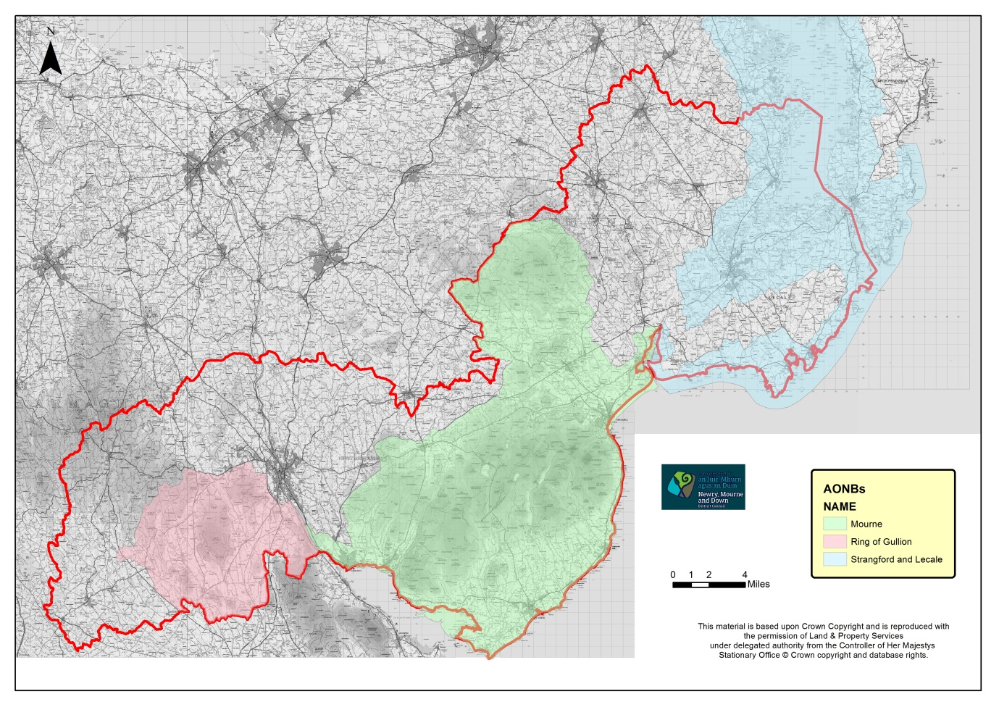
Source: DOE

Appendix 4 - Indicators Used for classifying the Highland Coast
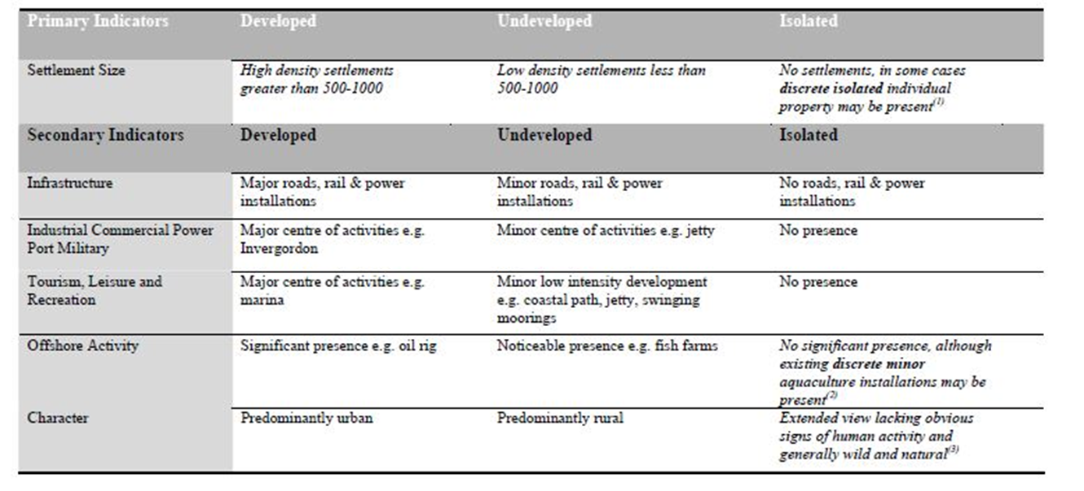
Source: Highland Council – Highland Coastal Development Strategy 2010

Newry, Mourne and Down District Council Economic Regeneration and Investment Strategy, 2015 – 2020
Towards an Integrated Coastal Zone Management Strategy for Northern Ireland 2006 – 2026.
https://www.daera-ni.gov.uk/articles/coastal-regions-northern-ireland
https://www.daera-ni.gov.uk/articles/coastal-regions-northern-ireland
Planning in the Coastal Area – A developer’s guide to planning considerations and environmental responsibilities - DOE, April 2015
Planning in the Coastal Area – A developer’s guide to planning considerations and environmental responsibilities - DOE, April 2015
Planning in the Coastal Area – A developer’s guide to planning considerations and environmental responsibilities - DOE, April 2015
DOE leaflet - Marine Conservation Zones in the Northern Ireland Inshore Region
DOE leaflet - Marine Conservation Zones in the Northern Ireland Inshore Region
https://www.daera-ni.gov.uk/articles/marine-conservation-zones
Planning in the Coastal Area – A developer’s guide to planning considerations and environmental responsibilities - DOE, April 2015
Paragraph 3.13, P13-14 Strategic Planning Policy Statement for NI (SPPS)
Legislative and policy response to the risk of coastal erosion and flooding in the UK and Ireland.
CCC) Committee on Climate Change (2016) Climate Change Risk Assessment 2017 [online] available from: http://nia1.me/39p
Towards an Integrated Coastal Zone Management Strategy for Northern Ireland 2006 – 2026
Northern Ireland Climate Change Adaptation Programme – DOE, 2014
Legislative and Policy Response to the risk of coastal erosion and flooding in the UK and Ireland. NI Assembly Research and Information Research Paper 7th September 2016.
Legislative and Policy Response to the risk of coastal erosion and flooding in the UK and Ireland. NI Assembly Research and Information Service Research Paper – 7th September 2016.
https://www.infrastructure-ni.gov.uk/articles/how-flood-maps-ni-was-produced
Legislative and Policy Response to the risk of coastal erosion and flooding in the UK and Ireland. NI Assembly Research and Information Service Research Paper – 7th September 2016.
NIEA EIA Screening Opinion on application LA07/2015/0800/F Page 13.
J.A.G. Cooper, et al., Coastal defences versus coastal ecosystems: A regional appraisal, Mar. Policy (2016), http: //dx.doi.org/10.1016/j.marpol.2016.02.021i
J.A.G. Cooper, et al., Coastal defences versus coastal ecosystems: A regional appraisal, Mar. Policy (2016), http: //dx.doi.org/10.1016/j.marpol.2016.02.021i
Argyll and Bute Council Local Development Plan Proposals for adoption Written Statement Feb 2015 Chapter 3, para 3.4.
BNMAP Technical Supplement 8 – Countryside Assessment Vol 1
Highland Council Coastal Development Strategy May 2010.
Highland Council – Highland Coastal Development Strategy May 2010.
http://www.keepnorthernirelandbeautiful.org/cgi-bin/generic?instanceID=29
EU Bathing Water Designation for Lecale Beaches A report summarising work undertaken for Strangford Lough and Lecale Partnership - September 2015
https://keepnorthernirelandbeautiful.etinu.net/keepnorthernirelandbeautiful/documents/006877.pdf
http://www.keepnorthernirelandbeautiful.org/cgi-bin/generic?instanceID=31
EU Bathing Water Designation for Lecale Beaches A report summarising work undertaken for Strangford Lough and Lecale Partnership - September 2015
Mourne and Strangford Lough Coastal Walking Path Technical and Feasibility Study – August 2015
Belfast Telegraph 6th December 2016 see http://www.belfasttelegraph.co.uk/business/news/1000-new-jobs-could-be-created-in-36m-kilkeel-harbour-expansion-plan-35269877.html
Regional Locational Guidance (RLG) for Offshore Renewable Energy Developments in NI Waters, September 2011
Regional Locational Guidance (RLG) for Offshore Renewable Energy Developments in NI Waters, September 2011
http://www.seageneration.co.uk/background.php
Regional Locational Guidance (RLG) for Offshore Renewable Energy Developments in NI Waters, September 2011
Regional Locational Guidance (RLG) for Offshore Renewable Energy Developments in NI Waters, September 2011
Nick Medic Director of offshore renewables at RenewablesUK (http://www.businessgreen.com/bg/news/2384460/northern-irelands-only-offshore-wind-project-scrapped)
Marine Policy and Legislative Framework in Northern Ireland taken from Planning in the Coastal Area – A developer’s guide to planning considerations and environmental responsibilities - DOE, April 2015

