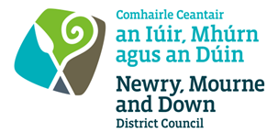

GUIDE TO REGISTERING ON NM&DDCs e-HUB

HOW TO BECOME A POTENTIAL SUPPLIER TO NM&DDC

- Registering as a new supplier enables you to receive potential Purchase Orders.
- It also enables you to register your interest and/or apply for any Tenders/Requests for Quotations (RFQs) and to download any associated documents.

NEW SUPPLIERS:

- Please visit our e-Procurement site:
http://www.newrymournedown.org/Procurement

- Click on New Users:

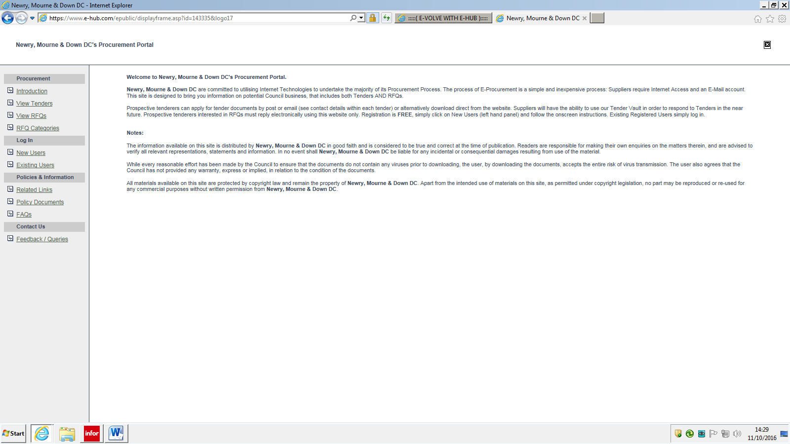

- Follow the instructions to get a verification code – i.e. phone 02830254872 or 00442830254872 (R.O.I) and request one.
- Due to the on-going Covid-19 situation e-Hub’s telephone support is at reduced capacity – if you receive no response by telephone, make your verification code request by sending an email to info@e-hub.com

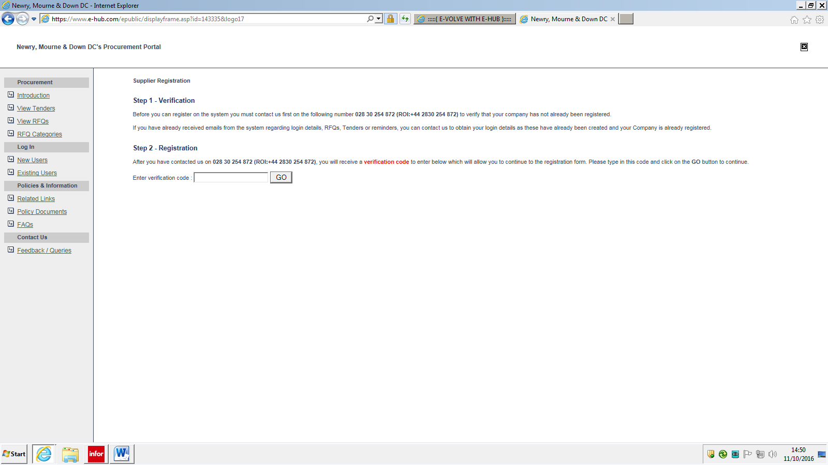

- Enter the verification code in the box and click ‘GO’ to proceed to the registration form:

- Fill in details on the registration form (all fields marked * need completed).
- The email address you use ideally should be generic or checked regularly so you do not miss orders or opportunities:

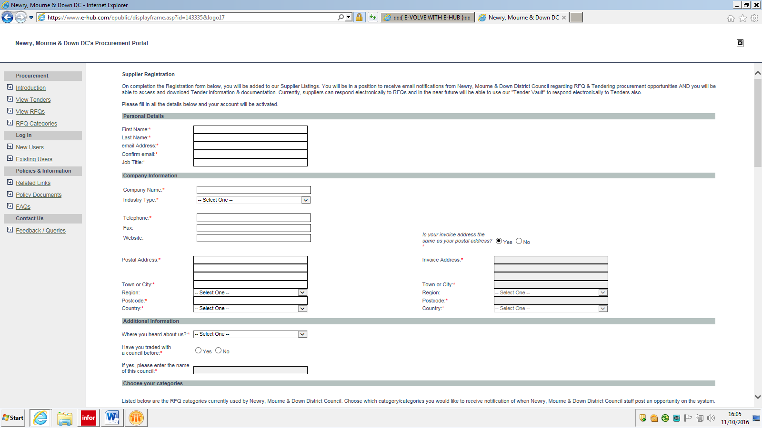

- Fill in your Personal Details:

- Company Name – Enter the name you trade under. Important - you must have a bank account in this name i.e. you need to be able to cash a cheque under this name as initially this is how you will be paid:

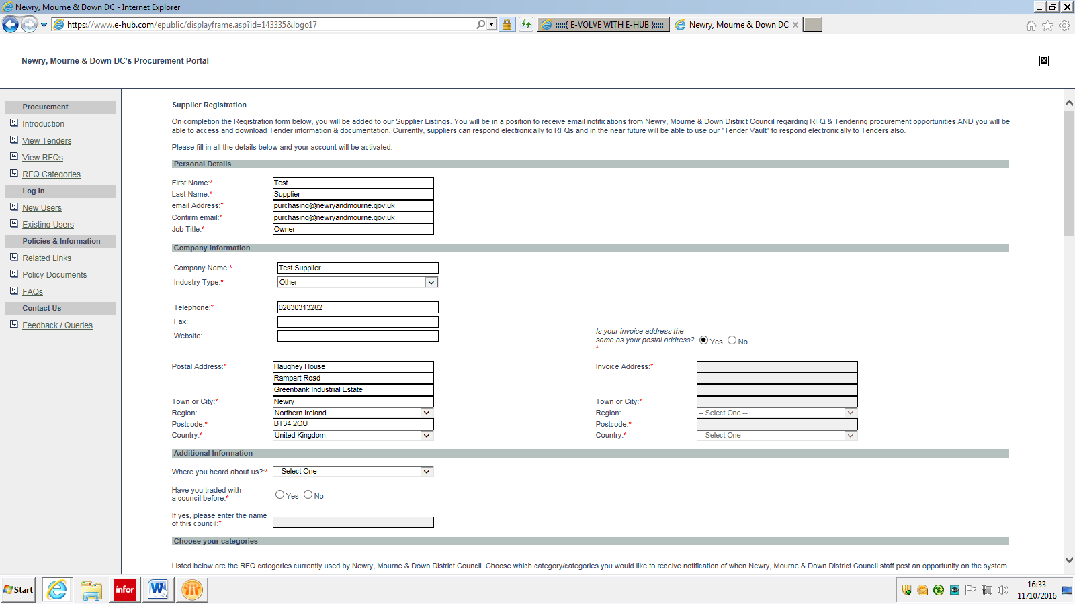

- Industry Type – Enter the type of business you operate. If none of the categories match select ‘other’. Important – do not leave this field blank otherwise your registration will not complete:

- Invoice Address – Regardless if this is the same as your postal address you still need to select the ‘No’ option and complete the details:

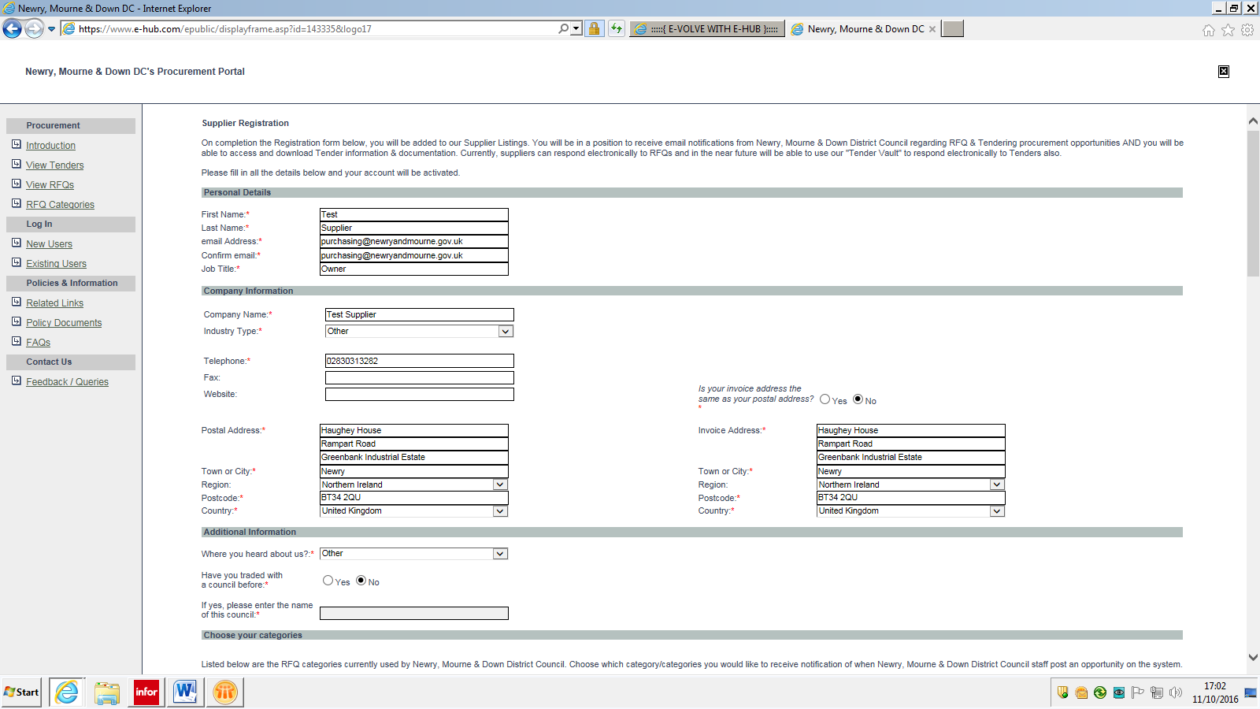

- Fill in the additional information:

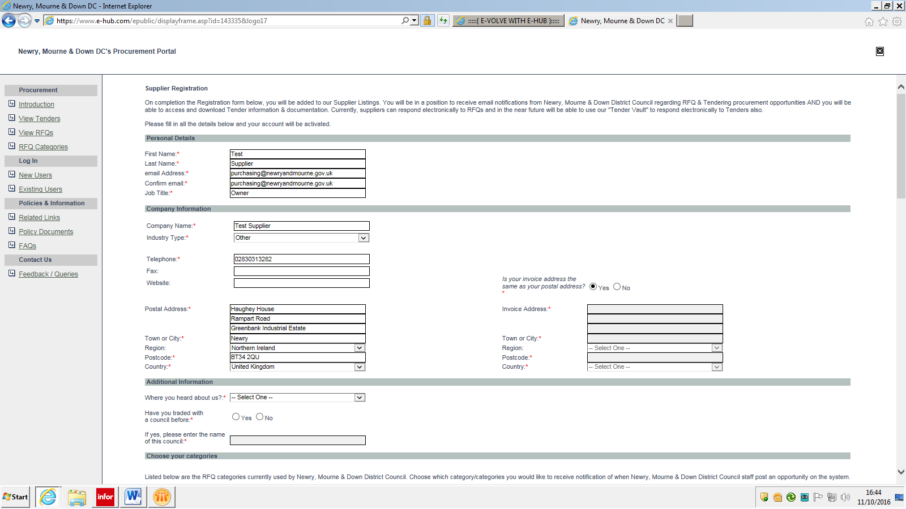

- Choose your categories – select the categories your business operates in and/or you have an interest/capability of operating in. Important - at least one category has to be selected or your registration will not complete. If unsure select other, you can always update this.
- These categories determine what competitions you will potentially be invited to take part in. An email notification will be sent from ‘administrator@e-hub.com’ when a competition is published on e-Hub which is assigned to one of your registered categories.
- These categories are subject to change, so please keep up to date and check them regularly:

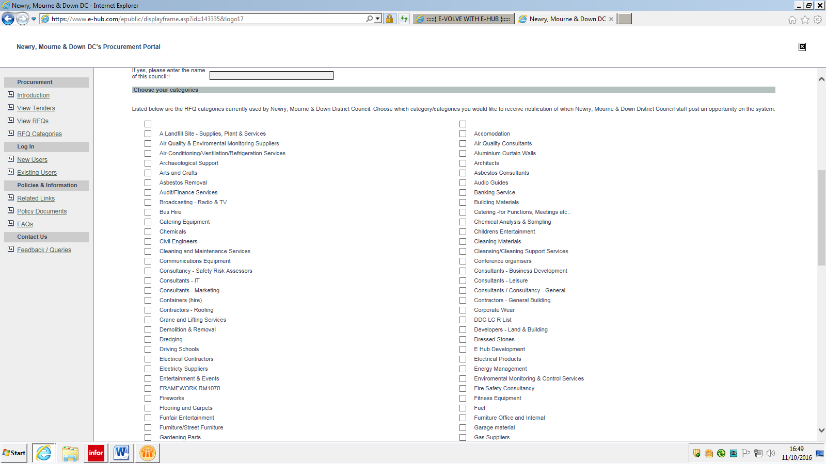

- Once you have your category(s) selected create a username and password which you will require each time you wish to log on to the e-portal:

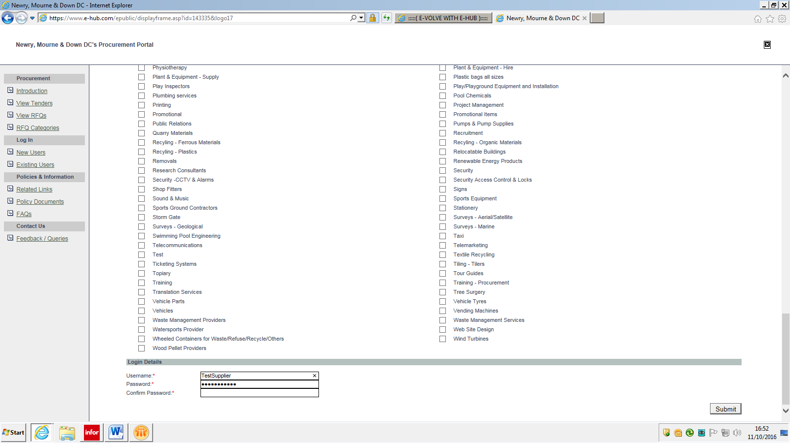

- Once your registration has completed you will see this page:

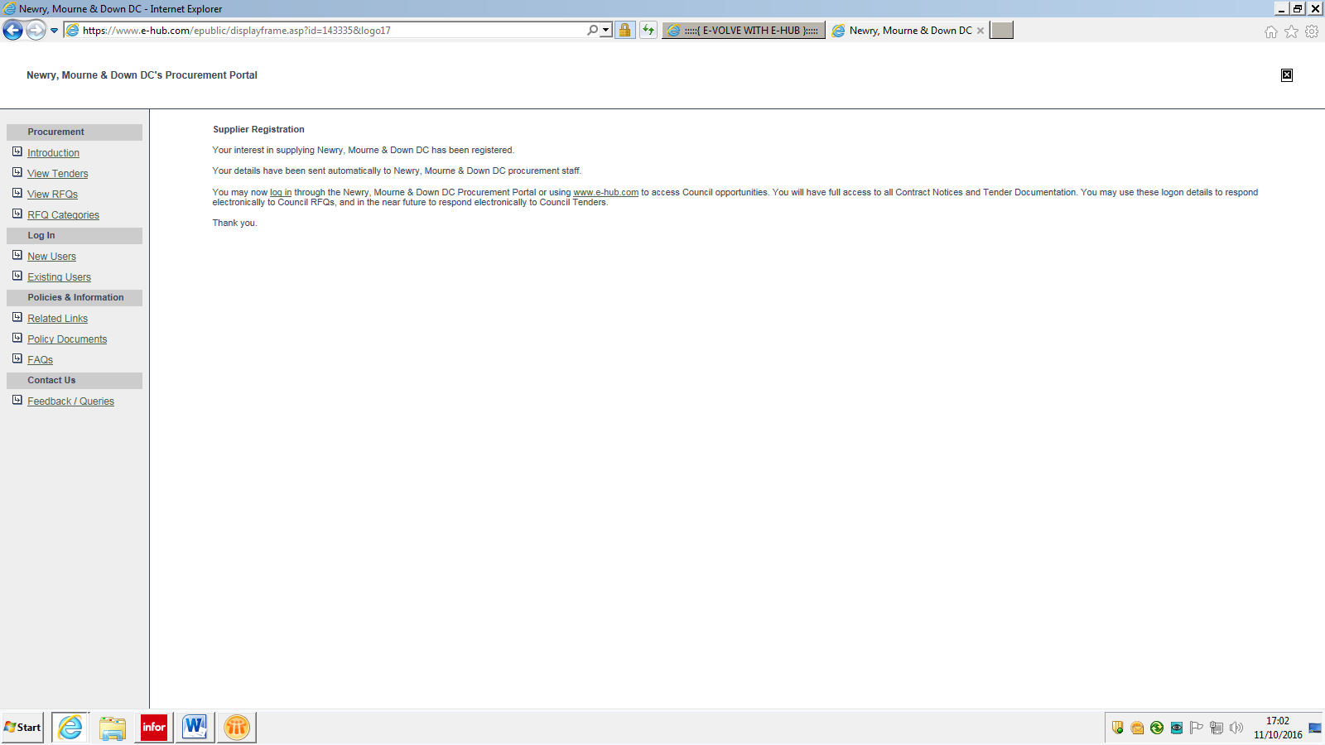

- You will also receive an email to the address you registered which confirms all your details including username and password.

Any problems with registering or using the portal please email info@e-hub.com for assistance.

