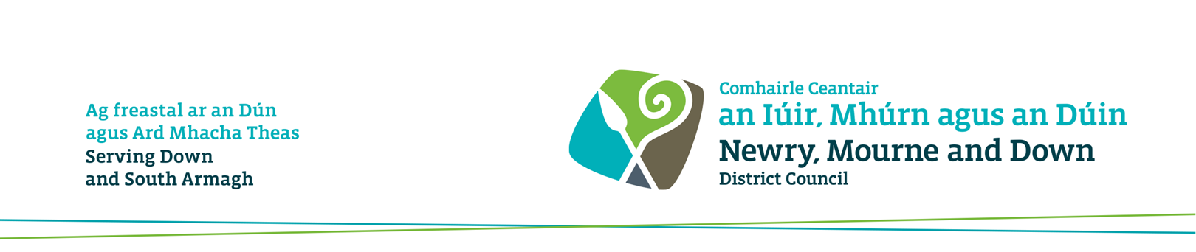

HOW SUPPLIERS CAN ACCESS REQUESTS FOR QUOTATIONS (RFQS) ON E-HUB

Visit - www.newrymournedown.org/procurement

New Users:

If you have not already registered, please register as a supplier – click on ‘New User’ on the left-hand side of the screen and follow the instructions

This will allow you to register an interest in a RFQ, download any documents, return your RFQs online and receive potential Purchase Orders.

Keep your registration details safe, as only you can easily change your company details, addresses, users, categories, as we don't have direct access to this side of the portal.

Once Registered or Existing Users:

- Click on ‘Existing User’ on left-hand side of the screen and enter your User Name and Password (any problems please email: info@e-hub.com).
- Then under ‘My Work Area’ (towards top right of screen) select RFQ-Selling from the drop-down menu.

- Click on 'Public RFQs' to left of screen.
- Then click on the box to ‘Add to Manager’ (to the far right of the relevant RFQ) and click 'Add' (scroll to bottom of screen 'add' is on the right).
- Note: The closing date and time will always be as listed on this page.

- Click on 'Sell Manager' to left of Screen.

- Click on 'Actions' box to right of the relevant.
- Review the RFQ options in the Actions column and download the documents stored under ‘Buyer Attachments’.

- If during the RFQ process you have a query, please address it using the 'Request Additional Details' facility - your query will be addressed and posted to the site for all other parties as well, ensuring openness and equality. (Unless you wish it disclosed, please don't enter your personal or company details in the body of the question).

- To upload your completed document(s) use the 'Respond to RFQ' facility which is also in the actions column. Please ensure each file uploaded is less than 4mb, multiple file uploads are allowed, as are compressed files using an industry standard method e.g. ZIP, RAR etc.

- Please ensure you allow adequate time for this process. You can check or edit your returns once uploaded although this must not be done after the deadline as your return will be marked late.

- Finally, if you have received an invitation to a RFQ and you do not wish to take part simply select the 'Reject RFQ' option and you will receive no further notifications in relation to that RFQ.

Any problems with registering or using the portal please email: info@e-hub.com.

