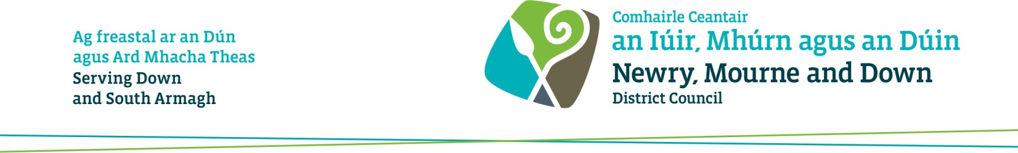

Guidance notes for Temporary Street Trading application for Newry Christmas Switch-on Event, Thursday 19th November 2026

Applicants must read the following information before completing the Application Form.

How to apply for a Temporary Street Trading Licence

- Application packs are available to download from our website: www.newrymournedown.org/street-trading
- Scan the QR Code to apply on-line
- If you need an application emailed or posted out, please contact us
on licensing@nmandd.org

Documentations required to be submitted with the application for a Temporary Street Trading Licence

Please note failure to provide any of the information listed below prior to the closing date will result in your application being deemed as incomplete and your application will not be considered for allocation of a street trading site.

- Completed application form in full along with the form of consent for criminal convictions.
- A copy of your current valid Public Liability Insurance cover. To include name, address and expiry date.
- One form of identification of the person proposing to trade e.g. copy of driver’s licence/passport
- One passport type photograph of the person proposing to trade
- Photograph of generator being used for trading
- Photograph of the trading stall or when fully set-up
- All traders must provide exact dimensions of trading stall, including any trailer and towbar when erected. All dimensions must be accurate.
- Food traders must provide a copy certificate of registration with Environmental Health Department under Food Safety Order Northern Ireland 1991 and a copy of Level 2 Food Hygiene Certificate.

Application Fees and Payment options

- The fee for a single pitch, i.e. 5 m x 2m, is £88.00
- The fee for the double pitch (Site No. 3 & 4) i.e. 10 m x 2 m is £142
Please note the application fee is non-refundable

Cheques/Postal Order Payment
Cheques to be made payable to: Newry, Mourne and Down District Council’ and posted to Newry, Mourne and Down District Council, Licensing Section, Newry Office, Haughey House, Rampart Road, Greenbank Industrial Estate, Newry, BT34 2QU

Card Payment
If you wish to make a card payment, please ensure you provide your contact details on the application form, and we will contact you to make card payment.

Cash Payment
For cash payments you will be required to arrange an appointment with staff at the Newry Office to take payment.

Gazebos
If you are intending to use a gazebo, you must ensure the following:
- Gazebos must be in good condition, fit for purpose, and suitable for outdoor use.
- Traders are responsible for ensuring their gazebo is safely erected and secured at all times.
- All structures must be used in accordance with the manufacturer’s instructions, particularly regarding anchoring and maximum wind speeds.
- All legs of the Gazebo must be weighted at all times.
- Gazebos must be made safe or dismantled if weather conditions become unsafe.

Generators

If you are intending to use a generator, you must ensure the following:

- The Council encourages the use of silent diesel generators.
- Correct guard around generator (traders that do not have correct protective guard around generator will be refused permission to trade on the day of trading)
- Noise limiter
- Generator must not emit fumes
- Fuel must be kept in a proper container in a safe place and safe re-fueling procedures should be in place.
- Co² fire extinguisher to be provided
- Generators must be kept within the confines of the allocated street trading pitch and must not obstruct footways
There will be no Electrical Power supply provided for traders.

Banned Goods

The following items are not permitted for sale/display: -

- Any type of pellet guns
- Any type of knives
- Laser lights
- Spray string and paint and similar items
- Stink bombs, snap bangers and similar items
- Offensive articles e.g. t-shirts etc.
- Vapers

Selection Process – Criteria

Persons fitting into the first criteria (1) will be awarded a Street Trading Licence subject to the number of pitches being available. If no applicants meet the first criteria, then the District Council shall continue down the following list (in order) until an applicant meets one of the criteria: -

(1) Applicant who currently holds a Street Trading Licence for the Council area and has no relevant convictions in relation to that trading or breaches under the 2001 Street Trading Act.

(2) Applicant who has previously traded within the Council area and has no relevant convictions in relation to that trading or breaches under the 2001 Street Trading Act.

(3) A new Applicant with or without trading history either inside or outside of the District and has no history of relevant trading convictions or breaches under S the 2001 Street Trading Act.
In the situation of two or more Applicants meeting any of the above criteria then the following scores will be awarded to their application, and the highest score will be awarded the Licence.

- 2 or more verbal or written warnings | - minus | 5 Points
- Fixed Penalty in previous 12 months (each) | - minus | 5 Points
- Breaches under Section 9 of the Street Trading Act 2001 (b-g inclusive) (each) | - minus | 5 Points
- Appearance and Appropriateness of stall/vehicle by assessment of the following subject matters: Consumer Protection, Food Hygiene, Health & Safety, Odour, Compatibility of Commodity, Litter control and/or Noise | + plus | 0-8 Points

Schedule for assessment of applications and notification of outcome

Closing date and time: 4pm on Tuesday 20 October 2026

Application Assessment date: Friday 23 October 2026

We aim to advise applicants via email of the outcome of their application by Thursday 29 October 2026. This schedule may change for operational reasons.

