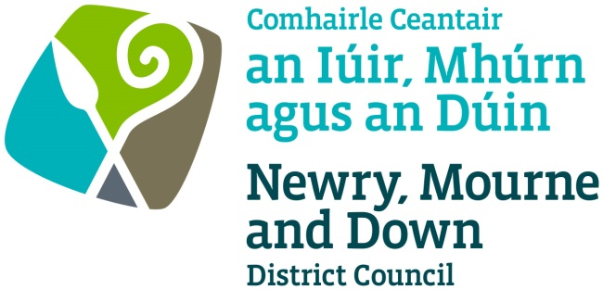

STREET TRADING ACT (NORTHERN IRELAND) 2001

APPLICATION FOR GRANT/RENEWAL/VARIATION OF A STREET TRADING LICENCE

Completed Application to be sent to one of the offices below:

Oifig Dhún Padraig  Downpatrick Office  Licensing Section  Enterprise, Regeneration and Tourism Department  Downshire Civic Centre  Downshire Estate  Ardglass Road  Downpatrick  BT30 6GQ | Oifig an Iúir  Newry Office  Licensing Section  Enterprise, Regeneration and Tourism Department  O’Hagan House  Monaghan Row  Newry  BT35 8DJ
For further details contact: -
Telephone: 033 0137 4030
Email: licensing@nmandd.org
Website: www.newrymournedown.org

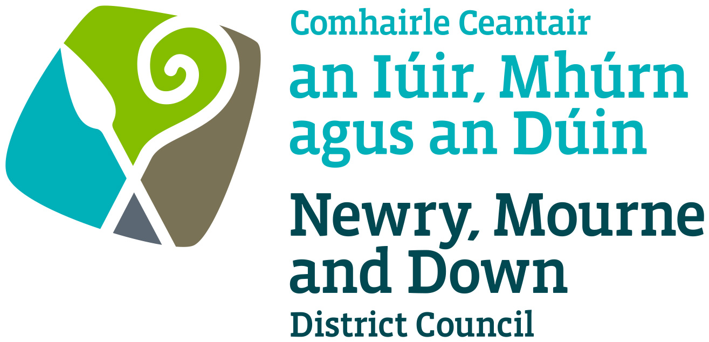
NMD Ref: M / 60 /

APPLICATION FOR A STREET TRADING LICENCE

Please ✓tick appropriate box

Application for Grant of a Stationary Street Trading Licence
Application for Grant of a Mobile Street Trading Licence
Application for Renewal/Variation of a Stationary Street Trading Licence
Application for Renewal/Variation of a Mobile Street Trading Licence
Application for a Temporary Street (first/subsequent) Trading Licence

See Fees Sheet - Please note the application processing fee is non-refundable.

The application form must be completed in BLOCK LETTERS using BLACK INK.

Title: MR/MRS/MISS… |  |  |  |  |  |  |  |  |  |  |  | Date of Birth:
Full Name:
Home Address:
Postcode: |  |  |  |  |  |  |  |  |  | Telephone Number:
Email:
Business Name and Address (if different from above):
Description of articles to be sold:
Description of vehicle or stall:
Dimension of vehicle or stall: |  |  |  |  |  |  |  |  |  |  |  |  | (to include tow bar, projections e.g. canopy etc.)
- Maximum dimension of stall/vehicle allowed is 5m x 2m |  |  |  |  |  |  |  |  |  |  |  | Photographs of stall/vehicle to be included with application.
Registration number of vehicle:
Do you own the vehicle or stall? |  |  |  |  |  |  |  | YES / NO
If not, give the name and address of the owner:
Address at which the vehicle or stall is to be kept when not in use:
Address at which articles for sale will be stored:

Stationary or Temporary Street Trading Licence

Detail exact location of pitch: Hill Street, Newry

Please provide details of the times of trading for each day: -

DAY | TIME FROM | TIME TO
Monday
Tuesday | 17th March 2019 - 11:00am to 4:00pm
Wednesday
Thursday
Friday
Saturday
Sunday

Mobile Street Trading Licence

Please provide details of times and areas of trading for each day. This is to include details of streets or housing estates where you will be trading that day.

DAY | TIME FROM | TIME TO | NAMES OF STREET OR AREAS WHERE TRADING IS TAKING PLACE

Monday
Tuesday
Wednesday
Thursday
Friday
Saturday
Sunday

Traders Selling Food

- Are you registered with your local Environmental Health Department under the Food Safety Order Northern Ireland 1991: YES / NO

- Please provide name of Local Authority where registered and date of last inspection: -

- Please provide the date of your Level 2 Food Hygiene Certificate (valid for three years):
___________________
It is a legal requirement that businesses display their Food Hygiene Rating in a prominent place e.g. a window/front door (otherwise may be fined £200.00).
Please ensure your Food Hygiene Rating is clearly displayed.

- Will bottled gas be used: YES / NO

- Will a generator be used for power: YES / NO

Declaration and Signature

- Regarding this application for the grant, renewal or variation of a Stationary/Temporary/Mobile Trading Licence, if you provide information which you know to be false, you will be prosecuted for that offence. On conviction you are liable to a maximum fine of £1,000.
- Information provided as part of this application may be disclosed in response to a request under the Freedom of Information Act 2000 or the Environmental Information Regulations 2004.
- The Council to which you are submitting this application form, collects data for the purposes of the management and application of the Street Trading Act. The data may also be passed onto other related Government Agencies and to other Council Departments, to facilitate Statutory Requirements, Service Level Agreement of or similar purposes.
- Newry, Mourne and Down District Council collects the Data on this Form for the purpose of administering Street Trading under the Street Trading NI Act 2001. The Data Collected on this Form will be shared with the relevant Council Departments, the Police Service under the Data Protection Act 1998.

The Council’s Privacy Notice can be accessed via our website www.newrymournedown.org/privacy-policy.

Ticking this box indicates that you have read and understood the above declaration.

I enclose herewith fee in amount of: £ | Official Use Only
Print Full Name: | Date Received
Signature: | Receipt Number
Date: | £

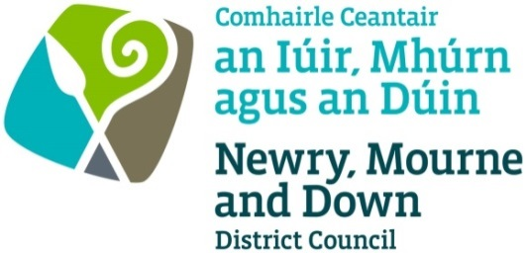

FORM OF CONSENT FOR CRIMINAL CONVICTIONS

Dear Applicant

Regarding your application/renewal/variation for a Street Trading Licence it is necessary for me to inquire if the Police have any record of convictions of a trading nature against you.
As such information can only be made available to me with the written consent of the person concerned, I would ask you to please complete and sign the form of consent below and return it to me with your application.

This office is covered under the Data Protection Act 1984 to hold and request this information.

Registration Number: ZA057622

FORM OF CONSENT

I, |  |  |  | of
Date of Birth:
Hereby authorise the Chief Constable of the Police Service for Northern Ireland to make available to the Licensing Section, Newry, Mourne and Down District Council, O’Hagan House, Monaghan Row, Newry, BT35 8DJ, or, Downshire Civic Centre, Downshire Estate, Ardglass Road, Downpatrick, BT30 6GQ details of any convictions of a trading nature against me during the last TEN YEARS.

Signed:
Date:

Checklist for Applicants

STREET TRADING LICENCE - I confirm I have enclosed the following:

- Completed Application Form and Form of Consent for Criminal Convictions.
- Current valid Public Liability insurance cover.
- Identification of person proposing to trade (e.g. copy of driver’s licence/passport).
- One passport type photograph of person proposing to trade.
- Photograph of generator.
- Photograph of the trading stall or unit when fully set-up.
- All traders must provide the exact dimensions of receptacle, including any trailer and tow-bar, when erected. All dimensions must be accurate.
- Fee for application of licence.
Please make cheque payable to: ‘Newry, Mourne and Down District Council’. Payment to be made in full or by Direct Debit. Failure to pay Direct Debit will
result in your licence being revoked.
- FOOD TRADERS: Copy certificate of registration with Environmental Health Department under Food Safety Order Northern Ireland 1991.
All documentation may be emailed to: licensing@nmandd.org.
We may ask for the original of any scanned or emailed document.
- Use of generators is restricted. Please note a Council Officer may refuse the use of any generator if deemed unsatisfactory.

Generator –
  - Must have correct guard around generator (traders that do not have correct protective guard around generator will be refused permission to trade on the day of trading)
  - Must have noise limiter
  - Must not emit fumes
  - Fuel must be kept in proper container in safe place
  - Co² fire extinguisher to be provided
  - Must be kept within the confines of the allocated street trading pitch

- Banned goods - the following are not permitted: -
✗ - Any type of pellet guns
✗ - Any type of knives
✗ - Laser lights
✗ - Spray string and similar items
✗ - Spray paint and similar items
✗ - Stink bombs and similar items
✗ - Offensive articles e.g. t-shirts etc.
✗ - Vapers

NEWRY, MOURNE AND DOWN DISTRICT COUNCIL

FEES - STREET TRADING

EFFECTIVE FROM 1ST AUGUST 2019

TYPE OF LICENCE | APPLICATION FEE  (Non-refundable)  £ | LICENCE FEE  (Including Application Fee)  £
Stationary Licence | £80.00 | £930 (April to March)
Mobile Licence | £80.00 | £320 (April to March)
Temporary Licence | £80.00 | £80 for first application  £50 for each subsequent application per calendar year (maximum of four).  £130 for Double pitch (maximum allocation)  Standard pitch size is 5m x 2m
Variation | £55.00 | n/a

