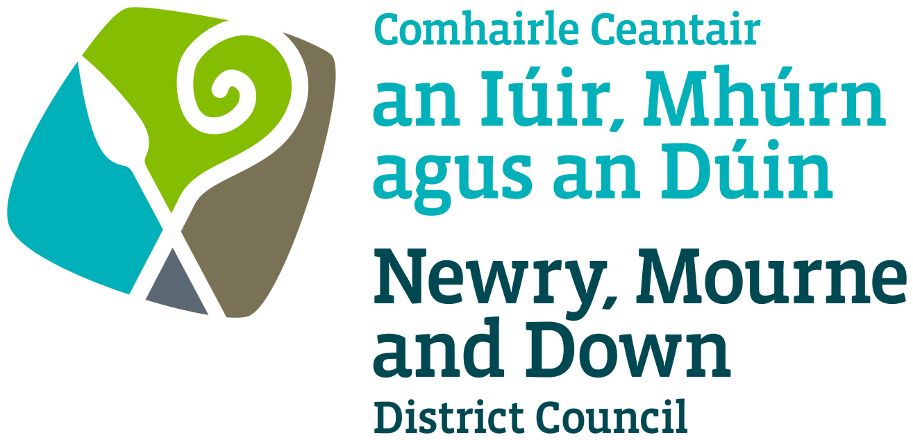

Pavement Cafés

Designation Policy

NEWRY, MOURNE & DOWN DISTRICT COUNCIL

ENTERPRISE REGENERATION AND TOURISM DEPARTMENT

Dated: 14 February 2022

Contents

 | Page | Paragraph
Purpose | 1 | 1
Scope | 1 | 2
References | 1 | 3
Background | 1-2 | 4
General Principles | 2-3 | 5
General | 3-5 | 6
Criteria | 5-6 | 7
Fees | 6 | 8
Powers of Enforcement | 7 | 9
Appeals | 7 | 10
Policy Owner | 7 | 11
Contact details in regard of this policy | 7-8 | 12
Policy Authorisation | 8 | 13
Policy Effective Date | 8 | 14
Policy Review Date | 8 | 15
Procedures | 8 | 16
Equality Impact Assessment | 8 | 17

1. Purpose

By virtue of the Licensing of Pavement Cafés Act (Northern Ireland) 2014 the District Council may regulate the placing on public areas of furniture for use for the consumption of food and drink.

Pavement cafés are becoming a familiar sight across the UK and Ireland. They can help develop a local café culture, which in turn can have a positive effect on urban environments, promote town and city centres, contribute to the general well-being of communities and appeal to tourists.

The purpose of this Policy is to provide guidance on matters, which should be considered when deciding whether to designate a street or part thereof as a pavement café and whether to grant or refuse an application for a pavement café.
Its aim is to provide, insofar as is possible, consistent decision making so as to develop and thereafter maintain public confidence in Newry, Mourne and Down District Council’s (here after called ‘the District Council’) performance of its duties.

2. Scope

This Policy is intended to ensure that the District Council’s Members and Officers are aware of those matters to be taken into consideration when determining if a street or part thereof should be designated for the purpose of the pavement café licence and whether to grant a pavement café licence.
Initially the District Council will consider those areas in respect of which applications have been received for, or already licensed for a pavement café (including those areas where applications have previously been refused).

3. References

3.1 Licensing of Pavement Cafés Act (Northern Ireland) 2014
3.2 Pavement Café Designation Procedure
3.3 Guidance for Applicants

4. Background
The Licensing of Pavement Cafés Act (Northern Ireland) 2014 (here after called ‘the Act’) enables District Councils to regulate public areas by preventing undue nuisance, interference or inconvenience to people and traffic. The Act shall come into force on the 1st October 2016.

The Act requires the District Council to designate specific areas, streets or part thereof in the District Council as being suitable for a pavement café licence. This is designed to be an open system, which allows everyone an opportunity to comment on the proposal to permit a pavement café licence in a particular area.

5. General Principles

  - Each case must be considered on its own merits, but there are general principles that apply in all cases. The duty of the District Council is to make sure that each pavement café licence application is fairly and objectively assessed and that all relevant factors are considered.

  - The District Council will consider applications, in writing on the prescribed form, to a pavement café licence at a designated site within the boundaries of the District Council.

Consultees

The District Council will consult with –
- The Department of Infrastructure as regards that Department’s functions with respect to roads and regulation of road traffic.

- The District Commander of the Police Service of Northern Ireland (PSNI) in which the premises are situated; where such premises are issued under the Licensing Order

The District Council may also consult other persons, as it considers appropriate e.g.

- The District Council’s Planning Department
- Relevant Chamber of Commerce/Trade
- Town Centre Management Bodies
- Community Groups/Local residents
- Business and Commercial premises in the vicinity of the site in respect of which the application has been received
- The District Council may consult other persons, as it deems appropriate

5.4 Additional Factors

Without prejudice to the District Council’s rights, the District Council shall take account of the following in determining the suitability of each proposed area covered by the licence:

- The safety of the public and any risks which may arise; including the size, type and layout of furniture.
- The future development plans for the location;

- The appropriateness and suitability of the site and furniture in relation to the location and to the potential adverse impact that it would have upon the character and appearance of the area in question.

- The amount of interference or inconvenience to persons or vehicles using the street.

- The potential environmental effects arising from the location of the proposed designated site, such as additional litter, cleansing requirements, noise, odour and the possibility of increasing anti-social activities;

- Any statutory grounds which would be appropriate to consider;

- Complaints arising from or about the current pavement café’s licence location;
- Any other relevant facts

- Hours of licence

- Period of licence for review

  - These issues may also be taken into account should the District Council decide to rescind or vary any Designation Resolution

General

6.1 The District Council retains its right to amend or replace this Policy at any given time.

6.2 All licence ‘application fees’ are non-refundable

6.3 An application for a pavement café licence will be deemed valid only if it is in the approved application form, fully completed and accompanied by all requested documentation and payment of fees.

6.4 Licences will only permit trading on the stated days and times on the licence. The time during which the licence holder may operate as a pavement café must be agreed with the District Council prior to the issuing of the licence.

6.5 It shall be the policy of the District Council that a trader must obtain a separate licence for each pavement café.
6.6 Pavement café licences cannot be sub-let, sold on or transferred. Where a licence refers to a business partnership and a partner dies or withdraws from the business, the licence may remain in force, with a remaining person(s) named in the licence treated as a licence holder.

6.7 Refunds of ‘pavement café fees’ will only be considered when the licence holder has not been able to trade due to circumstances beyond their control, for example when a road is closed or a site is inaccessible for any purpose such as road works etc. In the event of this occurring, the District Council must be informed no later than the day of trading.

6.8 Pavement café licences can be issued for a maximum period of 3 years or for such term as the District Council will determine.

6.9 Safety of Pedestrians

- In order to safeguard the interests of pedestrians, a minimum width of 2 metres clearance must be maintained on the pavement including the kerbside beyond the perimeter of the licensed area. Where conditions permit, a reduction to 1.5m will be considered. This reduction shall be regarded as the absolute minimum and shall be restricted in length to a maximum of 6.0 m.

- Where the seating area is adjacent to a road junction or vehicular access, 10 metres clearance should be left to allow for junction visibility.

- All furniture, including menu boards associated with the Pavement Café is to be placed within the licensed area. The licensed area must be screened with appropriate screening to the satisfaction of the Council unless the Licensee can justify a reason not to do so.

6.10 The District Council must grant an application for a pavement café licence which is made to it in accordance with the Act unless it considers that it ought to refuse in accordance with section 4, paragraph (2) of the Act.

6.11 If it refuses an application, the District Council will notify the applicant in writing of its decision.

6.12 The District Council may vary the condition or area covered by licence:
(a) on receipt of an application from the holder of the licence
(b) on receipt of an application for a renewal of the licence by the holder of the licence.
(c) on receipt of an application from the holder of the pavement café licence to remove an alcohol condition.

6.13 The District Council may at any time revoke a pavement café licence where:
(a) all or any part of the public area becomes unsuitable.
(b) continuing to place such furniture in that area that would be likely to result in undue interference or inconvenience to persons or vehicles in the vicinity.
(c) that the licence holder made a statement which the applicant knows to be false or failed to display a notice in compliance with Section 11 of the Act.
(d) that any condition of the licence has not been complied with.
(e) that the licence holder has failed to pay any fee due to the District Council under Section 12 of the Act.

6.14 The District Council may at any time suspend a pavement café licence where the licence holder has failed to pay any fee due to the District Council under Section 12 of the Act.

6.15 The District Council may at any time suspend a pavement café licence where a notice of any revocation.

6.16 The District Council may at any time suspend a pavement café licence where the licence holder has failed to pay any fee due to the District Council under Section 12 of the Act.

6.17 The District Council may at any time suspend a pavement café licence where a notice of any revocation.

6.18 The pavement café licence shall be displayed at, or close to the licensed area.

7. Criteria

7.1 The criteria is laid out in the applicant criteria. The District Council retains its right to amend or replace these criteria at any given time.

7.2 Application criteria:

- All applicants must submit a completed application form with the correct fee.

- All applicants must provide a location plan to scale of 1:1250 showing sufficient area around the proposed pavement café to enable consideration of all related issues.

- All applicants must provide a site plan to a scale of not less than 1:100 showing access points, building lines, boundaries, kerbs, table and chair arrangement, bins, lighting, trees, other items.

- All applicants must provide details of the furniture including photographs/manufacturers details.

- All applicants must provide risk assessments

- All applicants must provide proof of planning permission, where appropriate

- All applicants must provide confirmation of public liability insurance with a minimum indemnity of £10m.

- All applicants are required to fix a public notice to the premises on the day the application is made to the District Council.

8. Fees

8.1 Section 12 of the Pavement Cafés Act (Northern Ireland) 2014
enables a District Council to charge:-

- for the grant or renewal of a pavement café licence;
- for a variation of a pavement café licence

Such fees as the District Council may determine and as may be sufficient in the aggregate, taking one year with another to cover any reasonable administrative or other costs in connection with its functions under this Act, not otherwise recoverable. The District Council may determine the time and manner in which fees or charges are to be paid.

8.2 The pavement café fees are:

 | Administration costs  (Non-refundable) | Compliance monitoring  (2 visits) | Actual cost  for 3 year licence
Grant of pavement café licence | £280.00 | £95.00 | £375.00 total
Renewal or Variation of pavement café licence | £185.00 | £95.00 | £280.00 total
(Table 1)

9. Powers of Enforcement

Failure to obtain an appropriate licence or failure to comply with the conditions attached to a licence may result in enforcement action being instigated.

  - Unlicensed pavement cafés
- It is an offence to place furniture (for the use of consumption of food and drink) on a public area without a pavement café licence. The offence is liable to a fine of up to £1,000 on summary conviction.

- Council Enforcement Officers shall gather evidence that an offence has been committed prior to initiating legal proceedings.

  - Power to remove unlicensed furniture

- The District Council has the power to remove furniture from unlicensed pavement cafés.

- The District Council has a duty to notify the person responsible (if known) as to how the furniture may be recovered and allows the Council to recover the costs of removing and storing the furniture.

- The District Council has the authority to dispose of the furniture if it remains unclaimed after three months.

10. Appeals

Any appeal must be made to the court of summary jurisdiction by notice under the relevant order. Any appeal must be brought within 21 days beginning with the day after the date on which notice is given of refusal, grant, renewal, variation, revocation, suspension or extension (as the case may be), in accordance with Section 21 of the Act.

11. Policy Owner

Mr Conor Mallon, Director of Enterprise Regeneration and Tourism

12. Contact details in regard of this policy are:

Mr Colum Jackson,
Assistant Director of Enterprise Regeneration and Tourism
(Building Control and Regulation)
Newry, Mourne and Down District Council
O’Hagan House
Monaghan Row
Newry
BT35 8DJ
Tel 028 3031 3000

13. Policy Authorisation

Enterprise Regeneration & Tourism
Committee Meeting Authorised on 14 February 2022

Council Authorised on February 2022

14. Policy Effective Date – 1st March 2022

15. Policy Review Date – 1st April 2026 (or sooner as required)

The policy will be reviewed in line with the Council’s agreed policy review cycle i.e. every 4 years (as per Council’s Equality Scheme commitment 4.31).

16. Procedures

Refer to the Pavement Café Designation Procedure

17. Equality Screening

The policy has been equality screened and it is recommended it not be subject to an equality impact assessment (with no mitigating measures required).

This policy has been screened in accordance with the provision of Section 75 of the Northern Ireland Act 1998.

Version 1.0

