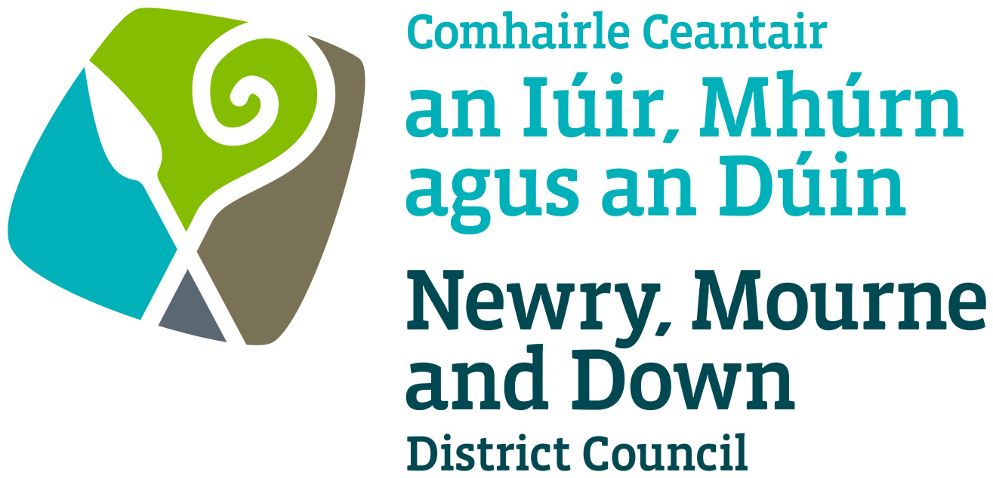

Pavement Cafés

Enforcement Policy

NEWRY, MOURNE & DOWN DISTRICT COUNCIL

ENTERPRISE REGENERATION and TOURISM DEPARTMENT

Dated: 14 February 2022

Contents

 | Page | Paragraph
Purpose | 1 | 1
Scope | 1 | 2
References | 1 | 3
Background | 1 | 4
General Principles | 1-2 | 5
Unlicensed Pavement Cafés | 2 | 6
Contravention of Licensing Conditions | 3-4 | 7
Revocation of a Pavement Café Licence | 4-5 | 8
Powers of Seizure | 5-6 | 9
Policy Owner | 6 | 10
Contact details in regard of this policy | 6 | 11
Policy Authorisation | 6 | 12
Policy Effective Date | 6 | 13
Policy Review Date | 6 | 14
Procedures | 6 | 15
Equality Screening | 6-7 | 16

1. Purpose

By virtue of the Licensing of Pavement Cafés Act (Northern Ireland) 2014 the District Council may regulate street trading through enforcement powers in a street or part thereof in its District.
The purpose of this Policy is to provide guidance on matters, which should be considered when deciding whether to take enforcement action against a person of whom there is reasonable grounds to suspect commission of an offence under this Act while involved in Pavement Cafés. Its aim is to provide, in so far as is possible, consistent decision making so as to develop and thereafter maintain public confidence in Newry, Mourne and Down District Council’s (here after called ‘the District Council’) performance of its duties.

2. Scope

This Policy is intended to ensure that the District Council Members and Officers and all other interested parties are aware of those matters to be taken into consideration when determining, what if any, enforcement action is to be taken.

3. References

3.1 Licensing of Pavement Cafés Act (Northern Ireland) 2014
3.2 Pavement Café Designation Procedure
3.3 Guidance for Applicants

4. Background
The Licensing of Pavement Cafés Act (Northern Ireland) 2014 (here after called ‘the Act’) enables District Councils to regulate public areas through designating, licensing and enforcement procedures. The Act received Royal Assent in May 2014 and became operative on 1st October 2016.

Sections 22 to 24 of the Act details those activities which would be in contravention of the Licensing of Pavement Cafés Act (Northern Ireland) 2014 and which would be enforced by means of a prosecution or seizure by authorised officers of the District Council.

5. General Principles

  - Each case must be considered on its own merits, but there are general principles that apply in all cases. The duty of the District Council is to make sure that each pavement café licence application is fairly and objectively assessed and that all relevant factors are considered.

  - Officers upon becoming aware of a contravention of a pavement café licence may use their discretion and implement such steps as the Officer thinks fit to:-

- Issue a verbal warning
- Issue a formal caution with a recommendation to prosecute or
- Invoke the powers of seizure

6. Unlicensed Pavement Cafés

6.1 Subject to subsection (2), if at any time while a business involving the supply of food or drink in or from any premises to members of the public, or of a section of the public, is being carried out (“the time in question” ) -

- furniture for use for the consumption of food or drink supplied in or from the premises is placed on a public area in the course of the business, or
- furniture for such use which has been placed on a public area in the course of the business remains on that public area.

each responsible person commits an offence.

  - Section 1 and 2 of the Act states that ‘if the holder of a pavement café licence contravenes a condition of a kind specified in paragraphs 1to 3 of Section 6’.

6.3 When an authorised Officer of the District Council has reasonable grounds for suspecting that furniture for the consumption of food or drink has been placed in an unlicensed area, then the authorised Officer or a Constable may:
- if the Officer/Constable knows or is satisfied than an offence has taken place then he/she shall proceed with initiation of legal proceedings as outlined in section 5.2 above, against the responsible person and advise to remove the furniture immediately.

- If the Officer/Constable is not satisfied with the identity given by that responsible person or cannot verify this identity then the authorised officer/constable may begin seizure powers immediately. All possible steps shall be taken by the District Council to ascertain the identity of alleged offender to initiate legal proceeding against him/her.

7. Contravention of Licensing Conditions

7.1 An authorised officer may at any reasonable time, in order to obtain information required by the Council for a purpose mentioned in section 22(2) of the Act;

- enter and inspect premises to which a pavement café licence
relates, or to which an application for the grant, renewal or variation of such a licence relates;
- inspect furniture placed on a public area for use for the consumption of food or drink supplied in or from any premises;
- inspect any other object placed on a public area with such furniture.

7.2 When an authorised Officer of the District Council becomes aware of a contravention of conditions of a pavement café licence they may record such contravention/s in a properly documented manner and the licensee may be cautioned in regard to the contravention. A report will be prepared, detailing the contravention and may be taken to Council with a view to recommending prosecution.

7.3 An authorised Officer of the District Council, upon becoming aware of contraventions of a pavement café licence as set out in Section 6, paragraph 1 to 3 will issue a verbal warning to the responsible person.

7.4 The responsible person must desist from operating a pavement café in breach of his/her Licence within a period of thirty minutes of the warning issued by the authorised Officer of the District Council. If the responsible person refuses to desist from operating the Council may cease any temporary furniture which is unlicensed to be removed from a public area and stored.

7.4 The authorised Officer of the District Council shall record details of the warning issued and particulars of the offence in his/her designated log book and a copy of this entry will be given to the Trader. The District Council shall notify the responsible person within 14 days of the removal and storage and of how the furniture may be recovered.

7.5 Contraventions:
Any person who:
- without reasonable excuse contravenes any condition of a pavement café licence, which is a condition of a kind specified in paragraphs 1 to 3 of Section 6 of the Act;
- fails on demand and without reasonable excuse to produce his/her pavement café licence to an authorised Officer;
- fails to state his/her name and address or states a name or an address that is incorrect;
- in connection with an application for the grant, renewal or variation of a street trading licence or the grant of a temporary licence makes a statement which he knows to be false in a material particular;
- resists or intentionally obstructs an authorised Officer in the execution of his duties under this Act.

8. Revocation of a Pavement Café Licence

8.1 14 (1)A District Council may at any time revoke a pavement café licence if it is satisfied -
- that all or part of the public area where the licence permits the placing of temporary furniture for use for the consumption of food or drink has become, or is going to become, unsuitable for that purpose;
    - that continuing to place such furniture on, or on a particular part of, that area for use for the consumption of food or drink supplied in or from the premises specified in the licence would be likely to result in undue interference or inconvenience to persons or vehicles in the vicinity, or in the disorder;
    - that the licence holder, in connection with an application for the grant, renewal or variation of the licence, made a statement which the applicant knew to be false in a material respect or failed to comply with section 11 of the Act.
    - That any condition of the licence has not been complied with; or
    - That the licence holder has, without reasonable explanation, failed to pay any fee due to the District Council under section 12 of the Act.

8.2 Where the District Council proposes to revoke, suspend or impose a compulsory variation it shall give the licence holder, “notice in writing”.
8.3 The notice of any revocation, suspension or compulsory variation referred to in 8.2 must-
(a) state when the revocation, suspension or variation takes effect;
(b) in the case of suspension, state when the suspension ends;
(c) state the grounds for the revocation, suspension or variation; and
(d) include the notice of the licence holder’s rights under section 21 of the Act.

8.4 (1) A council may at any time revoke a pavement café licence if it is satisfied –
(a) that all or any part of the public area where the licence permits the placing of temporary furniture for use for the consumption of food or drink has become, or is going to become, unsuitable for that purpose;
(b) that continuing to place such furniture on, or on a particular part of, that area for use for the consumption of food or drink supplied in or from the premises specified in the licence would be likely to result in undue interference or inconvenience to persons or vehicles in the vicinity, or in disorder;
(c) that the licence holder, in connection with an application for the grant, renewal or variation of the licence, made a statement which the application knew to be false in a material respect of failed to comply with section 11;
(d) that any condition of the licence has not been complied with; or
(e) that the licence holder has, without reasonable explanation, failed to pay any fee due to the council under section 12.

8.5 (3)If the District Council considers that a licence could be revoked on any of the grounds mentioned in paragraphs (a) to (c) of subsection (1) the District Council may instead of revoking it, suspend a pavement café licence if it is satisfied that any of the grounds set out in section 14 (1) (c) to (e) is met.

9. Powers of Seizure

9.1 Where a District Council has reasonable grounds for suspecting that an offence under section 2 of the Act, has occurred, the Council may cause any temporary furniture which is unlicensed to be removed from a public area and stored.

9.2 Where any furniture is removed and stored under subsection (1), the council –
(a) must, where the name and address of the person in the course of whose business in the furniture was placed on the public area (“the responsible person”) is know, notify person of the removal and storage and of how the furniture may be recovered; and
(b) may recover from the responsible person the costs reasonably incurred by the council in removing and storing the furniture.

9.3 Any charges incurred by a council in pursuance of subsection (1) shall be payable by the responsible person before the return of the furniture to that person.

9.4 Where any furniture-
(a) has been removed under subsection (1), and
(b) has not been recovered by the responsible person within 3 months beginning with the date of its removal

The council may take such steps as are reasonable to sell it or to dispose of it in such other way as the council thinks fit.
9.5 The authorised Officer shall ensure that the appropriate removal/seizure forms are fully completed and attached to the appropriate file.

9.6 A person who intentionally obstructs an authorised officer acting in the exercise of powers under section 22 or 23 commits an offence. A person guilty of an offence under this section is liable on summary conviction to a fine not exceeding level 3 on the standard scale.

10. Policy Owner

Mr Conor Mallon, Director of Enterprise Regeneration and Tourism

11. Contact details in regard of this policy are:

Mr Colum Jackson,
Assistant Director of Enterprise Regeneration and Tourism
(Building Control and Regulation)
Newry, Mourne and Down District Council
O’Hagan House
Monaghan Row
Newry
BT35 8DJ
Tel 028 3031 3000

12. Policy Authorisation

Enterprise Regeneration & Tourism
Committee Meeting Authorised on 14th February 2022

Council Authorised on February 2022

13. Policy Effective Date –1st March 2022

14. Policy Review Date – 1st April 2026(or sooner as required)

The policy will be reviewed in line with the Council’s agreed policy review cycle i.e. every 4 years (as per Council’s Equality Scheme commitment 4.31).

15. Procedures

Refer to the Pavement Café Designation Procedure

16. Equality Screening

This policy has been equality screened and it is recommended it not be subject to an equality impact assessment (with no mitigating measures required).

This policy has been screened in accordance with the provision of Section 75 of the Northern Ireland Act 1998.

The policy has been equality screened and it is recommended it not be subject to an equality impact assessment (with no mitigating measures required).

Version 1.0
NEWRY, MOURNE AND DOWN DISTRICT COUNCIL

PROPERTY REMOVAL/RECEIPT FORM Ref No:
Use block capitals and black ink when completing this form
Removal Officer’s Name |  |  |  | Date |  |  | Time |  |  |  | Process Book No
Location of Property
Owner’s Name |  |  |  |  | Address
Responsible Person’s Name |  |  |  |  | Address
(if different from above)
List any pavement café furniture seized
 | Description |  | Quantity | Tag No. |  | Furniture Condition Report
1
2
3
4
5
6
7
8
9
10
I confirm that the above details are correct |  |  |  | Trader refused to sign  Tick |  |  |  |  | Received at compound  Time ……………. Date …….…..  Property Officer: ………………………………..……….  Signature: ………………………………………..
Traders Signature:
………………………………………..

