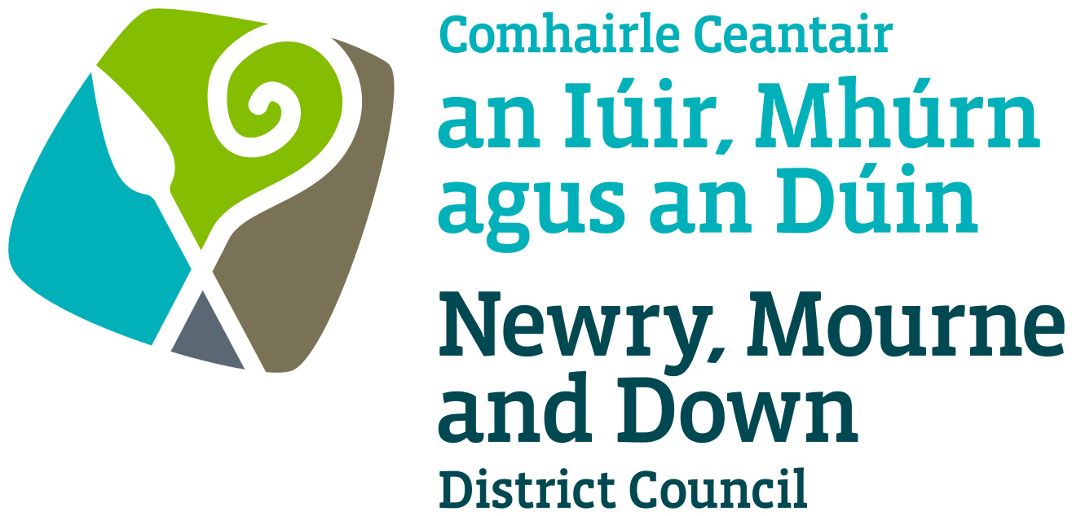

Street Trading

Stall Design and Trading Policy

NEWRY, MOURNE AND DOWN DISTRICT COUNCIL

ECONOMY REGENERATION AND TOURISM DEPARTMENT

Dated: 11 September 2023

CONTENTS

 | Page | Paragraph
Purpose | 1 | 1
Scope | 1 | 2
References | 1 | 3
Background | 1 - 2 | 4
Design, Guidelines and General Principles | 2 | 5
Licence Conditions | 3 | 6
Policy Owner | 3 | 7
Contact Details in regard of this Policy | 3 | 8
Policy Authorisation | 4 | 9
Policy Effective Date | 4 | 10
Policy Review Date | 4 | 11
Procedures | 4 | 12
Equality Screening | 4 | 13
Rural Impact Assessment | 4 | 14

1. Purpose

By virtue of Section 6, 7 and 14 of the Street Trading Act (Northern Ireland) 2001 the District Council may grant to a person a stationary, mobile or a temporary licence authorising him to engage in street trading in a street or part thereof in its District.

The purpose of this Policy is to provide guidance on the minimum standard of stall design, which should be considered when deciding whether to grant to a person a street trading licence. Its aim is to provide, insofar as is possible, consistent decision making so as to develop and thereafter maintain public confidence in Newry, Mourne and Down District Council’s (here after called ‘the District Council’) performance of its duties.

This Policy also includes standards with regards to trading conditions and stalls maintenance. This Policy is to be read in conjunction with the Stationary, Temporary and Mobile Street Trading Policies.

2. Scope

This Policy is intended to ensure that the District Council’s Members and Officers as well as licence applicants are aware of those matters in relation to stall design to be taken into consideration when determining whether to grant a street tra
ding licence.

3. References

3.1 Street Trading Act (Northern Ireland) 2001
3.2 Guide to the Street Trading Act (Northern Ireland) 2001

4. Background

The Street Trading Act (Northern Ireland) 2001 (here after called ‘the Act’) enables District Council’s to regulate street trading through designating, licensing and enforcement procedures. The Act received Royal Assent on the 5th April 2001, with a run-in period of 6 months and became operative on the 1st October 2001. The new Act repealed most of the provisions of the 1929 Street Trading (Regulation) Act, except Section 10, which contains the provisions whereby Market Rights can be acquired or extinguished.

Section 5 of the Act contains details on how an application for the grant, renewal or variation of Street Trading Licence should be made.

Section 6 of the Act contains details on the granting of Street Trading Licences.
Section 7 of the Act contains details on conditions in relation to street trading licences.

Section 14 of the Act contains details on temporary street trading licences.

5. Design Guidelines and General Principles

5.1 Each case must be considered on its own merits, but there are general principles that apply in all cases. The duty of the District Council is to make sure that each street trading licence application is fairly and objectively assessed and that all relevant factors are considered.

5.2 Designs, materials, signage and finishes should be appropriate for the context and of the highest quality. The design of any ‘stall’ must comply with all relevant Health and Safety Legislation.

5.3 It should be noted that these Design Guidelines are the Minimum Standard, which will be accepted, by the District Council. A high-quality contemporary design manufactured from 25 mm (1”) square steel tube, or equivalent, with a 2mm wall thickness to give strength which is zinc plated or hot-dip galvanised to overcome corrosion problems will be acceptable. The design of stall must be fitted with canvas or heavy-duty PVC fitted roof cover with scalloped edges. The roof must be pitched or domed to prevent water collection. A matching fitted ‘skirt’ must be attached to the counter area; this will give a professional looking appearance to the stall. Where walls are required for the stall, they must be of the same high-quality material used for the fitted roof and be made to measure to enable a fitted appearance. All materials used must be fire retardant.

5.4 In exceptional circumstances the District Council, subject to such consultation as it considers appropriate, may in particular locations consider novel alternative designs of stall, which add to the colour, ambience, vibrancy etc. of the area.

5.5 All ‘stalls’ no matter of what design must be easily moved to facilitate access.

5.6 All stalls must be fixed rail design.

5.7 For mobile or stationary licences, which require the use of a vehicle or trailer (such as ice-cream vans or catering trailers in Industrial Estates), the following standard will apply. The vehicle or trailer will be designed and constructed using materials, finishes and signage, which are appropriate for the context and of the highest quality. The vehicle or trailer must comply with all relevant Road Safety and Vehicle Legislation.

5.8 If, in any individual case and for whatever reasons, the District Council decide to grant a design, which varies from any of these guidelines, such a decision should not be taken to have created any kind of precedent in respect of future applications.

6. Licence Conditions

6.1 In exercise of the powers conferred by Section 7(2) of the Street Trading Act (NI) 2001, the District Council may specify conditions to a licence. The following conditions shall apply: -

- Any receptacle at which food and beverage products are stored, prepared, handled or sold must comply with the relevant Food Hygiene legislation.

- Any canopy or awning must not overhang the pitch.

- No containers, equipment (e.g., tables and chairs or similar items), materials, goods or articles to be placed outside the confines of the receptacle.
3

- If generators are being used for trading, it is required to be properly guarded, free from fumes and noise limited. Suitable fire-fighting equipment must be provided. Generators must be kept within the confines of the allocated pitch.

- Storage of fuel must be in proper containers fit for the purpose.

- Hot food and ice-cream vans must not produce excessive noise or exhaust fumes.

6.2 The District Council retains its right to amend or replace these conditions at any given time.

7. Policy Owner

Mr Conor Mallon, Director of Economy, Regeneration and Tourism

8. Contact Details in regard of this Policy

Mr Jonathan McGilly
Assistant Director of Economy, Regeneration and Tourism
Newry, Mourne and Down District Council
O’Hagan House
Monaghan Row
Newry
BT35 8DJ

Telephone: 0330 137 4000
9. Policy Authorisation

Development Committee Meeting Authorised on: 11 September 2023
Council Authorised on: 02 October 2023

10. Policy Effective Date
02 October 2023

11. Policy Review Date
02 October 2027

The policy will be reviewed in line with the Council’s agreed policy review cycle i.e. every 4 years (as per Council’s Equality Scheme commitment 4.31).

12. Procedures

Refer to the Stall Design and Trading Procedure.

13. Equality Screening

The policy has been equality screened, and the outcome is that it is not subject to an EQIA (with no mitigating measures required).

14. Rural Impact Assessment
Due regard to rural needs has been considered and a rural needs impact assessment has been completed.

Version 2.0

