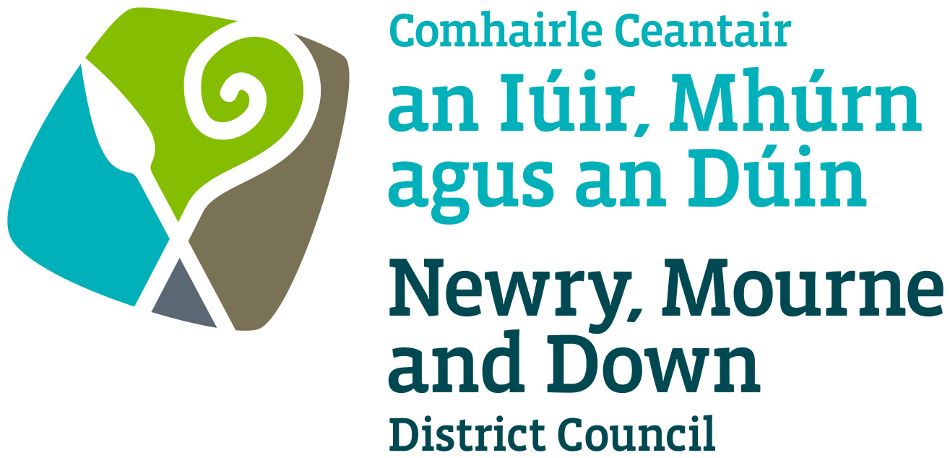

Street Trading

Policy for Dealing with Changed Circumstances Affecting Licensed Street Trading

NEWRY, MOURNE & DOWN DISTRICT COUNCIL

ECONOMY REGENERATION AND TOURISM DEPARTMENT

Dated: 11 September 2023

CONTENTS

 | Page | Paragraph
Purpose | 1 | 1
Scope | 1 | 2
References | 1 | 3
Background | 1 - 2 | 4
Guideline and General Principles | 2 - 4 | 5
Policy Owner | 4 | 6
Contact Details in regard of this Policy | 4 | 7
Policy Authorisation | 5 | 8
Policy Effective Date | 5 | 9
Policy Review Date | 5 | 10
Procedures | 5 | 11
Equality Screening | 5 | 12
Rural Impact Assessment | 5 | 13

1. Purpose

The purpose of this Policy is to outline the approach to be taken by the District Council when considering revocation etc of a street trading licence.

The Policy covers circumstances of a temporary nature, for example, where the unsuitability or lack of space is caused by ongoing construction works or similar, and where the space has become permanently inadequate or the site permanently unsuitable.

Its aim is to provide, insofar as is possible, transparent, well informed and legally sustainable decision making so as to develop and thereafter maintain public confidence in Newry, Mourne and Down District Council’s (here after called ‘the District Council’) performance of its duties under the Street Trading Act (Northern Ireland) 2001.

2. Scope

This Policy applies to:

- Stationary and Mobile trading licences.

This Policy does not apply to Temporary licences.

3. References

- Street Trading Act (Northern Ireland) 2001.
- Guide to the Street Trading Act (Northern Ireland) 2001.

4. Background

The Street Trading Act (Northern Ireland) 2001, (here after called ‘the Act’), enables the District Council to regulate Street Trading through designation, licensing and enforcement procedures.

Subsequent to the District Council granting or renewing a licence, circumstances may arise which render the street trading pitch unsuitable or the space on the street inadequate for the trading permitted by a licence to continue. Such circumstances may be;

- the location of a street trading pitch on which a licence holder trades as a stationary trader has become unsuitable, or,
- the space in the street has become inadequate to permit trading by a stationary trader without causing undue interference or inconvenience to persons or vehicles.
- The area or areas of the district in which the licence holder trades as a mobile trader have become unsuitable for the licence holder to do so without causing undue interference or inconvenience to persons or vehicles in the area or areas.

Examples of such circumstances may include: -

- Construction works or hoardings
- Road works
- Changes in vehicle traffic volumes
- Installation of new street furniture
- Changes associated with public realm improvement schemes
- New buildings
- Road re-alignment

By virtue of Sections 10 & 11 of the Street Trading Act (Northern Ireland) 2001, in such circumstances the District Council may revoke a street trading licence or vary its Conditions as appropriate.

Where possible the District Council will attempt to support the trader and his business by varying the licence.

Licences may be varied to the effect of relocating the trader to an alternative designated pitch or where appropriate changing the times or restricting the commodities permitted.

As such, the guidelines and general principles outlined below have been developed.

5. Guidelines and General Principles

The District Council shall, insofar as is practicable, try to anticipate such circumstances that would be likely to arise, and they may affect the licensed trader’s ability to trade. To this end, the District Council shall ensure that the D.R.D Roads Service and other relevant statutory bodies are informed of the location of all designated pitches.

Voluntary variation of a Street Trading licence

5.1 Where the District Council is aware that such circumstances may arise, it shall inform any licensed trader likely to be adversely affected and seek where possible to agree with the trader a variation to the licence that is acceptable to the trader taking into consideration the impact on their ability to trade.

5.2 Where the circumstances are likely to result in the displacement of the street trader, then the trader will be offered the choice of any vacant designated pitch allowing for the sale of their commodities. Where the trader agrees to trade from an alternative pitch they will be invited to make an application to vary their licence; no charge will be made for the application.

  - Where more than one trader is likely to be displaced and this results in competition for a particular vacant designated pitch, the District Council shall where possible apply the same criteria as set out in the Section 7 of the Stationary Street Trading policy.
5.4 Where a licensed trader has been displaced and his/her original pitch becomes available again, the trader will be returned to their original pitch. To this effect, the trader will be invited in writing to make an application to vary their licence within 21 days; no charge will be made for any such application, if the trader fails to make such an application within the 21 days, then the District Council will consider any application made for the original pitch.

Short-term displacement

5.5 When a street trader is likely to be displaced for a short period not exceeding five working days, the District Council may allow the trader to trade as close as possible to the designated pitch for that period. The decision shall be taken following consultation with interested parties such as D.R.D Roads Service together with consideration of Health and Safety implications and any other statutory provisions. The trader shall be notified in writing of any such decision. The District Council will consider issuing a refund or a reduction in Street Trading fees for short-term displacement.

Revocation or imposed variation to a Street Trading Licence

5.6 Where such circumstances arise and the District Council cannot successfully negotiate a licence variation acceptable with the trader or when there is no available vacant pitch or the vacant pitch does not allow for the sale of their commodity, then the District Council may consider revoking the licence or imposing a variation to the licence.

5.7 Where the District Council proposes to revoke or impose a licence variation it shall give the street trading licence holder, “notice in writing of its intentions” and invite representations from him/her.

5.8 The Notice of Intention referred to in 5.7 shall state- “that representations relating to the proposal may be made in writing to the District Council within such period, being not less than 21 days from the date of the notice, as may be specified in the notice”.

5.9 Before reaching any such decision, the District Council will consider representation from the street trader in accordance with the Council’s Hearing of Representations Procedure.

5.10 After considering all relevant representations and reaching a decision, the District Council will write to the licensee affected, giving Notice of the grounds on which, its final decision is based.

A person aggrieved by a decision of a Council: -
- with respect to any condition specified in a street trading licence
- to refuse, other than on any of the grounds specified in section 8 of the Act, an application for a street trading licence
- to grant an application for a street trading licence subject to any condition of a kind mentioned in subsection (2) of section 9 of the Act;
- to revoke a street trading licence under section 10 of the Act
- to vary under subsection (1)(b) or (2) of section 11 of the Act any conditions specified in a street trading licence; or
- to refuse to vary under subsection (1)(a) of that section the conditions specified in a street trading licence;

may, at any time before the expiration of the period of 21 days from the date on which notice of the decision is given, appeal to a court of summary jurisdiction by notice under Part VII of the Magistrates’ Courts (Northern Ireland) Order 1981 (NI 26).

5.11 The final Notice will also detail the right to appeal against the decision; this must be lodged within 21 days of the Notice in the Magistrates Court.

Enforcement

5.12 Where a licensed street trader, including a displaced trader, is found to be trading at any location other than that permitted in their licence, then formal action, including prosecution, may be considered by the District Council. Where paragraph 5.5 relating to short term displacement applies then this paragraph shall not have effect.

6. Policy Owner

Mr Conor Mallon, Director of Economy, Regeneration and Tourism

7. Contact Details in regard of this Policy

Mr Jonathan McGilly
Assistant Director of Economy, Regeneration and Tourism
Newry, Mourne and Down District Council
O’Hagan House
Monaghan Row
Newry
BT35 8DJ

Telephone: 0330 137 4000
8. Policy Authorisation

Development Committee Meeting Authorised on: 11 September 2023
Council Authorised on: 02 October 2023

9. Policy Effective Date
02 October 2023

10. Policy Review Date
02 October 2027

The policy will be reviewed in line with the Council’s agreed policy review cycle i.e. every 4 years (as per Council’s Equality Scheme commitment 4.31).

11. Procedures

Refer to the Dealing with Changed Circumstances Procedure.

12. Equality Screening

The policy has been equality screened, and the outcome is that it not be subject to an EQIA (with no mitigating measures required).

13. Rural Impact Assessment
Due regard to rural needs has been considered and a rural needs impact assessment has been completed.

Version 2.0
4.

