IARSMALANNA IMD
NMD MUSEUMS

LOANS POLICY
&
PROCEDURES
2023-2026

JULY 2023

Responsibility of NMD Museums Curators

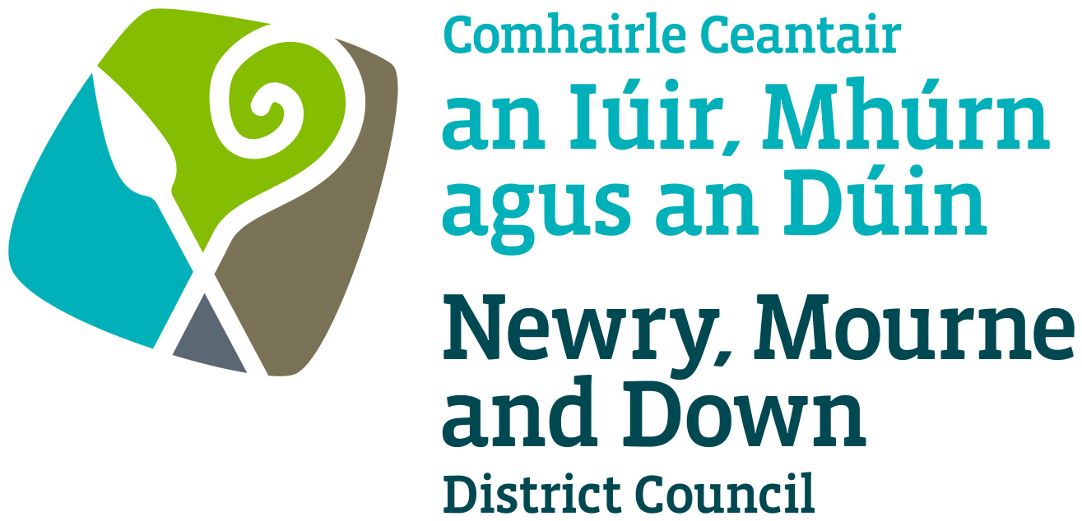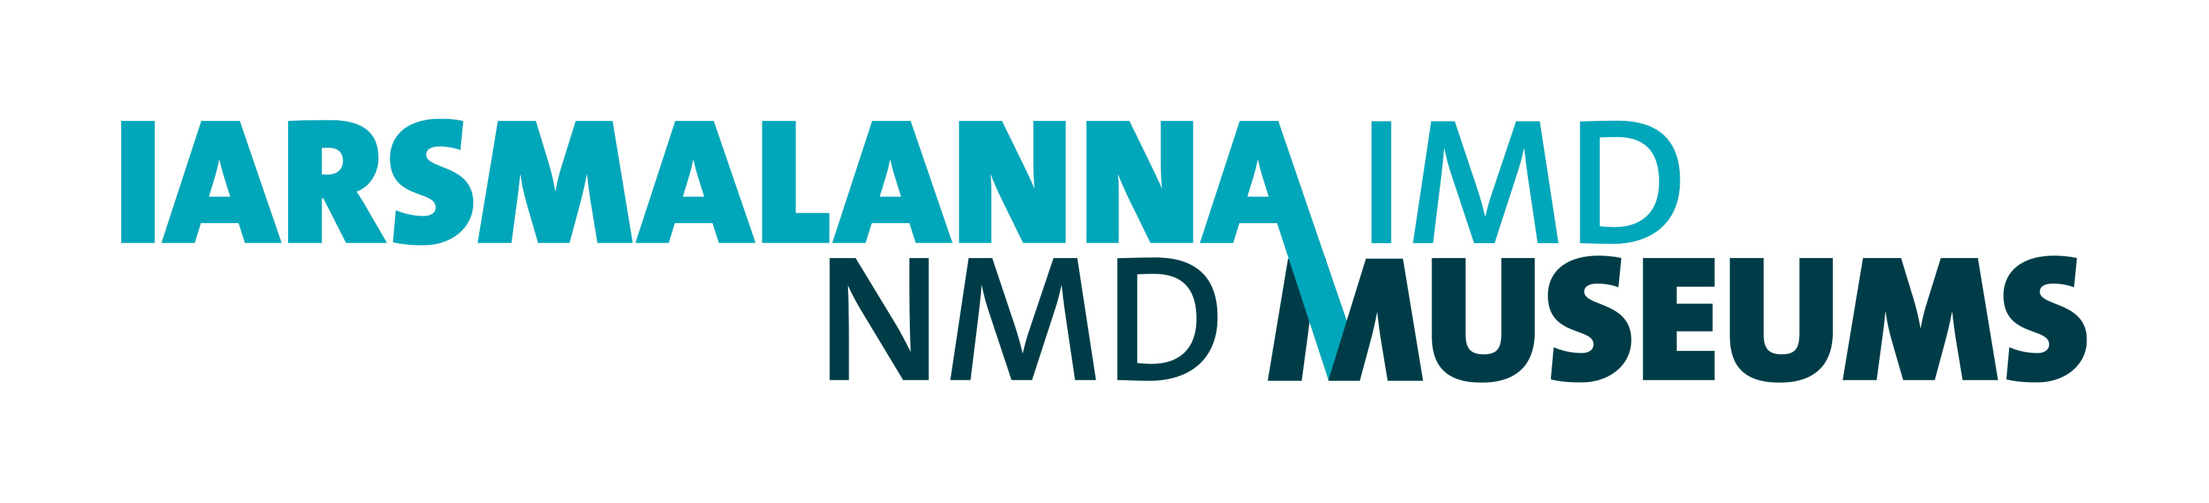

Contents
Contents
Loans Policy 3
Procedures for outward loans 4
Loan request 4
Venue approval 5
Object assessments 5
Insurance 5
Packing and couriers 5
Customs 6
Environment 6
Security 6
Approval of loan 6
Recall 6
Cancellation 6
Procedures for inward loans 7
Loan request 7
Facilities/Security report– 7
Object assessment 7
Insurance/Indemnity 7
Packing and couriers 7
Environment 7
Security 7
Approval of loan 7
Appendices 8
Loan out request form 8
Loan in request form 8
Loan out decision making flow chart 8
Loan Out Request 9
Loan In Request 10
Loan out decision making flow chart. 11

Loans Policy

This document covers the loan policy and procedures for Down County Museum and Newry and Mourne Museum, known as NMD Museums. Both Museums hold Accreditation Standards through Arts Council England.

NMD Museums borrows and lends objects for the purpose of public display and research, to:

- make its Collections available to a wide and diverse audience
- promote understanding of the history and material and cultural heritage of the Newry, Mourne and Down District Council area
- enhance the reputation of NMD Museums and foster relationships with other cultural institutions

NMD Museums are committed to providing the widest possible engagement with and access to its collections within their statutory responsibility to preserve the collections in the long-term by minimising possible risks of damage or loss.
NMD Museums will only lend accessioned artefacts from its Collection to UK museums, galleries and archival institution which have been granted full or provisional Accreditation by Arts Council England. Loans will only be made to international institutions which have similar status with their national scheme.
Loans will only be made to institutions which are open to the public.
Loans will only be made for the purposes of exhibition or research.
NMD Museums will not lend:
- Artefacts which are on long-term or temporary display
- Artefacts which are in a fragile condition
- To individuals for any reason
When requesting loans-in, NMD Museums will seek to ensure that the owner has full legal title and that they or any agent acting for them has full legal authority to enter into a loan agreement.
Objects approved for loan will be in a suitable physical condition for transport and display or research.
NMD Museums will not normally charge for the administration of loans. However, borrowers will usually be asked to meet the cost of:
- all risks insurance cover
- transport
- packing and courier requirements
- costs of preparation for objects to be borrowed
- additional security measures deemed necessary by NMD Museums
- any extraordinary costs incurred facilitating the loan such as conservation
- costs for loan checks prior to renewal of long term loan

Any costs will be notified to borrowers prior to final agreement of the loan.
Approval of a loan may be affected by NMD Museums’s availability of resources necessary to facilitate the loan.
This policy supports the Collections Development Policies of both Down County Museum and Newry and Mourne Museum.
This policy will be implemented in accordance with both Museum’s Documentation Procedural Manuals.
This Loan Policy is in accordance with industry standards, both national and international and guidelines, both national and international, including those listed below:
- Loans Between National and Non-National Museums, New Standards and Practical Guidelines, National Museums Directors’ Conference, 2003
- UNESCO Convention on the Means of Prohibiting and Preventing the Illicit Import, Export and Transfer of Ownership of Cultural Property, 1970
- Statement of Principles issued by the National Directors Conference on ‘Spoliation of works of art during the Holocaust and World War II period’, 1998
- Combating Illicit Trade: Due Diligence guidelines for museums, libraries and archives on collecting and borrowing cultural material. DCMS 2005
- SPECTRUM: UK Documentation Standard for Museums

Procedures for outward loans

Loan request
Initial enquiries for loans should be made at least one year in advance of the proposed dates for international loans and six months in advance for UK and Ireland loans. Enquiries for loans should be directed to the curator. A loan out request form (see appendix) provides a list of relevant information required. Loan request will be acknowledged by the curator.
A formal loan request from the borrower should be put in writing to the curator at least six months in advance of the proposed dates for international loans and three months in advance for UK and Ireland loans.
Formal loan requests should include as much information as possible to facilitate the approvals process. In the case of touring exhibitions, all venues should be listed with dates and name of the organisation with overall responsibility for the exhibition. Normally, loan agreements will be between NMD Museums and the borrowing venue – not the exhibition organiser.
All loans are subject to a formal loan agreement between the borrower and NMD Museums. All requirements for loans must be met prior to the release of the loan.

Venue approval
Once a formal request has been received the loan will be processed. To ensure NMD Museums fulfils its duty of care to the collections, a number of checks will be made for each venue.
- A facilities report for exhibition venues will be requested to ensure that adequate environmental and security conditions are met, including case supplement where applicable. As part of this a member of NMD Museums staff will need to perform a check of the potential venue.
- Research loans will be subject to individual agreements relating to the care of objects

Artefact assessments
Artefacts requested will be assessed against the following criteria:
- Artefact availability (To ensure that potential borrowers are made aware of internal requirements, competing requests, condition of objects and possible alternative objects at an early stage in the loans process)
- Condition of artefact (including identifying any conservation work necessary to render an object displayable)
- Suitability of artefact for display venue
- Availability of resources to facilitate any loan

Insurance
Borrowers will normally be required to provide ‘nail to nail’ all risks insurance or indemnity cover for the loan.
- Policy and indemnity conditions should be submitted well in advance of loan commencement, to allow time for the conditions offered to be approved. Where we consider policies or indemnities fail to provide adequate cover, insurance through a UK insurance broker, nominated by NMD Museums, must be arranged at the borrower’s cost.
- International borrowers not providing a governmental or state indemnity must arrange insurance through a UK insurance broker, approved by NMD Museums, at the borrower’s cost unless agreed with the Curator or Assistant Curators in advance and confirmed in writing.
- Loans between government-funded organisations cannot be commercially insured and are not eligible for UK Government Indemnity. In such cases, the loan is at the lender’s own risk.

Packing and couriers
Packing requirements will be specified by NMD Museums. All costs will be met by the borrower. The borrower will safely store any reusable packing materials for the duration of the loan, unless otherwise agreed with the Curator or Assistant Curators in writing.
We may require a courier to accompany the loan to and from each venue to oversee handling, transport, display or storage arrangements. All associated costs are the responsibility of the borrower.
Condition reports will be provided by NMD Museums and countersigned by the borrower on delivery and collection.

Customs
Customs formalities are the responsibility of the borrowing institution. Loans should not be unpacked for customs inspection en route. In the event that customs insist on visual inspection the Curator or Assistant Curators must be informed immediately.

Environment
Borrowers will be required to meet environmental conditions commensurate with the artefacts to be borrowed at all times, including transport, storage and installation and de installation, unless agreed in advance with the curator and confirmed in writing. Individual requirements can be discussed with the curator.

Security
Borrowers will be required to meet security conditions commensurate with the objects to be borrowed. We reserve the right to impose additional security requirements at the borrower’s expense. Individual requirements can be discussed with the Curator or Assistant Curators.

Approval of loan
If the loan is likely to be for an extended period the initial loan period will be three years, renewable at the discretion of NMD Museums. Any costs incurred checking a loan prior to renewal will be the responsibility of the borrower. All loans will be subject to annual inspections by NMD Museums.
Approval of loans will be notified to the borrower at the earliest opportunity with the loan agreement.

Recall
NMD Museums reserves the right to withdraw any loan at any time. Normally this will only happen in an emergency or where the borrower fails to comply with the loan agreement.

Cancellation
Where a loan is cancelled for valid reasons, NMD Museums will normally charge the borrower for actual costs incurred up to point of cancellation.

Procedures for inward loans

Loan request
A formal loan request from NMD Museums will be put in writing to the lender.

Facilities/Security report–
A facilities and security report will be sent to the lender on request.

Artefact assessment
Due diligence checks will be carried out on all loans to ensure NMD Museums complies with all relevant national and international standards.

Insurance/Indemnity
Artefacts will be covered by insurance provided by NMD Museums’s governing body, Newry, Mourne and Down District Council.

Packing and couriers
All packing and courier requirements stipulated by the lender will be adhered to by NMD Museums.

Environment
NMD Museums will meet environmental conditions commensurate with the objects to be borrowed at all times including transport, storage, installation, and de-installation, unless agreed in advance with the curator and confirmed in writing.

Security
NMD Museums will meet security standards as stated in the UK Government Indemnity Scheme Guidelines (Annex D), commensurate with the artefacts to be borrowed and as stipulated by the lender.

Approval of loan
Levels of approval will depend on value of the loan.

Appendices

Loan out request form

Loan in request form

Loan out decision-making flow chart

For internal use only

LOAN No. | Ex
Date Received

Loan Out Request

Borrower’s full name and address

Contact person | Name  Address  Telephone  email
Venue’s full name and address (if different from above)
Give complete list if multiple venues are proposed.

Exhibition Organiser’s full name, address and contact person (if applicable) | Company Name  Address  Contact Name  Telephone  email
Exhibition Title / Purpose of loan
Artefacts requested.
Attach list if necessary

Requested start and end date of loan

Opening and closing dates of exhibition (where applicable)

Any other information

For internal use only

LOAN No. | Ent
Date Received

Loan In Request

Lender’s full name and address

NMD Museums site and gallery
Exhibition Title/ Purpose of loan
Complete list of artefacts to be borrowed (attach list if necessary. Please include valuations)

Any special terms and conditions that apply to any object including packing and courier requirements
Requested start and end date of loan. If the loan is to be requested for an extended period please indicate how long

Opening and closing dates of exhibition

Any special display requirements e.g. specialist mounts or case requirements.

Any other information

Loan out decision-making flow chart.

Initial loan request to curator
Artefacts available and in suitable condition for loan
Artefacts not available or not in suitable condition for loan

Borrower makes formal request for loan to curator
Loan refused
Checks for venue suitability
Venue suitable
Venue not suitable
Loan approved
Loan refused
All loan conditions met

All loan conditions not met
Loan released
Loan not released.

