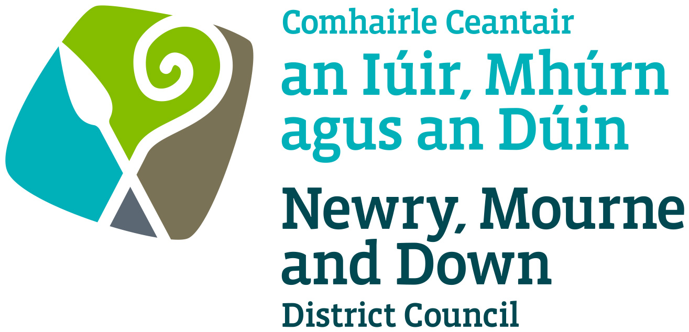

**ENTERPRISE, REGENERATION &TOURISM COMMITTEE**

**PROTOCOL FOR HEARING OF STATUTORY REFERRALS TO COMMITTEE**

**Introduction**

1. The following protocol has been developed for use by the Enterprise, Regeneration and Tourism (‘the Committee’). It should be read alongside relevant provisions of the Council’s Standing Orders and the Code of Conduct for Councillors and is not intended to replace either document. The key aims of the protocol are to ensure that:

1. Those who make, or make representation to, applications before the Committee are able to make informed representations and know the case which they have to meet; and
2. The Committee makes decisions in a soundly based, lawful, and transparent way and in a timely and efficient manner.

1. Meetings of the Committee will be open to the public; however, seating within the Committee Chamber will be limited according to venue capacity and associated fire and safety regulations.
2. Seating for applicants, statutory consultees, and objectors (‘the parties’) to an application will be reserved but only for the time in which their application is being considered.

**Representations to Committee**

1. Only those who have made written submissions and registered a request to speak in respect of an application shall be permitted to make oral representations before the Committee.
2. Parties to an application will be subject to the following conditions:

1. Deputations shall be heard in the following order:
2. Statutory consultees or other notice parties;
3. Objectors and/or their representatives;
4. Applicant and/or their representatives and/or those supporting the application.

1. Where more than one application is received in relation to a street trading site, deputations will be heard in alphabetical order according to the surnames of the applicants;
2. Deputations, unless otherwise agreed in advance by the Committee, shall consist of no more than 3 persons. Where there are more than 3 objectors or groups of objectors they will be required to arrange a single deputation to express their representations;
3. The privilege of such deputation shall be confined to the presentation of a statement and the making of a short address either by each member of the deputation or, should they so wish, by their nominated spokesperson or legal adviser;
4. Each deputation shall be permitted, as far as is reasonably practicable, a maximum of 10 minutes to address the Committee. Where more than one person wishes to make representation the 10 minutes should be shared between the members of the deputation;
5. Speakers will not be permitted to circulate papers to members at the Committee meeting. Documentation is to be submitted in accordance with para 7 below;
6. All members of a deputation must continue to be seated and remain silent whilst other deputations are making representations to the Committee;
7. Cross-examination, discussion or any type of debate between persons making representations to Committee shall not be permitted;
8. Once all deputations have been made, the parties shall be permitted an opportunity to rebut any factual inaccuracies only which may have arisen from the oral representations of another deputation and in respect of which they have not had an opportunity to comment. This will be strictly limited to responding to any such issue and the party will not be permitted to rehearse any representations which have already been made;
9. The Committee may, upon advice from officers, exclude any deputation from being present during the whole or part of the time when any other deputations are being made due to:

* the confidential nature of information relevant to the application to be discussed; or
* For such other reasons as may be appropriate;

1. The Committee may seek clarification from those who have spoken on any issues raised by them but should not enter into a debate with them;
2. Officers can address any issues raised during the course of representations from any deputation and the Committee can question officers; and
3. The Committee may agree to accept representations outside these procedures but will only do so in exceptional circumstances.

**Submission of representations to Council**

1. Each deputation shall submit a prepared statement in advance of the meeting in a format as required by the Committee.
2. The statement, along with any other supporting information, must be provided in sufficient time which, unless exceptional circumstances dictate otherwise, shall be 2 weeks prior to the date of the Committee at which the matter is to be considered and the statement shall be included in the report to Committee.
3. Save for exceptional circumstances, all material supplied to the Committee will be shared with the parties. In particular;

1. Objectors will receive the material supplied on behalf of the applicant or representatives in support of an application;
2. Applicants will receive the material supplied on behalf of objectors in opposition to an application; and
3. All parties to an application shall be supplied with the report and all appendices thereto which is to be presented to Committee apart from any information which is restricted by virtue of the confidentiality provisions in the Council’s publication policy.

1. Any relevant information which, in exceptional circumstances, was not made available for inclusion in the report to Committee in advance of the meeting must be received by the Building Control Service (in writing or by email to: buildingcontrol@nmandd.org) no later than 12.00noon two working days prior to the meeting. Any such information may then be verified or investigated and must also be supplied to all the parties to an application in advance of the meeting. Failure to do so may result in either the documentation being disregarded or the hearing being deferred.
2. Any documentation which is provided directly to any members of the Council must also be copied to the Building Control Service so as to ensure that the issues raised can be fully investigated by officers prior to the Committee hearing. Failure to do so may result in either the documentation being disregarded or the hearing being deferred.
3. All Committee papers will be available online. However, access to some documentation may be restricted by virtue of the Council’s publication policy. Information which is determined to be exempt by virtue of Schedule 6 of the Local Government (Northern Ireland) Act 2014 may be published where the Council considers that the public interest in disclosing same outweighs the public interest in maintaining the exemption.

**Role of Committee Chairperson**

1. It is the role of the Committee Chairperson to chair the proceedings in such a way as to facilitate decisions which are consistent with the Committee’s aims and to ensure that licensing decisions are properly debated.
2. The Chairperson will ensure that those making representations to the Committee adhere, as far as is practicable, to any time limits fixed for such presentations. These time limits will have been communicated to those making representations in advance of the meeting.
3. The Chairperson may at any time during the hearing of deputations, if s/he thinks it necessary to secure order, direct the removal of any individual from the meeting, or order that the meeting be cleared of all deputations.
4. When hearing deputations, the Chairperson will only permit questions to be put to persons appearing before the Committee and will require members engaging in debate to desist, until such time as all relevant information has been received.
5. The Chairperson may bring the questioning of any person appearing before the Committee to a close provided s/he is satisfied that all relevant issues have been addressed. The Chairperson may also prevent duplication of questions being put.
6. In any circumstances in which relevant information has been omitted from the information presented to the Committee, or the information appears to be deficient or appears to require further clarification or investigation, the Committee should consider deferring consideration of the matter to the subsequent monthly meeting of the Committee to allow the relevant information to be brought before it.

1. The Chairperson may permit any member of Council who is not a member of the Committee to appear before the Committee and make representations. As a non-Committee member, the member will take no further part in the proceedings or decision-making.
2. If a member of the Committee moves that the question be put to a vote and the Chairperson is of the opinion that the application before the Committee has been sufficiently discussed, s/he shall put the motion to the vote.
3. The Chairperson shall, if necessary, seek clarification on any proposal put by any member before a motion is put to a vote.

**Role of Committee Members**

1. The Committee’s aim will be to make decisions which are sound, lawful, fair and transparent. In particular, members of the Committee should ensure that they take into account all relevant considerations and leave out of account irrelevant considerations.
2. Members must act fairly and be seen to act fairly. This means that they must have an open mind when considering an application and not pre-determine, or appear to pre-determine, an application before all of the evidence has been heard.
3. In any application before the Committee under this protocol, the Committee may decide that a site visit is desirable before a decision is made. In these circumstances, a date and time for the visit will be arranged for all members of the Committee to attend.
4. Members should be satisfied that they have considered all of the evidence that has been presented. If a member has not been present for the entirety of the process and evidence, he/she is strongly advised to consider his/her further involvement in the proceedings including the vote.
5. Any member of the Committee who has any pecuniary interest or other personal interest in a particular decision of the Committee should declare same and is strongly advised to withdraw from the meeting whilst that matter is being considered.
6. Any member of the Committee who wishes to support an applicant or objector at a Committee hearing under this protocol may do so in their capacity as an Elected member in accordance with this protocol.  Any member in this position is strongly advised against taking any other part in the proceedings.
7. Only those members sitting on the Committee will be permitted to engage in the questioning of those giving presentations or making representations to the Committee.
8. If legal advice is provided by Legal Services, the Committee must have regard to any such advice before reaching a decision.

28. **Role of the Committee**

The Committee shall hear all representations and shall have authority of decision on the

Licence application.

29. **Right of appeal**

An applicant aggrieved by a decision refusing an application for the grant or renewal of a

Licence/Permit has the right of appeal to the County Court or as otherwise outlined under the

appropriate Legislation.

30. **Call-in process**

Decisions of the Committee taken under this protocol which are of a quasi-judicial or regulatory nature are subject to the Call-in process under Para 21 of Council Standing Orders.

31. **Policy Authorisation**

Enterprise, Regeneration and Tourism Committee

Recommended on 8th November 2021

To be ratified by Council on 6th December 2021

31. **Policy Effective Date** 13th December 2021

32. **Policy Review Date** 13th December 2025

The protocol will be reviewed in line with the Council’s agreed protocol review cycle i.e. every 4 years (as per Council’s Equality Scheme commitment 4.31), or sooner to ensure it remains reflective of legislative developments.