IARSMALANNA IMD
NMD MUSEUMS

SUSTAINABILITY Policy STATEMENT
2023 - 2026

JULY 2023

Responsibility of NMD Museums Curators

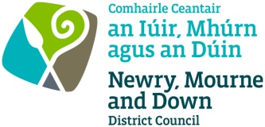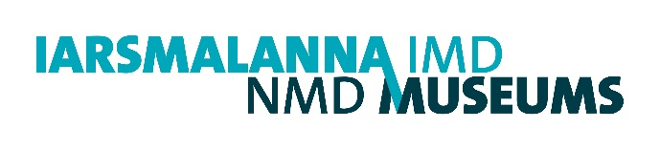
SUSTAINABILITY POLICY STATEMENT

1. Context

  - As a service within Newry, Mourne and Down District Council, NMD Museums operates within the scope of the Council’s Environmental Statement and its forthcoming Sustainability and Climate Change Strategy and Action Plan and Climate Adaptation Plan.

1.2 Energy consumption is monitored in buildings operated by Newry, Mourne and Down District Council. This includes:
- Heating Consumption kWh
- Electricity consumption kWh
- Water (m3)

2. Strategic Planning

2.1 NMD Museums is committed to continual improvement and prevention of pollution by reducing the environmental impacts that arise from its business activities and delivery of its services.

2.2 NMD Museums will set realistic and measurable objectives and targets to ensure continual improvement in sustainability performance.

3. Aims

3.1 The key aims and objectives of NMD Museums are to care for the heritage of the Newry, Mourne and Down District Council area, through the care and collection of a diverse range of material and providing accessibility to this resource. It will also ensure the preservation of Newry’s oldest known surviving building (Bagenal’s Castle) and the former Down County Gaol buildings.

3.2 The aim of this policy is to provide a rationale and framework to assist NMD Museums to continually improve its performance in terms of sustainability.

4. Objectives

4.1 NMD Museums will consider sustainability in all its actions.
- Minimise the amount of waste generated internally and disposed of to landfill. Where reduction is not practical, seek to reuse or recycle waste and ensure the safe disposal of all waste. This is achieved by reusing or recycling waste materials in education and family workshops, reusing materials in temporary exhibitions and reducing paper usage.
- Extend the life of graphic panels used in temporary exhibitions by giving them to other heritage groups in the Newry, Mourne and Down area.
- Conserve items for temporary exhibitions that can be later used in the main exhibitions.
- Develop strategies to maximize storage space and improve storage practices in the Museum Stores and reduce amount of conservation packing materials used without comprising conservation standards.
- Deliver a recycling element in appropriate education workshops to highlight the historical importance of recycling to children.
- Introduce measures to ensure best practice and the responsible use of natural resources such as water, fuel and energy where possible including monitoring of consumption of these, contributing to reduction of energy consumption by Newry, Mourne and Down District Council.
- Investigate and introduce measures to minimise the release of pollutants which cause damage to land, air and water due to the NMD Museums activities where possible.
- Maintenance of Museum lighting (LEDs on PIR sensors) will continue in Newry and Mourne Museum and will be extended in Down County Museum.
- Reduce the environmental impact of goods purchased through joint orders and at the same time encourage suppliers and contracted services to improve their environmental performance e.g. conservators.
4.2 Newry, Mourne and Down District Council have developed an Environmental Statement and are developing a Sustainability and Climate Change Strategy and Action Plan as well as a Climate Adaptation Plan. The Council are reviewing all operations and considering the threats of climate change including increased rainfall and extreme flooding, increased storminess, extremes of heat and cold, sea level rises and coastal erosion.
The Plan will include positive action to reduce the impacts of climate change (Mitigation) and increase resilience to deal with its impacts (Adaptation).

5. Legal Requirements

5.1 NMD Museums is committed to complying fully and, where possible, exceeding the requirements of applicable legislation and regulations through the application of Best Practice techniques. Newry and Mourne Museum’s building, Bagenal’s Castle, is a Scheduled Monument under Article 3 of The Historic Monuments and Archaeological Objects (Northern Ireland) Order 1995 and compliance with this legislation will be maintained. Down County Museum’s buildings, the former Down County Gaol are listed under Section 80 of the Planning Act (NI) 2011.

6 Communication

6.1 This statement shall be communicated in an effective and accessible manner so as to be understood and practised by all NMD Museums employees. We shall raise awareness of the sustainability issues among all those working for or on behalf of NMD Museums through appropriate training and dissemination of information in different formats where appropriate.

6.2 NMD Museums will address sustainability issues in an open manner and maintain close links with relevant authorities, regulatory agencies, research institutes, the local community and all relevant stakeholders to improve and protect our local and global environment.

7. Implementation and Review

7.1 This Sustainability Policy Statement will be submitted to Newry, Mourne and Down District Council for approval and will be reviewed every three years.

Policy Established: July 2023

Review Date: July 2026

