IARSMALANNA IMD
NMD MUSEUMS

VOLUNTEER POLICY
2023 - 2026

JULY 2023

Responsibility of NMD Museum Curators

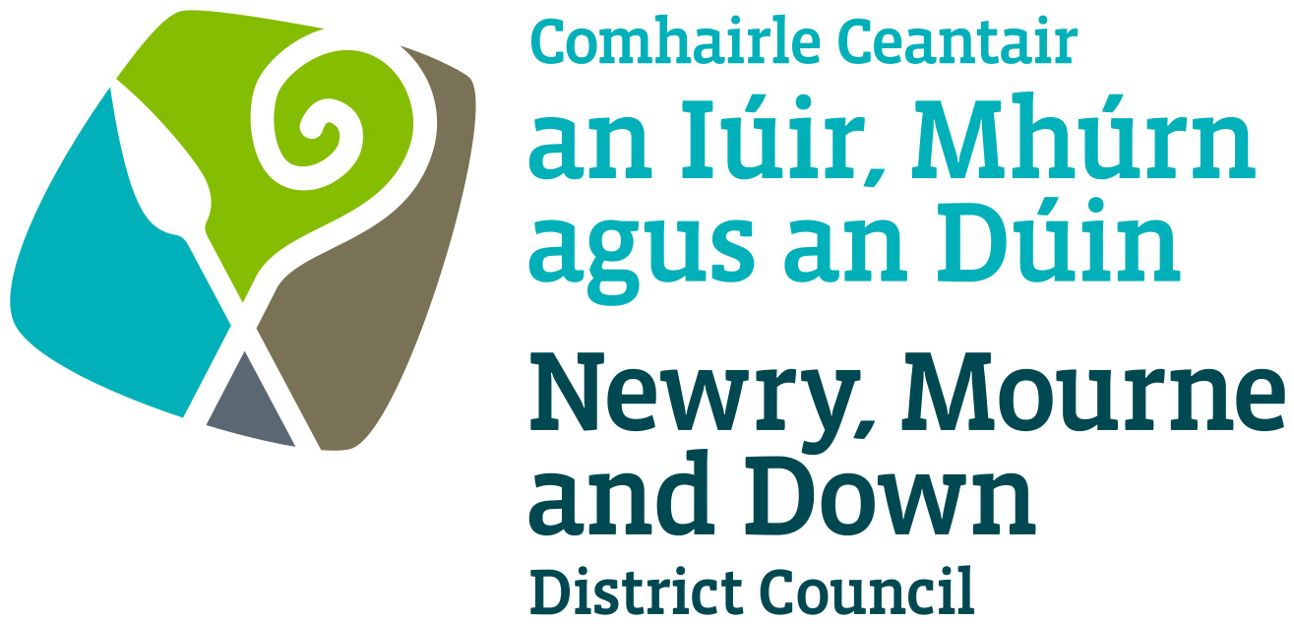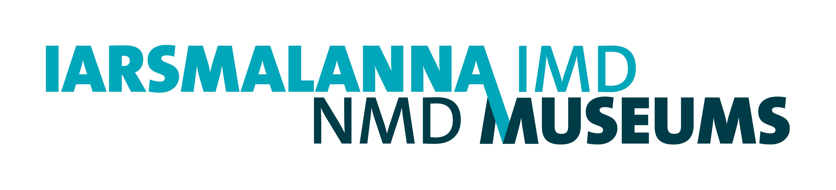

NMD Museums Volunteer Policy

NMD Museums believes that they make a major contribution to the quality of life in the region, through contributing directly and indirectly to the local economy, providing an invaluable learning resource and contributing to tourism. They seek to connect residents and visitors to the collections, place and history through dynamic and inclusive exhibitions and activities, with the aim to celebrate the unique places and identities of the area.
As part of this commitment to the local area, the NMD Museums will provide practical experience of working in a Museum for people who wish to pursue a career in the museum or heritage sector. NMD Museums has a full complement of staff and volunteers will only provide assistance and not undertake any core duties of paid members of staff.
NMD Museums Volunteer Policy is based on Newry, Mourne and Down District Council’s Volunteer Policy which encourages and supports volunteering within the Council. The Policy provides guidance to ensure the interests of volunteers, staff and service users are met within our volunteering activities. It seeks to develop and promote best practice in the involvement and support of volunteers in the work of NMD Museums.
We will provide experience in the following areas:
- Care and management of Museum Collections
- Research for, and assistance with, design and installation of exhibitions
- Research for family and local history queries
We will commit to the following practice:
- Provide volunteers with adequate information, training and assistance for them to be able to meet the requirements and responsibilities of their volunteer role.
- Provide volunteers with supervisory support.
- Respect volunteers’ skills, dignity and individual needs.
- Be receptive to any comment from volunteers regarding ways in which the Museum might mutually better accomplish our respective tasks.
- Value and recognise volunteers as a significant resource in achieving the goals of the organisation.
- Provide adequate insurance cover for volunteers whilst undertaking voluntary work approved and authorised by us.
- Provide volunteers with adequate training in support of our health and safety policy.
- Ensure that all volunteers are dealt with in accordance with Newry, Mourne and Down District Council’s equal opportunities policy.

Duration and recruitment of volunteer role:

- Volunteer roles will be of an agreed duration and detailed in the Volunteer Agreement.
- Work pattern will be arranged with volunteers according to their circumstances and nature or type of project.
- The Curator will retain a list of applicants who wish to avail of the Museum volunteer experience.
- Candidates must present their C.V.s and will meet with the Curator for an informal interview to establish suitability for volunteer role.
- Where volunteers or students may be working with children, the law may require us to ask for an Access NI check. This will always be discussed in advance with the person concerned.

The service will not take on volunteers or students when:
- there is no suitable member of staff with time to supervise the volunteer adequately.
- the administration costs of the role cannot be met by the service budget.
- the person applying is under 16 years of age.

We will not reimburse travelling expenses incurred by volunteer in execution of their role except where the project is externally-funded and volunteer expenses are factored in special projects.

The Volunteer will commit to the following:

- Perform their volunteering role to the best of their ability.
- Attend induction training and additional trainings relevant to the volunteer post.
- Follow the Newry, Mourne and Down District Council’s procedures, standards and policies, including record-keeping requirements, health and safety, equal opportunities and confidentiality in relation to staff, volunteers and users.
- Meet time and duty commitments, except in exceptional circumstances, or to provide adequate notice so that alternative arrangements can be made.
- Not to act in a way that will be in conflict with the aims and objectives of Newry, Mourne and Down District Council or in a way that may undermine the work of Newry, Mourne and Down District Council.
- Provide referees, as agreed, who may be contacted, and to agree to an Access NI check being carried out where necessary.

Before commencing their role, volunteers will sign a Volunteer Agreement with NMD Museums outlining the areas of work or projects in which they will be involved, duration of role, management and supervision and work pattern.

The volunteer agreement is binding in honour only and is not intended to be a legally binding contract between parties with no intention to create any employment relationship. The Volunteer Agreement may be cancelled at any time at the discretion of either of the parties.

Policy Established: July 2023

Review Date: July 2026

