Iarsmalann an Iúír agus Mhúrn

NEWRY AND MOURNE MUSEUM

Collections Development Policy
2023 - 2026

JULY 2023

Responsibility of Curator

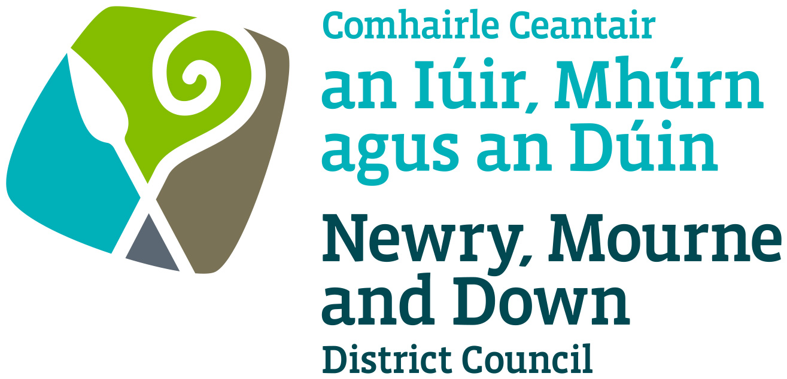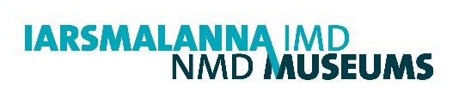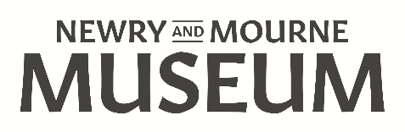

Name of museum:
Newry and Mourne Museum

Name of governing body:
Newry, Mourne and Down District Council

Date on which this policy was approved by governing body:

Policy review procedure:
The collections development policy will be published and reviewed from time to time, at least once every five years.

Date at which this policy is due for review:
July 2026
Northern Ireland Museums Council will be notified of any changes to the collections development policy, and the implications of any such changes for the future of collections.

Relationship to other relevant policies/ plans of the organisation:
1
  - The museum’s statement of purpose is:
To COLLECT, CARE for and RESEARCH our rich cultural heritage to support continued understanding of our history, culture and environment.

To CONNECT residents and visitors to our collections, place and history through dynamic and inclusive exhibitions and activities.

To CELEBRATE our unique places and identities.

  - The governing body will ensure that both acquisition and disposal are carried out openly and with transparency.

  - By definition, the museum has a long-term purpose and holds collections in trust for the benefit of the public in relation to its stated objectives. The governing body therefore accepts the principle that sound curatorial reasons must be established before consideration is given to any acquisition to the collection, or the disposal of any items in the museum’s collection.

  - Acquisitions outside the current stated policy will only be made in exceptional circumstances.

  - The museum recognises its responsibility, when acquiring additions to its collections, to ensure that care of collections, documentation arrangements and use of collections will meet the requirements of the Museum Accreditation Standard. This includes using Spectrum primary procedures for collections management. It will take into account limitations on collecting imposed by such factors as staffing, storage and care of collection arrangements.

  - The museum will undertake due diligence and make every effort not to acquire, whether by purchase, gift, bequest or exchange, any object or specimen unless the governing body or responsible officer is satisfied that the museum can acquire a valid title to the item in question.

Please include one of the following two paragraphs:
  - The museum will not undertake disposal motivated principally by financial reasons.
2

History of the collections

2.1 The Newry and Mourne Collection has been evolving since the
Museum opened in 1986. Comprising over 14,000 items and
donated mainly by members of the public, the Collection consists of
documents, photographs, fine art, ceramics, glass, textile and
wooden objects.

2.2 The relocation of the Museum to a new building, Bagenal’s Castle, in
2007 increased capacity for collecting, particularly material from the
20th century and the Troubles. Many of these items are on display in
Gallery 3 which is dedicated to the 20th century.

2.3 Significant acquisitions include three major archival collections: the
Reside Collection (2003), the Hugh Irvine Collection (2009) and the
Éamon Donnelly Collection (2013). Purchases include Newry glass
(2008/11) and art works by the Newry-born artists Sean Hillen (2010)
and Margaret Clarke (2016). A portrait of Sir Nicholas Bagenal (artist
unknown) was donated to the Museum in 2016. In 2018 an important
collection of objects and documents relating to the Newry to
Warrenpoint Railway was donated to the Museum.

An overview of current collections
3

3.1 The current Museum Collection comprises over 14,000 artefacts,
documents and photographs, representing many aspects of local social,
cultural and political heritage. Artefacts range in date from the prehistoric
period up to the 21st century. Items of special interest include:

- Medieval sculpture – a cross-carved grave stone dating from the 12th century and a carved stone head (15th century) from the Cistercian Abbey at Newry.
- Gelston Clock – a rare longcase clock made in Newry c.1780 by John Gelston.
- Newry glassware – decanters and drinking glasses made in Newry in the early 19th century.
- Textiles – most notably a set of Order of St. Patrick Robes owned by the 3rd Earl of Kilmorey, an Irish National Foresters uniform, a Deputy Lord Lieutenant’s uniform, a gentleman’s Burton suit (c.1946), Irish Dancing costumes (1970s), a complete set of robes worn by a High Court Judge who was also a Queen’s Counsel, examples of local Carrickmacross lace and Victorian and 20th century needlework.
- Artworks – portraits by Margaret Clarke (1884 – 1961) and photomontages by Sean Hillen (1961 - ), both Newry-born artists and a late 16th – century portrait of Sir Nicholas Bagenal (artist unknown).
- The Reside Collection - over 10,000 items dating from 1708 to 1986 relating to the life and work of Major G.W. Reside, a local architect and his wife, Margaret, a solicitor in Newry. The archive includes records relating to the Kilmorey, Downshire and Hall estates, maps, Land Purchase Commission papers, legal papers, newspapers and architectural plans.
- The Hugh Irvine Collection - a large collection of notes on index cards, miscellaneous documents and photographs relating to local history and genealogy in the Kilkeel and Mournes area. These were compiled by Hugh Irvine, a local historian and Principal of Kilkeel High School.
- The Éamon Donnelly Collection – c. 400 items relating to the life and career of Eamon Donnelly (1877–1944), a Nationalist and Republican politician who had a residence in Newry. The collection, dating from 1881–1972 (though primarily from the 1930s and early 1940s), includes correspondence, political material, newspaper cuttings and photographs. A particular highlight is the material relating to Michael Collins.
- The Newry and Warrenpoint Railway Collection – a collection of 312 objects and documents relating to the Newry and Warrenpoint Railway collected by the donors when the railway closed in 1965. The artefacts date from the 19th century to c.1965.
- The Performing Arts Collection – programmes, photographs, ephemera, medals, trophies, costume and objects relating to local music, drama and dance.

3.2 Other items of significance include a 19th- century plaster bust of
James McGeorge, one of the 19th century Town Commissioners of
Newry, two modern plaster busts of John Mitchel and John Martin who
were local Irish patriots, material relating to the Great Famine and a
large number of artefacts and archival material relating to the 20th-
century Newry. An important item pertaining to the recent history of
Newry is the charter from Queen Elizabeth II granting City status to the
town in 2002.

Themes and priorities for future collecting
4

4.1 The collecting remit of Newry and Mourne Museum aims to record,
preserve, display and interpret the social, cultural and political heritage of
the Newry and Mourne area. This objective is realised by the following
collecting themes:

- Links with St. Patrick and Early Christian settlement in Newry and Mourne
- The Cistercian abbey at Newry and the medieval period
- The Bagenal family and their relationship with the Gaelic Order
- The impact of the Ulster Plantation in south Armagh and south Down and 17th-century Newry
- The emergence of Newry as a mercantile centre and the development of the Canal
- The business and commercial life of Newry and its environs
- Impact of World Wars I and II
- The working life and folk traditions of rural and mountain areas
- Local churches and religious groups
- Fishing, trade and migration by sea
- Social life, sport, leisure and pastimes
- Art, music and drama in the area
- In accordance with the Identity and Language (Northern Ireland) Act 2022, the Museum will collect material relating to the Irish language and Ulster Scots. It will also collect material relating to other minority languages in the Newry and Mourne area.
- Modern experiences of life in the Border area (Newry, south Armagh and south Down), including the Troubles
- Material relating to the LGBTQ+ community in Newry and Mourne.

4.2 Newry and Mourne Museum will endeavour to collect material
representing the following aspects of contemporary culture, social life
and political changes:

- The development of Newry – including changes in housing, industry and business, restoration projects, new monuments etc
- Festivals and celebrations - including Newry Musical Feis, Newry Drama Festival and commemorative events
- Sporting events and achievements
- Work by artists living in, or associated with the district, where the subject matter relates to the history of the local area or to specific items in the collection
- Work by craftspeople living in, or associated with the district, where the work is based on or inspired by traditional crafts and motifs
- Material relating to the impact of national political developments on the district, including local elections, political demonstrations, peace-building initiatives and cross-border relationships
- Environmental issues
- Local impact of the withdrawal of the United Kingdom from the European Union
- Local impact of the Covid-19 pandemic

4.3 To make best use of the Museum’s resources and facilities, the
following collecting areas are closed:

- Bottles from local mineral water companies
- Programmes from local preforming arts organisations for which the Museum already possesses two copies
- Blacksmith’s tools
- Models e.g. buildings, vehicles or ships with specific conservation, storage or display requirements

However, an item which falls into the above categories but is thought
to have overriding historical significance may be accepted for
acquisition.

4.4 Duplicate items will also not be accepted except where historical
significance is paramount.

4.5 A number of gaps in the Collection have also been identified and
Newry and Mourne Museum will seek to acquire items of local
provenance relating to the following periods and themes:

- The Early Christian and medieval periods
- 16th century and 17th century
- 18th and early 19th centuries (particularly ceramics and glassware)
- Late 19th century industry
- Railways in the area
- Local schools
- Role and achievements of women in local society
- Political developments, 1912 - 1922
- 20th-century art relating to the Newry and Mourne area
- LGBTQ+ community

4.6 Newry and Mourne Museum is committed to ensuring that its
Collection is representative of the entire area covered by Newry, south
Armagh and south Down and will, therefore, add to the Collection
artefacts from the towns, villages and rural communities of this area.

4.7 The Collections Development Policy of Newry and Mourne Museum
will also respect the historic hinterland of Newry. A number of towns,
villages and local communities which were historically within the
hinterland of Newry e.g. Rathfriland, Poyntzpass, Markethill and
Omeath are now outside the boundaries of Newry, Mourne and Down
District Council. Using curatorial discretion, Newry and Mourne
Museum may collect artefacts from these areas.

4.8 Artefacts which are deemed to have a detrimental impact on the
resources and facility of the Museum will not be accepted for the
Museum Collection. This will include artefacts where ownership
cannot be established, which are too large, in a very poor state of
preservation, contain or are made from harmful materials or
substances, which require specific conservation, storage or display
conditions which are beyond the resources of the Museum or where
historical significance is not sufficient enough to render it useful to the
Museum’s purpose.
4.9 Donations will not be accepted where restrictions or conditions have
been placed by the donor.

4.10 As part of its Education Programme Newry and Mourne Museum
maintains a handling collection and a series of Reminiscence Loan
Boxes. Items of a generic nature, of local origin or an object that is
already duplicated in the Museum Collection, will be added to
the education and reminiscence handling collections. Objects
accepted for these collections must first have the permission of the
donor, understanding the inherent deterioration and eventual
disposal associated with their use as an educational resource.

Themes and priorities for rationalisation and disposal
5
  - The museum recognises that the principles on which priorities for rationalisation and disposal are determined will be through a formal review process that identifies which collections are included and excluded from the review. The outcome of review and any subsequent rationalisation will not reduce the quality or significance of the collection and will result in a more useable, well managed collection.

  - The procedures used will meet professional standards. The process will be documented, open and transparent. There will be clear communication with key stakeholders about the outcomes and the process.

  - To maximise storage space and optimise use of the Collection, the
Museum will de-accession generic and duplicate objects which were collected when the Museum first opened. These include bottles, ceramics and metal objects. Some of these objects are broken or in poor condition and will be de-accessioned for health and safety reasons.

Legal and ethical framework for acquisition and disposal of items
6
6.1 The museum recognises its responsibility to work within the parameters of the Museum Association Code of Ethics when considering acquisition and disposal.

Collecting policies of other museums
7
  - The museum will take account of the collecting policies of other museums and other organisations collecting in the same or related areas or subject fields. It will consult with these organisations where conflicts of interest may arise or to define areas of specialism, in order to avoid unnecessary duplication and waste of resources.

  - Specific reference is made to the following museum(s)/organisation(s):

National Museums Northern Ireland
Down County Museum
Armagh County Museum
F.E. McWilliam Gallery, Banbridge
Irish Linen Centre/Lisburn Museum
Craigavon Museums Service
Dundalk County Museum
Louth County Archive Office
Monaghan County Museum
Public Record Office of Northern Ireland

Archival holdings
8

8.1 The Museum collects archival material which is relevant to the Newry
and Mourne area as outlined in the themes in section 4 of this Policy.
Archival material will be acquired and made accessible to the public in
accordance with statutory regulations and the Collecting Policy of the
Public Record Office of Northern Ireland.

Acquisition
9
  - The policy for agreeing acquisitions is:

The curatorial staff of Newry and Mourne Museum, as Newry, Mourne
and Down District Council’s appointed museum professionals, have
delegated authority and responsibility for the acceptance or rejection of
potential donations or bequests to Newry and Mourne Museum and for
making purchases and soliciting donations in accordance within the
terms of this Policy.

  - The museum will not acquire any object or specimen unless it is satisfied that the object or specimen has not been acquired in, or exported from, its country of origin (or any intermediate country in which it may have been legally owned) in violation of that country’s laws. (For the purposes of this paragraph ‘country of origin’ includes the United Kingdom).

  - In accordance with the provisions of the UNESCO 1970 Convention on the Means of Prohibiting and Preventing the Illicit Import, Export and Transfer of Ownership of Cultural Property, which the UK ratified with effect from November 1 2002, and the Dealing in Cultural Objects (Offences) Act 2003, the museum will reject any items that have been illicitly traded. The governing body will be guided by the national guidance on the responsible acquisition of cultural property issued by the Department for Culture, Media and Sport in 2005.

Human remains
10
10.1 The museum does not hold or intend to acquire any human remains.

Biological and geological material
11
11.1 The museum will not acquire any biological or geological material.

Archaeological material
12
  - The museum will not acquire archaeological material (including excavated ceramics) in any case where the governing body or responsible officer has any suspicion that the circumstances of their recovery involved a failure to follow the appropriate legal procedures.

  - In England, Wales and Northern Ireland the procedures include reporting finds to the landowner or occupier of the land and to the proper authorities in the case of possible treasure (i.e. the Coroner for Treasure) as set out in the Treasure Act 1996 (as amended by the Coroners & Justice Act 2009).

Exceptions
13
  - Any exceptions to the above clauses will only be because the museum is:
    - acting as an externally approved repository of last resort for material of local (UK) origin
    - acting with the permission of authorities with the requisite jurisdiction in the country of origin
In these cases the museum will be open and transparent in the way it makes decisions and will act only with the express consent of an appropriate outside authority. The museum will document when these exceptions occur.

Spoliation
14

14.1 The museum will use the statement of principles ‘Spoliation of Works of Art during the Nazi, Holocaust and World War II period’, issued for non-national museums in 1999 by the Museums and Galleries Commission.

The Repatriation and Restitution of objects and human remains
15
  - The museum’s governing body, acting on the advice of the museum’s professional staff, if any, may take a decision to return human remains (unless covered by the ‘Guidance for the care of human remains in museums’ issued by DCMS in 2005), objects or specimens to a country or people of origin. The museum will take such decisions on a case by case basis; within its legal position and taking into account all ethical implications and available guidance. This will mean that the procedures described in 16.1-5 will be followed but the remaining procedures are not appropriate.
  - The disposal of human remains from museums in England, Northern Ireland and Wales will follow the procedures in the ‘Guidance for the care of human remains in museums’.

Disposal procedures
16
  - All disposals will be undertaken with reference to the Spectrum primary procedures on disposal.

  - The governing body will confirm that it is legally free to dispose of an item. Agreements on disposal made with donors will also be taken into account.

  - When disposal of a museum object is being considered, the museum will establish if it was acquired with the aid of an external funding organisation. In such cases, any conditions attached to the original grant will be followed. This may include repayment of the original grant and a proportion of the proceeds if the item is disposed of by sale.

  - When disposal is motivated by curatorial reasons the procedures outlined below will be followed and the method of disposal may be by gift, sale, exchange or as a last resort – destruction.

  - The decision to dispose of material from the collections will be taken by the governing body only after full consideration of the reasons for disposal. Other factors including public benefit, the implications for the museum’s collections and collections held by museums and other organisations collecting the same material or in related fields will be considered. Expert advice will be obtained and the views of stakeholders such as donors, researchers, local and source communities and others served by the museum will also be sought.

  - A decision to dispose of a specimen or object, whether by gift, exchange, sale or destruction (in the case of an item too badly damaged or deteriorated to be of any use for the purposes of the collections or for reasons of health and safety), will be the responsibility of the governing body of the museum acting on the advice of professional curatorial staff, if any, and not of the curator or manager of the collection acting alone.

  - Once a decision to dispose of material in the collection has been taken, priority will be given to retaining it within the public domain. It will therefore be offered in the first instance, by gift or sale, directly to other Accredited Museums likely to be interested in its acquisition.

  - If the material is not acquired by any Accredited museum to which it was offered as a gift or for sale, then the museum community at large will be advised of the intention to dispose of the material normally through a notice on the MA’s Find an Object web listing service, an announcement in the Museums Association’s Museums Journal or in other specialist publications and websites (if appropriate).

  - The announcement relating to gift or sale will indicate the number and nature of specimens or objects involved, and the basis on which the material will be transferred to another institution. Preference will be given to expressions of interest
from other Accredited Museums. A period of at least two months will be allowed for an interest in acquiring the material to be expressed. At the end of this period, if no expressions of interest have been received, the museum may consider disposing of the material to other interested individuals and organisations giving priority to organisations in the public domain.

  - Any monies received by the museum governing body from the disposal of items will be applied solely and directly for the benefit of the collections. This normally means the purchase of further acquisitions. In exceptional cases, improvements relating to the care of collections in order to meet or exceed Accreditation requirements relating to the risk of damage to and deterioration of the collections may be justifiable. Any monies received in compensation for the damage, loss or destruction of items will be applied in the same way. Advice on those cases where the monies are intended to be used for the care of collections will be sought from the Northern Ireland Museums Council.
  - The proceeds of a sale will be allocated so it can be demonstrated that they are spent in a manner compatible with the requirements of the Accreditation standard. Money must be restricted to the long-term sustainability, use and development of the collection.

  - Full records will be kept of all decisions on disposals and the items involved and proper arrangements made for the preservation and/or transfer, as appropriate, of the documentation relating to the items concerned, including
photographic records where practicable in accordance with
Spectrum procedure on deaccession and disposal.

Disposal by exchange
  - The museum will not dispose of items by exchange.

Disposal by destruction
  - If it is not possible to dispose of an object through transfer or sale, the governing body may decide to destroy it.

  - It is acceptable to destroy material of low intrinsic significance (duplicate mass-produced articles or common specimens which lack significant provenance) where no alternative method of disposal can be found.

  - Destruction is also an acceptable method of disposal in cases where an object is in extremely poor condition, has high associated health and safety risks or is part of an approved destructive testing request identified in an organisation’s research policy.

  - Where necessary, specialist advice will be sought to establish the appropriate method of destruction. Health and safety risk assessments will be carried out by trained staff where required.

  - The destruction of objects should be witnessed by an appropriate member of the museum workforce. In
circumstances where this is not possible, eg the destruction of controlled substances, a police certificate should be obtained and kept in the relevant object history file.

