Iarsmalann an Iúír agus Mhúrn

NEWRY AND MOURNE MUSEUM

COLLECTIONS CARE AND CONSERVATION POLICY STATEMENT
2023 - 2026

JULY 2023

Responsibility of the Curator

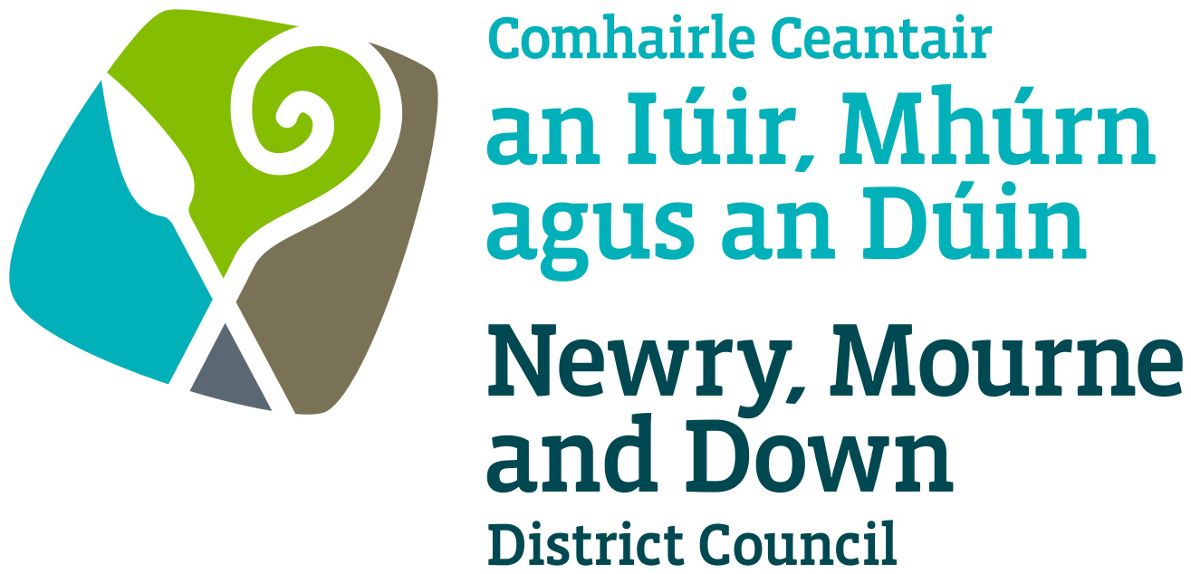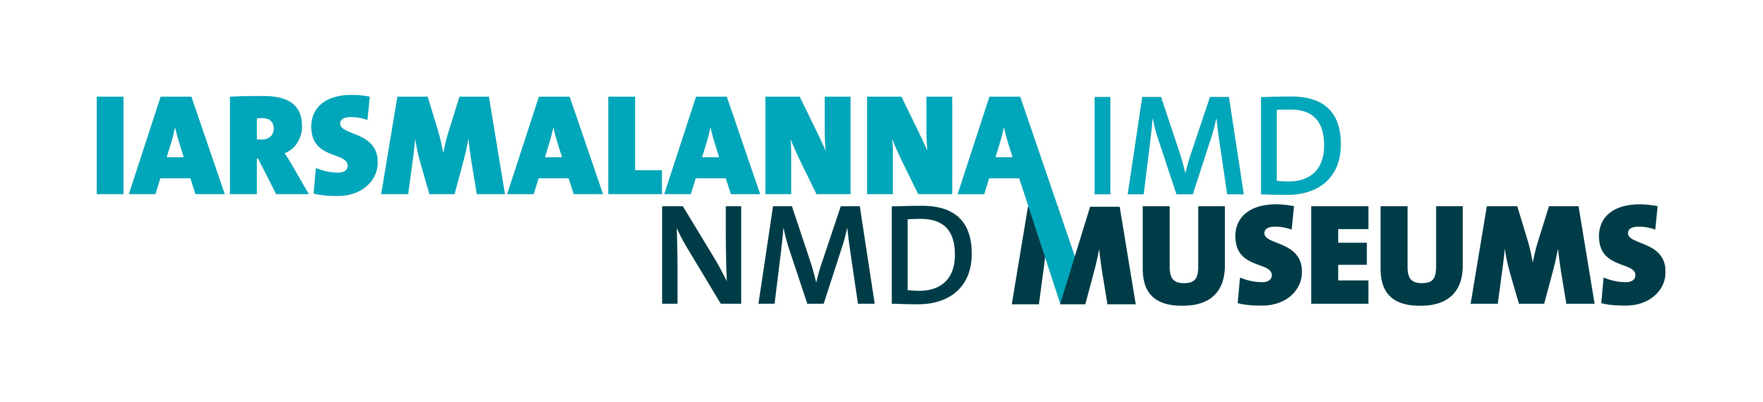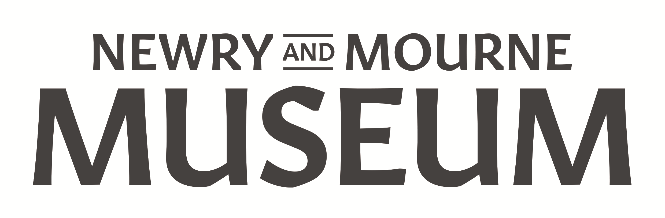
1. MISSION AND COMMITMENT

1.1 The collections held by Newry and Mourne Museum are at the core of the museum service and the unique role it plays in the community. These collections are essential to the Mission Statement of the Museum as set out in NMD Museums’ Forward Plan for 2023 – 2027.

1.2 The aims and objectives for NMD Museums’ Forward Plan are outlined under the five strands of Newry, Mourne and Down District Council’s Culture, Arts and Heritage Strategy 2022 – 2027: Placemaking, Education, Economic, Health and Well Being and Society and Community. The Conservation and Care Policy Statement is integral to the realisations of the aims and objectives under all of these strands.
This Policy also takes into account NDM Museums’ Sustainability Policy.

2. COLLECTIONS CONDITIONS OVERVIEW

2.1 A full collections condition overview of the Museum Collection, including artefacts on loan, was undertaken in 2013. This has been updated to include additions up to Spring of 2023. This overview sets out Newry and Mourne Museum’s approach to the care and conservation of the collections in its care and describes the improvements which will be made over time to improve collections care and conservation at the Museum and how these will be prioritised. Within this plan Care and Conservation Records are compiled to record conservation requirements for individual artefacts and collections.

The Collections Trust Spectrum Standard is used as the basis for condition checking and undertaking surveys.

3. PREVENTATIVE CONSERVATION

The International Council of Museums defines preventive conservation as “all measures and actions aimed at avoiding and minimizing future deterioration or loss.” These measures are indirect and do not impact on the materials, structure or appearance of an object.

The following measures implement preventive conservation at Newry and Mourne Museum:

3.1 Provision and maintenance of suitable building conditions
The Museum Curator is the Building Manager and is responsible for management of the museum building. Newry, Mourne and Down District Council, as owners of the building, are responsible for inspecting the buildings and undertaking repairs.

Collections are safeguarded through the following systems:
- Building management is undertaken through the NMD FM Portal. This includes building and facility security, internal and external environments and housekeeping, temperature of domestic heating system, fire prevention and evacuation, equipment, intruder alarms and Legionella.
- Building maintenance – monthly inspections of the building (exterior and interior) are carried out by the Museum Assistants and faults and issues are recorded and reported by the Building Manager and the Museum Services Officer using the NMD FM Portal.
- Mechanical and Electrical (M&E) Maintenance

All relevant M&E systems are covered by service contracts held centrally by Council and updated as required.

When capital developments are planned the care of the collections will be
taken into account and Museum Curatorial Staff will be involved in the
planning process.

Care and security of collections is also taken into account with regard to room hire to the public in the Museum.

3.2 Environmental monitoring
Newry and Mourne Museum monitors storage and display areas using the Hanwell Environmental Monitoring System, supplemented by hand-held meters as required. This system monitors relative humidity (RH), temperature, visible light and ultra-violet radiation (UV).

The Museum has a pest management programme in which insect traps are monitored on a monthly basis.

The Museum also collates, utilises and acts upon data to provide stable and appropriate collection environments.

3.3 Environmental control
Newry and Mourne Museum stores and displays collections in a managed environment that minimises their rate of deterioration, using the following control factors and methods:

3.3.1. Control factors:
- Relative humidity (RH): for general mixed media collections, 50 - 55%
RH with no more than a 5% deviation over a 24 hour period.
- Temperature: 12 – 17 degrees centigrade in storage areas and 18 – 21 degrees centigrade in exhibition galleries. There should be no more than a 1 degree deviation over a 24 hour period.
- Visible light: sensitive artefacts will displayed at 50 – 70 lux and more robust objects at 200 – 250 lux. Exposure times will be calculated based on estimates how long an artefact is exposed to light per day/week/month. Recommended exposure times for sensitive material is 100 – 120 kilolux hours per year and 580,000 kilolux hours for less sensitive artefacts.
- UV radiation: less than 75 mw/lm (micro watts per lumen)
- Display case construction: where appropriate objects are displayed in exhibition cases constructed using inert and conservation grade materials
including ZF MDF, fire retardant chipboard compliant with Class E1 requirements of BS EN 13986, conservation grade linings and paints. Prosorb
cassettes are used to maintain a stable RH and cases to do not contain lighting. All exhibition cases are constructed to security standards set out by the former MLA.
- Storage: collections in storage are housed in inert boxes on metal shelving. Arefacts stored in boxes are wrapped in acid-free tissue paper if appropriate and photographs and documents are placed in millenex envelopes. Large items are protected from dust with acid-free tissue paper and large documents are stored in metal map chests. Methods of storage will be in line with NMD Museums’ Sustainability Policy.

3.3.2. Control methods to be used:
- Relative Humidity (RH): Prosorb cassettes, humidifiers or dehumidifiers are used if required
- Temperature: conservation heating system
- Visible light: blinds
- UV Radiation: filtering films, daylight exclusion

Environmental control is managed in accordance with the NMD Museums’ Sustainability Policy to reduce use of natural resources in the Museum’s activities without compromising conservations standards.

3.4 Housekeeping

3.4.1 Cleaning
Housekeeping and cleaning programmes are followed in line with benchmarking standards. Staff and volunteers are trained to clean storage and display areas using methods and materials which are not detrimental to the collections. Vulnerable artefacts and areas have specific cleaning arrangements.

3.4.2 Quarantine procedures
New acquisitions and incoming materials are fully assessed and inspected prior to acquisition. If it is thought that an object may contain pests it is held in quarantine in a plastic box with an insect trap for one month, in a quarantine room. Items to be frozen are transferred to a conservator for this treatment. Items are acquired under the terms of the Museum’s Collection Development Policy and artefacts which are deemed to have a detrimental impact on the resources and facility of the Museum will not be accepted. This includes objects which might be infested with pests.

3.4.3 High risk organic material
Collections that are particularly vulnerable to insect infestation, e.g., feathers and fur, will be segregated to prevent the rapid spread of an infestation in the event of an outbreak. They will be stored in clearly marked boxes that are easily identifiable for regular visual inspections.

3.4.4 Pest monitoring
Pest monitoring traps are strategically located throughout the Museum building with special attention given to storage areas and galleries. These are inspected on a monthly basis and the results recorded. Should pests be repeatedly detected in an area, steps will be taken to eradicate the source or problem.

3.4.5. Exhibitions
Objects for exhibitions are chosen by the Curator and Collections Officer based on relevance to the exhibition themes and state of preservation of the object. The Collections Officer will liaise with conservators regarding conservation of the object, methods of display and special requirements.

In line with NMD Museums’ Sustainability Policy, display materials will re-used as far as is feasible in temporary exhibitions and resources shared with Down County Museum.

All loans for exhibitions are checked for pests and condition reports are prepared. Loans procedures are followed as set out in SPECTRUM and the Museum’s Documentation Procedural Manual.

3.5 Handling, moving and transport

3.5.1. Handling, moving and transport of artefacts is undertaken by the Collections Officer with the assistance of the Museum Assistants. All staff are trained in artefact handling techniques and handling and movement of objects are done with appropriate risk assessments.

3.5.2. The Museum Collection is accessible to the public for research purposes. However, fragile artefacts are withheld from public use. Where possible, copies of archival documents can be used instead. The ongoing digitisation of archival documents has reduced the need for handling by members of the public.

3.5.3. Movement of large items will be planned in advance with risk assessments and methods statements prepared. They will be packed and protected with conservation packing materials.

3.5.4 Items which are being moved to a conservator’s studio or another museum will be packed using conservation packing materials and taken by either the Curator or Collections Officer. Items which are to be transported farther afield will be taken by a courier.

3.5.5. Items will be moved in accordance with Movement Control procedures set out in SPECTRUM.

3.6 Disaster planning
Newry and Mourne Museum’s Emergency Plan is regularly reviewed and updated where necessary.

4. INTERVENTIVE CONSERVATION

4.1 Interventive conservation is the active treatment of an object to stabilise its
condition, or to enhance its condition, or some aspect of its significance for
study and interpretation. All interventive conservation carried out by Newry and Mourne Museum will be in accordance with the Museum Association’s Code of Ethics and the following principles:

4.2 Only appropriately qualified and experienced conservators will be employed to carry out conservation work. Museum Assistants and volunteers will only undertake basic cleaning of ceramic, glass, metal and wooden objects at the discretion of, and under the supervision of, the Collections Officer.

4.3 Conservation work should be underpinned by knowledge and understanding of the object. Critical to this is documentation of its condition and treatment, and a long-term plan for the care of the object.

4.4 Conservation work should be planned and carried out in consultation with
curatorial staff and undertaken by an appropriately qualified person, or
under the supervision of an appropriately qualified person.

4.5 Work undertaken by conservators for Newry and Mourne Museum will conform to the standards set down in the code of ethics of the United Kingdom Institute for
Conservation of Historic and Artistic Works (UKIC) and will be in line with
the Health and Safety at Work Act.

4.6 All treatments will be photographed and documented.

5. EXPERTISE, ADVICE AND SERVICES

5.1 Newry and Mourne Museum is committed to continuing professional development of its staff and volunteers and to the building of relevant knowledge and expertise.

5.2 Caring for the collections is the responsibility of all staff. The Collections Officer will provide training to raise awareness of collections care issues and how good collections care preserves museum collections for the future.

5.3 The Collections Officer will provide training in collection care to two volunteers / placement students per year over a six-month period in addition to training in other museum activities.

5.4 Newry and Mourne Museum will also provide advice to the public, including organisations with historic collections, on conservation issues and care of historic objects and documents to individuals or through occasional public lectures.

6. REVIEW

6.1 This Collections Care and Conservation Policy Statement will be submitted to Newry, Mourne and Down District Council for approval and will be reviewed every three years.

Policy established: July 2023

Review date: July 2026

