IARSMALANNA IMD
NMD MUSEUMS

DOCUMENTATION POLICY STATEMENT 2023 - 2026

JULY 2023

Responsibility of NMD Museums Curators

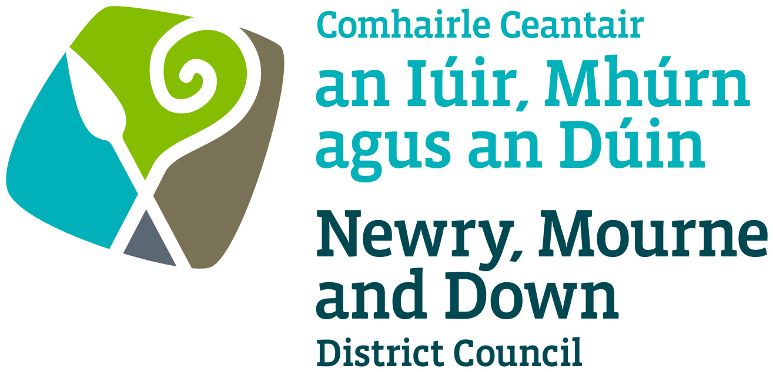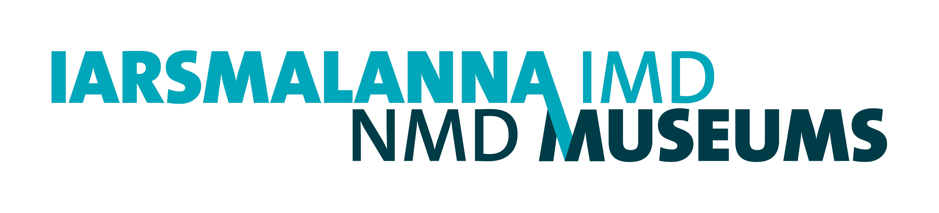
NMD Museums Documentation Policy Statement

1. Introduction

This policy NMD Museums’ (Down County Museum and Newry and Mourne Museum) approach to its collection documentation. It has been prepared in conjunction with the Collections Development Policy and Documentation Plans for each Museum NMD Museums Documentation ProceduralManual.

Documentation is all the information a museum holds about an object in its collection including what the object is, where it came from, how it should be stored and where it is stored or displayed. Documentation underpins every aspect of museum activity. Recording collection information is central to being accountable for the collections, their accessibility, management, research, study and use.

This policy is designed to ensure our collections documentation provides useful and useable information, linked to the Mission Statement of Newry, Mourne and Down Museums (NDM Museums), and that our activities meet ethical commitments and legal requirements.

A commitment to documentation is made in the Forward Plan 2023-26, through Strategic Objective 5; Developing and valuing our collection. NMD Museums is committed to maintaining a collections management framework to ensure that the future care, preservation, development, and presentation of the Collection are maintained to museum best practice and to the Accreditation Standard.

- Mission of NMD Museums

The Vision, Mission, and Values of NMD Museums are set out in the Forward Plan 2023-2026. The Mission Statement is

- To collect, care for and research our rich cultural heritage to support continued understanding of our history, culture, and environment.

- To connect residents and visitors to our collections, place and history through dynamic and inclusive exhibitions and activities.

- To celebrate our unique places and identities.

3. Aims and Objectives
The aim of this Policy is to ensure that we fulfill our guardianship, stewardship, and access responsibilities in line with NMD Museums Mission Statement. Through implementation of this policy the Museum aims to maintain Spectrum Standard in all areas of documentation.
Committing to the principles outlined in this Policy will:

- Improve accountability for the collections.
- Maintain at least minimum Spectrum Standard in documentation procedures and collection information and attain the very highest standards wherever possible, to ensure the preservation of the Collection for future generations.
- Improve access to Collection information.
- Control security and access to the Museum Collection, including sensitive information.

4. Standards

NMD Museums will meet the Accreditation Standard for documentation. The Museum Accreditation Standard for documentation is drawn from Spectrum 5.1, the UK Museum Collections Management Standard. Spectrum represents a common understanding of good practice for collections management in museums.
While the Spectrum Standard includes 21 procedures, Museum Accreditation requires compliance with the nine Primary Procedures (listed below) and encourages the pursuit of the full Spectrum Standard as museums are able.
Primary Procedures:
  - Object entry
  - Acquisition and accessioning
  - Location and movement control
  - Inventory
  - Cataloguing
  - Object exit
  - Loans in (borrowing objects)
  - Loans out (lending objects)
  - Documentation planning

NMD Museums will follow Spectrum Standard for the other procedures when relevant:

Other Procedures:
  - Condition checking and technical assessment
  - Collections care and conservation
  - Valuation
  - Insurance and indemnity
  - Emergency planning for collections
  - Damage and loss
  - Deaccessioning and disposal
  - Rights management
  - Reproduction
  - Use of collections

Collections Management System and MDA Code
NMD Museums use MODES Complete as a Collections Management System and continue to use the MDA museum codes (DOWDM for Down County Museum and NRNMM for Newry and Mourne Museum) when accessioning objects as well as for inventory marking/labelling, for ease of identification and movement control.

5. Levels of Documentation for Archival Collections

5.1 NMD Museums is committed to record significant information about the objects in our care so that each object we are legally responsible for (including loans as well as permanent collections) can be identified and located.

For the majority of the collections, curatorial staff document to individual item level. However, in the case of bundles of documents which are part of larger archival collections, it is neither feasible nor practical to document the material to this detail, and these items are documented to group level. Bundles have an accession number and a description of contents on the MODES database. The Museum aims to have a detailed catalogue entry for all identified items and groups within the collection.
The Museum documents collections to catalogue level, as described below:

- Catalogue level: all collections/objects will have detailed documentation, thus raising the standard of information to catalogue level. Such documentation will include the known history of an artefact, and references to any relevant publications etc.

5.2 NMD Museums does not accept long term or ‘permanent’ loans from private individuals but will accept short term loans for temporary exhibitions. At Newry and Mourne Museum have long term loan agreements are in place with National Museums Northern Ireland to fill gaps in the main galleries. Loans documentation (entry forms, condition reports and insurance records) are kept on file and on our computer system. Loans are not catalogued on the main MODES database.

6. Accessibility

6.1 NMD Museum’s documentation system will be developed to maintain and extend access to collections information, so that it can be made available to internal and external users as appropriate.

Currently details of all accessioned objects are entered on the Museum’s Collection Management System, MODES. All items added to the Collection will be entered on this database as per the Spectrum acquisition and accessioning primary procedures.
In order to ensure that our current system does not become obsolete, the Museum will remain informed of system updates and ensure the long-term accessibility of the information held. We are members of the MODES Association and receive regular updates on new software.
6.2 Controlled Access to Sensitive Information
NMD Museums will consider all legal requirements as laid out in the BSI’s PAS 197:2009. and will also be aware of the following:
- General Data Protection Regulations (GDPR)
- Freedom of Information Act (2000)

In consultation with Newry Mourne and Down District Council’s Compliance Section all requests for information will be considered in terms of compliance with GDPR and the Freedom of Information Act (2000) and the Environmental Information Regulation (2004). We will review requests for confidential data (such as donor information, environmental information, valuations or site details) on a case-by-case basis, and in accordance with the applicable legislation and any legal agreements or conditions of gift.

7. Security

NMD Museums has measures in place to ensure the physical security and long-term preservation of all documentation records, whether paper or digital. Staff will update all manual and digital records as appropriate. Regular backups will be made to secure digital data, which is stored on servers off site.

8. Review

This Documentation Policy will be submitted to Newry, Mourne and Down District Council for approval. It will be used to inform a Documentation Plan and will be reviewed in 2026.

Policy Established: July 2023

Review date: July 2026

