IARSMALANNA IMD
NMD MUSEUMS

ACCESS POLICY

JULY 2023

Responsibility of the Education and Outreach Officers

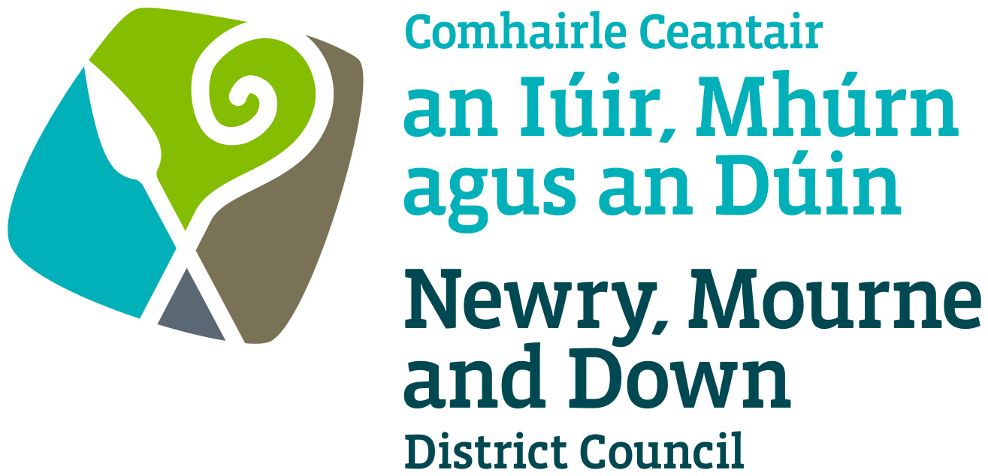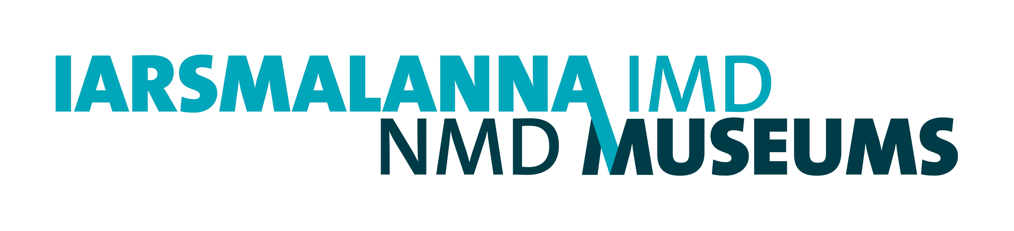

NMD Museums – Access Policy

Newry, Mourne and Down District Council was established in 2015, merging Down District Council and Newry and Mourne District Council

Newry and Mourne Down Museums is the service offered by the two Museums operating in those two previous jurisdictions.

Access Policy

Context

Down County Museum was established in 1981 to serve as a resource for the people of County Down to explore and understand their past, their cultural heritage, and their material culture. The Museum is based in the historic buildings of the late eighteenth-century gaol of Down. The Museum’s collection numbers over 11,000 objects and 50,000 photographic images.

Newry and Mourne Museum established in 1986, is housed in a restored 16th century fortified house, Bagenal’s Castle, and adjoining 19th century warehouse. It provides an important tourism, cultural and heritage resource for the area. The Museum galleries which interpret the history of the Castle and the development of the area from earliest times provide a leisure and learning service to the local community and visitor.

2. Strategic planning

2.1 The Museums’ Vision is to preserve and promote our past, enriching our present and building our future together. In developing a joint statement of our mission and values, we show our commitment to continued access to our collections and facilities.

Our Mission
To COLLECT, CARE for and RESEARCH our rich cultural heritage to support continued understanding of our history, culture, and environment.
To CONNECT residents and visitors to our collections, place and history through dynamic and inclusive exhibitions and activities.
To CELEBRATE our unique places and identities.

Our Values
We will:
- Provide a service which is professional, authentic, and sustainable.
- Be open, accessible, and welcoming to diverse audiences.
- Engage with our audiences through dynamic, lively, and resourceful activities.
- Respect and take pride in our community, historic places, and collections.
- Connect, collaborate, and communicate effectively.

- Access Aims

We aim to provide all members of our community and visitors with the resources to explore Newry, Mourne and Down’s rich cultural heritage. We have a responsibility to provide welcoming spaces where local people and visitors can interact with our collections and historic buildings, and where they can enjoy a diverse range of events in a secure shared environment.
We continue to review access and make improvements to our access provision, through Access Audits to identify action points and determine priorities.

Both Museums were access audited in 2021 by Access Matters. The findings and recommendations of this report will be actioned on an ongoing basis and will develop into NMD Museums Access Plan.

3.1 Physical access at NMD Museums

- Lift access to all levels.
- Assistance dogs are welcome throughout the Museums.
- Portable stools/chairs for gallery use.
- Staff are trained in evacuation procedures including fire refuge points, and evacuation chairs.
- First Aid is provided by Museum staff. Their names and contact details are signposted throughout the Museums. Accident books, first aid kits and defibrillators are onsite.
- Baby change facilities are located within accessible toilets on the ground floor.
- Outreach. Handling sessions, reminiscence work, etc for those with additional access and sensory needs for whom a physical visit would be a barrier.

3.2 Physical access at DCM

The Museum seeks to provide all visitors with access to the restored gaol buildings, museum galleries, historic gaol site and visitor facilities, making alternative provision where required, within the constraints of a Grade Two listed site.
Physical access is supported by:
- Level access and ramped entrances to all buildings, galleries, and most facilities.
- Wheelchair available at the entrance for use.
- Toilets and accessible toilets in adjacent locations.
- Tactile orientation model of the museum site and tactile objects on display.
- Induction loop in the function room.
- Disabled parking bays on the street.

Priorities for improvement as identified in the Access Audit 2021 are:
- restoration of courtyard surface and accessible pathway to improve access for those with mobility needs.
- toilets
- signage and site interpretation

  - Physical access at NMM
The Museum is fully accessible by wheelchair-users with a passenger lift to all levels. The Museum has one entrance.

- Parking is free onsite.
- Disabled parking bays onsite
- Level access into the building.
- Accessible toilet on the ground floor.
- Induction loop available at Reception and in the Banqueting Room.
- Free audio-guides are available.

Priorities for improvement as identified in the Access Audit 2021 are:

- Develop new or reprint leaflet current to include access details with location map, site plan.
- Develop a standard procedure for bookings, identifying needs and requirements.
- Clear mark out parking bays and define Museum area.

b) Intellectual and community access

Both museums promote and deliver intellectual and community access through:

- School sessions are tailored to different learning styles, including multi-sensory sessions, which support students with additional needs.
- Guided tours, talks, handling sessions and other activities for a variety of audiences.
- Exhibition space for community groups and a programme of temporary exhibitions with complementary activities.
- Publications in print and online.
- Website to provide enhanced access to the collection.
- Social media presence, including FB, Twitter, and Instagram
- Provision of information leaflets in a range of languages at DCM. Multi-language audio guides at NMM.
- Collaboration with other council departments, the voluntary sector, and other organisations to broaden and enhance community access.
- NMM offers placements for university students and provides volunteer opportunities and associated training.
- Information about facilities and services can be requested in advance of a visit.
Priorities for improvement:
- Enhances accessibility to the website, including alt text on all images.
- Improved interpretation in gallery text to enhance readability, agree an interpretation standard.

c) Access issues

We also aim to provide access to visitor facilities for the widest possible number of people.

- Access to the museums is free.
- Opening hours: Tuesday to Saturday, and specified Bank Holidays. Mondays or evenings openings can be arranged in support of community development.
- Room hire is provided to community groups and other organisations, at concessionary rates to charities.
- Advice on family history, local history and other enquiries is provided by Museum staff.

6. Recruitment, staff training and development

6.1 The Museum is part of Newry, Mourne and Down District Council and adheres to its recruitment practices. People with disabilities receive equal opportunities in recruitment, employment, and training.

6.2 Museum staff receive appropriate training from various agencies in access-related issues.

6.3 The Museum adheres to Council policy in child and vulnerable adult protection/safeguarding, health and safety and data protection.

7. Implementation and review

The Access Policy will be submitted to Newry, Mourne and Down District Council for approval and will be reviewed every five years.

Policy Established: July 2023

Review date: July 2026

