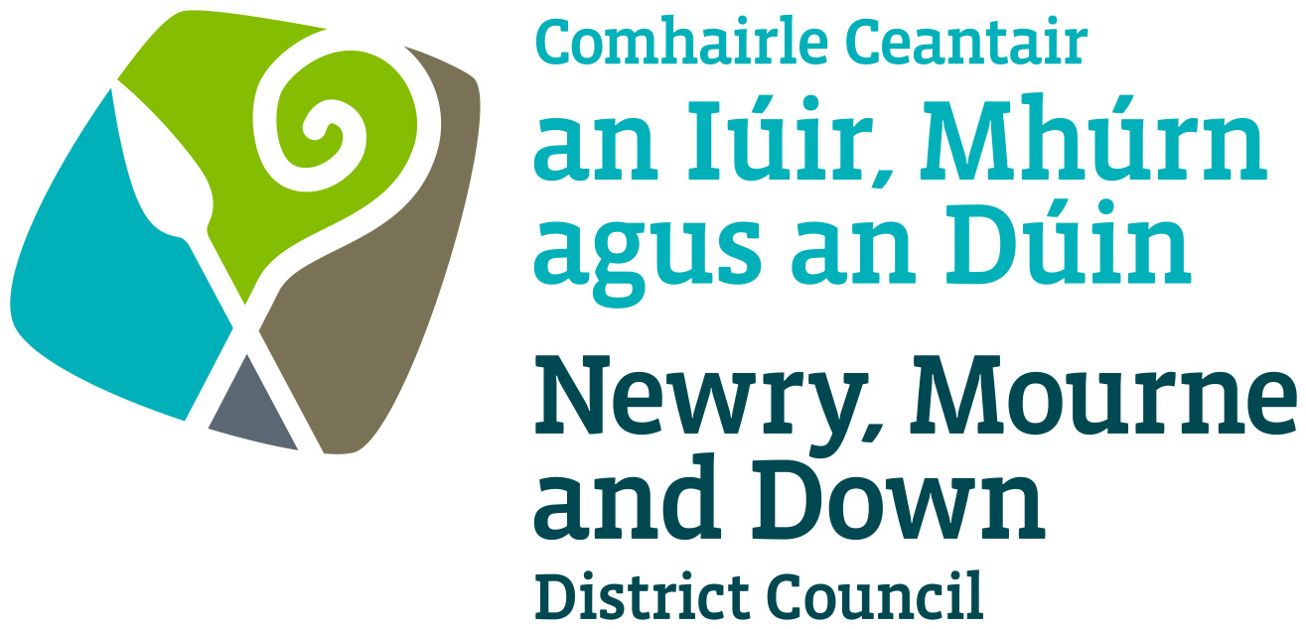

Street Trading

Enforcement/Seizure
Policy

NEWRY MOURNE AND DOWN DISTRICT COUNCIL

ECONOMY REGENERATION AND TOURISM DEPARTMENT

Dated: 11 September 2023

CONTENTS

 | Page | Paragraph
Purpose | 1 | 1
Scope | 1 | 2
References | 1 | 3
Background | 1 | 4
General Principles | 1 | 5
Contravention of Licensing Conditions | 2 | 6
Unlicensed Street Trading | 2 | 7
Revocation of a Street Trading Licence | 3-4 | 8
Powers of Seizure | 4 | 9
Policy Owner | 4 | 10
Contact Details in regard of this Policy | 4 | 11
Policy Authorisation | 5 | 12
Policy Effective Date | 5 | 13
Policy Review Date | 5 | 14
Procedures | 5 | 15
Equality Screening | 5 | 16
Rural Impact Assessment | 5 | 17

1. Purpose

By virtue of Sections 16 to 22 (inclusive) of the Street Trading Act (Northern Ireland) 2001 the Council may regulate street trading through enforcement powers in a street or part thereof in it’s District.

2. Scope

This Policy is intended to ensure that Newry Mourne and Down District Council Members and Officers are aware of those matters to be taken into consideration when determining, what if any, enforcement action is to be taken.

3. References

  - Street Trading Act (Northern Ireland) 2001
  - Guide to the Street Trading Act (Northern Ireland) 2001.
  - Fixed Penalty

4. Background

The Street Trading Act (Northern Ireland) 2001 enables District Councils to regulate Street Trading through designating, licensing and enforcement procedures. The Act received Royal Assent on the 5 April 2001, with a run-in period of 6 months and became operative on 1 October 2001. The new Act repealed most of the provisions of the 1929 Street Trading (Regulation) Act, except Section 10, which contains the provisions whereby Market Rights can be acquired or extinguished.

Section 17 of the Act details those street trading activities which would be in contravention of the Street Trading Act (Northern Ireland) 2001 and which would be enforced by means of a fixed penalty, a prosecution or seizure by authorised officers of the District Council.

5. General Principles

5.1 Each case must be considered by its own merits, but there are general principles that apply in all cases. The duty of Newry Mourne and Down District Council is to make sure that each trading situation is fairly and objectively assessed and that all relevant factors are considered.

6. Contravention of Licensing Conditions

When an authorised officer of the Council or a Constable upon becoming aware of a contravention of conditions of a street trading licence, the licensee may be cautioned in regard to the contravention. A Council may at any time revoke a street trading licence. A fixed penalty notice may be issued.

Contraventions
Any person who: -
- without reasonable excuse contravenes any condition of a street trading licence, which is a condition of a kind specified in paragraph (b) (d) (e) (f) or (g) of Section 7 (1) of the Act;
- fails on demand and without reasonable excuse to produce his street trading licence or temporary licence to an authorised officer of a constable;
- fails, on being required to do so under section16(2) of the Act, to state his name and address or states a name or an address that is incorrect;
- in connection with an application for the grant, renewal or variation of a street trading licence or the grant of a temporary licence makes a statement which he knows to be false in a material particular;
- resists or intentionally obstructs an authorised officer in the execution of his duties under this Act.

7. Unlicensed Street Trading

  - Section 17(1) of the Street Trading Act (NI) 2001 states that a person who-
- engages in street trading in a district and is not the holder of a street trading licence or a temporary licence granted by the Council for the district;
- is the holder of a street trading licence and contravenes a condition of a kind specified in paragraph (a) or (c) of Section 7(1) of the Act; or
- is the holder of a temporary licence and engages in street trading on a day or in a place not specified in that temporary licence;
shall be guilty of an offence and liable on summary conviction to a fine not exceeding level 3 of the standard scale.

7.2 It shall be the policy of the District Council that when an authorised officer of the Council or a constable has reasonable grounds for suspecting that a person is engaged in unlicensed street trading, then the authorised officer or a constable may: -

- if the Officer/Constable knows or is satisfied with the identity given by the trader then he/she shall proceed with initiation of legal proceedings against him/her and advise the trader to stop trading immediately. Failure to comply will result in seizure powers being invoked.
- If the Officer/Constable is not satisfied with the identity given by that trader or cannot verify this identity, then the authorised Officer/Constable should begin seizure powers immediately. All possible steps shall be taken by the Council to ascertain the identity of alleged offender to initiate legal proceeding against him/her.

8. Revocation of a Street Trading Licence

8.1 (1) Council may at any time revoke a street trading licence if it is satisfied that:
- owing to circumstances which have arisen since the grant or renewal of the licence -
  - the location of the street trading pitch on which the licence holder trades as a stationary trader has become unsuitable, or
  - the space in the designated street in which the licence holder trades as a stationary trader has become inadequate for him to engage in the trading permitted by the licence without causing undue interference or inconvenience to persons or vehicles using the street; or
  - the area or areas of the district in which the licence holder trades as a mobile trader have become unsuitable for the licence holder to do so without causing undue interference or inconvenience to persons or vehicles in the area or areas;
    - a designating resolution has been rescinded or varied with respect to the street in which the licence holder trades as a stationary trader;
    - the licence holder has, without reasonable excuse, failed to avail himself to a reasonable extent of his licence;
    - the licence holder has, in connection with an application under section 5 with respect to the licence, made a statement which he knows to be false in a material particular;
    - the licence holder is, on account of misconduct or some other reason relating to trading activities that has come to the attention of the Council since the grant or renewal of the licence, unsuitable to hold the licence;
    - the licence holder has, without reasonable explanation, failed to pay any fees or charges due to the council under section 15;
    - the licence holder has persistently failed to remove to a place of storage the receptacles used by him for trading; or
    - the licence holder has persistently failed to comply with any condition of his licence.

8.2 (2) A Council shall not take any steps to revoke a licence under paragraph
(g) or (h) of subsection (1) unless –
- it has notified the licence holder in writing of the conduct on his part that it considers to constitute a failure of a kind mention in either of those paragraphs; and
- the licence holder has thereafter continued or repeated that conduct.

8.3 (3) If the Council considers that a licence could be revoked on any of the
grounds mention in paragraphs (a) to (c) of subsection (1) the Council
may instead of revoking it, vary its conditions under section 11(1) by-
- reducing the number of days in any week or the period in any one day during which the licence holder is permitted to trade; or
- specifying –
  - in relation to a licence holder who trades as a stationary trader, a different street trading pitch in the designated street in which he trades, or a street trading pitch in another designated street, or
  - in relation to a licence holder who trades as a mobile trader, a different area or different areas.

In which the licence holder may sell articles or things, or supply a service; or
(c) restricting the description of articles, things or services in which the licence holder is permitted to trade.

8.4 The Council may revoke a Temporary Street Trading Licence where the holder of a temporary licence has failed to comply with any of the conditions specified in the licence. The District Council will consider any representation made to the Council by the holder of the temporary licence under its Hearing of Representations Procedures, before deciding to revoke a licence.

9. Powers of Seizure

If an authorised officer or constable has reasonable grounds for suspecting that a person has committed an offence under section 17 of the Act, he may seize: -
- any article or thing being offered or exposed for sale by that persons.
- Any other article or thing of a similar nature to that being offered or exposed for sale which is in the possession or under the control of that person; and
- Any receptacle or equipment being used by that person.

Which may require to be used as evidence in any proceedings or may be the subject of an application for a forfeiture order under section 19 of the Act.
3

10. Policy Owner

Mr Conor Mallon, Director of Economy, Regeneration and Tourism

11. Contact Details in regard of this Policy

Mr Jonathan McGilly
Assistant Director of Economy, Regeneration and Tourism
Newry, Mourne and Down District Council
O’Hagan House
Monaghan Row
Newry
BT35 8DJ

Telephone: 0330 137 4000

12. Policy Authorisation

Development Committee Meeting Authorised on: 11 September 2023
Council Authorised on: 02 October 2023

13. Policy Effective Date
02 October 2023

14. Policy Review Date
02 October 2027

The policy will be reviewed in line with the Council’s agreed policy review cycle i.e. every 4 years (as per Council’s Equality Scheme commitment 4.31).

15. Procedures

Refer to the Street Trading Designation Procedure.

16. Equality Screening

The policy has been equality screened, and the outcome is that it not be subject to an EQIA (with no mitigating measures required).

17. Rural Impact Assessment
Due regard to rural needs has been considered and a rural needs impact assessment has been completed.

Version 2.0
4.

