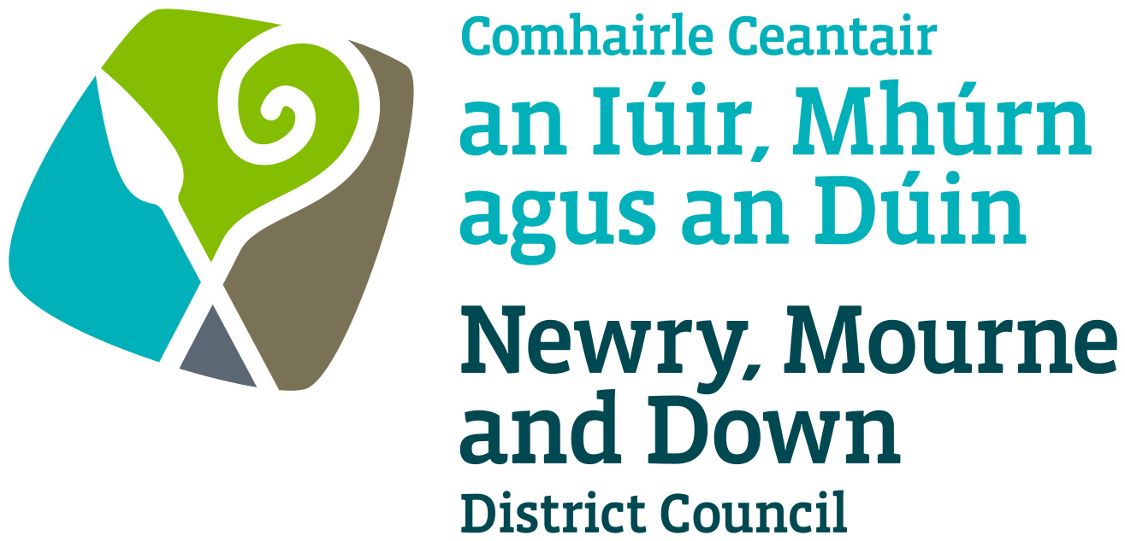

Street Trading

Designation
Policy

NEWRY, MOURNE & DOWN DISTRICT COUNCIL

ECONOMY REGENERATION AND TOURISM DEPARTMENT

Dated: 11 September 2023

CONTENTS

 | Page | Paragraph
Purpose | 1 | 1
Scope | 1 | 2
References | 1 | 3
Background | 1-2 | 4
General Principles | 2-3 | 5
Street Trading Designation Procedure | 3-4 | 6
Applications to Trade | 4 | 7
Appeals | 5 | 8
Policy Owner | 5 | 9
Contact Details in regard of this Policy | 5 | 10
Policy Authorisation | 5 | 11
Policy Effective Date | 5 | 12
Policy Review Date | 5 | 13
Procedures | 5 | 14
Equality Screening | 6 | 15
Rural Impact Assessment | 6 | 16

1. Purpose

By virtue of Section 3 of the Street Trading Act (Northern Ireland) 2001 the District Council may pass a Resolution Designating a street in which it may allocate trading pitches to holders of street trading licences.

The purpose of this Policy is to provide guidance on matters, which should be considered when deciding whether to designate a street or part thereof for Street Trading. Its aim is to provide, insofar as is possible, consistent decision making so as to develop and thereafter maintain public confidence in Newry, Mourne and Down District Council’s (here after called ‘the District Council’) performance of its duties.

2. Scope

This Policy is intended to ensure that the District Council’s Members and Officers are aware of those matters to be taken into consideration when determining if a street of part thereof should be designated for the purposed of the Street Trading Act (Northern Ireland) 2001.

Initially the District Council will consider those areas in respect of which applications have been received for, or are already licensed for, street trading (including those areas where applications have previously been refused).

The District Council will consider on an annual basis in October of each year any new areas proposed for designation. The District Council will also take these opportunities to review existing designated sites. In so doing the District Council will consider all representations made to it in respect of said areas.

The District Council will review all annual licences in October of each year prior to renewal using the above criteria, and in accordance with its Stationary Licence Policy.

3. References

3.1 Street Trading Act (Northern Ireland) 2001
3.2 Guide to The Street Trading Act (Northern Ireland) 2001

4. Background
The Street Trading Act (Northern Ireland) 2001 (here after called ‘the Act’) enables District Councils to regulate street trading, by preventing undue nuisance, interference or inconvenience to people and traffic. The Act came into force on the 1st October 2001. The new Act repealed most of the provisions of the Street Trading (Regulation) Act 1929, except Section 10, which contains the provisions whereby Market Rights can be acquired or extinguished.

The Act requires the District Council to designate specific areas, streets or part thereof in the District Council as being suitable for street trading. This is designed to be an open system, which allows everyone an opportunity to comment on the proposal to permit street trading in a particular area.

5. General Principles

Each case must be considered on its own merits, but there are general principles that apply in all cases. The first duty of the District Council is to make sure that each location is fairly, independently, objectively assessed and that all relevant facts are considered.

Consultees

The District Council will consult with: –
- The Sub-Divisional Commander of the Police Service of Northern Ireland (PSNI) in which the streets are situated;

- The Department for Regional Development as regards that
Department’s functions with respect to roads and regulation of road traffic.

The District Council may also consult other persons, as it considers appropriate for example: -
- The District Council’s Planning Department
- Relevant Chamber of Commerce/Trade
- Town Centre Management Bodies
- Community Groups/Local residents.
- Business and Commercial premises in the vicinity of the site in respect of which the application has been received.
- The District Council may consult other persons, as it deems appropriate

5.2 Additional Factors

Without prejudice to the District Council’s rights, the District Council shall take account of the following in determining the suitability of each proposed street trading designation: -

- The safety of the public and any risks which may arise;

- The future development plans for the location;

- The appropriateness and suitability of the site and commodities in relation to the location and to the potential adverse impact that it would have upon the character and appearance of the area in question;

- The proximity of existing street traders and retail outlets, trading in similar goods in the immediate vicinity;

- The amount of interference or inconvenience to persons or vehicles using the street;

- The potential environmental effects arising from the location of the proposed designated site and/or the commodity on sale, such as additional litter, cleansing requirements, noise, odour and the possibility of increasing anti-social activities;

- Any Statutory Provision which would be appropriate to consider;

- Complaints arising from or about the current trading location;
- Any other relevant facts;

- Type of trading – Hot Food; Horticultural (Plants, flowers etc);
Produce (fish, fruit etc) and open use;

- Hours of trading;

- Period of licence for review.

5.3 These issues may also be taken into account should the District Council decide to rescind or vary any Designating Resolution.

Street Trading Designation

  - Where in relation to any street, a request has been received for a
Designated Trading area, a report will be taken before Council for consideration: -
- before a proposal for a Street Designation is considered
- before any additional trading areas are Designated.

6.2 Where in relation to any street, a District Council proposes to pass a designation resolution, the District Council shall: -
- Publish notice of its intention to do so in 2 or more newspapers circulating in its district, the council website and Facebook page.
- Inform all of the relevant business owners in the vicinity in writing.
- Consult with its nominated consultees.

  - Where a District Council proposes to pass a resolution it shall also consult licence holders who trade from street trading pitches in the street to which the proposed resolution would apply, and any body representative of those traders.

6.4 The notice referred to in section 6.1 (a) above –
(a) shall contain a draft of the proposed resolution; and
(b) shall state that representations relating to it may be made in writing to the District Council within such period, being not less than 28 days from the date of first publication of the notice, as may be specified in the notice.

6.5 Not less than 28 days after the first publications of the notice in the paper the District Council will consider all written representations from statutory consultees and any other persons in accordance with its Hearing of Representations Procedures.

6.6 After the District Council has considered those representations, it may if it thinks fit pass the designating resolutions.

6.7 The District Council will specify when the resolution comes into effect, this must be: -
- No sooner than 28 days after the date of passing the Resolution
- No sooner than 28 days after the decision was first published in press.

6.8 On coming to a determination the District Council will publish its decision, on two consecutive weeks in at least two newspapers circulating in the District.

6.9 The District Council may at any time vary or rescind a designating resolution using the above procedures.

7. Applications to Trade

7.1 After the designation resolution period has elapsed the District Council will consider all written applications to trade at the designated site/area.

7.2 All applications will be considered using the Stationary Licence Policy.

7.4 The District Council will not issue a licence under the Act to permit street trading from a stationary position in a street which has not been designated.

8. Appeals

There is no right of appeal against the decisions to pass, revoke or vary a Designation Resolution.

9. Policy Owner

Mr Conor Mallon, Director of Economy, Regeneration and Tourism

10. Contact Details in regard of this Policy

Mr Jonathan McGilly
Assistant Director of Economy, Regeneration and Tourism
Newry, Mourne and Down District Council
O’Hagan House
Monaghan Row
Newry
BT35 8DJ

Telephone: 0330 137 4000

11. Policy Authorisation

Development Committee Meeting Authorised on: 11 September 2023
Council Authorised on: 02 October 2023

12. Policy Effective Date
02 October 2023

13. Policy Review Date
02 October 2027

The policy will be reviewed in line with the Council’s agreed policy review cycle i.e. every 4 years (as per Council’s Equality Scheme commitment 4.31).

14. Procedures

Refer to the Street Trading Designation Procedure.

15. Equality Screening

The policy has been equality screened, and the outcome is that it not be subject to an EQIA (with no mitigating measures required).

16. Rural Impact Assessment
Due regard to rural needs has been considered and a rural needs impact assessment has been completed.

Version 2.0

