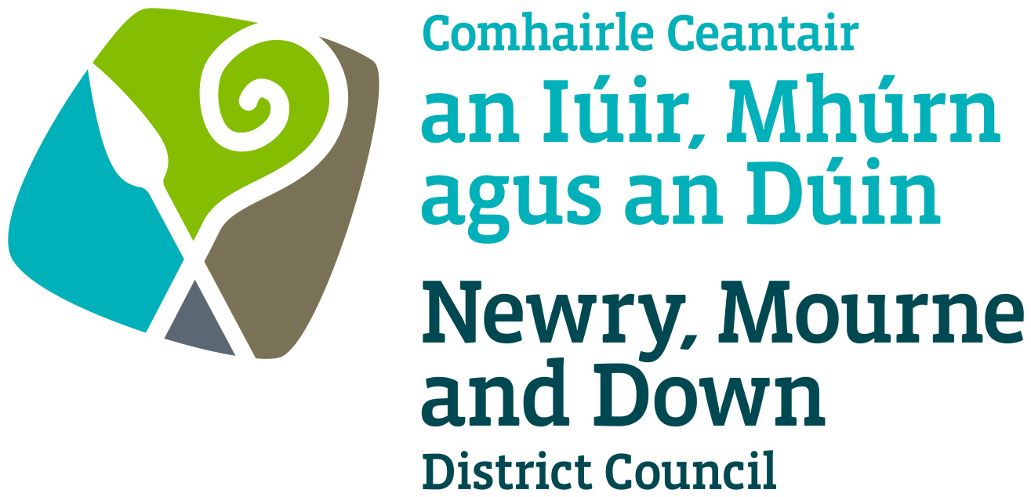

Elected Member
Learning & Development Policy

November 2014

- Title

Elected Member Learning & Development Policy

- Statement

2.1 The purpose of this policy is to set out Newry Mourne & Down District Council’s approach to helping Members develop their own performance and contribution to lead and serve a District that is ambitious, prosperous, healthy, sustainable & desirable.

2.2 Newry Mourne & Down District Council is committed to providing quality services, which represent good value for money and make their council areas a better place to live, work and visit.

2.3 Elected Members are integral to achieving each Council’s aims and strategic objectives and to the delivery of high quality services.

- Aim

Newry Mourne & Down District Council is working to support the development of all its Elected Members to enable them to perform effectively in their roles and to develop to meet future challenges and potential expansion of their roles. We are therefore committed to ensuring that:

- All Elected Members have access to appropriate learning and development activities to enable them to acquire the knowledge and skills required to be an effective Elected Member.
- A planned and structured approach to Elected Member learning and development needs is taken.
- Access to learning and development activities is equitable.
- Learning and development, wherever possible, should be linked to Members roles.
- Member learning and development activities should be adequately resourced and within available budgets.
- Members should be encouraged to identify their own development needs and participate fully in learning and development activities.
- An agreed Member learning and development programme will be produced which will be linked to the Council’s strategic plan, the roles and function of councillors and the key changes affecting the Council’s priorities.
- Members will routinely be invited to assess their individual training needs; necessary for their Corporate role. This will assist the Human Resources (HR) Department to work with Members to identify appropriate learning and development interventions. This will also form the basis for individual Personal Development Plans (PDPs) designed to meet learning and development needs.

- Scope

4.1 This policy is intended to be a common framework for the provision of all Elected Member learning and development within Newry Mourne & Down District Council.

- Equality of Opportunity

  - Elected Members will have the opportunity to benefit from learning and development opportunities, regardless of ability, age, gender, religion, race, political persuasion, colour, sexual orientation or disability.

  - Elected Members will have equal access to information relating to learning and development opportunities.

  - Elected Members will have equal access to participation in learning and development opportunities which supports the needs of their roles and responsibilities. Every effort will be made where possible, to ensure arrangements for training events take account of those with work and/or family commitments.

  - All learning and development provisions will conform to the Council’s equal opportunities policies and practices.

- Related Policies

6.1 Procedure for Elected Members Wishing to Undertake Accredited Training Programmes

- Definitions

Identification of Learning and Development Needs

Learning and development needs will be identified at a number of levels.

7.1 Individual
- Each Elected Member will routinely be invited to assess their individual learning and development needs and create his/her own PDP.
- Newly Elected Members will have an opportunity to discuss learning and development needs as part of their induction.
- Should they wish to do so, Members can discuss their learning and development needs on a one to one basis with the Council’s Learning and Development Officer.

7.2 Role Specific
- Each Elected Member role will have a role description (Refer to Appendices 1-3)
- Members whose roles change will be encouraged to review their learning and development needs.

7.3 Corporate
- Elected Members will have opportunties to participate in learning and development relating to commonly identified corporate issues (such as matters relating to the Corporate Plan, Organisational and Legislative changes and requriements etc.)

8.0 Learning and Development Programme

8.1 To ensure that the maximum is achieved for the investment, learning activities need to be planned. To do this, the Elected Member Development Sub Committee will agree the learning and development programme for approval by Council.

8.2 The purpose of the programme is to:

- Establish clear priorities for learning and development and show linkage to the Council’s corporate plan.
- Enable identified needs to be prioritised and linked to the Council’s corporate plan.
- Identify appropriate development methods.
- Identify resources required to deliver the plan and any resources gaps.
- Provide a framework for evaluation.
- Ensure the best use is made from learning and development financial budgets and other resources.

8.3 A flexible approach to the delivery of learning and development will be adopted to make use of the different development methods available and meet the needs of Elected Members.

8.4 Where appropriate, shared Member and officer development activities will be encouraged.

- Individual Requests for Learning and Development.

9.1 Should an Elected Member wish to attend a specific training event / Conference, it should be raised and considered at a full Council meeting under a Standing Agenda Item of Learning / Training Activities. The criteria for approval should be as follows:

- What is/are the learning objective(s)?
- What Corporate Objective(s)does it relate to?
- What's the benefit to the Elected Member?
- What's the benefit to the Council?
- What's the benefit to the Community?

- Accredited Training Programmes
Accredited Training is training undertaken by an Elected Member which leads to the award of a recognised academic/vocational/professional qualification. Courses are normally undertaken at college in the evenings, on a day release basis or through open learning.

The process for Elected Members to avail of such learning and development opportunities is set out in the separate Procedure for Elected Members Wishing to Undertake Accredited Training Programmes.

11. Evaluating Learning & Development
11.1 Following attendance at a training event / Conference, Elected Member(s) will share their learning with other Members at the next Council meeting using the following format:

- Was/were the learning objective(s) met?
- What did the Elected Member learn?
- How can that benefit Newry Mourne & Down District Council?
- How can that benefit the Community?

12 Resources to Support Elected Member Learning and Development.

12.1 Elected Member learning and development will be resourced from an allocated Elected Member development budget, which will be reviewed annually in line with the estimates process. This budget will be prioritised to cover priority needs linked to the member learning and development programme and corporate learning and development needs.

12.2 When attending learning and development events, Elected Members will be entitled to travel and subsistence in accordance with normal allowance rules.

12.3 The Elected Member development budget will be administered through Human Resources by the Learning & Development Officer and overseen by the Elected Member Development Sub Committee.

13. Learning and Development Records

13.1 It is the responsibility of the HR Department to maintain learning and development records.

14. Roles and Responsibilities in Elected Member Learning and Development

14.1 The Elected Member Development Sub Committee
- To approve the annual and subsequent amendments to the Member Development Programme
- To maintain and encourage commitment to the continuous learning and development of all members and acknowledge the pivotal role which member learning and development plays in the effective operation of Council business.
- To monitor the application of this policy.
- To review the effectiveness of member learning and development.
- To provide updates to Council and raise pertinent issues on learning and development matters.

14.2 Individual Elected Members
- Identify and review their own learning and development needs.
- Seek opportunities to improve their effectiveness and increase their potential.
- Submit individual learning development requests in accordance with Section 10 of this Policy
- Attend arranged learning and development activities.
- Share learning experiences with their peers in accordance with Section 11 of this Policy
- Regularly review and update their PDPs.
- Apply the knowledge and skills developed through learning.

14.3 Party Leaders
● To pledge commitment to the continuous learning and development for members from all political parties.
● To encourage party members to take ownership of their own learning and development needs and to attend all scheduled learning and development events.
● To encourage the sharing and transfer of knowledge and skills between party members.
● To assign a mentor (from the established party members) to all future new members in the party. In respect to independent members or a singular member of a party; then established independent members may be used as mentors, or a party colleague from another Council. A mentor will be assigned for a minimum of six weeks, however can be extended to meet requirements.

14.4 Learning & Development Officer
- Work with the Elected Member Development Sub Committee in compiling the Member Learning and Development Programme
- Source relevant learning and development activities for members for inclusion in the Member Learning and Development Programme
- Liaise with members on all aspects related to their learning and development needs.
- Assist Elected Members to develop and review their PDPs
- Maintain Member learning and development records
- To evaluate the effectiveness of the Member Learning and Development Programme
- To administer the annual learning and development budget for Members.
- To compile and present required business for the Member Development Sub Committee.

14.5 Head of Human Resources
- To oversee the effective implementation of this policy

14.6 Democratic Services Manager
- To coordinate the delivery of Elected Member induction and training in relation to their roles on Council Committees and Groups.
- To assist in the identification of learning requirements of Elected Members to ensure they are able to fulfil their roles in accordance with statutory requirements
- To assist in scheduling departmental meetings, conferences, presentations and other business activities.

14.7 Chief Officers/Heads of Departments
- To identify any departmental specific learning and development areas for members.
- To bring to the attention of the Learning & Development Officer of any learning and development activities that would be of benefit to members to attend.
- To ensure that they and their departmental staff keep Elected Members abreast any new developments in order that their knowledge is kept up to date.

14.8 Chief Executive
- To ensure commitment from the Senior Management Team to the continuous learning and development of Members.

15. Policy Owner:
Head of Human Resources

16. Contact details in regard of this policy are:

Human Resources Department 02844610805

17 Policy Authorisation

Agreed with Elected Member Development Sub Committee | 11.11.14

Approved by Finance and Resources Committee | 18.11.14

Adpoted by Council | 02.12.14

18. Policy Effective Date

19 Policy Review Date:
This policy will be subject to review on an ongoing basis to ensure that is meets the needs of the Council and its members.

20 Procedures
N/A

21 Equality Impact Assessment

"While the Council will equality screen the Elected Member Learning & Development Policy, at this stage of development it is not envisaged it will
be required to be subject to an equality impact assessment."

Members will not be entitled to claim travel and subsistence expenses incurred as a result of undertaking Accredited Training. These are payable by the Elected Member. Refer to Procedure for Accredited Training programme.

