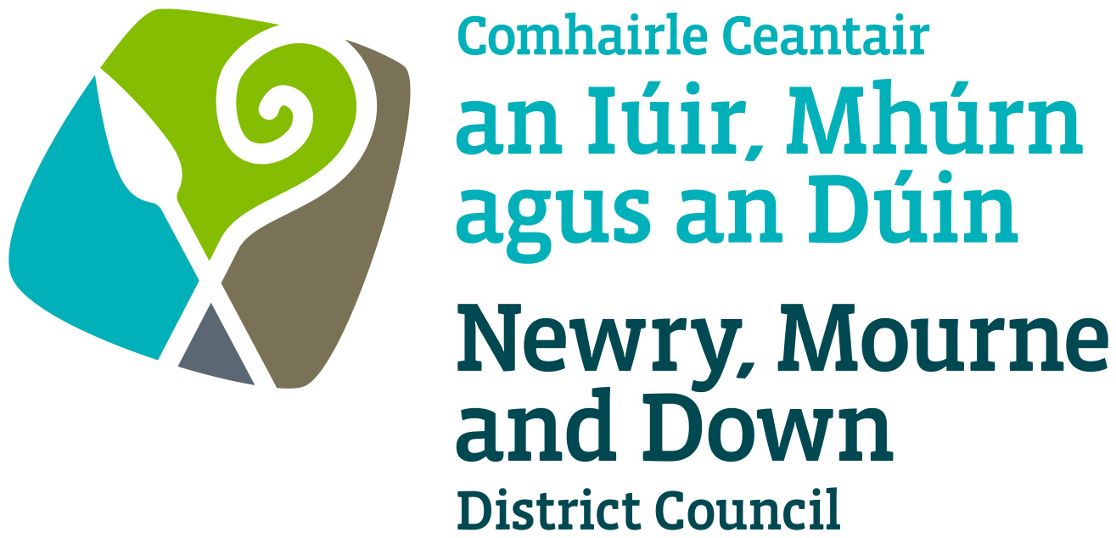

Agile Working Policy

July 2022

Policy reference: | CS42
Title: | Agile Working Policy
Version: | V2.0
Directorate / Departmental ownership: | Corporate Services/Human Resources & Safeguarding
Officers responsible: | Ways of Working Strategic Working Group
Date of ratification: | July 2022
Review Date: | The Agile Working Policy will be reviewed every four years in accordance with the below Policy Approval Process or as stated in Section 14.0 if required
Equality screening and Rural Need Impact Assessment completed by: | C Moffett, Head of Corporate Policy
Equality screening and Rural Needs Impact Assessment date: | 10 May 2022
Location where document is held and referenced: | Responsible Department    Corporate Policy repository  

CONTENTS
- TITLE ……………………………………………………………………………………………………………. 4
- STATEMENT …………………………………………………………………………………………………… 4
- AIMS …………………………………………………………………………………………………………….. 4
- Scope ……………………………………………………………………………………………………………. 4
- Related Policies and Legislation ……………………………………………………………………….. 4
Internal Procedures ……………………………………………………………………………………………… 5
- DEFINITIONS ………………………………………………………………………………………………… 5
- BENEFITS OF AGILE WORKING ……………………………………………………………………….. 5
Benefits for the Council ………………………………………………………………………………………… 5
Benefits for the Employee …………………………………………………………………………………….. 5
- UNDERLYING PRINCIPLES ………………………………………………………………………………. 6
- ASSESSING AGILE WORKING …………………………………………………………………………. 6
- ROLES AND RESPONSIBILITIES ………………………………………………………………………. 7
Corporate Responsibility ………………………………………………………………………………………. 7
  - Line Mangers ……………………………………………………………………………………………. 7
  - Employees ……………………………………………………………………………………………….. 7
- WORKER STYLES …………………………………………………………………………………………… 8
- AGILE WORKING HOURS ……………………………………………………………………………….. 8
- Arrangements for Working from Home ……………………………………………………………. 9
13.1) Home Expenditure …………………………………………………………………………………... 9
13.2) Mileage Claims ………………………………………………………………………………………... 9
13.3) Broadband Connection/WiFi ……………………………………………………………………... 9
13.4) IT and Other Equipment …………………………………………………………………………... 9
14.0) Monitoring, Review and Evaluation …………………………………………………………………. 9
15.0) Equality Impact Assessment …………………………………………………………………………… 9
16.0) Rural Needs Impact Assessment …………………………………………………………………….. 9
17.0) Document Owner …………………………………………………………………………………………. 10

- TITLE

AGILE WORKING POLICY

- STATEMENT
Newry, Mourne and Down District Council recognises the need to develop modern working practices that enable employees to maximise their performance whilst maintaining a good work life balance. The Council is seeking to strike a balance between employees work commitments and the faster pace of personal and working lives, with the emphasis primarily on the needs of the organisation at all times.

Agile working enables employees to work efficiently and effectively from a range of locations, for example, their home, a Council building or a public place.

- AIMS
This policy provides a framework for consistent and fair practice on the issues to be considered when implementing and managing agile working arrangements.

This Policy aims to assist employees and line managers in providing a framework to assist with minimising risk and sets out the Council’s requirements for compliance and its duty of care to employees who work in a range of locations.

The Policy should be read in conjunction with the current version of the Agile Working Guide (to be developed) which provides additional information to support agile working arrangements.

This policy is distinct from the statutory right of some employees to make a Flexible Working request and from any other family friendly policies in existence for all employees.

Application of this policy will be guided by Worker Style Designations.

- Scope
This policy applies to all directly employed Council employees including agency workers, where appropriate, whose roles have been defined as suitable for agile working in accordance with the Worker Styles as defined.

Casual staff will not be included within the remit of this policy.

- Related Policies and Legislation

- The Health and Safety at Work Order (NI) 1978
- The Management of Health and safety at Work Regulations (NI) 2000
- The Workplace Health Safety and Welfare Regulations
- (NI) 1993
- General Data Protection Regulations 2018
- Data Protection Act 1998
- Computer Misuse Act 1990
- Data Protection Act 2018
- Managing Attendance Procedure
- TOIL procedure
- Flexi Procedure

Internal Procedures/Documents

- Access to Information Policy and Procedure
- Code of Conduct for Local Government Employees
- Corporate Privacy Notice
- Information Security Policy Statement
- IT Policies and Procedures
- Planned Leave Policy
- Worker Styles Definitions

- DEFINITIONS
“Agile working” is a term used to describe employees who are able to work away from their main fixed place of work (as set out in their Statement of Main Terms and Conditions).

“An agile worker” is someone who meets the worker style designation as Field or Flexible.

- BENEFITS OF AGILE WORKING
Agile working arrangements can provide a number of benefits for both the Council and the employee.

Benefits for the Council:

- Recruitment and Retention – different working practices may help the Council to recruit and retain employees.
- Improved Productivity – reducing unnecessary travel time and office distractions can lead to improved productivity and more effective working.
- Modernising Service Delivery – using new technology to deliver services provides possibilities for streamlining services and providing rate payers with greater access to online joined up services.
- Accommodation – agile working will help the Council reduce accommodation needs and allow for better use to be made of Council buildings.
- Environmental – agile working will lead to fewer, and shorter, car journeys being made, which will help with reduced congestion at peak times and thus reducing pollution improving air quality and easing demand for employee car parking at Council buildings.

Benefits for the Employee:

- Improved Productivity – Agile working can reduce distractions and interruptions often seen in the traditional workplace and allow employees to better concentrate on their work.
- Improved Worklife Balance – agile working will allow employees to better balance their working and home life demands, thus supporting a more inclusive workforce.
- Travel Time – agile working can reduce, or remove completely, an employee’s travel time and costs.
- Increased Wellbeing – Agile working can increase an employee’s autonomy in relation to work activities, thus reducing stress and giving more control as to when and where work is undertaken.

- UNDERLYING PRINCIPLES
The Council will encourage and support agile working so long as any proposed agile working arrangement does not affect service delivery, or the quality of the work being undertaken.

All employees undertaking agile working will be expected to comply with their service area’s working practices, protocols and procedures.

Agile working will be available on a voluntary basis to the defined staff and employees are free to continue to work on their traditional basis if they wish to do so.

In addition to existing working practices, protocols and procedures, agile workers will also be expected to comply with Council’s policy and procedures relating to, for example, Information Security, Health and Safety and GDPR legislation. Further details can be found in the current Agile Working Guide.

Agile working does not replace the Council’s flexible working policy, employees can still apply for flexible working separately or in conjunction with an agile working arrangement.

- ASSESSING AGILE WORKING
A variety of factors need to be taken into consideration before an agile working arrangement can commence. All eligible employees have access to the agile working process, but outcomes may differ as the impact on service delivery will not be the same for all Departments.

The following areas should be considered when entering into an agile working arrangement:
- The effect on the ability to meet customer demand (internal and external to the Council).
- The impact on work quality or performance.
- Rotas of individual departments.
- Whether the job can only be carried out in an office environment.
- Relevant performance related issues as already discussed between the manager and the employee.
- Financial considerations e.g. cost of providing equipment/technology.
- The ability to work effectively at home, including employee assurance that adequate quality of broadband provision is in place.
- Access to relevant information/people (e.g. legal files/highly confidential information).

- ROLES AND RESPONSIBLITIES
Agile working by its very nature provides a way of working flexibly and as such prescriptive working practices cannot be written for each and every agile working situation. As such it is important that line managers and employees within an agile working agreement understand their responsibilities.

Corporate Responsibility
- The Chief Executive, on behalf of Council, carries overall responsibility for ensuring the appropriate processes are in place which adequately and appropriately supports its employees, regardless of what working pattern or arrangement they have.

- The HR team is responsible for providing advice, guidance and training on this policy.

- Directors are responsible for establishing their own arrangements to ensure:
- Effective implementation of the policy
- Continued service delivery; and

- Directors are responsible for delegating authority to Heads of Service/Line Managers to take action under this policy, as appropriate.

10.1) LINE MANAGERS
Managing agile workers brings different challenges to managing staff who attend the same single work location every day. Establishing effective team communication and trust between managers and employees is essential. Line managers have a responsibility to:
- Ensure employees within their teams are aware of expectations and the required standard of work, if undertaking agile working.
- Ensure staff within an agile working pattern are aware of their responsibilities they must adhere to for example, health and safety, information security, confidentiality and GDPR etc.
- Providing appropriate approval, advice or guidance on Council’s Agile Working Policy.
- Referring to and complying with other relevant Council policies, procedures and guidelines which impact on agile working.
- Setting and monitoring defined performance measures or work outcomes.
- Being flexible, open and constructive in discussing and agreeing agile working arrangements whilst remaining focused on the needs of the service.
- Ensuring their actions do not expose the Council to any unnecessary financial, legal or contractual risk.

10.2) Employees
Employees undertaking agile working have responsibility for:
- Complying with all Council policies and procedures whilst working remotely.
- Being flexible, open and constructive in discussing and agreeing agile working arrangements, whilst remaining focused on the needs of the service.
- Delivering agreed work objectives and work standards.
- Facilitating contact in an emergency or as required by their line manager or colleagues whilst they are out working in other locations.
- Complying with the specific requirements relating to health and safety information security, confidentiality and GDPR.
- Taking care of any Council supplied equipment.
- Reporting lost, damaged or stolen equipment (especially if the equipment contains documentation or data belonging to the Council), breaches of confidentiality, loss of data or information and for advising their line manager of accidents or incidents whilst working remotely.
- Working within the agreed “housekeeping rules” (e.g. maintenance of Council equipment, appropriate work area for working at home etc.) and abiding by the all Council policies (available on the intranet) whilst working in this way.

- WORKER STYLES
The ability to work in an agile manner will be based on the worker style of the role as defined by the Council.

Six Worker Styles describe how people work, providing a basis to determine if their role could be considered for an agile working.

The following worker styles have been identified.

- Field Worker*
- Flexible Worker*
- Fixed Desk Worker
- Office Worker
- Operative
- Homeworker

*Only Field and Flexible workers can avail of agile working.

Worker Styles – Further information on Worker Styles can be found in Council’s Worker Styles Guide.

It will be the responsibility of the Assistant Director of each department to assign the Worker Style.

- AGILE WORKING HOURS
An employee working under an agile working arrangement is required to continue to fulfil their normal contracted working hours as per agreement with line manager.

All hours worked within an employee’s contracted working week will be paid at the same rate as would have been paid if they were not working within an agile arrangement.

Additional hours or TOIL should only accrue in the same circumstances that would apply to an employee and are subject to the same approvals.

- Arrangements for Working from Home
Employees who work from home as part of an agile working arrangement should ensure they have a suitable location in which to carry out their work. Further information on this can be accessed in the Agile Working Guide.

13.1) Home Expenditure
The Council are not responsible for any additional costs an employee may experience as a result of increased energy costs, broadband provision, home insurance premiums etc as a result of an agile working arrangement.

13.2) Mileage Claims
Mileage claims should continue to be made in the normal way with employees deducting home to their usual place of work mileage before submitting a claim for mileage. Whilst undertaking an agile working arrangement an employee’s normal place of work will remain for the purpose of claiming mileage and will not change to their home address.

13.3) Broadband Connection/Wi-Fi
A stable broadband connection should be available for employees working from home and a minimum download speed of 2-3mbps will be required to ensure good connectivity through video calling/conferencing software.

Advice and guidance should be obtained from the Council’s IT Department if an employee’s Wi-Fi is for example provided by satellite or is not at the required speed.

Where Wi-Fi is not suitable the Council are not responsible for improving connectivity and the agile working element from home may not be possible.

13.4) IT and Other Equipment
The Council will only provide one set of IT or other equipment to an employee, e.g. laptop, charger, wireless keyboard, docking station etc. If an employee within an agile working arrangement is required to work at another location, they will be expected to transport and set up whatever equipment they need to undertake their role at the alternative location.

- Monitoring, Review and Evaluation
This policy will be reviewed every four years in consultation with Senior Management and Trade Unions. However, the policy will be reviewed sooner in the event of any one or more of the following:
- Failure or weakness in the policy is highlighted
- Changes in legislative requirements
- Changes in Government/Council or other directives and requirements.

- Equality Impact Assessment
This Policy has been “screened out” for Equality Impact Assessment. A copy of the equality screening is available from Human Resources.

- Rural Needs Impact Assessment
Due regard to rural needs has been considered and the policy has been subject to a rural needs impact assessment.

- Document Owner

Ways of Working Strategic Working Group.

