Reserves
Policy

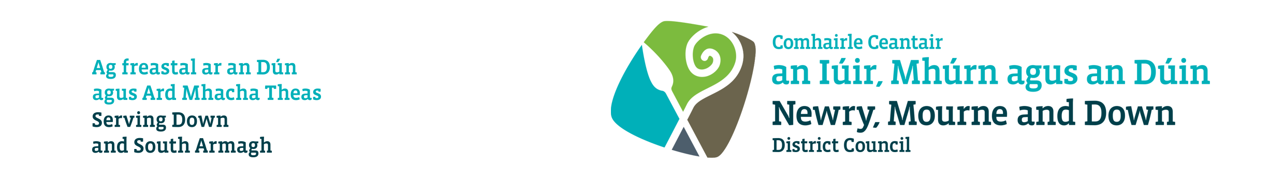

Policy title: Reserves Policy

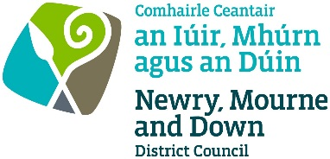

Policy Control

Policy reference: | CS41
Title of Policy: | Reserves Policy
Version: | 1.0
Directorate / Departmental ownership: | Corporate Services / Finance and Performance
Officer responsible: | Chief Financial Officer
Date of ratification: | 3 November 2025
Review date: | 1 October 2029
Equality screening and Rural Needs Impact Assessment completed by: | Assistant Director of Finance and Performance
Equality screening and Rural Needs Impact Assessment date: | 6 August 2025
Location where document is held and referenced: | Responsible Department ☒  Corporate Policy repository ☒

Policy approval process

Meeting | Date
CMT | 6 August 2025
SMT | 12 August 2025
Relevant Committee(s) e.g. Strategy, Policy & Resources Committee | 11 September 2025 & 16 October 2025
Monthly Council Meeting | 6 October 2025 (Deferred) & 3 November 2025

Contents
Title of policy 4
Statement 4
Aim 4
Scope 4
Related policies and legislation 4
Definitions (as per CIPFA Code of Practice) 4
Usable Reserves 5
Unusable Reserves 5
Review Date 6
Procedures and arrangements for implementing and impact of the Policy 6
Equality Screening 6
Rural Needs Impact Assessment 6

1. | Title of policy
 | Reserves Policy
2. | Statement
 | The purpose of this document is to set the Council’s policy in relation maintaining its financial reserves and funds to allow proper financial planning and ensure adequate financial resilience.
3. | Aim
The Council shall maintain balances within reserves as required by the Code of Practice on Local Authority Accounting and shall maintain balances within its funds as it considers prudent bearing in mind the financial risks and opportunities to which it is exposed in line with CIPFA guidance.

In making decisions the Council will have regard to the reports presented by the Chief Financial Officer and/or the Director of Corporate Services.

4. | Scope
 | In order to assess the adequacy of unallocated general reserves when setting the budget, the Chief Financial Officer should take account of the strategic, operational and financial risks facing the Council.
5. | Related policies and legislation
The Local Government Finance Act (NI) 2011 provides the legal framework for Council reserves and funds as follows:

Section 6 – Adequacy of reserves
Section 7 – Controlled reserves
Section 8 – General Fund
Section 9 – Power to establish funds
Section 10 – Limitations on use of funds

CIPFA Bulletin 13 Local Authority Reserves and Balances provides guidance regarding the levels maintained in Council Reserves and funds.

CIPFA Code of Practice on Local Authority Accounting in the United Kingdom (the Code) details the external accounting requirements for all reserves and funds.

6. | Definitions (as per CIPFA Code of Practice)
Usable Reserves are those reserves, funds and accounts which are resource-backed and can be applied to fund expenditure or reduce local taxation, subject to a statutory requirement to maintain a prudent level of reserves.

Unusable Reserves are those reserves, funds and accounts are used to reconcile accounting requirements driven by reporting standards to statutory requirements.
They are not resource-backed and cannot be used for any purpose other than that set out in the Code. Examples include the Revaluation and Pension Reserves.

Typically, such balances relate to unrealised accounting gains or losses (for example when the market value of capital assets increase due to indexation or revaluation). Such balances only become usable once the balance is realised (for example, when a revalued asset is sold).

7. | Usable Reserves
Under Legislation, the Council shall maintain a statutory fund called the General Fund. This fund is for working capital purposes to allow the effective and efficient management of day-to-day transactions and to mitigate the financial effect of unexpected events.
The General Fund is not ringfenced (earmarked) for any specific expenditure. Its purpose is to smooth the impact of uneven cashflow or cover unexpected /emergency expenditure. It is not intended to fund on-going expenditure.
The General Fund will be replenished as part of the budget process in any year where it has been utilised for unexpected/emergency expenditure. Council shall endeavour to maintain a balance in this fund of a minimum or equivalent to one months working capital. Where this is not possible at any budgeting or reporting period, Council must agree a medium-term plan to restore this balance.
Council also maintains other non-statutory funds Earmarked Funds. The creation of earmarked reserves will be subject to Council approval.
Councils position is that reserves are not used for balancing the budget (applying a balance) but are for non-recurrent purposeful investment or spend and to ensure that there is financial provision set aside to meet known future one off commitments or liabilities. They are also held as a means of ensuring financial resilience against unknown events and risks.

8. | Unusable Reserves
The Council shall maintain the following reserves as explicitly or implicitly required by the Code: For example, but not limited to: -
Unusable Reserves

• Capital Receipts Reserve
• Capital Grants Received in Advance Reserve
• Capital Grants Unapplied Account
• Revenue Grants Unapplied Account
• Capital Adjustment Account
• Revaluation Reserve
• Pensions Reserve
• Accumulated Absences Account
• Provisions Discount Rate Reserve

Balances in these reserves shall be maintained in accordance with the requirements of the Code (CIPFA Code of Practice).
9. | Review Date
 | The Policy will be reviewed in line with the Council’s agreed policy review cycle i.e. every 4 years (as per Council’s Equality Scheme commitment 4.31), or sooner to ensure it remains reflective of legislative developments.
10. | Procedures and arrangements for implementing and impact of the Policy
 | The Reserves Procedure document references the implementation procedures required for delivery of the policy and relevant monitoring arrangements to assess the impact.
11. | Equality Screening
 | This Reserves policy has been screened and will not be subject to an EQIA (with no mitigating measures required).
12. | Rural Needs Impact Assessment
The Rural Needs Act (Northern Ireland) 2016 requires the Council to have due regard to rural needs when: (a) developing, adopting, implementing or revising policies, strategies and plans, and (b) designing and delivering public services.

The Reserves Policyhas been subject to Rural Needs Impact Assessment.

.

