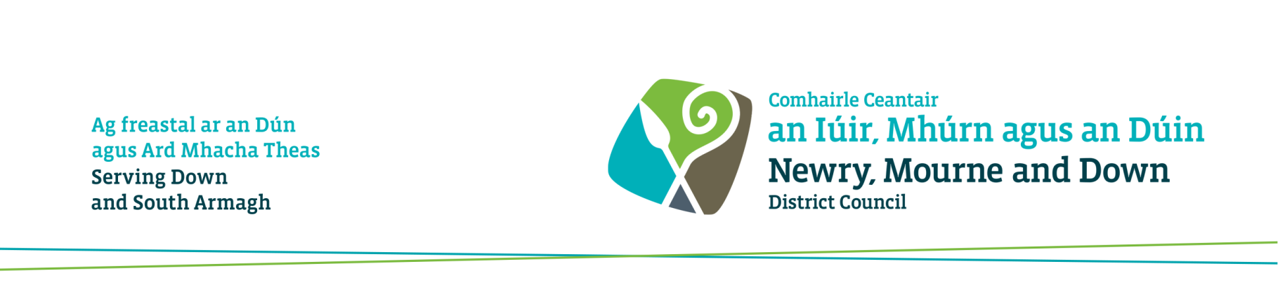

Community Facilities Booking Application Form – for Bookings

1 SEPTEMBER 2022 TO 31 AUGUST 2023

This form is used to book Newry, Mourne and Down District Council Community Facilities. Bookings can be made for one off events or for block bookings over a series of dates. Additional information may be required depending on the nature of the booking. The act of submitting a form does not automatically guarantee that the requested facilities will be allocated to you. If all is satisfactory, your booking will be confirmed by E-Mail.

ALL COMPLETED FORMS AND DOCUMENTATION SHOULD BE E-MAILED TO
ccbookings@nmandd.org

Name of Person / Group /Organisation
Name of Facility you wish to Book
Event or Proposed Use
If your request is unavailable, you will be contacted to discuss alternatives – please ensure you add a contact telephone number on next page

SINGLE BOOKING
Day | Date | Facilities Required  (eg Main Hall, Multi-Purpose Room, Meeting Room, Training Room, Changing Rooms, Pitch, Car Park, etc) |  | Times  From – To  (to include set-up and clear-up times)

BLOCK BOOKING
Day | Date  From | Date  To | Facilities Required  (eg Main Hall, Multi-Purpose Room, Meeting Room, Training Room, Changing Rooms, Pitch, Car Park, etc) | Times  From – To  (to include set-up and clear-up times)
Please list any dates where you know you will not require facilities

Estimated number of Participants and Spectators? |  | Estimated number requiring Changing Facilities?

Equipment Requirements
How many Chairs are required? |  | How many Tables are required?
Please state any other equipment required or room layout:-

Payment by Invoice ONLY
Invoice Address
Please provide the name, address and contact number you would like your invoice sent to (for Club bookings please state the name of Club Treasurer)

General Information
- All hirers must abide by the Council’s Conditions of Hire for Use of Council Facilities, see Appendix 1. It is the hirer’s responsibility to ensure they have read and understand these Conditions
- You are strongly advised to carry out Access NI vetting checks on prospective employees and volunteers whose normal duties include teaching, training, care, supervision, advice or transportation of children and vulnerable adults. You will commit an offence if you knowingly employ a disqualified person to work/supervise children and/or vulnerable adults. As part of your booking you may be required to submit a recent Access NI check(s) for our records
- As part of the Conditions of Hire for Use of Council Facilities, you will be required to submit a copy of your Public Liability Insurance, see Appendix 2 for Insurance thresholds
- If tuition/instruction/coaching is given throughout the booking, you will be required to produce a recognised coaching qualification, see 15.3 of Conditions of Hire for Use of Council Facilities (Appendix 1)
- Please let us know if you, a member or members of your group have a disability or special needs which may affect your/their ability to evacuate the premises. This can be done by informing reception on your arrival
Declaration – Please tick as appropriate |  |  |  |  |  |  |  |  |  | Yes | No
I have read the Council’s Conditions of Hire for Use of Council Facilities and will ensure my Group, Club and Organisation adhere to the terms and conditions of use set out
I have read and understand my safeguarding responsibilities (see Section 15 of Conditions of Hire) and submitted a recent Access NI check(s) as required
I have submitted a copy of my own, Group, Club or Organisations Public Liability Insurance as required
I have submitted instruction/coaching qualifications where required
I will record details of those Participants and Spectators in attendance for the purpose of Fire Safety procedures
I acknowledge that this is merely an application for use and will not assume the facilities have been booked until I receive confirmation by E-Mail
Name |  |  |  |  | Signature
Address |  |  |  |  | Position within Group/ Organisation
Postcode |  |  |  | Contact Tel Number(s) | Day |  |  |  | Evening
E-Mail |  |  |  |  |  |  |  | Date
For Office Use Only
Date and Time Received |  |  |  |  |  | Received By

