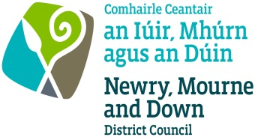
SCHEDULE 1 Application for a Dog Breeding Establishment Licence
The Welfare of Animals (Dog Breeding Establishments and
Miscellaneous Amendments) Regulations (Northern Ireland) 2013
Application for a Dog Breeding Establishment Licence

Please use BLOCK LETTERS
Details of applicant
Title (Mr,  Mrs, etc) | Forename/s |  |  | Surname
Address |  |  | Postcode
Contact telephone number:
Email address (if available):
Full address of each premises comprising the breeding establishment:

Number of breeding bitches over 6 months to be kept on the breeding
establishment under the licence:
The number of other dogs over 6 months old to be kept on the breeding establishment under the licence:
Name and address of owner and number of
breeding bitches kept on the premises but not owned by the keeper of the Establishment:
Is a control condition notice in force attaching control conditions under Article 30A (2) of the Dogs Order (Northern Ireland) 1983 to a previous dog licence held in respect of any breeding bitch or stud dog: |  |  |  |  | Yes/No
If Yes, please give the serial number of notice:
Date of expiry of previous single/block breeding establishment licence (if any):
NOTE:-The information given above may be subject to verification
Nominated Veterinary Practice name and address:

I enclose the appropriate fee of £ for breeding bitches over 6 months old
I declare that the information given above is correct in every respect. I am not under 16 years of age and I have not been disqualified from keeping animals under any legislation. I keep on the above breeding establishment three or more breeding bitches and*
- Breed 3 or more litters of puppies in any 12 month period;
- Advertise 3 or more litters of puppies for sale in any 12 month period
- Supply 3 or more litters of puppies in any 12 month period; or
- Advertise a business of breeding or selling puppies; and
*(delete whichever condition is not applicable)
I meet all the requirements specified in Schedule 4 of the above named Regulations. I therefore apply for a licence.
www.newrymourneanddown.org/private-policy
Office use only
Signed: ________________  Date: __________________  Initials |  | Fee paid |  |  | £
 |  | Eligibility certified |  |  | Yes/No
 |  | Licence No. Issued
 |  | Date

