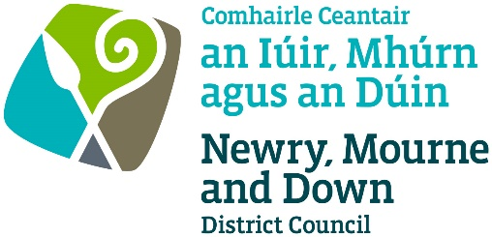

Guidance Note to accompany Application for Holding a Special Event on a Public Road

Please also read ‘The Special Events on Public Roads for Applicants’ available at www.newrymournedown.org/special-events-on-public-roads
Section 1 – Applicant Details
Name of applicant | Person organising the event
Address of applicant | Applicant’s home address
Name of company/club/society | Company, club or society organising the event
Section 2 – Event Details
Name of Event | The name the event is being advertised under
Club/Society/Charity | Name of Club/Society/Charity on behalf of which event is being held.
Fee (Large event, small event) | The payment is to be made when submitting the application.  Please see ‘The Special Events on Public Roads for Applicants’ in relation to the criteria for a small event. https://www.newrymournedown.org/special-events-on-public-roads
Fee – Voluntary/charitable/not for profit organisation | The payment is to be made after the advertisement of the event.  Promoters will be liable for advertising and administration costs.  In the event of notification of an event cancellation, advertising and administration costs will not be refunded.
Type of restriction (full road closure/lane restriction(s) /prohibition of certain types of vehicles/footway closure etc) | Please list the name of roads/street effected and the type of restriction including full road closure, lane restriction, prohibition of certain types of vehicles and footway closures. Pedestrian access to be maintained on all roads/streets on which the event is being held.
Date of restriction and times of restriction | It is important to quote the exact day, date and start/finish times of the proposed restriction for the event.
Has the event been held previously? | Provide relevant details
Are the previous arrangements amended in any way? | If yes, detail amendments
Please give details of any structures of other equipment that you plan to erect or place on the public road | Please detail methods to be employed to protect road surfaces. Depending on the structure or equipment being placed, technical approvals/safety certificates for any structure erected may also be required (e.g. stage)
Section 3 – Declaration and signature
Ensure you have enclosed the following information with your application:-
Plan/map of the route | Organisers must identify the exact roads/streets affected including the start and end locations, diversion routes, and provide a marked-up plan/drawing to indicate same. The plan must show, the length of the road to be prohibited or restricted in use (indicated in red) and the proposed diversion route (indicated in green) This plan must be clear and indicate road names. It should also include position of marshals/stewards and first aid positions to inform Council’s consultees.
Traffic Management Plan and Signing Schedule | To include detailed maps (as above), a signing schedule and details of how traffic is to be managed and any diversionary routes.  Where a traffic management company is engaged the traffic management plan must be competent to undertake this work.  Signs may only be erected by Chapter 8 accredited personnel trained to work on live highways. Traffic control on the public highway can only be undertaken by a Police Officer in uniform. Marshals and Stewards do not have the authority to control traffic on the public highway.
Event Management Plan / Risk Assessment | Identifies responsible persons, roles, risks identified and safety measures employed, event timetable.
Public Liability Insurance | An Order will not be granted without insurance cover being in place.
Application Fee | Application fee for large and small events must be submitted with the application.  - The fee for a large event is £655  - The fee for a small event is £435  - The fee for voluntary/charitable/not for profit organisation will be payable to the Council after the advertisement of the event.
Confirmation that you have contacted any businesses, including bus services and residents which may be affected by the event. | For Full Road Closures - Provide evidence that you have contacted residents, businesses etc which may be affected by the proposed special event – this may include copies of letters/flyers.

