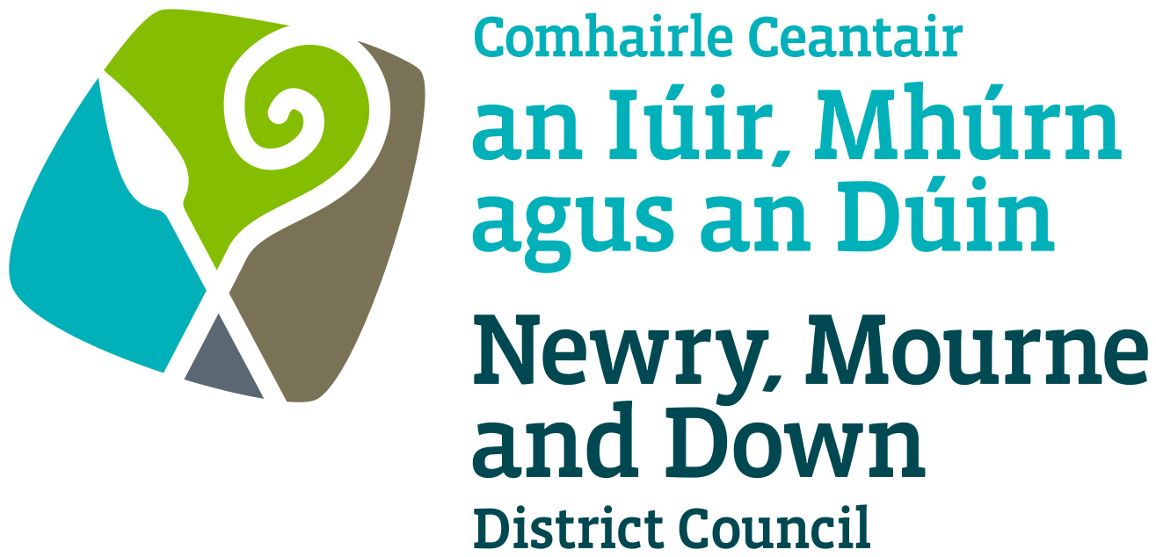
Ref:
The Betting, Gaming, Lotteries and Amusements
(Northern Ireland) Order 1985 –Article 136)

Application for Licence of a Society Lottery

Please tick ✓ type of Licence applied for:
Registration Retention
I ___________________________ of ______________________________________________ do hereby apply to Newry, Mourne and Down District Council being the Local Authority under the above Order, for the Registration / Retention of Registration of the undernoted society for the calendar year of 20 .
PARTICULARS
- Name of Society in Full _______________________________________________________

- Address of Office of the Society in Full ___________________________________________

- Purpose for which the Society is established ______________________________________
__________________________________________________________________________
I hereby declare, to the best of my knowledge and belief:-
- that no person connected with any lottery promoted or proposed to be promoted on behalf of the above Society has been convicted of:
  - an offence under Article 132 or 139(1) or (2); or
  - an offence under Section 25 of the Betting and Lotteries Act (Northern Ireland) 1957; or
  - any offence involving fraud or dishonesty; or
- that any lottery promoted by or on behalf of the Society within the last five years has been properly conducted.
- Information provided as part of this application may be disclosed in response to a request under the Freedom of Information Act 2000 or the Environmental Information Regulations 2004.
- The Council to which you are submitting this application form, collects data for the purposes of the management and application of the Registration of a Society. The data may also be passed onto other related Government Agencies and to other Council Departments, to facilitate Statutory Requirements, Service Level Agreement of or similar purposes.
- Newry, Mourne and Down District Council collects the Data on this Form for the purpose of Administering the Registration of Societies under the Betting, Gaming, Lotteries & Amusements (NI) Order 1985. The Data Collected on this Form will be shared with the relevant Council Departments for the purposing of administering the permit under the Data Protection Act 1998

The Council’s privacy notice can be accessed via our website www.newrymournedown.org/privacy-policy

Ticking this box indicates that you have read and understood the above declaration.

Signature of Applicant

Position of Applicant in the Society
Date (dd/mm/yyyy)

This application form, together with the prescribed fee of £35 (Registration) or £17.50 (Retention) and a copy of your lottery scheme (or the attached lottery scheme) should be forwarded to the Licensing Section, Newry, Mourne and Down District Council, Downshire Civic Centre, Downshire Estate, Ardglass Road, Downpatrick, BT30 6GQ. Telephone 0330 137 4030. A copy of this application form and lottery scheme is to be sent to the Police Service of Northern Ireland.
The Betting, Gaming, Lotteries and Amusements
(Northern Ireland) Order 1985 – Article 136

Chairman – Full Name & Address:- _______________________________________________
_______________________________________________
_______________________________________________
Previous Address:- _______________________________________________
_______________________________________________
Date of Birth:- _______________________________________________
Telephone No:- _______________________________________________

Secretary – Full Name & Address:- _______________________________________________
_______________________________________________
Previous Address:- _______________________________________________
_______________________________________________
Date of Birth:- _______________________________________________
Telephone No:- _______________________________________________

Treasurer – Full Name & Address:- _______________________________________________

_______________________________________________
Previous Address:- _______________________________________________
_______________________________________________
Date of Birth:- _______________________________________________
Telephone No: _______________________________________________
DATA PROTECTION ACT 1998
Newry, Mourne and Down District Council collects the Data on this Form for the purpose of Registration of Societies under the Betting, Gaming, Lotteries and Amusements (Northern Ireland) Order 1985 – Article 136. The Data collected on this Form will be shared with the Police Service of NI for the purpose of administering the Registration of Societies under the above legislation.
Please Note: Society’s Lottery – Return by Promoter form, is to be sent by the promoter of the lottery to the District Council not later than the end of the third month after the date of the lottery. Failure to do so may result in your licence being revoked or no approval being granted for the Retention of Registration of a Society. They must be authorised by a qualified accountant who is eligible for appointment as the company auditor under Article 28 of the Companies (NI) Order 1990 – Article 2(2) of the Betting etc Order as amended by S.R 1993 No. 67.
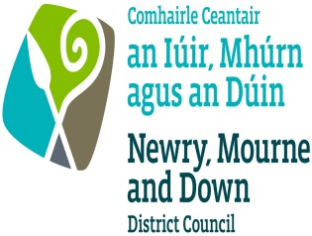
NEWRY, MOURNE AND DOWN DISTRICT COUNCIL

LOTTERY SCHEME

1. | Name and Address of Promoter
 | Promoter’s Telephone Number (during business hours)
 | Position held by Promoter in Society
2. | Name and Address of External Consultant
 | External Consultant’s Telephone No. (during business hours)
 | (Applicable only if an external lottery consultant is employed instead of a promoter from within the society)
3. | Number of tickets to be offered for sale
4. | Price per ticket
5. | (Maximum £1)  Estimated expenses for printing etc.
6. | (a) |  | .  Value of prizes to be provided from proceeds of the lottery
 | (b) |  | Value of prizes to be donated (if any)
7. | Proposed value of the most expensive prize
8. | Purpose for which the proceeds are to be applied
9. | Date(s) of proposed lottery or lotteries
I hereby request that the above details be registered as the Lottery Scheme for the above-named Society and that any changes, whether by way of substitution or otherwise, shall be notified to the Council before any tickets or chances are sold in any lottery conducted under a new or revised lottery scheme.

The promoter named above is authorised by the society to act in that capacity.

*Signed:
Position in Society:
Date:

* NOTE
The promoter cannot be the authoriser.

