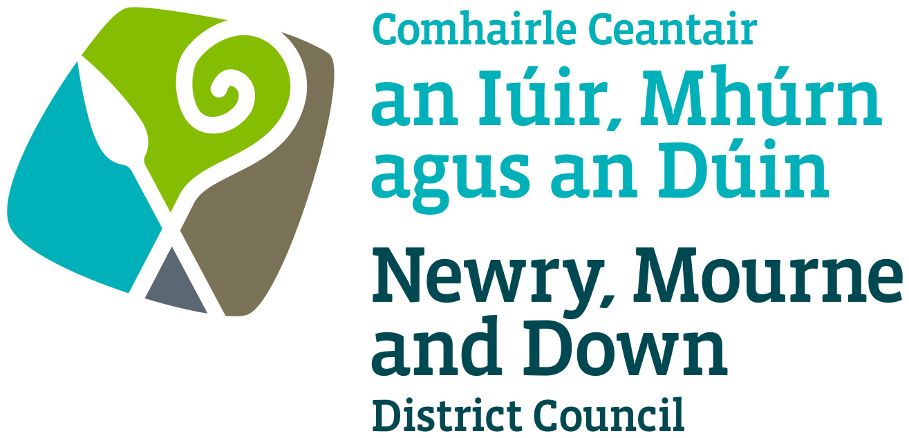

THE MARRIAGE (NORTHERN IRELAND) REGULATIONS 2003
THE CIVIL PARTNERSHIP (NI) REGULATIONS 2005
THE MARRIAGE (SAME-SEX COUPLES) AND CIVIL PARTNERSHIP (OPPOSITE-SEX COUPLES) (NORTHERN IRELAND) REGULATIONS 2019

APPLICATION FOR VARIATION FOR 3 YEAR PLACE APPROVAL FOR CIVIL MARRIAGES AND CIVIL PARTNERSHIPS
– ADDITION OF ROOMS

Completed Application to be sent to one of the offices below:

Oifig Dhún Padraig  Downpatrick Office  Licensing Section  Enterprise, Regeneration and Tourism  Department  Downshire Civic Centre  Downshire Estate  Ardglass Road  Downpatrick  BT30 6GQ | Oifig an Iúir  Newry Office  Licensing Section  Enterprise, Regeneration and Tourism  Department  O’Hagan House  Monaghan Row  Newry  BT35 8DJ
For further details contact:
Tel: 033 0137 4030
Email: licensing@nmandd.org
www.newrymournedown.org

NMD Ref: SB/12/

APPLICATION FOR 3 YEAR PLACE APPROVAL FOR CIVIL MARRIAGES AND CIVIL PARTNERSHIPS - ADDITION OF ROOMS
The Marriage (NI) Regulations 2003
The Civil Partnership (NI) Regulations 2005
The Marriage (Same Sex Couples) and Civil Partnership (Opposite Sex Couples) (NI) Regulations 2019

Please read “Guidance to the Requirements and Conditions for Approved Premises for Civil Marriages and Civil Partnerships” - available on our website.

Please tick ✓application type: -

Application for Additional room(s) - 3 Year Place Approval for Civil Marriages
Application for Additional room(s) - 3 Year Place Approval for Civil Partnerships

Section 1 of 6 - Details of Premises

Please give the full name, address, telephone number and email address of the Premises. Information provided in Section 1 will be available to the public and appear on the Registrars website.

Premises Name:
Address:
Telephone No: |  |  |  | Email:

Section 2 of 6 - Details of Applicant

(a) The details below should be of the person making the application. The person is normally the Proprietor or Trustee of the Premises (See Guidance Part 1- 1.1).

Full Name:
Home Address:
Telephone No: |  |  | Email:

(b) If the venue is part of a limited company, please also give the address of the registered office.

Company:
Address:
Telephone No: |  |  |  | Email:

If an approval is granted the Applicant at 2(a) will be known as the ‘Approval Holder’ and will be responsible for ensuring all conditions and requirements are satisfied in respect of the premises for its use as a venue for Civil Marriages and Civil Partnerships.

Section 3 of 6 - Occupier of Premises

Is the person named in Section 2 the sole occupier of the Premises?

Yes No

If No, please give the names and addresses of other occupiers and the nature of their occupancy below:

Section 4 of 6 - Ceremony Room(s)

Please list the room(s) to be added in addition to the room(s) already stated on your current Place Approval.

- Describe the primary and other use(s) of the room(s) which will be used for Civil Marriage and Civil Partnership Ceremonies (e.g. Banqueting hall, conference room, garden area, marquee etc.)

- Also state the maximum number of people who are permitted to occupy the room(s) under any Fire Risk Assessment which applies. (See Guidance Part 1 –1.3.)

Room/Location | Max Number

Please ensure there is a separate confidential interview room conveniently located to the ceremony room, which is available to the Registrar.

Section 5 of 6 - Responsible Person(s)

Please give details of the person and their deputy who will be responsible for arranging and co-ordinating the Civil Marriages and Civil Partnerships and ensuring compliance with requirements and conditions as attached if different from current Place Approval. (See Guidance Part 3- 3.1.)

(1) Full Name: |  | Occupation:
Home Address:
Telephone No: |  | Mobile No:

(2) Full Name: |  | Occupation:
Home Address:
Telephone No: |  | Mobile No:

Section 6 of 6 - Declarations and Signature
- I apply for additional rooms identified in Section 1 to be approved for solemnisation of Civil Marriages/Civil Partnerships for my current Place Approval.
2. I understand that: -
- That the place may be inspected for suitability before approval is granted and, if this application is successful may be subject to subsequent inspection;
- The premises must satisfy the local authority on fire precautions and health and safety provisions;
- Approval, if granted will be for the inclusive 3-year period of the current Place Approval subject to revocation, suspension or variation;
- Approval, if granted, does not guarantee the availability of a Registrar.
3. I enclose the documents requested.
4. I declare that:
- I have read and understood “Guidance to the Requirements and Conditions for Approved Premises for Civil Marriages/Civil Partnerships”
- The place has no recent or continuing religious connection
- I have obtained any necessary permissions regarding use of and access to the premises
- I will comply with the Conditions attached to the Approval.
- Information provided as part of this application may be disclosed in response to a request under the Freedom of Information Act 2000 or the Environmental Information Regulations 2004.
- The Council to which you are submitting this application form, collects data for the purposes of the management and application of the Civil Marriage and Civil Partnership Regulations. The data may also be passed onto other related Government Agencies and to other Council Departments, to facilitate Statutory Requirements, Service Level Agreement of or similar purposes.
- Newry, Mourne and Down District Council collects the Data on this Form for the purpose of Administering Place Approvals under The Marriage (NI) Regulations 2003, The Civil Partnership Regulations (NI) 2005 and The Marriage (Same Sex Couples) and Civil Partnership (Opposite Sex Couples) (NI) Regulations 2019. The Data Collected on this Form will be shared with the relevant Council Departments, the Police Service of NI and the NI Fire and Rescue Service under the Data Protection Act 1998.

Ticking this box indicates that you have read and understood the above declaration.

 | Official Use Only
Print Full Name: | Date Received:
Signature: | Receipt Number:
Date: | £:

Checklist for Applicants

Variation for 3 Year Place Approval for Civil Marriages and Civil Partnerships – Addition of Rooms(s)

Please ensure you have enclosed the following

All documentation may be emailed to: licensing@nmandd.org.
We may ask for the original of any scanned or emailed document if we feel the need to see the original.

Tick ✓

1. | Completed Application Form
2. | Public Liability Insurance  Confirmation from your Insurance Company of current valid insurance cover for the premises.
3. | Floor Plan  One copy of the floor plan drawn to a scale of not less than 1:100, showing the ceremony rooms and interview room must be provided.  If a current Entertainment Licence is held for the same areas which are to be approved for the Civil Marriages and/or Civil Partnerships then a floor plan is not required, provided no alterations have been made to the premises.
4. | Fee  Place Approval Variation regarding addition of rooms: £55  - Cheques payable to: ‘Newry, Mourne and Down District Council’.

All documentation may be emailed to licensing@nmandd.org.
We may ask for the original of any scanned or emailed document if we feel the need to see the original.

All documentation may be emailed
(as PDF or MS Word format attachment) to licensing@nmandd.org.
We may ask for the original of any scanned or emailed document.

All documentation may be emailed to: licensing@nmandd.org.
We may ask for the original of any scanned or emailed document if we feel the need to see the original.
All documentation may be emailed to: licensing@nmandd.org.
We may ask for the original of any scanned or emailed document if we feel the need to see the original.
All documentation may be emailed to: licensing@nmandd.org.
We may ask for the original of any scanned or emailed document if we feel the need to see the original.
DATA PROTECTION ACT 1998

Newry, Mourne and Down District Council collects the Data on this Form for the purpose of Administering Entertainment Licensing under the Local Government (Miscellaneous Provisions) NI Order 1985. The Data Collected on this Form will be shared with the relevant Council Departments, the Police Service of NI and the NI Fire and Rescue Service for the purposing of administering the licence.

