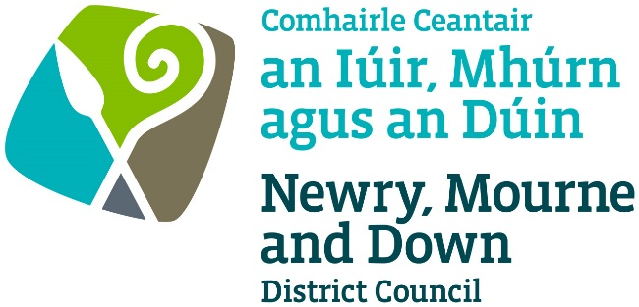

THE MARRIAGE (NORTHERN IRELAND) REGULATIONS 2003
THE CIVIL PARTNERSHIP REGULATIONS (NORTHERN IRELAND) 2005
THE MARRIAGE (SAME-SEX COUPLES) AND CIVIL PARTNERSHIP (OPPOSITE-SEX COUPLES) (NORTHERN IRELAND) REGULATIONS 2019

APPLICATION FOR TEMPORARY PLACE APPROVAL FOR CIVIL MARRIAGES AND CIVIL PARTNERSHIPS

Completed Application to be sent to one of the offices below:

Oifig Dhún Padraig  Downpatrick Office  Licensing Section  Enterprise, Regeneration and Tourism  Department  Downshire Civic Centre  Downshire Estate  Ardglass Road  Downpatrick  BT30 6GQ | Oifig an Iúir  Newry Office  Licensing Section  Enterprise, Regeneration and Tourism  Department  O’Hagan House  Monaghan Row  Newry  BT35 8DJ
For further details contact:
Tel: 033 0137 4030
Email: licensing@nmandd.org
www.newrymournedown.org

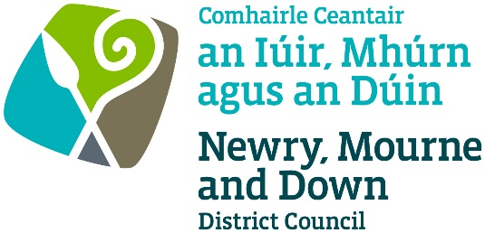
NMD Ref: SB/12/

APPLICATION FOR TEMPORARY PLACE APPROVAL FOR CIVIL MARRIAGES AND CIVIL PARTNERSHIPS
The Marriage (NI) Regulations 2003
The Civil Partnership (NI) Regulations 2005
The Marriage (Same Sex Couples) and Civil Partnership (Opposite Sex Couples) (NI) Regulations 2019

Please read “Guidance to the Requirements and Conditions for Approved Premises for Civil Marriages and Civil Partnerships” – available on our website.

Please tick ✓application type: -

Application for Temporary Place Approval for Civil Marriages
Application for Temporary Place Approval for Civil Partnerships

Section 1 of 7 - Details of Premises

Please give the full name, address, telephone number and email address of the Premises.

Premises Name:
Address:
Proprietor:
Telephone No: |  |  | Email:

Section 2 of 7 - Details of Applicant

This application must be made by the Partners. Please give the full name, address, email and telephone number. Please also state the date on which you wish the Approval to be granted for.

Full Name:
Address:
Telephone No: |  |  | Email:

Date of Proposed Civil Marriage or Civil Partnership:
Time of Proposed Civil Marriage or Civil Partnership:

If an approval is granted the Applicant will be known as the “Approval Holder” and will be responsible for ensuring all conditions and requirements are satisfied in respect of the premises for its use as a temporary venue for Civil Marriages and Civil Partnerships.

Section 3 of 7 - Nature of Premises
Please describe the nature of the premises (e.g. Hotel, Civic Building etc.) and the primary and other uses to which they are regularly put. (See Guidance Part 1- 1.2 and Appendix A)

Section 4 of 7 - Occupier of Premises
Is the person named in Section 2 the sole occupier of the Premises?

Yes No

If No, please give the names and addresses of other occupiers and the nature of their occupancy below:

Section 5 of 7 - Ceremony Room(s)
Please describe the primary and other use(s) of the room(s) which is (are) to be used for Civil Marriages and Civil Partnership Ceremonies (e.g. Banqueting hall, conference room, garden area, marquee etc.)

Please also state the maximum number of people who are permitted to occupy these room(s) under any Fire Risk Assessment which applies. (See Guidance Part 1- 1.3)

Room/Location | Maximum Number

Please ensure there is a separate confidential interview room conveniently located to the ceremony room, which is available to the Registrar.
Section 6 of 7 - Responsible Person(s)

Please give details of the person and their deputy who will be responsible for arranging and co-ordinating the Civil Marriages and Civil Partnerships and ensuring compliance with requirements and conditions as attached. (See Guidance Part 3- 3.1.)
(1) Full Name: |  | Occupation:
Home Address:
Telephone No: |  | Mobile No:

(2) Full Name: |  | Occupation:
Home Address:
Telephone No: |  | Mobile No:

Section 7 of 7 - Declarations and Signature
- I apply for the premises identified in Section 1 to be approved for solemnisation of a Civil Marriages or Civil Partnership ceremony on the date specified in Section 2.
2. I understand that: -
- The place may be inspected for suitability before approval is granted and if this application is successful may be subject to subsequent inspection;
- The premises must satisfy the local authority on fire precautions and health and safety provisions;
- Approval, if granted will be for the date specified in Section 2 only;
- Approval, if granted, does not guarantee the availability of a Registrar.
3. I enclose the documents requested.
4. I declare that: -
(a) I have read and understood “Guidance to the Requirements and Conditions for Approved Premises for Civil Marriages/Civil Partnerships”.
(b) The place has no recent or continuing religious connection
(c) I have obtained any necessary permissions regarding use of and access to the premises
(d) I will publish in a prominent place notice of my application for a period of 21 days
(e) If an Approval is granted, I will comply with the Conditions attached to the Approval.
- Information provided as part of this application may be disclosed in response to a request under the Freedom of Information Act 2000 or the Environmental Information Regulations 2004.
- The Council to which you are submitting this application form, collects data for the purposes of the management and application of the Civil Marriage and Civil Partnership Regulations. The data may also be passed onto other related Government Agencies and to other Council Departments, to facilitate Statutory Requirements, Service Level Agreement of or similar purposes.
- Newry, Mourne and Down District Council collects the Data on this Form for the purpose of Administering Place Approvals under The Marriage (NI) Regulations 2003, The Civil Partnership Regulations (NI) 2005 and The Marriage (Same Sex Couples) and Civil Partnership (Opposite Sex Couples) (NI) Regulations 2019. The Data Collected on this Form will be shared with the relevant Council Departments, the Police Service of NI and the NI Fire and Rescue Service under the Data Protection Act 1998.
The Council’s Privacy Notice can be accessed via our website www.newrymournedown.org/privacy-policy.

Ticking this box indicates that you have read and understood the above declaration.

 | Official Use Only
Print Full Name: | Date Received:
Signature: | Receipt Number:
Date: | £:
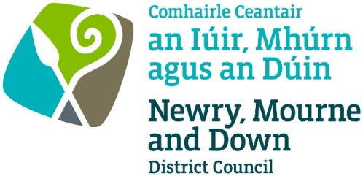

Checklist for Applicants

Temporary Place Approval for Civil Marriages and Civil Partnerships

Please ensure you have enclosed the following

Tick ✓

1. | Completed Application Form
2. | Public Liability Insurance  Confirmation from your Insurance Company of current valid insurance cover for the premises.
3. | Fire Risk Assessment  - Full Fire Risk Assessment for first application or if alterations  have been made to the premises since last Place Approval.  - Fire Risk Assessment Review for renewal application.
4. | Floor Plan  One copy of the floor plan drawn to a scale of not less than 1:100 of the premises showing the ceremony rooms and interview room must be provided.
5. | Site Location Map
6. | Fee  Application for Temporary Place Approval: £170  - Cheques payable to: ‘Newry, Mourne and Down District Council’.

All documentation may be emailed to licensing@nmandd.org
(as PDF or MS Word format attachment).
We may ask for the original of any scanned or emailed document.

DATA PROTECTION ACT 1998

Newry, Mourne and Down District Council collects the Data on this Form for the purpose of Administering Entertainment Licensing under the Local Government (Miscellaneous Provisions) NI Order 1985. The Data Collected on this Form will be shared with the relevant Council Departments, the Police Service of NI and the NI Fire and Rescue Service for the purposing of administering the licence.

DATA PROTECTION ACT 1998

Newry, Mourne and Down District Council collects the Data on this Form for the purpose of Administering Entertainment Licensing under the Local Government (Miscellaneous Provisions) NI Order 1985. The Data Collected on this Form will be shared with the relevant Council Departments, the Police Service of NI and the NI Fire and Rescue Service for the purposing of administering the licence.

