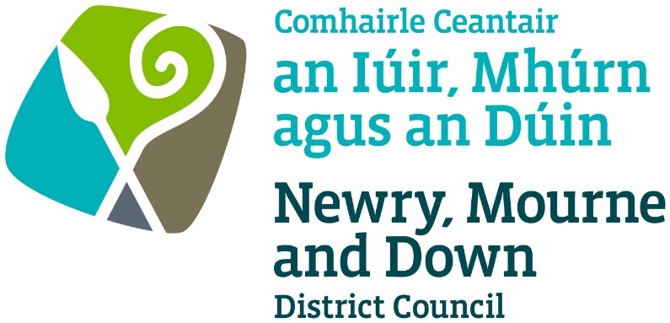

THE PETROLEUM (CONSOLIDATION) ACTS
(NORTHERN IRELAND)
1929 AND 1937

APPLICATION FOR GRANT/RENEWAL/TRANSFER OF A PETROLEUM LICENCE

Completed Application to be sent to one of the offices below:

Oifig Dhún Padraig  Downpatrick Office  Licensing Section  Economy, Regeneration and Tourism  Department  Downshire Civic Centre  Downshire Estate  Ardglass Road  Downpatrick  BT30 6GQ | Oifig an Iúir  Newry Office  Licensing Section  Economy, Regeneration and Tourism  Department  Unit 19 Rampart Road  Greenbank Industrial Estate  Newry  BT34 2QU
For further details contact:
Tel: 033 0137 4030
Email: licensing@nmandd.org
www.newrymournedown.org

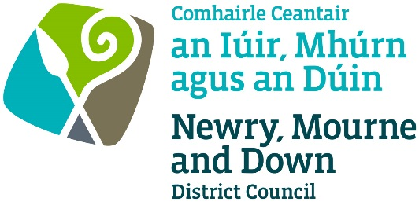

Ref: M/59/____

PETROLEUM (CONSOLIDATION) ACTS (NI) 1929 AND 1937

APPLICATION FOR GRANT/ RENEWAL/TRANSFER OF A PETROLEUM STORAGE LICENCE

SECTION 1 OF 8

Please ✓ tick appropriate box
☐ Application for the Grant of a Petroleum Storage Licence
☐ Application for the Renewal of a Petroleum Storage Licence
☐ Application for the Transfer of a Petroleum Storage Licence
Applicant Details

Name of Applicant

Address of Applicant

Email Address
Telephone Number
Mobile Number

If the application is in respect of a legal partnership, then the Trading Name (if applicable) and the name and address of each partner must be listed. Please indicate if this is a partnership?
☐ Yes ☐ No
If a Limited Company:

Name of Company

Registered Address

Telephone Number
Company Registration Number

V2/25

SECTION 2 OF 8 - Premises to be Licensed

Name of Premises/Trading Name

Premises Address

Do you own this site? (If no, give details below)

☐ Yes ☐ No

Name of Owner of Site

Address of Owner of Site

Premises Details

Description of the premises

Distance of premises from
nearest residential
accommodation

SECTION 3 OF 8 - Products Stored

Give the maximum amount (litres or kg) of other products stored and method of storage

Type of Fuel | Quantity (litres) | Mode of storage  State if under or above ground tanks.  If cans or drums- state where the cans or drums are to be kept
Petroleum Spirit (Petrol)
Petroleum mixtures

Liquefied petroleum gas (LPG)

Diesel

Paraffin/Kerosene

Heating Fuel

Other flammable substance

V2/25

SECTION 4 OF 8 - Pumping Equipment

Number of Pump Islands | Number of Petrol Dispensing Lines (or Nozzles)? | Make and Model of pump, and year of installation, if known

SECTION 5 OF 8 - Mode of Operation

Tick as appropriate: -

Licensee Controlled Deliveries | ☐ |  | Driver Controlled Deliveries | ☐
Daylight Deliveries only | ☐ |  | Deliveries 24 hours | ☐
Attended Self Service | ☐ |  | Attended Service | ☐
Unattended Service | ☐ |  | Unmanned Operation | ☐
Independent Wet stock reconciliation | ☐ |  | Third Party Fuel Management | ☐
Vapour Recovery Stage 1 | ☐ |  | Vapour Recovery Stage 2 | ☐
Interceptor | ☐ |  | No Interceptor | ☐

Reason for storing petroleum

☐ Manufacturing purposes ☐ Private Use ☐ Sale to the public

SECTION 6 OF 8 - Petroleum Spirit Stored in Tanks

Total capacity of petroleum
spirit tanks (litres)

Number of tanks

Provide the following details about each tank

Tank Number | Tank Type  e.g. underground | Construction Material | Date Installed | Grade of Petroleum Spirit | Capacity (Litres)
~ Continue on separate page if necessary

V2/25

SECTION 7 OF 8 - Additional Details

Provide any additional information which is required or relevant to your application (check for local guidance notes and conditions which may provide details of specific requirements in your area).

SECTION 8 OF 8 - Payment Details

Fee payable to: ‘Newry, Mourne and Down District Council’.

To keep a quantity of petroleum spirit: - | £
- Not exceeding 2,500 litres = | 42.00
- Exceeding 2,500 litres and not exceeding 50,000 litres = | 58.00
- Exceeding 50,000 litres = | 120.00
- Transfer of a Petroleum Storage Licence = | 8.00

Fee amount paid (£)

Advisory Notes and Declaration

- I am aware of the provisions of The Petroleum (Consolidation) Acts (Northern Ireland) 1929 and 1937. The details contained in the application form and any attached documentation are correct to the best of my knowledge and belief.
- Information provided as part of this application may be disclosed in response to a request under the Freedom of Information Act 2000 or the Environmental Information Regulations 2004.
- The Council to which you are submitting this application form, collects data for the purposes of the management and application of the Petroleum Regulations. The data may also be passed onto other related Government Agencies and to other Council Departments, to facilitate Statutory Requirements, Service Level Agreement of or similar purposes.
- Newry, Mourne and Down District Council collects the Data on this Form for the purpose of administering Petroleum Licensing under the Petroleum Regulation Acts (NI) 1929 & 1937. The Data Collected on this Form will be shared with the relevant Council Departments under the Data Protection Act 1998.

The Council’s privacy notice can be accessed via our website www.newrymournedown.org/privacy-policy

By signing below, this indicates that you have read and understood the above declaration.

Application Signature by Licensee / Partner / Secretary | Official Use Only
Print Full Name: | Date Received:
Signature: | Receipt Number:
Date: | £

Please return the application and required associated certificates to licensing@nmandd.org

V2/25

CONDITIONS OF APPLICATION

The following Certificates, where appropriate, shall accompany the application:

- ELECTRICAL CERTIFICATES
- Filling Station Electrical Periodic Inspection Report.
(b) Certificate of Electrical Inspection and Testing at filling stations following the periodic inspection of existing installations in and associated with potentially flammable atmospheres, Health and Safety at Work (N.I.) Order 1978, Electricity at Work Regulations (N.I.) 1991, and Dangerous Substances and Explosive Atmospheres Regulations (N.I.) 2003.

A certificate should be from a competent engineer stating that the electrical installations on site have been examined and tested and found to be in a satisfactory condition. The approved engineer must have been assessed for the hazardous area extension under the UKAS accredited scheme. Current membership of NICEIC, Institute of Electrical Engineers (IEE), Electrical Contractors Association (ECA), or Electrical Contractors Association of Scotland (ECAS) is considered as an acceptable qualification. IET, ECSSA or RECI can be considered as methods of demonstrating that the contractor has appropriate skills and knowledge. Some organisations such as NICEIC and ECA/ECAS operate UKAS accredited schemes. This means that the member electrical companies are assessed against a specific set of competency requirements. Accreditation aims to ensure independence and integrity and focuses on safety and competency.
Report & Certificate Enclosed: YES ☐ NO ☐

2. FIRE-FIGHTING EQUIPMENT
A Certificate confirming that all fire-fighting equipment on site is in good working condition and suitable for the purpose for which it is intended to British Standard BS 5306 (2009).
Certificate Enclosed: YES ☐ NO ☐

3. SEPARATOR/INTERCEPTOR (where applicable)
Routine inspection and maintenance should be undertaken at least every six months and a log maintained of inspection date, depth of oil and any cleaning that is undertaken. A copy of the most recent certificate of maintenance should be provided for inspection.
Certificate Enclosed: YES ☐ NO ☐

4. TANK and DELIVERY PIPEWORK CERTIFICATION (from Contractor - where applicable)
Where appropriate, precision or vacuum testing certification confirming the integrity of the petroleum storage tanks.
Certificate Enclosed: YES ☐ NO ☐

5. DSEAR RISK ASSESSMENT
A reviewed copy of the DSEAR Risk Assessment. The Health and Safety Executive recommend a DSEAR risk assessment review is carried out every 3 years, or sooner if there has been:
- any change (new tanks, new fuel types, equipment, site layout)
- any incidents/near-misses
- change to substances used
- statutory guidance changes
Enclosed: YES ☐ NO ☐
New applications only
A Site Location Map to a scale of 1:1250 or 1:2500 indicating all site boundaries and a Site Layout Plan to scale 1:100 clearly indicating the present layout of complete Filling Station or Petrol Storage Depot. The Layout Plan must show the following: -

- Location of storage tanks and tank capacities
- Position of fill points and their identification
- Location of pipework including all vent pipes etc
- Location of metering pumps, dispensers etc
- All site drainage and its discharge location
- Petrol interceptor location & drainage discharge point
- All other buildings within the site and their use
- All neighbouring buildings within 6m from the boundary
- Position of LPG storage, if applicable
- Location of car wash and drainage if applicable
- Main electrical intake points and distribution board
- Position of all fire-fighting appliances

PETROLEUM LICENSING GUIDANCE NOTES

1. An application for a Petroleum Licence consists of: -
  - Completed application form
  - Completed certificates as required
  - Appropriate fee, effective from May 2012
For details of fees see The Health and Safety (Fees) Regulations (NI) 2012. This legislation can be accessed from the following website: http://www.hseni.gov.uk.

To keep a quantity not exceeding 2,500 litres | £ 42.00
Exceeding 2,500 not exceeding 50,000 litres | £ 58.00
Exceeding 50,000 litres | £120.00
Transfer of a licence | £ 8.00

The applicant must ensure that an up to date site plan, showing the general layout of the fuel installations including tanks, pipe work, drains, vents and any building or shop is lodged with the Council.

- The application must be signed by one of below: -

  - in the case of a sole trader, the licensee
  - in the case of a partnership, one of the partners
  - in the case of a registered company, the company secretary

- When received the application will be recorded, receipted and checked and acknowledged within 10 working days.

- The premises will be inspected by an authorised Council Officer to ensure compliance with the conditions.

- A licence may be issued following satisfactory completion of all above criteria.

- Dangerous Substances and Explosive Atmosphere Regulations (Northern Ireland) 2003 shall be referred to as DSEAR within this application pack.

All documentation may be submitted to us electronically by email
(as PDF or MS Word format attachments) to licensing@nmandd.org although we may ask for the original of any scanned or emailed document.

NEWRY, MOURNE AND DOWN DISTRICT COUNCIL
PETROLEUM (CONSOLIDATION) ACT (NORTHERN IRELAND) 1929

MAINTENANCE OF PETROLEUM INTERCEPTORS

Name of Licensee:
Address of Licensed Premises:

I am the person undertaking the work regulated by this certificate and I have inspected the petroleum interceptor installed at the above-named premises and can therefore complete this certificate. I am aware that it is an offence under The Health and Safety at Work (NI) Order 1978 Article 31(1) for any person to willfully or recklessly make a false statement for the purpose of obtaining the issue of a licence.

Signed:
Print Name:

Name of Contractor:
Address:
Telephone Number:
Date of Inspection:
Capacity of Interceptor (litres):
Contents removed to:

Signed:
Print Name:
Date:

