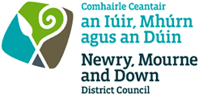

Application to Request a Dual Language Street Nameplate
Applications for dual language street nameplates can be submitted by:
- A resident* of a property in a street (commercial or residential) may apply to Newry, Mourne and Down District Council to request a street nameplate erected in the street in a language other than English.

- An elected member may apply to Newry, Mourne and Down District Council to request for street nameplate on behalf of a *resident(s) in their electoral area. Elected members must provide the name and address of the resident(s) who they are submitting the request on behalf of.

- A developer of a new street may apply to Newry, Mourne and Down District Council to request a street nameplate erected in the new street in a language other than English

*Residents shall be taken to be a person who resides in a dwelling (one person per dwelling over the age of 18) (including a house, flat, maisonette or house in multiple occupancy (HMO)) located on the street, plus the owner or tenant in actual possession of commercial premises, but not employees within such premises.
For further information and to view the Development Naming, Postal Numbering and Erection of Nameplates Policy please visit: www.newrymournedown.org/postal-numbering-and-street-nameplates
Please email the completed application form to licensing@nmandd.org or post to the address below:
Newry, Mourne and Down District Council
Newry Office: 19 Rampart Road, Greenbank Industrial Estate, Newry, BT34 2QU
Downpatrick Office: Downshire Civic Centre, Downshire Estate, Ardglass Road, Downpatrick, BT30 6GQ

Telephone: 0330 137 4030 Email: licensing@nmandd.org Website: www.newrymournedown.org

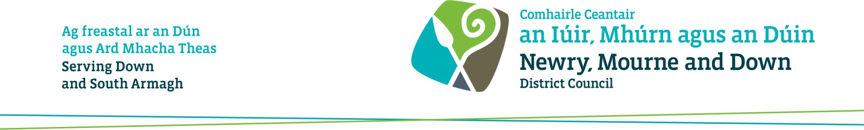

Application to Request a Dual Language Street Nameplate
Applicants Details
Please select from one of the options below that enables you to meet the criteria
☐ Resident
☐ An Elected member submitting a request on behalf of a resident in their electoral area
☐ Developer of a new street
First Name(s):
Surname:
Address:
Email Address:

Telephone Number:

If this application is being submitted by an Elected Member on behalf of a resident, the name of the elected member should be supplied below:
Name of Elected Member:

Street Details
Name of the street where a dual language nameplate is being requested:

State proposed language being requested: (the street name will also be provided in English)

Declaration and Signature
- I confirm that I have read and understand the ‘Development Naming, Postal Numbering and Erection of Nameplates Policy’. The details contained in the application form are correct to the best of my knowledge and belief. Information provided as part of this application may be disclosed in response to a request under the Freedom of Information Act 2000 or the Environmental Information Regulations 2004.

- Newry, Mourne and Down District Council collects the Data on this Form for the purpose of Administering Dual Language Street Nameplates. The data collected on this form will be shared with the relevant Council Departments, for the purposes of administering the permit under the UK General Data Protection Regulation (UK GDPR) and the Data Protection Act 2018 (DPA).

By signing below, this indicates that you have read and understood the above declaration.
The Council’s privacy notice can be accessed via our website www.newrymournedown.org/privacy
Print Full Name:
Signature:
Date:

