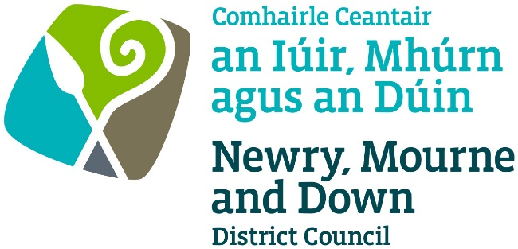

THE CINEMAS (NORTHERN IRELAND) ORDER 1991
The Fire and Rescue Services (Northern Ireland) Order 2006
The Fire Safety Regulations (Northern Ireland) 2010

APPLICATION FOR LICENCE/RENEWAL OF A
CINEMA LICENCE

Completed Application to be sent to one of the below offices:

Oifig Dhún Padraig  Downpatrick Office  Licensing Section  Enterprise, Regeneration and Tourism  Department  Downshire Civic Centre  Downshire Estate  Ardglass Road  Downpatrick  BT30 6GQ | Oifig an Iúir  Newry Office  Licensing Section  Enterprise, Regeneration and Tourism  Department  O’Hagan House  Monaghan Row  Newry  BT35 8DJ
For further information contact:
Tel: 0330 137 4030
Email: licensing@nmandd.org
www.newrymournedown.org

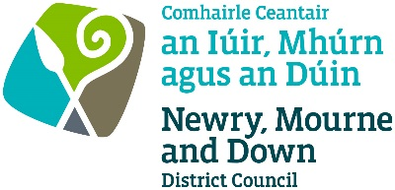
Ref: M/70/____

APPLICATION FOR LICENCE/RENEWAL FOR USE OF PREMISES FOR FILM EXHIBITIONS
The Cinemas (Northern Ireland) Order 1991
The Fire and Rescue Services (Northern Ireland) Order 2006
The Fire Safety Regulations (Northern Ireland) 2010

I/We hereby make application for *Licence / Renewal of a Licence under the above Act for the giving of film exhibitions. [ *Please select ]

Name & Address of Premises to be Licensed | Name and Address of Applicant(s)
Daytime Telephone Number: | Daytime Telephone Number:
Email Address: | Email Address:

Declaration and Signature
- Information provided as part of this application may be disclosed in response to a request under the Freedom of Information Act 2000 or the Environmental Information Regulations 2004.
- The Council to which you are submitting this application form, collects data for the purposes of the management and application of the Cinema Order. The data may also be passed onto other related Government Agencies and to other Council Departments, to facilitate Statutory Requirements, Service Level Agreement of or similar purposes.
- Newry, Mourne and Down District Council collects the Data on this Form for the purpose of Administering Cinema Licensing under The Cinemas (Northern Ireland) Order 1991.
- The Data Collected on this Form will be shared with the relevant Council Departments, the Police Service of NI and the NI Fire and Rescue Service under the Data Protection Act 1998.

The Council’s privacy notice can be accessed via our website www.newrymournedown.org/privacy-policy.

☐ Ticking ✓ this box indicates that you have read and understood the above declaration.

 | Official Use Only
Print Full Name: | Date Received:
Signature: | Receipt Number:
Date: | £
CHECKLIST
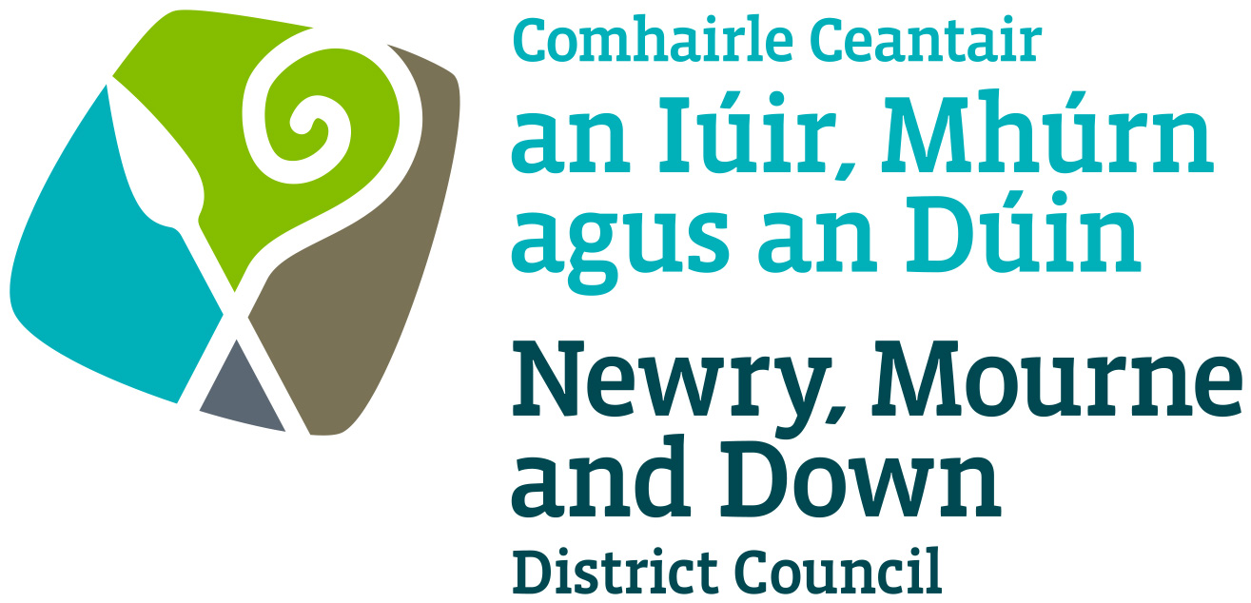

CINEMA LICENCE - I confirm I have enclosed the following:

Tick ✓

1. | Completed Application Form | ☐
2. | Application Fee  Card, cash or cheque payment accepted.  Cheques to be made payable to: ‘Newry, Mourne and Down District Council’.  The application fee is £600 for a period of one year or £120 for Transfer of Licence. | ☐
3. | Public Liability Insurance  Confirmation from your Insurance Company that your premises has current valid public liability insurance cover. To include premises name, address and expiry date. Please note Employer’s Liability Insurance is not acceptable. | ☐
4. | Fire-Fighting Equipment Certificate | ☐
5. | Fire Risk Assessment – Under the Fire Safety Regulations (Northern Ireland) 2010 you must carry out a fire risk assessment of your premises.  - Full Fire Risk Assessment is required for first application or if alterations have been made to the premises since last Licence.  - Reviewed Fire Risk Assessment is required for renewal applications. | ☐
6. | * Electrical Installation Condition Report  This certificate must be submitted annually unless authorised for longer by the inspecting electrical contractor, up to a maximum of 3 years. | ☐
7. | * Emergency Lighting Certificate | ☐
8. | * Fire Alarm System Certificate | ☐
9. | Floor Plan  If first application or alterations have been made to premises since last Licence, one copy of a floor plan to a scale of not less than 1:100 must be provided. The plan must reflect the physical measures shown in your Fire Risk Assessment, e.g. escape routes, emergency lights, emergency exits, fire doors, fire alarm points, fire safety notices, occupancy numbers for each area etc. | ☐
* These three certificates must be signed and completed by one of the following: -

(a) an approved Electrical Contractor on Roll of NICEIC
(b) a member of the Electrical Contractors Association
(c) an approved member of the Institute of Engineering & Technology (IET)

Please note if an Electrical Contractor is not a member of any of the third-party accreditation bodies listed above, verification must be provided of training and competencies for maintenance and testing to relevant British Standards from an approved training body. If verification is not provided we will not be able to accept Fire Alarm System Certificates and Emergency Lighting Certificates from the Electrical Contractor.
All documentation may be emailed to: licensing@nmandd.org (as PDF or MS Word format attachments). We may ask for the original of any emailed document.

