Ag freastal ar an Dún
agus Ard Mhacha Theas
Serving Down
and South Armagh
Name of Nominating Club/Organisation/Person
Click or tap here to enter text.

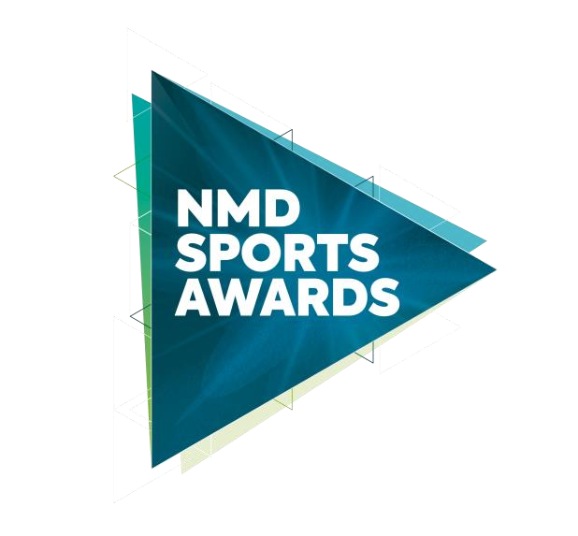
Senior Team of the Year 2025
In association with
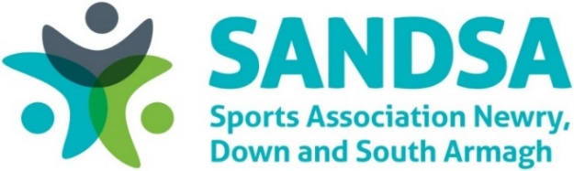
Closing Date: Monday 26 January 2026 @ 4pm
Shortlisting Week Ending: Friday 30 January 2026
Notification to applicants: WB Monday 2 February 2026
Photocall for Nominees:
- Downpatrick Wednesday 18 February 2026 (3pm-7pm)
- Newry Thursday 19 February 2026 (3pm-7pm)
Ticket Sales: WB Monday 2 February 2026 - £30 per person
Sports Awards Event:
Slieve Donard Hotel, Newcastle Friday March 20, 2026 @ 6:30pm

This award recognises the achievements of a Senior Team based in the Newry, Mourne and Down District Council area, which has excelled in either provincial, interprovincial, national (UK or Ireland), International or world competition from January 1, 2025 – December 31, 2025.

Criteria
Nominees must demonstrate the following:

- Significant success during the period January 1, 2025 – December 31, 2025.
- All Seniors on the team must be over the age of 18 on 1st January 2025.
- Please provide evidence of team involvement, achievements and successes from January 1, 2025 – December 31, 2025.
- Provide supporting information for this application and include team dedication, motivation, commitment, and enthusiasm in their role.

Each criterion is assessed individually and must therefore be completed in full. Nominating NMDDC Club should not rely on information included in a previous answer for another criteria.
All sections of this form must be completed and must not extend beyond the pages provided.

Contact details for nominee
Nominee Name: Click or tap here to enter text.
Club / Sport: Click or tap here to enter text.
Address: Click or tap here to enter text.
Telephone: Click or tap here to enter text.
Email: Click or tap here to enter text.

Contact details of person nominating Senior Team of the Year (for reference only)
Name: Click or tap here to enter text.
Role: Click or tap here to enter text.
Address: Click or tap here to enter text.
Telephone: Click or tap here to enter text.
Email: Click or tap here to enter text.

Nominee Information:
Prior consent for all nominations must be obtained.
Has the Nominee consented to the nomination? Choose an item.

Please confirm Senior Team nominee is available to attend photocall and Sports Awards night. Choose an item.:

Nominees who are not available on scheduled dates, please email leisureandsport@nmandd.org

Has Nominee received financial support from NMDDC Recognition of Achievement for High Performance Levels in Sport and / or Elite Athlete Scheme?
Choose an item.

- Please provide evidence of the Senior Team’s involvement, specific competitions entered and details of achievements and successes for period January 1, 2025 – December 31, 2025. (Max 1800 characters) (20 Marks)

- Provide supporting information for this application and include team dedication, motivation, commitment, and enthusiasm in their role. (5 Marks)

Dedication (Max 350 characters)
Motivation (Max 350 characters)
Commitment and enthusiasm (Max 350 characters)

The information on this form is required by Council for the purpose of processing your form. The information is covered by the provisions of the Data Protection Act 1998. By ticking this box you allow the Council to process and retain the information for the purpose(s) stated.
Accept Declaration ☐

Closing Date

Nominations must be received by 4pm on Monday 26 January 2026 to be considered for the NMD Sports Awards in association with SANDSA. Any nominations received after this date will not be considered. The judges’ decision is final, and no correspondence will be entered.

You can email your completed form to: leisureandsport@nmandd.org

You can post your completed form to either:
Sports Awards Sports Awards
Leisure and Sport Department Leisure and Sport Department
Newry Leisure Centre Down Leisure Centre
60 Cecil Street 114 Market Street
Newry Downpatrick
BT35 6AU BT30 6LZ

Newry, Mourne and Down District Council takes the confidentiality of personal data seriously and is committed to protecting your privacy. Our privacy notice explains how we collect, use and disclose information that you provide to Newry, Mourne and Down District Council. A copy of our privacy notice is available on request or via the following link: http://www.newrymournedown.org/media/uploads/privacy_notice.pdf

