Ag freastal ar an Dún
agus Ard Mhacha Theas
Serving Down
and South Armagh
Name of Nominating Club/Organisation/School/Person
Click or tap here to enter text.

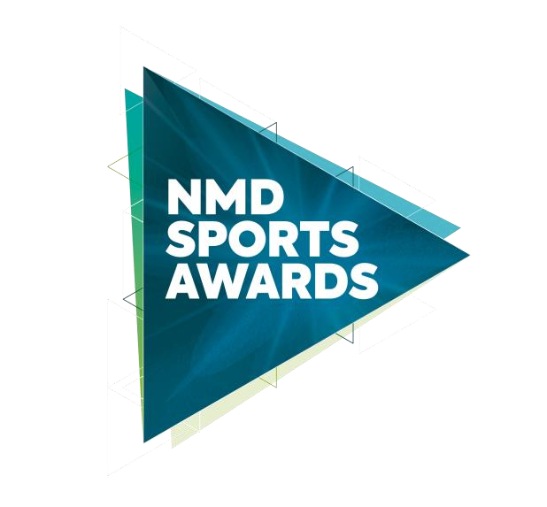
Sports Coach of the Year 2025
In association with
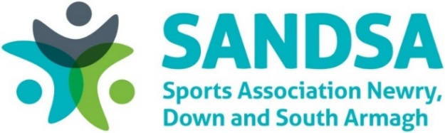
Closing Date: Monday 26 January 2026 @ 4pm
Shortlisting Week Ending: Friday 30 January 2026
Notification to applicants: WB Monday 2 February 2026
Photocall for Nominees:
- Downpatrick Wednesday 18 February 2026 (3pm-7pm)
- Newry Thursday 19 February 2026 (3pm-7pm)
Ticket Sales: WB Monday 2 February 2026 - £30 per person
Sports Awards Event:
Slieve Donard Hotel, Newcastle Friday March 20, 2026 @ 6:30pm

This award recognises the important work carried out by a coach, based in the Newry, Mourne and Down District Council area, through their coaching achievements and the impact made on the people they coached during the calendar year January 1, 2025 – December 31, 2025.

Criteria
Nominee must demonstrate the following:

- The coach must be actively coaching within Newry, Mourne and Down District Council area.
- The coach should meet all appropriate governing body professional coaching standards.
- Evidence of active coaching involvement, achievements, developments, and successes during the calendar year January 1, 2025 – December 31, 2025.
- Contribution in the field of senior coaching:
- Educating, tutoring, or mentoring other coaches
- Promotion of character development and ethical values in sport (fairness, integrity, responsibility, and respect)
Each criterion is assessed individually and must therefore be completed in full. Nominating person should not rely on information included in a previous answer for another criteria.
All sections of this form must be completed and must not extend beyond the pages provided.

Contact details for nominee
Nominee Name: Click or tap here to enter text.
Club / Sport: Click or tap here to enter text.
Address: Click or tap here to enter text.
Telephone: Click or tap here to enter text.
Email: Click or tap here to enter text.

For Nominee under 18 years of age by 1st January 2025:
Date of Birth:Click or tap to enter a date.
Parent / Guardian Telephone: Click or tap here to enter text.
Parent / Guardian Email:Click or tap here to enter text.

Contact details of person nominating Coach of the Year 2025 (for reference only).
Name: Click or tap here to enter text.
Role: Click or tap here to enter text.
Address: Click or tap here to enter text.
Telephone: Click or tap here to enter text.
Email: Click or tap here to enter text.

Nominee Information:
Prior consent for all nominations must be obtained.
Has the Nominee / Parent / Guardian of Nominee consented to the nomination? Choose an item.

Please confirm Sports Coach nominee is available to attend photocall and Sports Awards night. Choose an item.:

Nominees who are not available on scheduled dates, please email leisureandsport@nmandd.org

Coaching Qualifications:
Click or tap here to enter text.

- Please provide evidence of the nominee’s coaching involvement, achievements and successes from January 1, 2025 – December 31, 2025. (Max 1200 characters) (20 Marks)

- Coach of the Year: Please indicate under criteria ‘Contribution in the field of coaching’ (A-B)
- A) Educating, tutoring, or mentoring other coaches. (Max 1200 characters) (5 Marks)

- B) Promotion of character development and ethical values in sport (fairness, integrity, responsibility, and respect). (Max 1200 characters) (5 Marks)

- Although active coaching is the main reason for receiving the award, supporting consideration will be given for the following contribution in the field of coaching and scored proportionally.

- Please provide supporting information for this application to include dedication, motivation, commitment, and enthusiasm in their role. (5 Marks)

Dedication (Max 350 characters)
Motivation (Max 350 characters)
Commitment and enthusiasm (Max 350 characters)

The information on this form is required by Council for the purpose of processing your form. The information is covered by the provisions of the Data Protection Act 1998. By ticking this box, you allow the Council to process and retain the information for the purpose(s) stated.
Accept Declaration ☐

Closing Date

Nominations must be received by 4pm on Monday 26 January 2026 to be considered for the NMD Sports Awards, in association with SANDSA. Any nominations received after this date will not be considered. The judges’ decision is final, and no correspondence will be entered.
You can email your completed form to: leisureandsport@nmandd.org

You can post your completed form to either:

Sports Awards Sports Awards
Leisure and Sport Department Leisure and Sport Department
Newry Leisure Centre Down Leisure Centre
60 Cecil Street 114 Market Street
Newry Downpatrick
BT35 6AU BT30 6LZ

Newry, Mourne and Down District Council takes the confidentiality of personal data seriously and is committed to protecting your privacy. Our privacy notice explains how we collect, use and disclose information that you provide to Newry, Mourne and Down District Council. A copy of our privacy notice is available on request or via the following link: http://www.newrymournedown.org/media/uploads/privacy_notice.pdf

