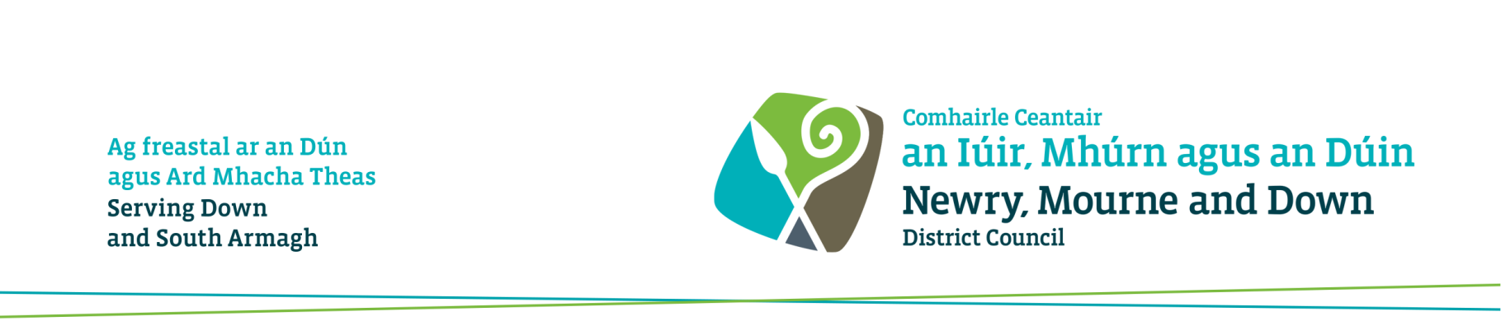

Consultation on the draft Performance Improvement Plan and Objectives for 2017-18

I am responding: | Choose an item.

Name: | Click here to enter text.
Job title  (if applicable): | Click here to enter text.
Organisation and address: | Click here to enter text.
Telephone | Click here to enter text.
Fax | Click here to enter text.
E-mail | Click here to enter text.

Question 1
Which consultation group do you belong to? Please check all boxes that apply.
Resident ☐
Elected Member ☐
Local Business ☐
Local Community Organisation ☐
Local Voluntary Organisation ☐
Statutory Organisation ☐
Other ☐
If other, please provide further information below.
Click here to enter text.

Question 2
Do you agree that the draft performance improvement objectives and supporting project(s) are appropriate for our District?
Performance Improvement Objective 1 | Agree | Disagree
Encourage healthy lifestyles through increased participation in leisure, sport and recreational activities | ☐ | ☐
Comments:
Click here to enter text.

Performance Improvement Objective 2 | Agree | Disagree
Improve economic growth by creating new business starts, supporting the growth of existing businesses and promoting Newry, Mourne and Down as a premier tourist destination | ☐ | ☐
Comments:
Click here to enter text.

Performance Improvement Objective 3 | Agree | Disagree
Deliver urban and rural regeneration initiatives that will create a District where people want to live, work and invest in | ☐ | ☐
Comments:
Click here to enter text.

Performance Improvement Objective 4 | Agree | Disagree
Create a cleaner, greener, more attractive District | ☐ | ☐
Comments:
Click here to enter text.

Performance Improvement Objective 5 | Agree |  | Disagree
Encourage and empower local communities to participate in Council engagement structures | ☐ |  | ☐
Comments:
Click here to enter text.

Question 3
What alternative performance improvement objective(s) and supporting projects would you suggest?
Click here to enter text.

Question 4
Which of the areas outlined below would you like to see Newry, Mourne and Down District Council make improvements to in the future? (please tick)
Area
Arts, Culture and Events | ☐
Building Control and Licensing | ☐
Community Services | ☐
Registration Services (Births, Deaths, Marriages & Civil Partnerships) | ☐
Economic Development and Tourism | ☐
Environmental Health | ☐
Leisure and Recreation | ☐
Parks and Open Spaces | ☐
Planning | ☐
Urban and Rural Regeneration | ☐
Waste Collection and Recycling | ☐
Street Cleansing | ☐

Please provide details, in the space provided, concerning the specific areas of the Council that you would wish to see improvements made in.
Click here to enter text.

Thank you for taking the time to respond to this questionnaire. Your feedback is important to us and will help inform the development of the performance improvement objectives 2017-18.

Completed questionnaires, comments or further information on the draft performance objectives should be returned by midday on 19 May 2017 to:

In Writing: Kate Bingham
Performance Improvement Department
Newry, Mourne & Down District Council
O’Hagan House
Monaghan Row
Newry
Co Down
BT35 8DJ

Telephone: 0300 013 2233

Email: kate.bingham@nmandd.org

We look forward to hearing from you.

