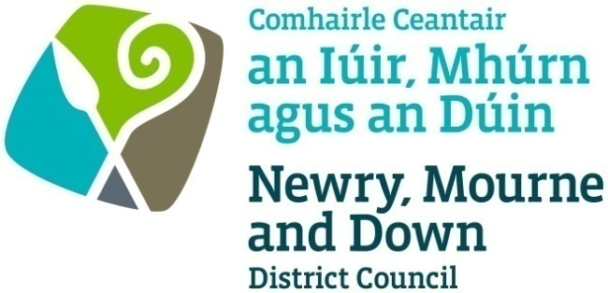

**Newry, Mourne and Down District Council  
  
  
Licensing of Pavement Cafés Act**

**(Northern Ireland) 2014**

**Application Form**

**Appendix 1**

**APPLICATION FOR A PAVEMENT CAFÉ LICENCE**

I / We hereby make application to Newry, Mourne and Down District Council under the provisions of the Pavement Cafés Act (Northern Ireland) 2014 for the:

**Application type** - *tick as appropriate*

|  |  |  |  |
| --- | --- | --- | --- |
| **Grant of a Pavement Café Licence** |  | **Variation of a Pavement Café Licence** |  |
| **Renewal of a Pavement Café Licence** |  |  | |

**Applicant details** - Name : ______________________________________________

Address: ______________________________________________________________

______________________________ BT_________ Tel : ______________________

Email : ______________________________ D o B : _____________________

Designation : Owner / Director / Manager - or otherwise state _________________

**Premises details** - Type : ______________________________________________

Name : ______________________________________________________________

Address : _____________________________________________________________

_______________________________ BT : ___________ Tel :__________________

**Operating details**

|  |
| --- |
| Proposed days and hours of operation of the Pavement Café |
|  |

**Licensing details**

|  |  |  |  |  |  |  |  |  |  |  |  |
| --- | --- | --- | --- | --- | --- | --- | --- | --- | --- | --- | --- |
| Is alcohol to be consumed in the curtilage of the Pavement Café? | | | | | | | | | YES | NO | |
| Are the premises licensed under the Licensing (N I) Order 1996? | | | | | | | | | YES | NO | |
| Public House |  | Off  Sales |  | Restaurant |  | Hotel |  | Guest house  with restaurant | | |  |

**Proposal details**:

Total width of footpath ____________m

Is the area within 10metres of a road junction: Yes No

Dimensions of café area: ________________________ Number of tables & chairs _________

Barrier Height: _____________________ Barriers/Tap Rails: Yes No

**Site details** – *(see guidance document)*

|  |  |  |  |
| --- | --- | --- | --- |
| Provide an area Location Plan, scale 1:1250, depicting location of Pavement Café and sufficient surrounding area with infrastructure. | | Here  enclosed | To  follow |
| Provide a proposed Site Plan, scale not less than 1:100, depicting street space occupied, size and type of barriers, number and type of tables and chairs, and any other pavement café furniture. | | Here  enclosed | To  follow |
| Provide specification of furniture (Photographs/manufacturers detailed brochures or of existing furniture would be an advantage) | | Here  enclosed | To  follow |
| Where will the Pavement Café furniture be stored when it is not in use? **(Ensure furniture is stored remote from designated fire escapes)** | State | | |

|  |  |
| --- | --- |
| I confirm that I wish to apply for a Pavement Café Licence for the development as described within this application. | Tick |
| I confirm that that the information provided in this application is correct. | Tick |
| I confirm that all furniture must be of a temporary nature that can be removed swiftly within 20 minutes at the end of the permitted period or when access to the area is required by any statutory body or in the event of an emergency. | Tick |
| I confirm that I have placed the appropriate notice in a prominent place at or near the premises that it can easily be read by the public, and that the notice shall be displayed for 28 days from the date of this application. | Tick |
| **Applicant signature :_______________________________________    Date : ________________________** | |

**CHECKLIST**

|  |  |
| --- | --- |
|  | **Application form**, signed and dated. |
|  | **Location plan** to a scale of 1:1250 showing sufficient area around the proposed pavement café to enable consideration of all related issues. |
|  | **Site plan** to a scale of not less than 1:100 showing access points, building lines, boundaries, kerbs, table and chair arrangement, bins, lighting, trees, other items. |
|  | **Details of the furniture** including photographs/manufacturers details. |
|  | **Risk Assessments** |
|  | **Fee** |
|  | **Public liability insurance** |
|  | **Planning permission**, if appropriate. |
| S | **Site Notice** |

**Appendix 2**

**NEWRY, MOURNE AND DOWN DISTRICT COUNCIL**

**Licensing of Pavement Cafés Act (Northern Ireland) 2014**

**PUBLIC NOTICE**

**APPLICATION FOR A PAVEMENT CAFÉ LICENCE**

### NOTICE IS HEREBY GIVEN THAT

*(Name of applicant) __________________________________________*____________

*(Address of applicant) _____________________________________________*_________  
__________________________________________________________________________

has applied to Newry, Mourne and Down District Council for a Pavement Café Licence at

*(Name and address of premises) _______________________________________________*

***________________________________________________________________________________________________________________________________***

Any objection relating to the application should be made within 28 days of the date of this Notice. The objection should be addressed to Newry, Mourne and Down District Council, Licensing Section, Regulatory and Technical Services Department, Monaghan Row, Newry, BT35 8DJ

Any objection must be in writing and must specify the grounds of the objection, the name and address of the person making it and must be signed by them or their agent.

It should be noted that where an objection is made after the 28 day time period referred to, but before a final decision is taken on the application, it is appropriate for the Council to consider it, if there is sufficient reason why the objection was not made within the stated time period.

*(Applicant’s Signature)* ___________________________ *(Date) ______________________*

**This site notice must be displayed for the whole of the period of 28 days in a prominent place at or near the premises so that it can be conveniently read by the public.**

**Appendix 3**

Examples of pavement cafés



